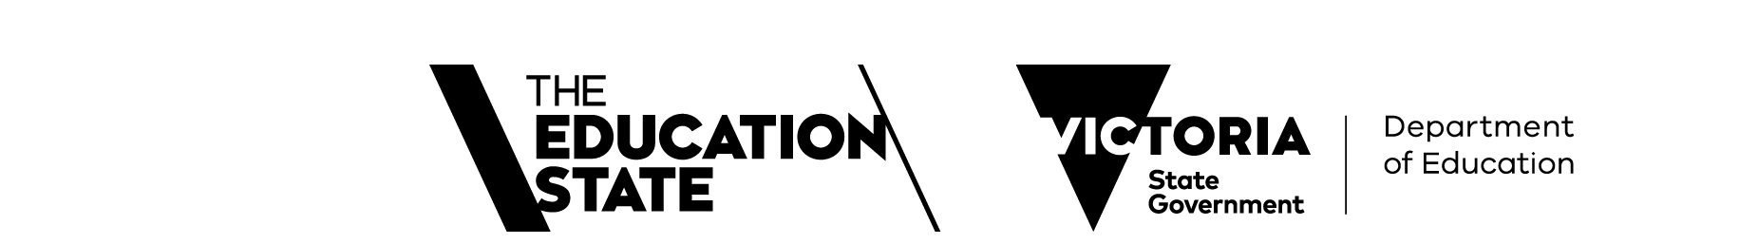

Quality Assessment & Regulation Division Annual Report 2023

Acknowledgements
Photography: Jina Zheng, Studio Z Photography.
Thank you to all the services that were photographed for their support.

Data Reliability Statement
Data included in this report is primarily sourced from the National Quality Agenda IT System. Data regarding previous years may be slightly different than previously published, as records may be updated for accuracy.
Rounding
Percentages may not always sum up to 100% due to rounding.

© State of Victoria (Department of Education) 2024.



Quality Assessment and Regulation Division Annual Report 2023 is provided under a Creative Commons Attribution 4.0 International licence. You are free to re-use the work under that licence, on the condition that you credit the State of Victoria (Department of Education), indicate if changes were made and comply with the other licence terms, see Creative Commons Attribution 4.0 International: https://bit. ly/1rMF155.
The licence does not apply to:
- any images, photographs, trademarks or branding, including the Victorian Government logo and the Department of Education logo; and
- content supplied by third parties.
Authorised by the Department of Education, 2 Treasury Place, East Melbourne, Victoria, 3002. Copyright queries may be directed to copyright@education.vic.gov.au.

Contents

Welcome from our Executive Director 4
About the regulator 6
Strategic objectives 6
Statement of Expectations 6
Quality Assessment and Regulation Division objectives 7
Our operations 7
Regulatory framework 9
National Quality Framework 9
Children’s Services regulatory regime 10
Enforcement of the Child Safe Standards 10
National Quality Framework objectives 10
Children’s Services Act 1996 objectives 10
Principles for compliance with the Child Safe Standards 10
About the sector 11
What we regulate 11
Education and care services regulated under the NQF 12
Children’s services regulated under the Children’s Services Act 1996 12
Statistical overview 13
Sector profile 14
Overall quality rating comparisons by care type 18
Centre-based care overview 20
Family day care 25
Supporting the sector 27
2019 NQF Review implementation 27
Child Safe Standards implementation 28
Enquiries and support 28
Quality Assessment and Regulation Update newsletter 28
Information sessions 28
Early childhood website 29
Sector reference groups 31
Red tape reduction 31
Stakeholder Satisfaction Survey 32
Regulatory performance 33
Risk-based regulator 33
Applications and notifications of change 34
Monitoring quality and compliance 35
Assessment and rating 35
Case study: Compliance and quality improvement driven by data-informed regulatory practice 36
Case study: Service improvement through tailored individual QARD support 37
Compliance and investigations 37
Enforcement 39
Child Safe Standards Enforcement 40
Reforms and initiatives 41
Refinements to the quality assessment and rating process 41
NQF Review 2019 42
Premises approval in principle scheme – multi-storey buildings 42
Maintaining alignment between the children’s services regulatory regime and the NQF 43
Co-regulatory partners 43
Glossary 45
Data tables 47



Welcome from our Executive Director

I am pleased to present the Quality Assessment and Regulation Division (QARD) Annual Report for 2023.

The early childhood sector continued to grow in 2023, providing education and care to greater numbers of Victorian children. Victoria now has 4,759 approved services regulated under the National Quality Framework (NQF) that provide 326,500 approved places, and 194 approved services under the Victorian Children’s Services Act 1996 (CS Act).
2023 was a year of considerable change for the early childhood sector with two major reforms that required providers and services to make significant changes to their systems and practices. The first was the implementation of the new Child Safe Standards (CSS) in Victoria, followed by the amendments resulting from the 2019 NQF Review.
On 1 January 2023, QARD became the integrated regulator of the CSS for the early childhood sector in Victoria; a completely new regulatory scheme in addition to the NQF and the CS Act. QARD now monitors compliance with the CSS as an integrated part of our regulatory approach, using our existing powers under the NQF and CS Act regimes to ensure that all early childhood services are complying with their obligations. Through our monthly newsletter and information sessions, QARD provided information and guidance on implementing these new requirements, and our authorised officers further supported the sector by discussing the CSS and answering questions when they visited services. Our QARD enquiry line staff also played an important role, responding to queries and explaining new obligations.
In addition to these changes, services were required to make changes to their policies, procedures and practices following the 2019 NQF Review. The changes included transportation, safe sleep, evacuations, safe arrivals, improvements to Family Day Care (FDC) and many other areas. Once again QARD supported the sector to successfully make the necessary changes using the same approach as with the CSS.

QARD undertook over 4,800 visits to approved services in 2023. Each visit is an important opportunity to interact with individual educators, service leaders and approved providers to support their quality improvement journey. Our
authorised officers completed 1,489 quality assessment and rating visits, the highest number of assessment and rating visits ever conducted by QARD in one year, as part of our commitment to visiting services that had missed out due to COVID-19 pandemic, as well as new services.
On a systems level, QARD successfully implemented the new ‘Joined Up Approvals’ process together with the Australian Government and other state and territory Regulatory Authorities. From July 2023, prospective approved providers have been able to submit applications for provider and service approvals together with their application for child-care subsidy through a single portal. This joined up process has seen efficiencies for both applicants and agencies as well as greater consistency of approach to suitability of applicants.
Thank you to early childhood staff, services and providers for your continued commitment to children in Victoria. Your focus and efforts to ensure the safety, health and wellbeing of all children attending services as well as improving their educational and social outcomes make a real difference to their lives.

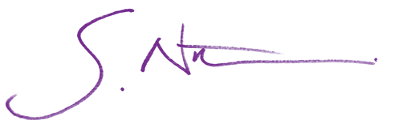
Greg Norton Executive Director
Quality Assessment and Regulation Division



About the regulator

Strategic objectives
QARD’s objectives and strategic plan are informed by broader departmental objectives and:
- the Department’s strategic intent and strategic plan 2023–2027
- obligations and duties of the regulatory authority under the Education and Care Services National Law (National Law), the Education and Care Services National Regulations (National Regulations), and the Children’s Services Act 1996 (CS Act) and Children’s Services Regulations 2020 (CS Regulations)
- obligations as the integrated sector regulator of the CSS for early childhood services in Victoria, under the Child Wellbeing and Safety Act 2005 (CW&S Act)
- the Statement of Expectations (SoE) from the Minister for Children (the Minister)
- the National Law and CS Act objectives.

Statement of Expectations
The administration and enforcement of our regulatory framework is guided by the Statement of Expectations (SoE) issued by the Minister which is published on the Department’s website along with the QARD response.
The Regulatory Risk Committee provides oversight of progress against the SoE. To read the SoE online see: www.vic. gov.au/ministerial-statement-expectations-regulators-department-education.
We continually evolve our approach to strengthen regulatory performance, to ensure the safety, health and wellbeing of children attending early childhood services and to improve educational and developmental outcomes. This report outlines our initiatives and regulatory performance against our objectives.

Quality Assessment and Regulation Division objectives
- Confidence in the regulator: Effective administration of our legislative frameworks to maintain community confidence in the system of regulation overseeing the provision of Victorian early childhood education and care and the Child Safe Standards.
- Being a high-performing regulator: Exemplifying best regulatory practice to efficiently deliver regulatory outcomes.
- Engaging with the sector: Engaging and guiding services to facilitate the provision of high-quality education and care services.
- Supporting reforms and initiatives: Being responsive to government reforms and initiatives, and community priorities.
- Excellent workforce: Developing a high-performing, valued and empowered workforce.

Our operations
Part of the Early Childhood Education Group of the Department, QARD regulates services operating under the NQF and the CS Act and CS Regulations in Victoria under delegation from the Secretary.
Broadly, the Division comprises an Operations Branch, a Regulatory Strategy, Services and Compliance Branch and a Legislative Reform Unit.

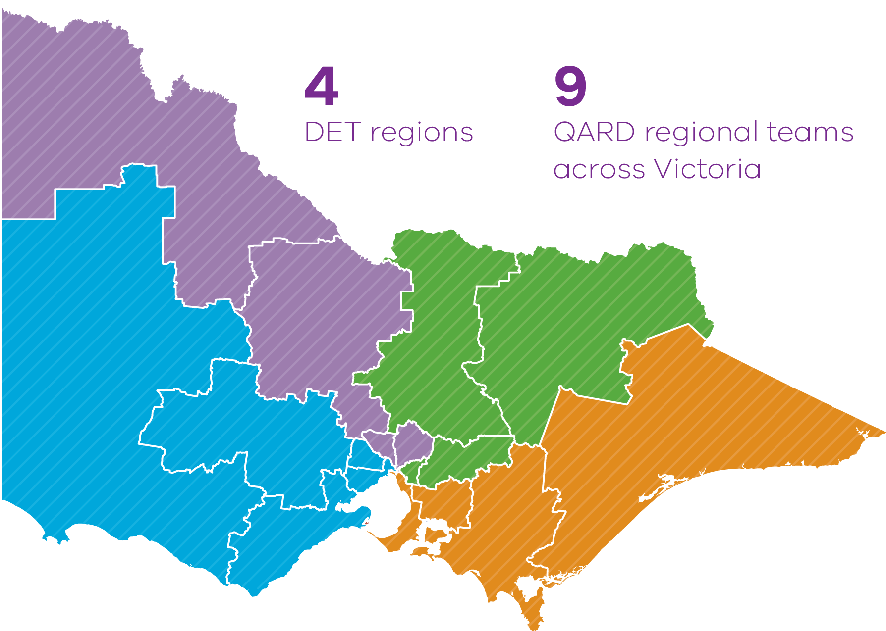

Operations Branch
The Operations Branch manages and supports 9 area-based teams within four regions, delivering training and managing Freedom of Information requests centrally. The teams comprise authorised officers and support staff who assess and rate NQF approved services against the National Quality Standards (NQS), conduct inspections to monitor compliance with regulatory requirements of the National Law, CS Act and the CSS, and investigate alleged non-compliances. Regional teams engage with the sector through educative sessions and other opportunities to support and guide providers of early childhood services.

QARD Regional Teams:

North-Western Victoria
- Loddon Mallee
- Northern Metropolitan
South-Western Victoria
- Barwon South West
- Grampians
- Western Metropolitan
North-Eastern Victoria
- Hume
- Eastern Metropolitan
South-Eastern Victoria
- Gippsland
- Southern Metropolitan

The Operations Branch also includes the Investigations Unit (INV) that acts as a state-wide resource within QARD leading and supporting complex and high priority investigations across all regions. The unit also provides training and support to authorised officers, advice to managers and makes recommendations for statutory sanctions and prosecutions, developing briefs of evidence for court matters.

Regulatory Strategy, Services and Compliance Branch
Service Administration and Support Unit (SASU): provides a first point of contact for prospective, new and existing providers of early childhood services through the administration and assessment of applications, notifications of change of circumstances, and assesses applicants’ fitness and propriety. This team also responds to queries via the QARD hotline – 1300 307 415.
Business Systems and Review Unit (BSRU): maintains QARD’s information management systems, provides user support, undertakes systems improvement, reporting, data analytics, business planning, budget planning, risk assurance and governance.
Monitoring and Compliance Unit (MCU): provides specialist enforcement advice within QARD for matters involving significant non-compliance and takes enforcement action.
Joint Monitoring and Data Sharing Unit (JMDS): a project team that works collaboratively with the Commonwealth Department of Education to share information and conduct joint compliance and monitoring activities in respect of high- risk services, with the aim of harmonising and streamlining regulatory processes across jurisdictions.

Executive
Legislative Reform Unit (LRU): provides legislative policy advice and support on the National Law (where Victoria is the host jurisdiction) and National Regulations, and the CS Act and CS Regulations. It also leads strategic stakeholder engagement and communications functions.
Corporate Support: provides corporate and operational support for QARD in relation to people development and training, information and briefing requests and emergency management.



Regulatory framework

QARD is responsible for the approval and regulation of over 4,950 early childhood services in Victoria under two regulatory regimes. We regulate providers of early childhood services in Victoria with the objective of driving continuous improvement of quality in the provision of education and care.

The Department’s regulatory functions are established by the National Law and National Regulations, and the CS Act and CS Regulations.
As the regulatory authority for Victoria under the National Law and the regulatory authority under the CS Act, the Secretary of the Department has delegated this responsibility to QARD.
Of the more than 4,950 approved early childhood services in Victoria at the end of 2023, around 4,760 were education and care services approved under the NQF, and around 190 were children’s services approved under the CS Act.

National Quality Framework
The NQF promotes high quality education and care services through a legislative framework which comprises:
- the National Law
- the National Regulations including the National Quality Standard (NQS).
Administratively, responsibility for implementing and administering the NQF is shared between State Regulatory Authorities and the National Authority, the Australian Children’s Education and Care Quality Authority (ACECQA).

Children’s Services regulatory regime
The Children’s Services regulatory regime comprises:
- the Children's Services Act 1996 (CS Act)
- the Children's Services Regulations 2020 (CS Regulations).
This scheme operates in Victoria and regulates services that offer care to children on a non-regular, or ad hoc basis, as well as a small number of services providing regular education and care that are excluded from regulation under the NQF.

Enforcement of the Child Safe Standards
Established under the CW&S Act, the Victorian CSS require organisations that work or volunteer with children and young people to have policies, procedures and practices to protect children and young people from harm and abuse.
All early childhood services in Victoria must comply with the CSS.
On 1 January 2023, the Secretary of the Department of Education became the integrated sector regulator of the CSS in the early childhood sector under the CW&S Act. This function is delegated to QARD which:
- uses its powers under the National Law and the CS Act to monitor and enforce compliance with the CSS
- monitors compliance with the CSS as an integrated part of our regulatory approach.
- collaborates with the Commission for Children and Young People (CCYP) and other sector regulators where organisations operate in more than one sector.

National Quality Framework objectives
  - Ensure the safety, health and wellbeing of children attending education and care services.
  - Improve educational and developmental outcomes for children attending education and care services.
  - Promote continuous improvement in the provision of quality education and care services.
  - Reduce the regulatory and administrative burden for education and care services by enabling information to be shared between participating jurisdictions.
  - Improve public knowledge, and access to information, about the quality of education and care services.
  - Establish a system of national integration and shared responsibility between participating jurisdictions in the administration of the NQF.

Children’s Services Act 1996 objectives
  - The CS Act replicates the first 3 objectives of the NQF.

Principles for compliance with the Child Safe Standards
Enforcement of the CSS is based on principles that include:
  - Organisations are responsible for continuously improving the ways in which:
    - the safety of children is promoted
    - child abuse is prevented
    - allegations of child abuse are properly responded to.
  - The CCYP and its co-regulators should collaborate to promote compliance.



About the sector

What we regulate
Our regulatory approach is designed to facilitate and motivate service providers to provide high quality services that ensure the safety, health and wellbeing of children as well as improving children’s educational and developmental outcomes.
Because the foundations for children’s long-term development are laid in the early years, high quality early childhood education is crucial for the development of cognitive and emotional skills such as reasoning, problem solving, and how to get along with others. The pivotal time for the development of vision, emotional control and language is before the age of 3, and the development of social skills is before the age of 6. Participation in high quality early childhood education therefore supports children to develop important skills such as creativity, resilience and communication.
In this report we use the term ‘Standalone Kindergarten’ (KGN) to describe early childhood services that only provide educational programs to 3 and 4-year-old children. We refer to kindergarten programs delivered in all other settings, such as LDC where younger children also attend the service, as ‘funded kindergarten programs’.

Education and care services regulated under the NQF

Centre-Based Care
Delivered on premises suitable for education and care, including:
Standalone Kindergarten (KGN):
  - Standalone kindergarten delivers educational programs for 3 and 4-year-old children only (not younger children).
  - Children have traditionally attended kindergarten in the year before starting school, usually when they are 4 years old. Since 2022, 3-year-old children across the state have been offered between 5 and 15 hours of a funded kindergarten program, and this will progressively increase as infrastructure and workforce capacity in the system grows.
Long Day Care (LDC):
  - Education and care programs delivered by early childhood teachers and diploma and Certificate III level-qualified educators.
  - Primarily aimed at children aged 0–6 years of age.
  - Most LDC services also offer funded kindergarten programs to 3 and 4-year-old children.
Outside School Hours Care (OSHC):
  - Usually located at or close to primary schools.
  - Provide care for primary school aged children (5 to 12 years) outside school hours and during school holidays.
  - Education and care may also be provided on student free days and school holidays.

Family Day Care (FDC)
  - Can be provided to children from birth through to school age.
  - Generally provided by a single educator in their own home.
  - Educational program is based on the developmental needs, interests, and experiences of each child.
  - May be available overnight or on weekends for families who are on-call or work shifts.

Note: Centre-based services offering more than one type of service are classified as follows: services which provide LDC in addition to any other service type are classified as LDC services; services which provide preschool/kindergarten as well as OSHC are classified as Standalone kindergarten services (KGN); services which provide OSHC only are classified as OSHC.

Children’s services regulated under the Children’s Services Act 1996
Children’s services regulated under the CS Act are specifically excluded from regulation under the NQF.
All children’s services provide centre-based care. They include occasional care services, limited hours services, school holidays care services that operate for fewer than 28 days per year, early childhood intervention services, “mobile” services and former Budget Based Funded services.
There are 2 children’s service approval types:


Limited Hours Service
- Each child is cared for or educated for not more than
3 hours a day, and not more than a total of 6 hours a week.



Occasional Care Service
- All other children’s services that are not Limited Hours services.
- Provides care primarily on an ad hoc or casual basis which is not usually full-time, all day or on an ongoing basis.
- No limit to the number of hours children can be educated and cared for each week.
- Most of the children are not school aged children.

Statistical overview




1,845

approved providers operating early childhood services in Victoria

1,729

approved providers operating NQF services in Victoria

345

providers operate more than one NQF service in Victoria

1,384

single-service NQF providers in Victoria

143

approved providers operating CS Act children’s services

17

providers operate more than one CS Act service

126

single-service CS Act providers

27

approved providers operating both NQF and CS Act services in Victoria

4,953

approved early childhood services in Victoria

4,613

centre-based services

146

family day care services

194

CS Act children’s services


326,519

approved early childhood places in Victoria*

321,763

for centre-based services under the NQF

4,756

under the CS Act
*Approved places not collected for FDC.



Sector profile

At the end of 2023 there were 4,953 approved early childhood services in Victoria with 326,519 approved places.

Overall, there was a 1% increase in the number of approved services in the early childhood sector, with a net additional 72 services in 2023 compared with 2022.
This has meant continued growth in the number of approved places available for children, with a net additional 10,099 places added in 2023.
Approved places at a centre-based service or children’s service reflect the maximum number of children that can be educated and cared for by the service at any one time.
Some services, like standalone kindergartens, may also operate multiple daily sessions. For example, a service that is approved for 60 places may operate twice daily for a total of 120 children.

Figure 1: Number of approved ECEC services and places, 2013–2023
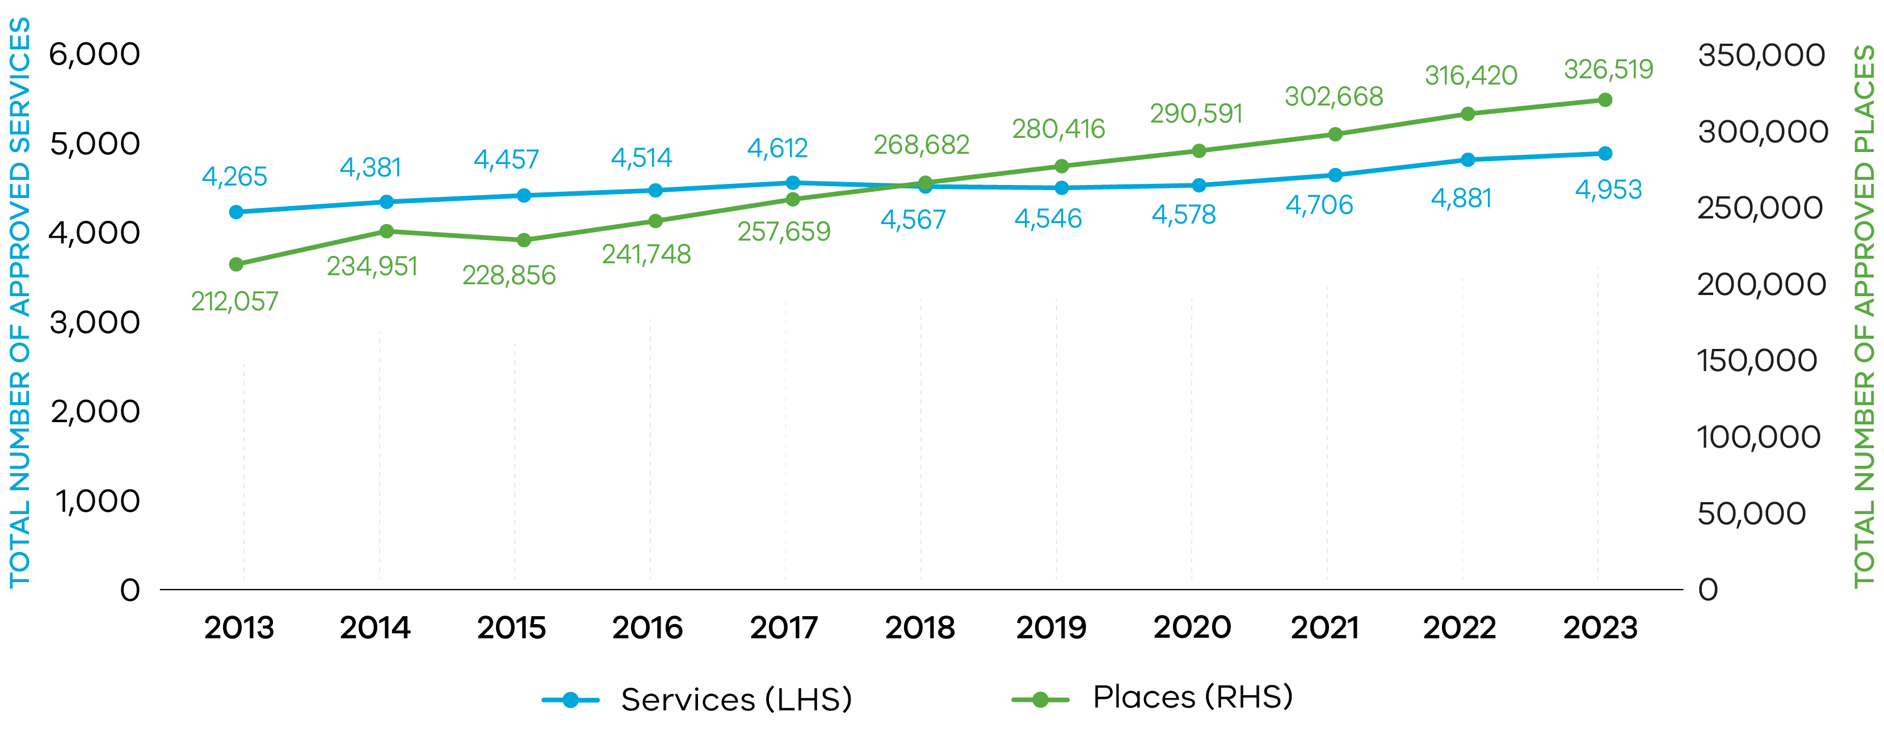
Note: ‘Places’ only relate to centre-based services under the NQF and children’s services regulated under the CS Act. Places data for FDC services is not collected. The number of places reflects services’ approved capacity.

Figure 2: Number of new NQF services and places, 2013–2023
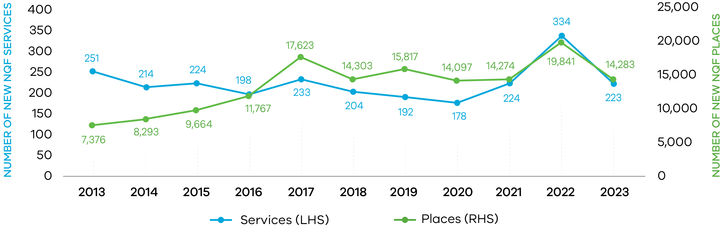
Note: Number of new services refers to services approved in that year and excludes services suspended, surrendered or cancelled.

While the number of LDC services continues to increase, the number of FDC services has declined from 2017 and then stayed relatively constant between 2020 and 2023, as can be seen in Figure 3.

Figure 3: Number of approved NQF services by care type, 2013–2023
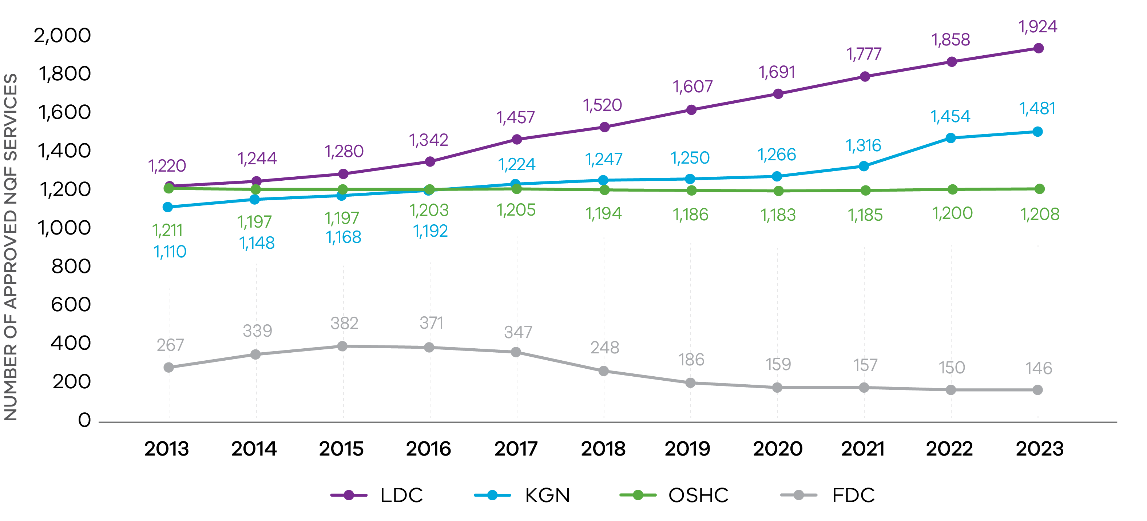

Table 1 shows the rate of growth of all centre-based education and care services for NQF and CS Act services over time.

Table 1: Average number of new places approved within each year by care type, 2013–2023

Care type | 2013 | 2014 | 2015 | 2016 | 2017 | 2018 | 2019 | 2020 | 2021 | 2022 | 2023
NQF places | 60 | 59 | 59 | 74 | 83 | 75 | 85 | 83 | 67 | 61 | 68
Long Day Care (LDC) | 93 | 97 | 79 | 98 | 104 | 105 | 112 | 103 | 100 | 100 | 96
Standalone Kindergarten (KGN) | 48 | 51 | 58 | 51 | 44 | 50 | 48 | 58 | 50 | 57 | 56
Outside School Hours Care (OSHC) | 47 | 45 | 47 | 52 | 60 | 53 | 51 | 55 | 39 | 42 | 43
CSA places | na | na | 27 | 22 | 26 | 30 | 26 | 18 | 21 | 19 | 22

For NQF services, private for profit is the largest single provider management type, operating 2,540 services (53%) of all NQF services in 2023, as can be seen in Figure 4. Of these, 3,402 (71%) are run by multi-service providers, many of whom also have services in other jurisdictions.
Private for profit providers continue to grow steadily as a proportion of the sector, with the other management types remaining stable.
Figure 4: Number of approved NQF services by provider management type, 2023
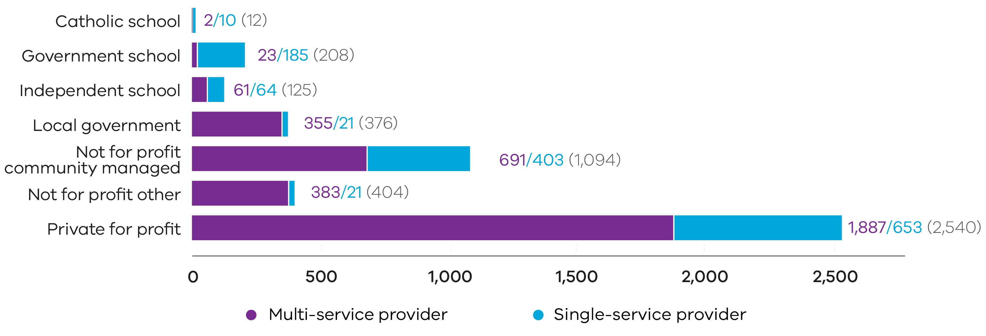
Note: ’Multi-service providers’ refers to providers that provide more than one service nationally.

In 2023, LDC remains the largest care type, with both the largest number of services and places (see Figures 5 and 6 and Table 2).
Figure 5: Number of approved services by care type, 2023
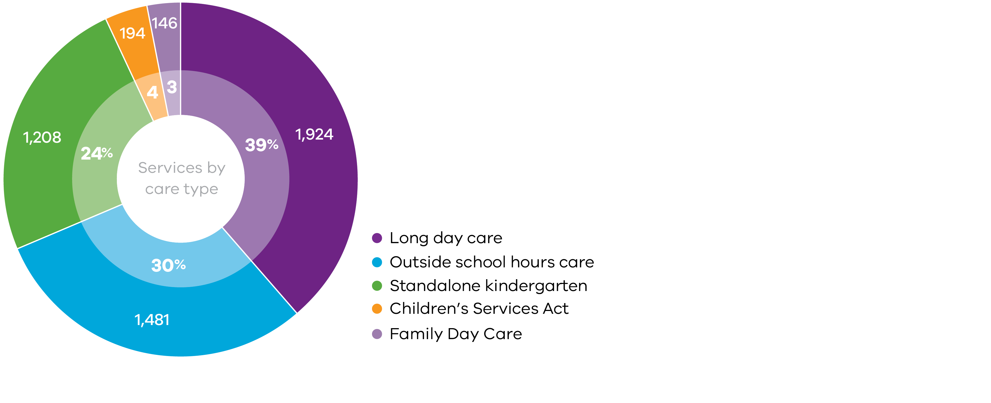
Figure 6: Number of centre-based approved places by care type, 2023
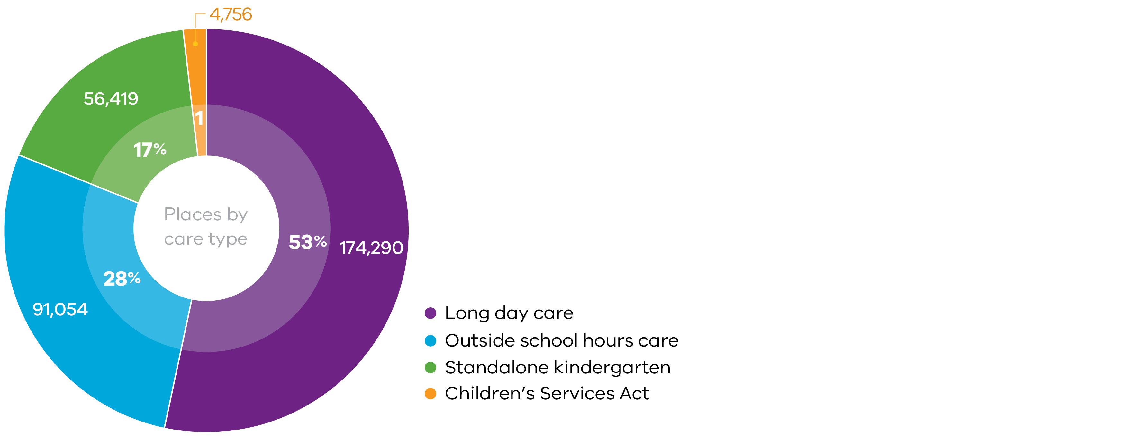
Note: ‘Places’ only relate to centre-based NQF services and services regulated under the CS Act. Places data is not collected for FDC services. The number of places reflects services’ approved capacity.

Table 2: Number of approved services and places by care type, 2023

Care type | Approved services | Approved places
Total | 4,953 | 326,519
NQF | 4,759 | 321,763
Centre-Based Care | 4,613 | 321,763
- Long day care | 1,924 | 174,290
- Standalone Kindergarten | 1,208 | 56,419
- Outside school hours care | 1,481 | 91,054
Family Day Care | 146 | 0
Children’s Services Act | 194 | 4,756

Note: ‘Places’ only relates to centre-based services and services regulated under the CS Act. Places data is not collected for FDC. The number of places reflects services’ approved capacity.

The total number of approved CS Act services has been declining in recent years, with some services moving to the NQF.

Table 3: Number of approved CS Act services and places, 2013–2023

 | 2013 | 2014 | 2015 | 2016 | 2017 | 2018 | 2019 | 2020 | 2021 | 2022 | 2023
Services | 457 | 453 | 430 | 406 | 379 | 358 | 317 | 279 | 271 | 219 | 194
Places | 11,248 | 11,078 | 10,569 | 10,103 | 9,516 | 9,140 | 8,002 | 7,039 | 6,771 | 5,319 | 4,756

Overall quality rating comparisons by care type
One of the key objectives of the NQF is to promote continuous improvement in the provision of quality education and care services, which is assessed by QARD’s authorised officers during assessment and rating visits. CS Act services are not assessed and rated. The quality of the ECEC sector continues to improve, with 94% of services rated Meeting NQS or above in 2023.

Figure 7: Overall quality ratings by care type and rating level, 2023

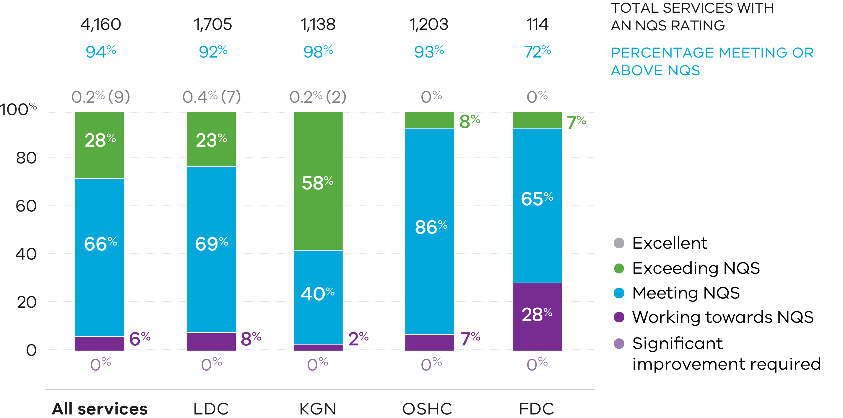

In 2023, no services received the rating of Significant Improvement Required (SIR). The SIR rating is given to services that do not meet a quality area or relevant related regulation in a way that poses a significant risk to the safety, health or wellbeing of any child or children being educated and cared for at the service.
Overall, there has been a steady increase in the number of services receiving a rating of Meeting NQS. There has been a decrease in services receiving a rating of Working Towards NQS, as can be seen in Figure 8.

Figure 8: Overall quality ratings by rating level, 2019–2023
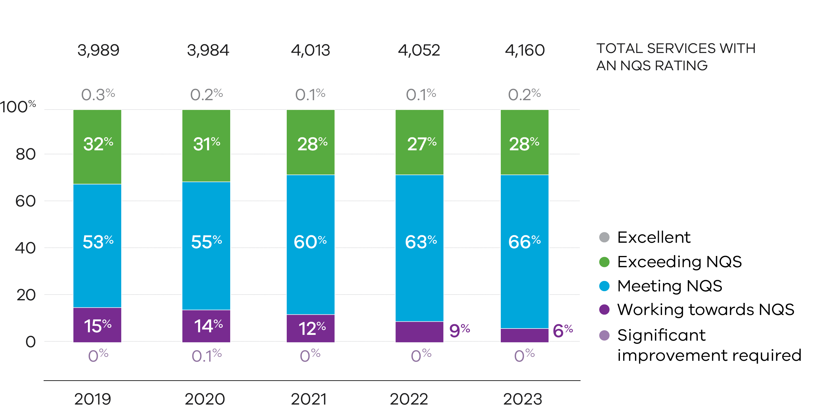

Figure 9: Overall quality ratings by provider management type and rating level, 2023
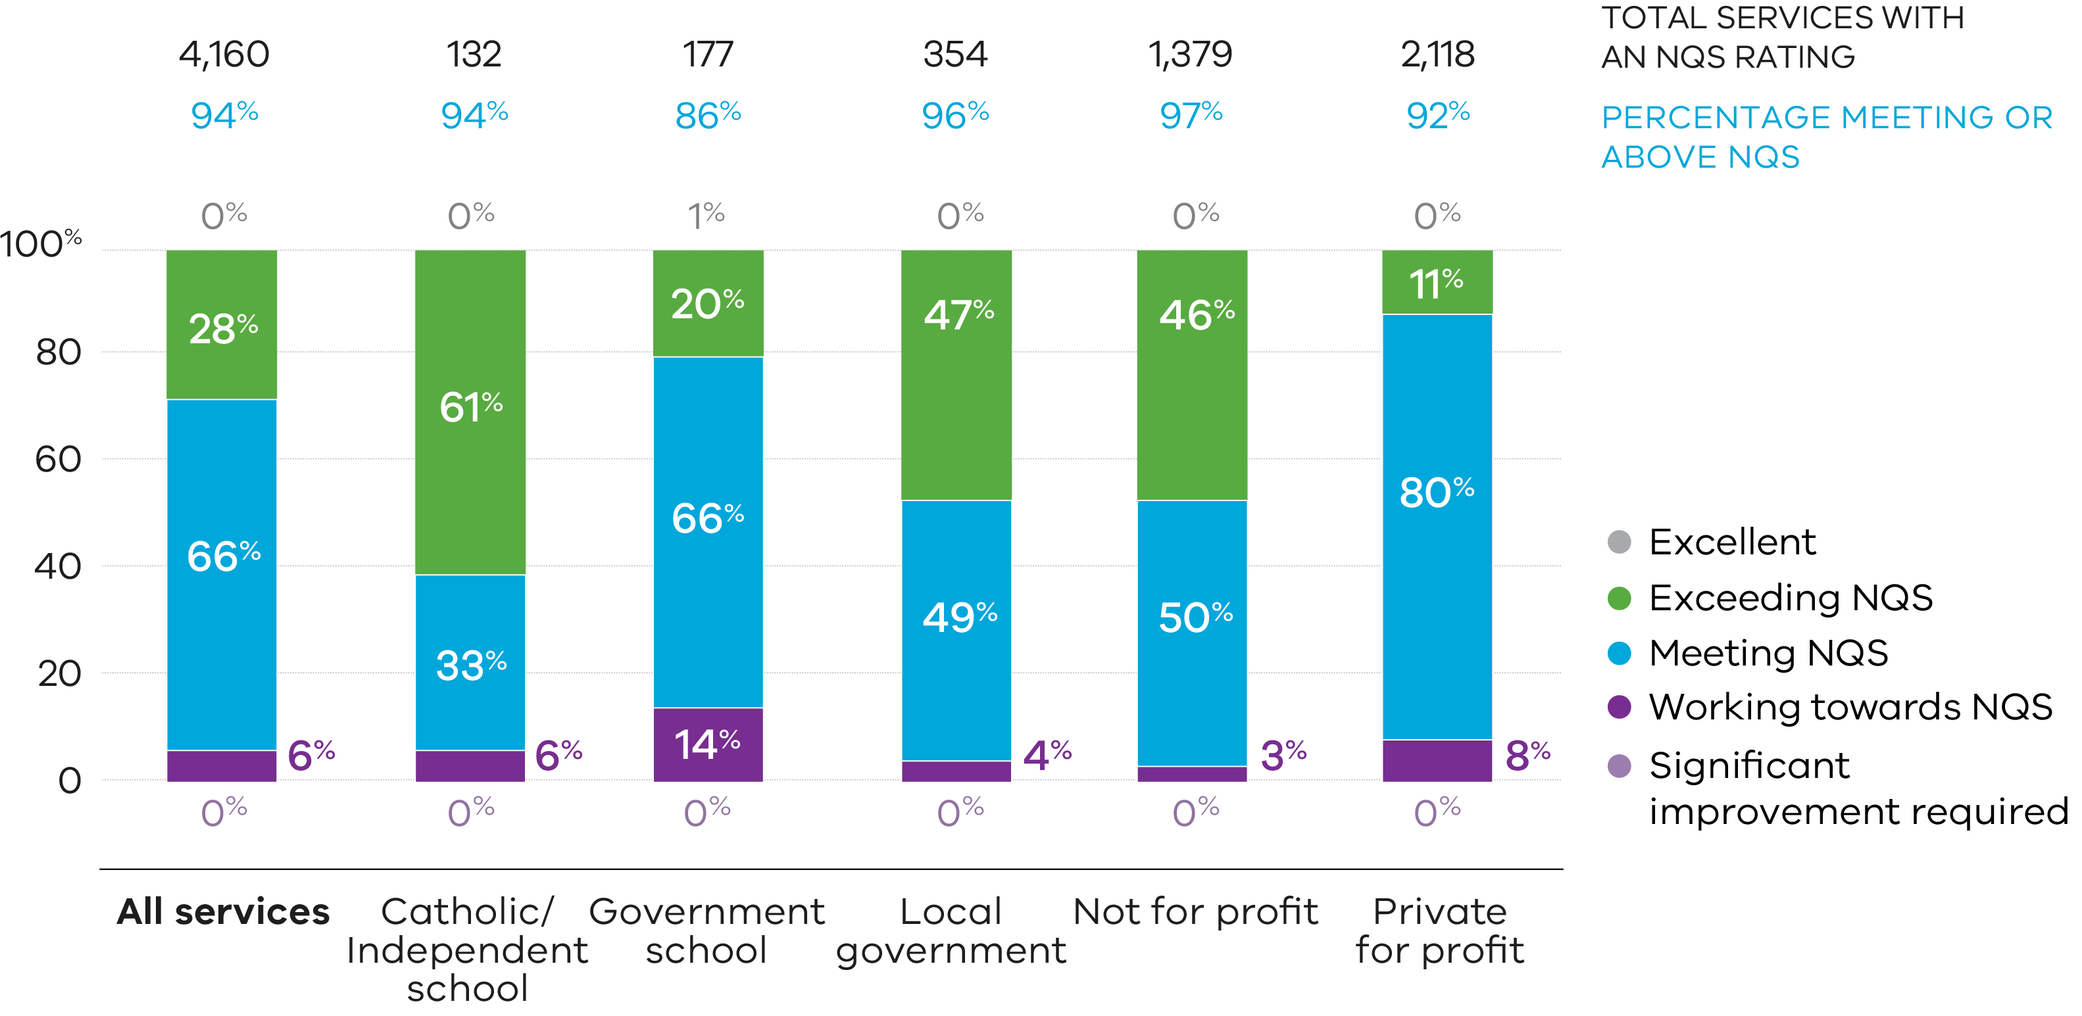

Excellent rated services
An Excellent rating, the highest rating possible under the NQF, is assessed and determined by ACECQA following application from a service. The service must be rated Exceeding NQS by the Regulatory Authority in all quality areas in order to apply for an Excellent rating. At the end of 2023, 9 Victorian services were rated as Excellent, 7 LDC and 2 standalone kindergarten services.
Those services were:
- Balnarring Preschool
- Bubup Wilam Aboriginal Child and Family Centre Inc.
- Capel Sounds Educational Child Care Centre
- Carrum Family and Children’s Centre
- Clarendon Children’s Centre Co-op
- Essex Heights Juniors
- Goodstart Early Learning Clayton
- Gowrie Victoria Broadmeadows Valley
- Yuille Park Children’s Centre
Balnarring Pre-School, Clarendon Children’s Centre Co-operative and Gowrie Victoria Broadmeadows Valley have achieved the Excellent rating more than once.

Centre-based care overview

Long Day Care (LDC)
The LDC sector makes up the largest component (40%) of services under the NQF, offering around half of all NQF approved child care places in Victoria. Almost all LDC services (91%) are funded on a per capita basis by the Victorian Government to provide a 3 and 4-year-old funded kindergarten program.
There has been steady growth in the number of approved LDC services and places operated by private for profit providers (see Figure 10 and Figure 11).

Figure 10: Number of approved LDC services, 2013–2023
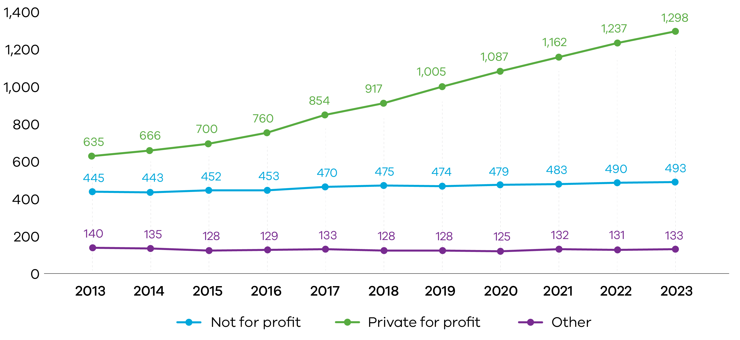

Figure 11: Number of approved LDC places (rounded), 2013–2023
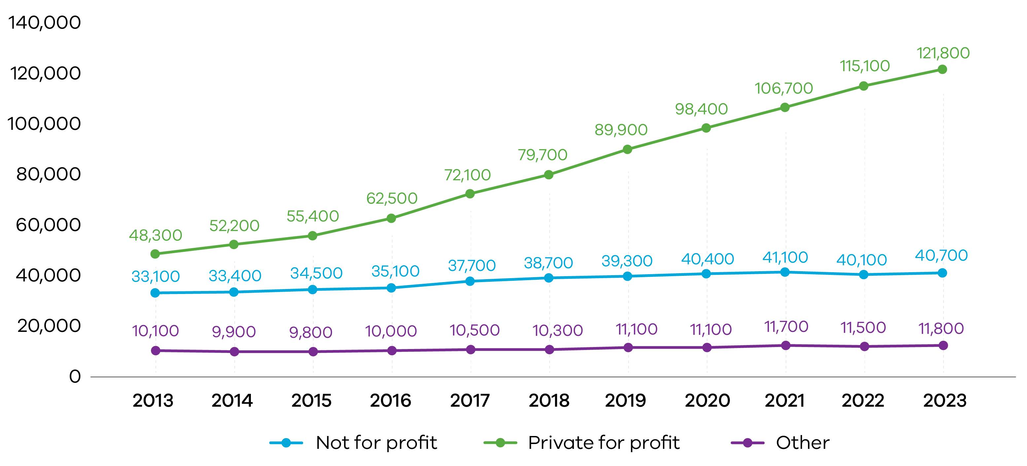
Note: ‘Other’ in Figures 10 and 11 refer to provide management types including local government and Catholic, independent and government school providers.

LDC quality rating

Figure 12: Number and proportion of LDC services with quality ratings at the end of the year, by rating level 2019–2023
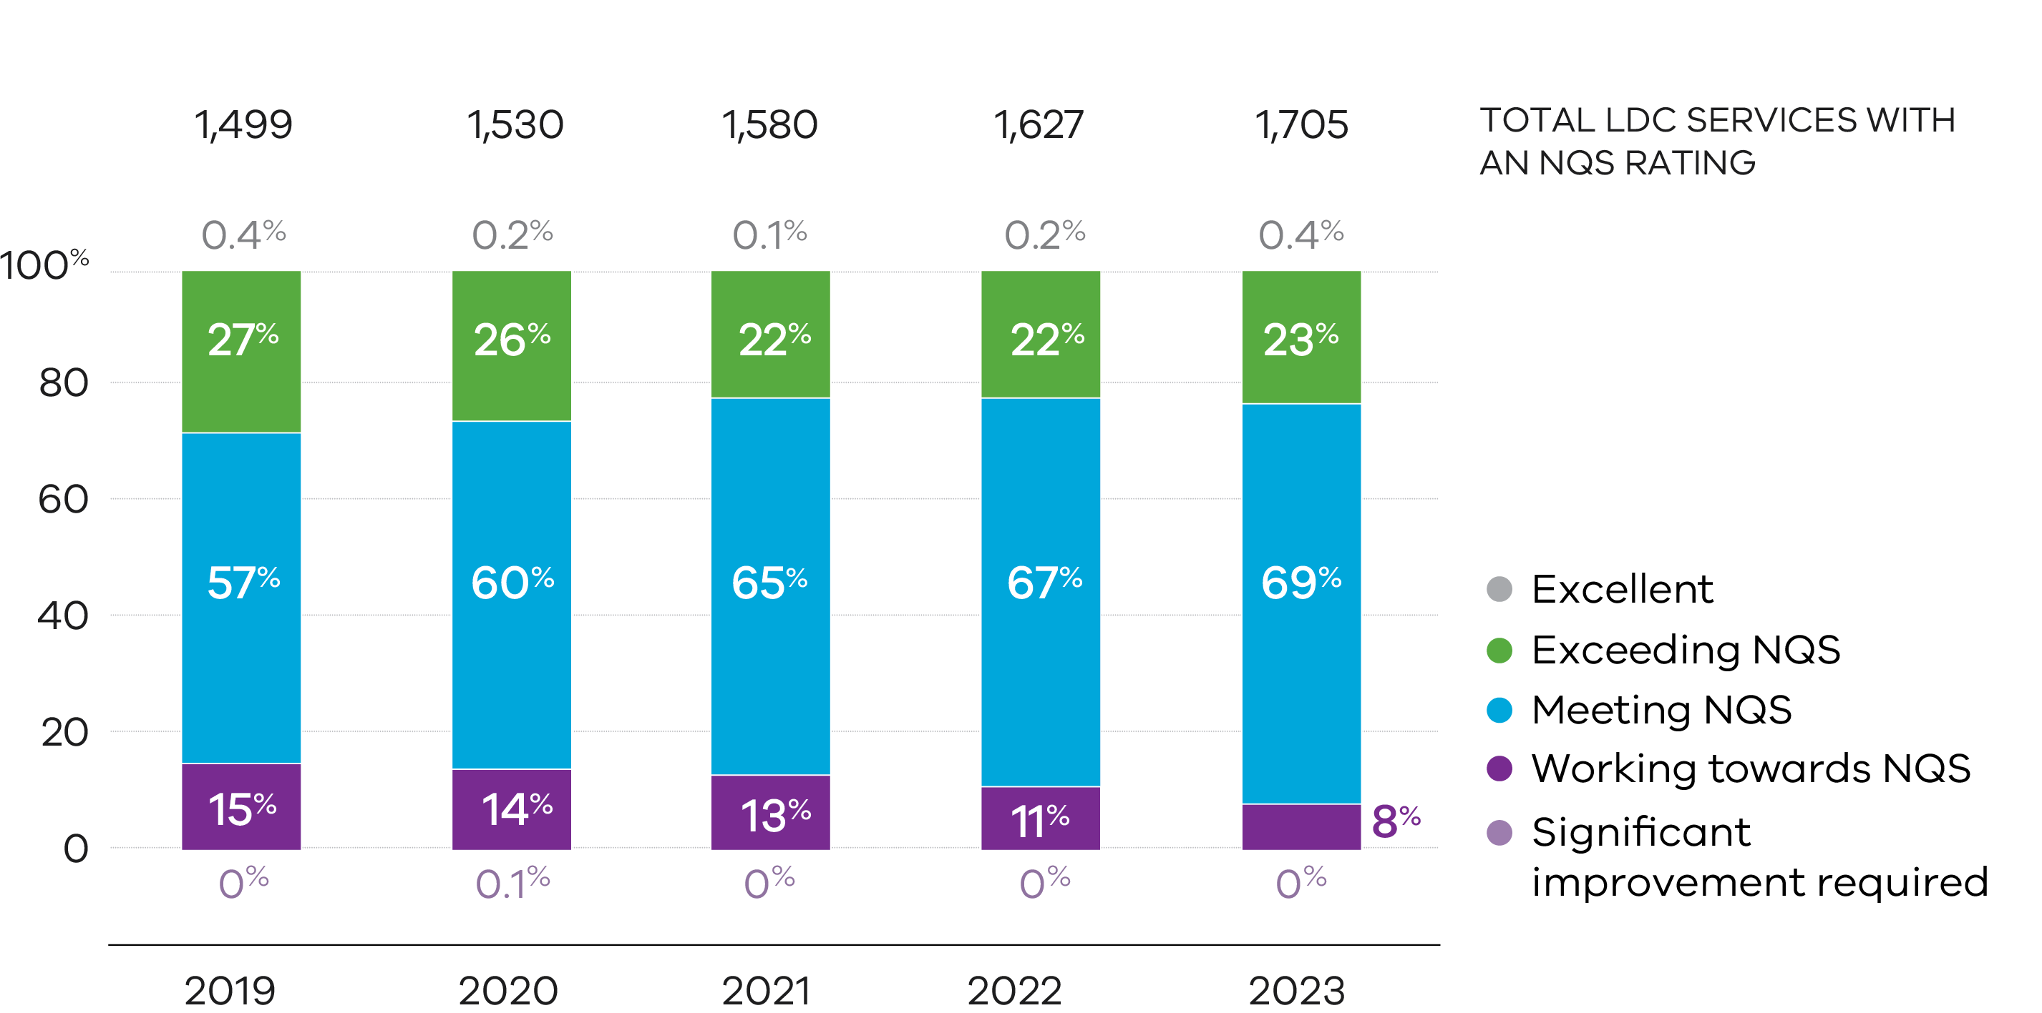

There has been a steady improvement in the quality of LDC services over time with increasing numbers of LDC services in Victoria achieving a quality rating of Meeting NQS, and fewer LDC services receiving a rating of Working Towards NQS as can be seen in Figure 12.

Figure 13: Overall LDC quality ratings by provider management type and rating level, 2023

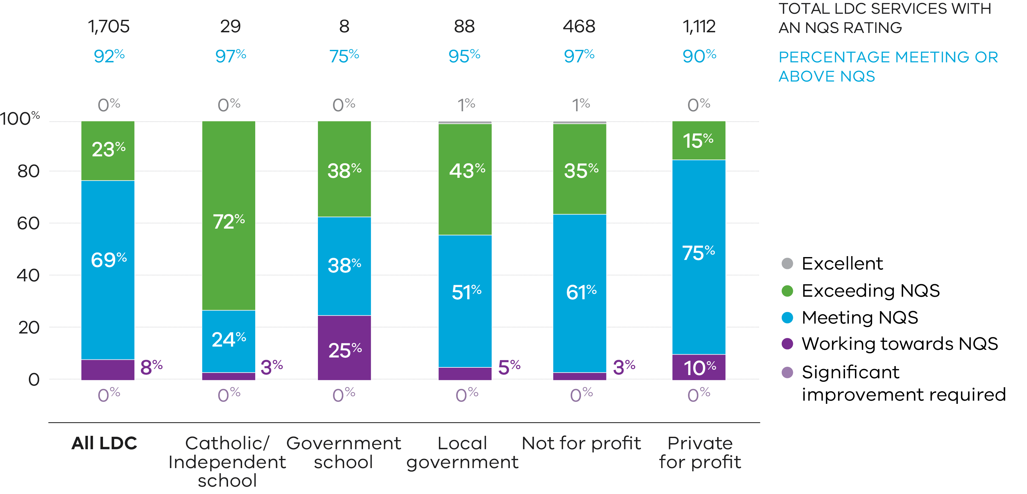

Kindergarten (KGN)
The standalone kindergarten sector in Victoria (KGN, excluding LDC services) is almost exclusively operated by not- for-profit and local government managed providers (90% of all standalone kindergarten services as at 2023). Of these, 74% of services are managed by providers that operate more than one standalone kindergarten service in Victoria.
Victoria regulates the highest number of standalone kindergartens across Australia, with 1,208 approved services at the end of 2023, compared with New South Wales (762 services), Queensland (495 services) and South Australia (413 services).
Figure 14: Number and proportion of standalone kindergarten services with quality ratings at the end of the year, by rating level, 2019–2023
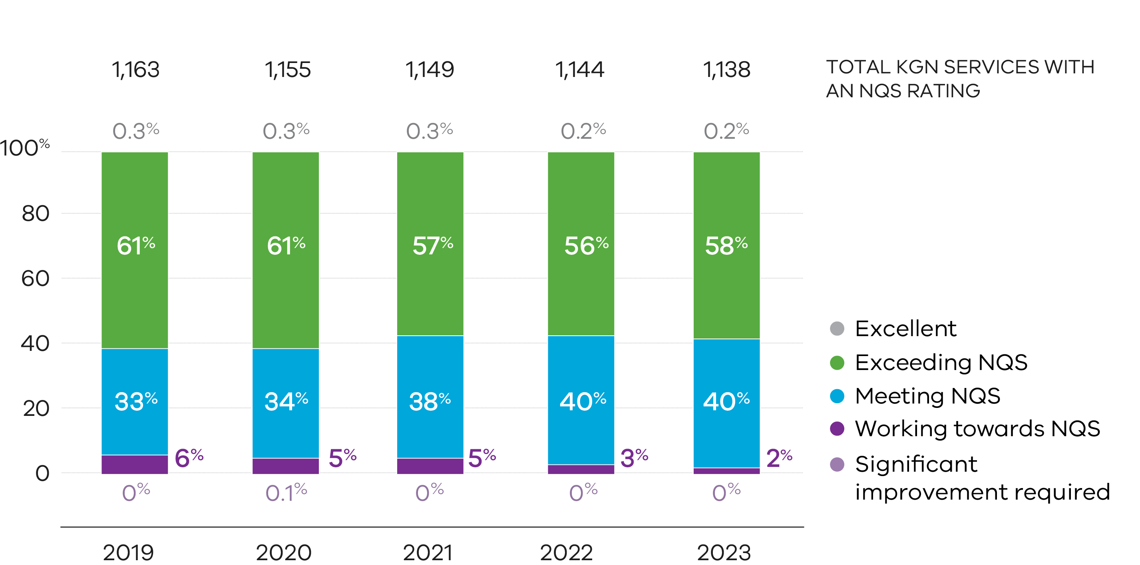

Standalone kindergarten services have the highest quality ratings compared with other service types, in both Victoria and nationally. The vast majority (98%) of these services in Victoria also had a rating of Meeting NQS or above at the end of 2023. Standalone kindergarten services tend to have a higher proportion (58%) of services rated Exceeding NQS compared to other service types.
Most standalone kindergarten services (97%) and LDC services (91%) are funded to provide 3- and/or 4-year-old kindergarten programs in Victoria. Services receiving this funding generally perform better in all quality areas (including those with kindergarten programs provided within LDC services).
Figure 15: Overall standalone kindergarten quality ratings by provider management type and rating level, 2023
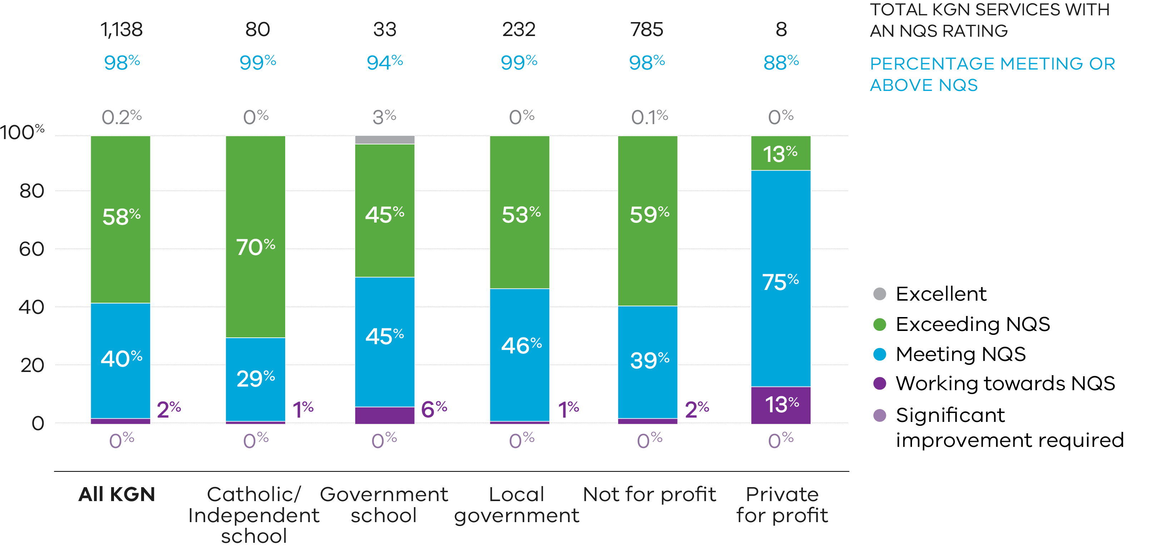

Outside School Hours Care
Most schools that offer OSHC engage third party providers to deliver their OSHC programs. The main providers in Victoria are private for-profit providers that operated 1,121 services in 2023. Multi-service, private for-profit providers manage three-quarters (75%) of OSHC services, while government schools (through school councils) managed 11% of these services in 2023.

Figure 16: Number of approved OSHC services, 2013–2023

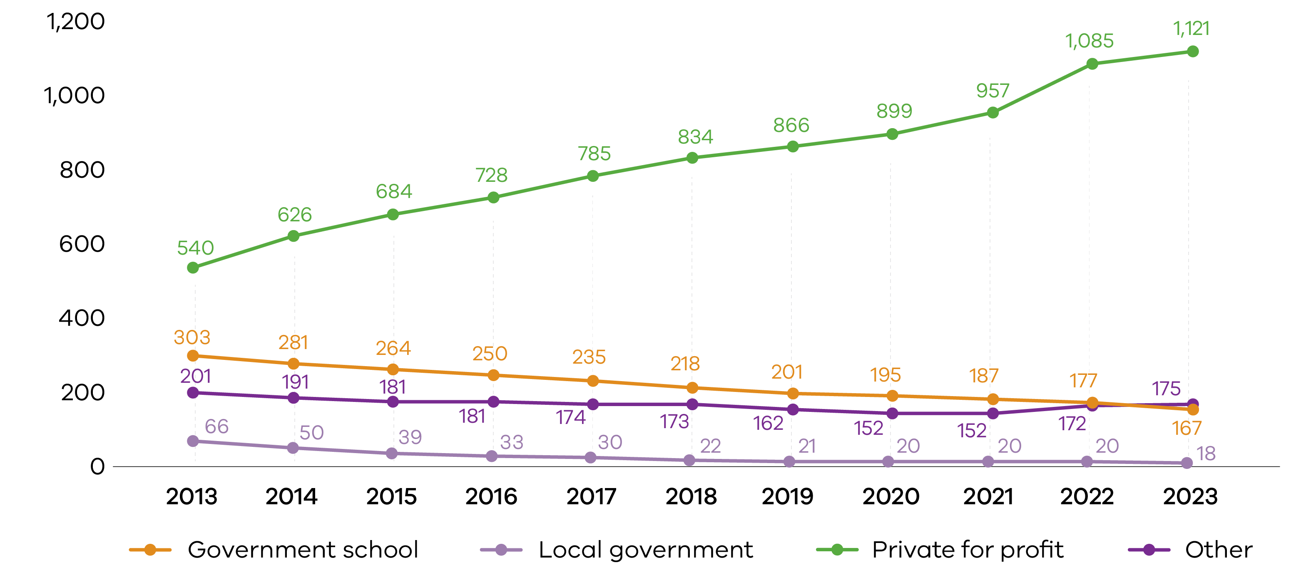

Figure 17: Number of approved OSHC places (rounded), 2013–2023

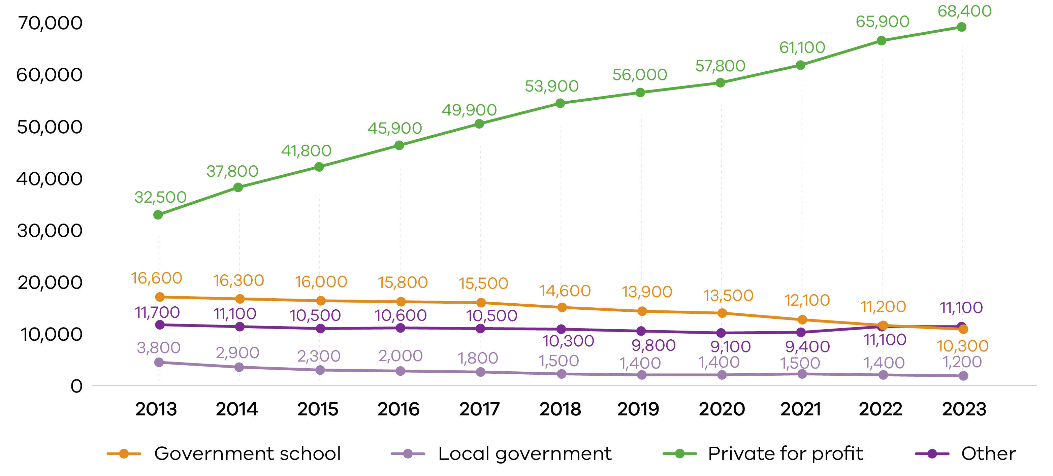

Note: ‘Other’ in Figures 16 and 17 refer to provide management types including Catholic and independent school and not for profit providers.

Outside School Hours Care quality rating

Figure 18: Number and proportion of OSHC services with quality ratings at the end of the year, by rating level, 2019–2023
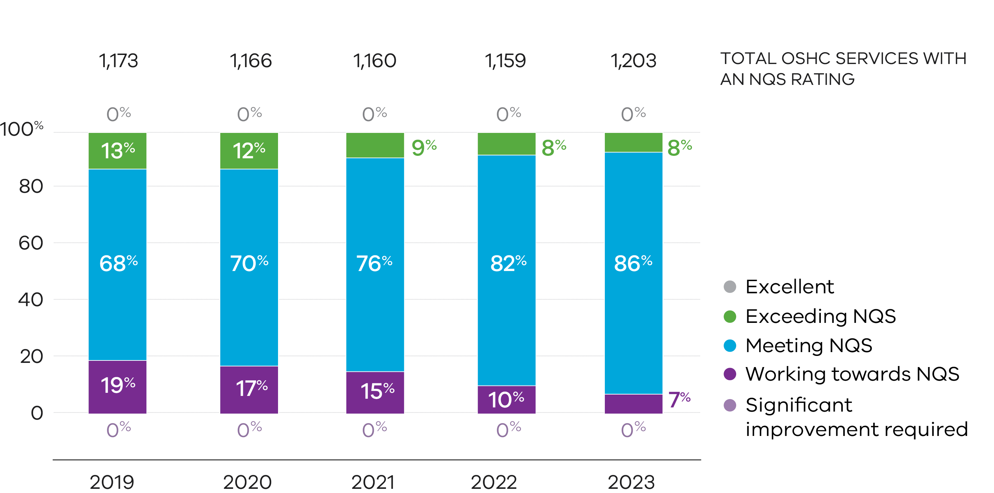

The proportion of OSHC services rated as Working Towards NQS has continued to decrease over time as the OSHC sector has matured in Victoria.
Victoria has one of the highest proportions of OSHC services with a Meeting or Exceeding NQS rating compared with other jurisdictions. 93% of OSHC services in Victoria had a quality rating of Meeting NQS or above at the end of 2023, compared with 87% nationally. Victoria has a higher requirement for diploma qualified staff than other jurisdictions.
Victorian OSHC services have performed better than the national OSHC average in all 7 quality areas, particularly Quality Area 1 (educational program and practice), Quality Area 2 (children’s health and safety) and Quality Area 7 (governance and leadership).

Figure 19: Overall OSHC quality ratings by provider management type and rating level, 2023

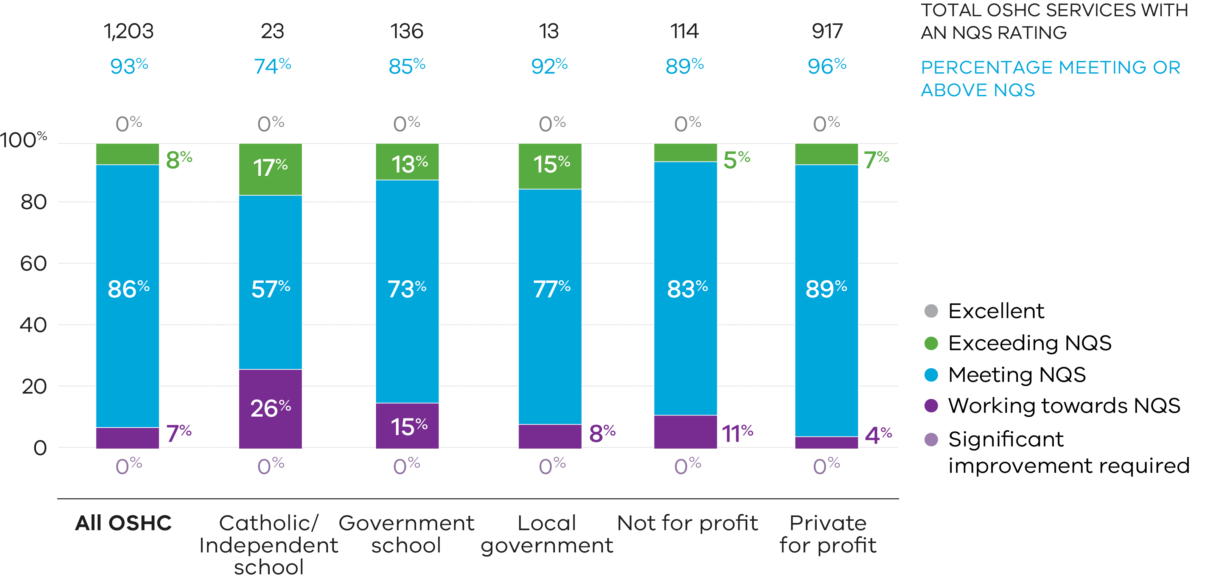

Family day care
Family day care (FDC) is regulated under the National Law. Traditionally, the FDC model was a popular way for providers such as local councils to increase access to affordable and flexible early learning and care for their communities.
The rapid growth in the number of approved FDC services seen between 2013–2015 has reversed, with the number of services falling each year since the peak of 382 services in 2015 to 146 at the end of 2023. In 2023 only 12 new FDC services were approved (see Figure 20).

Figure 20: Number of FDC services, 2013–2023
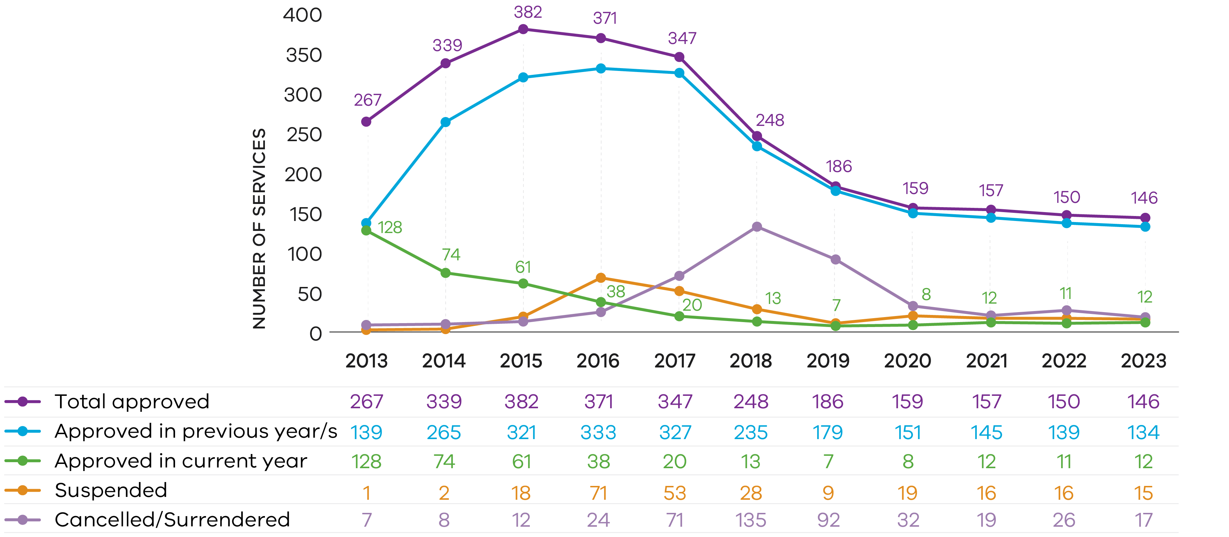

Family day care quality rating
The FDC sector continues to show improvement its quality over time with 72% of quality ratings being Meeting or Exceeding NQS, as can be seen in Figure 21.

Figure 21: Number and proportion of FDC services with overall quality ratings at the end of the year, by rating level, 2019–2023
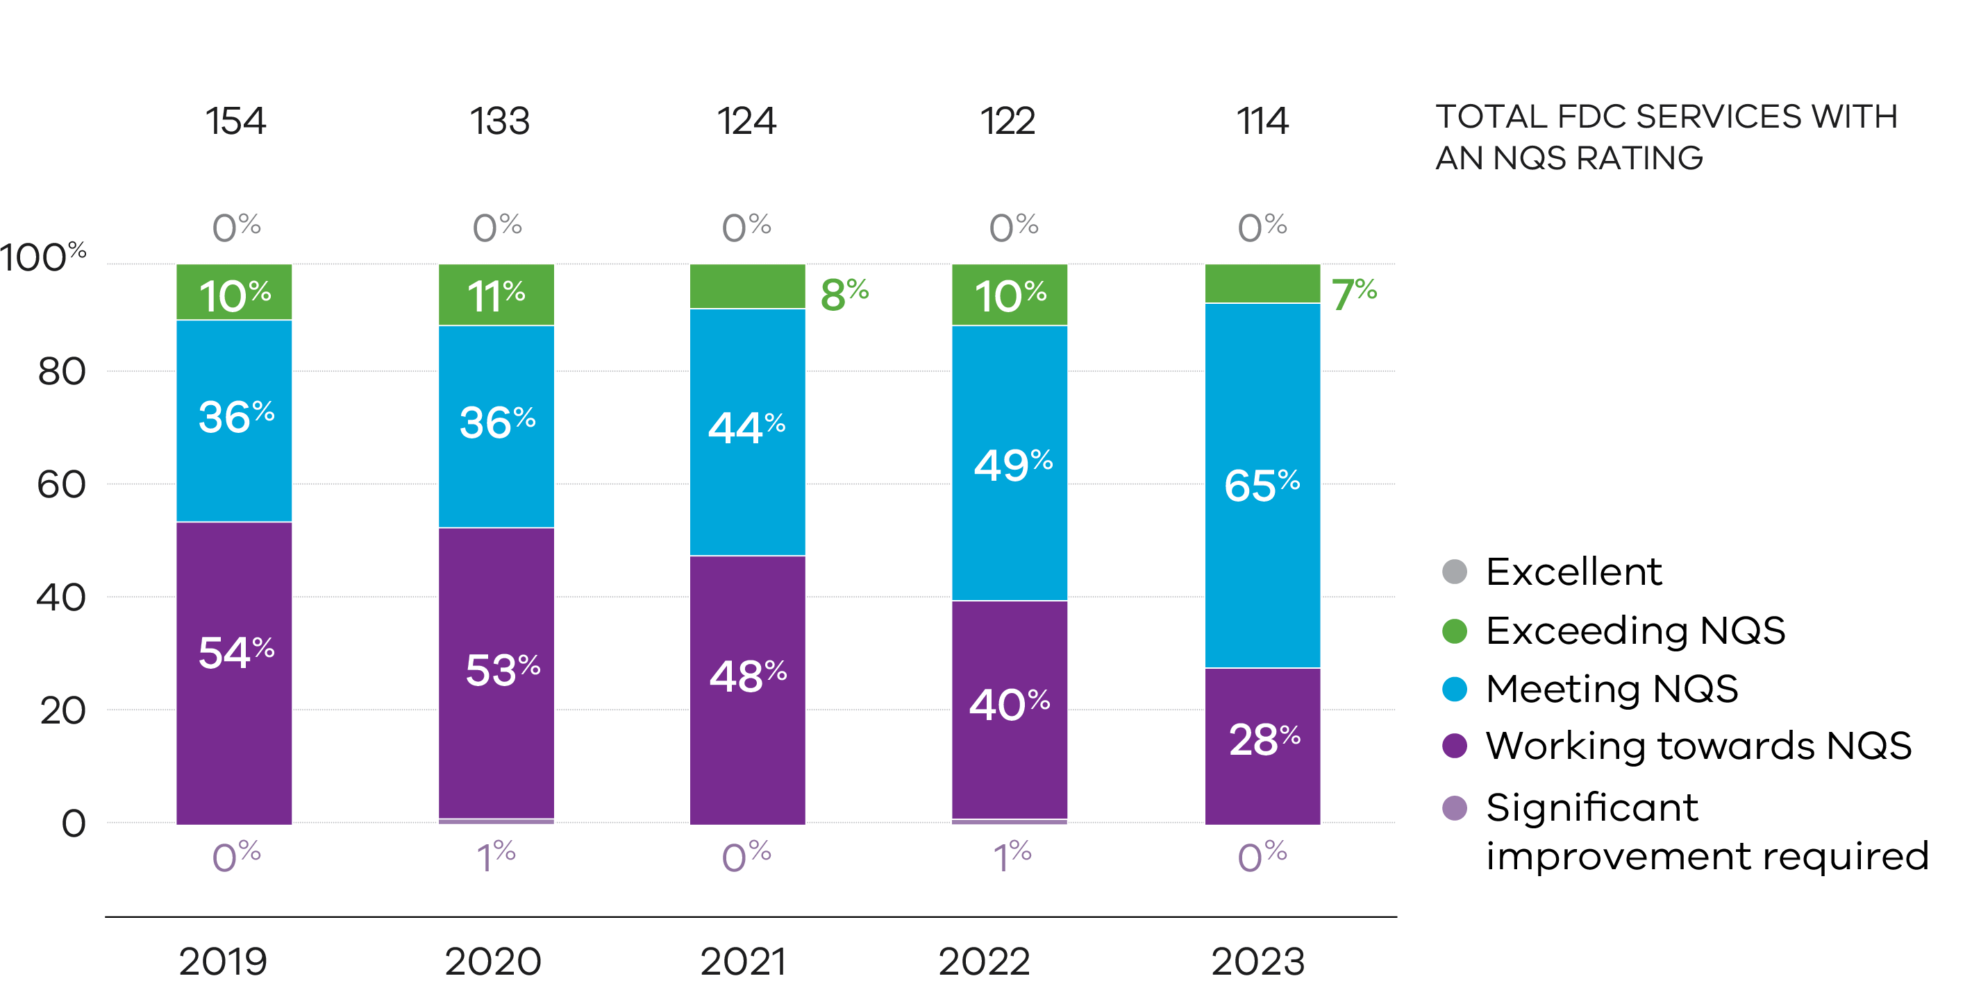

FDC services operated by not-for-profit providers received higher quality ratings than those operated by private for profit providers. In 2023, 92% of not-for-profit services received a rating of Meeting or above NQS, compared with 68% of for-profit services (see Figure 22).

Figure 22: Overall FDC quality ratings by provider management type and rating level, 2023

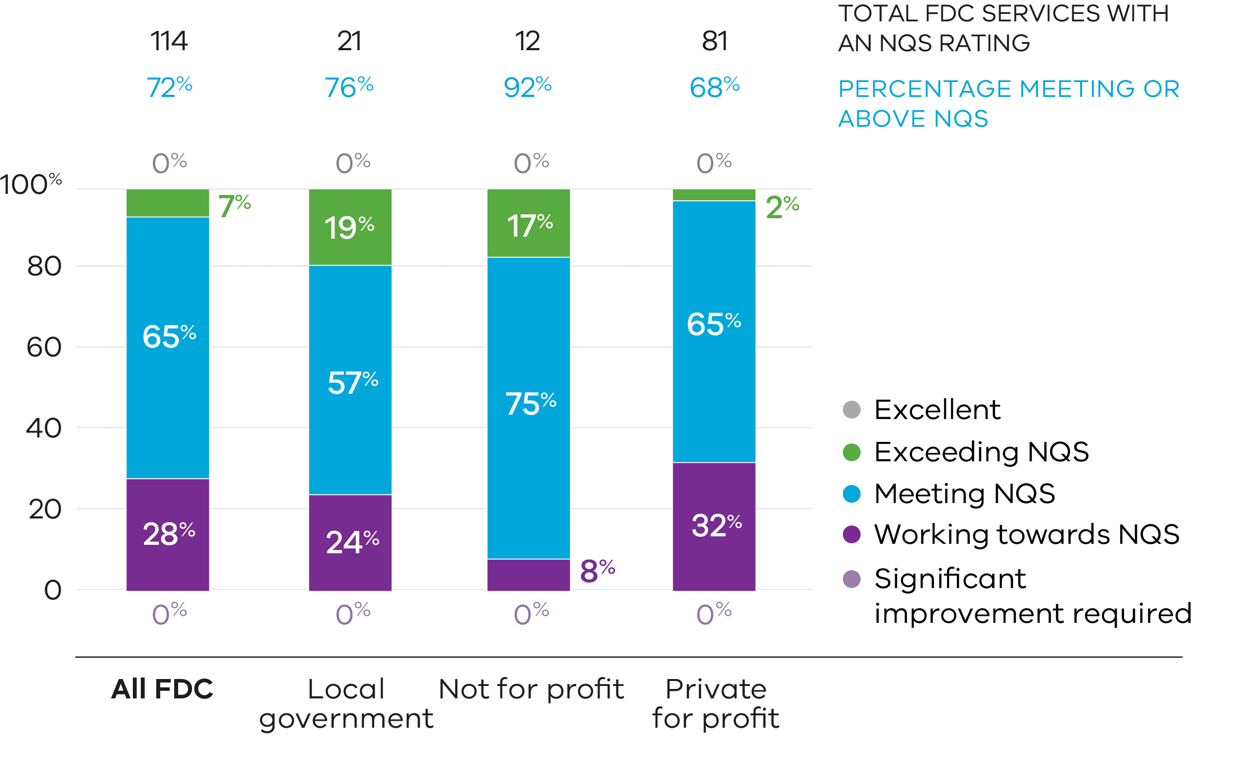

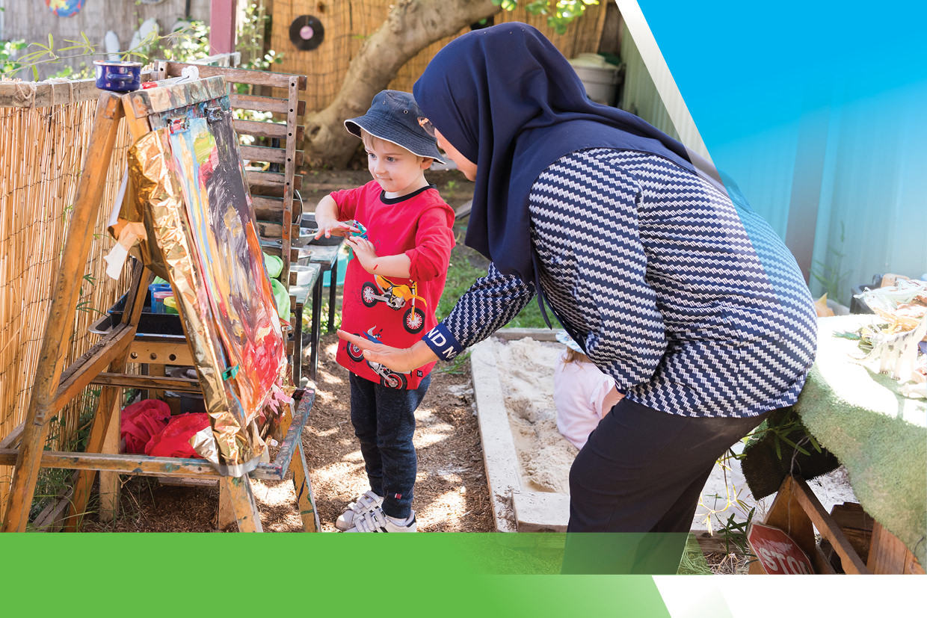

Supporting the sector

QARD seeks to improve early childhood education and care for children in Victoria through providing information, guidance, targeted online education sessions, and individual support to services.

2019 NQF Review implementation
After two rounds of consultation with the education and care sector, families and the broader community, Ministers from all jurisdictions supported the recommendations from the 2019 NQF Review (the Review) to ensure that the NQF continues to meet the objectives of the National Law.
While ACECQA published information about the regulatory changes resulting from the Review, QARD provided additional information and guidance to Victorian providers and services.
QARD delivered 3 in-person and 4 online information sessions that were attended by approximately 300 people. The sessions included a summary of the Review outcomes as well as the new requirements to improve the safety and wellbeing of children in services. The sessions supported approved providers and educators to understand and implement the changes in their everyday work with children.
Throughout 2023, QARD published articles in its sector newsletter each month to support services by further explaining the NQF changes, and directing them to supplementary guidance and resources.

Child Safe Standards implementation
Early childhood services have been required to comply with new CSS since 1 July 2022. On 1 January 2023 QARD became the integrated sector regulator for the CSS in early childhood services in Victoria.
QARD took an educative approach during 2023, providing online information and guidance tailored to early childhood services in their ongoing adoption of the new CSS.
QARD reinforced the requirements of the CSS and clarified queries on specific topics through articles in the monthly sector newsletter. A particular focus was providing information and support for services in establishing culturally safe environments for Aboriginal children, a key new requirement established by CSS 1. These articles included information about First Nations languages resources, cultural safety for Koorie families and raising awareness of key dates such as NAIDOC week.
In 2023 QARD authorised officers integrated discussions about the implementation of the new CSS requirements into service visits, identifying action needed to address any non-compliances.

Enquiries and support
QARD provides a dedicated QARD Hotline and email to respond to enquiries from the ECEC sector and other stakeholders.
In 2023, 9,600 calls were received and managed from educators, service staff and members of the public making enquiries or complaints about service operations or requirements. Depending on the nature of these enquiries, callers were provided information, directed towards resources, or referred to an authorised officer for detailed guidance or support.

Quality Assessment and Regulation Update newsletter
QARD distributes a monthly email newsletter to providers and services that provides guidance on current regulatory issues, showcases quality practice, and provides information on opportunities for improvement.
Each newsletter was distributed to more than 5,400 sector contacts each month in 2023, including more than 1,200 voluntary subscribers.
Topics covered in 2023 included:
- information and guidance on complying with the new CSS and other child safety schemes
- emergency management, including bushfire and grassfire risks as well as online training
- safety issues including water activities, safe sleep and transportation
- educator resources, staffing requirements, professional development opportunities
- reminders about immunisation, health and hygiene, infection control, healthy eating, ventilation, privacy, and protection from mosquito-borne disease
- law reform including the 2019 NQF Review, and changes to the Approved Learning Frameworks.
In addition to the monthly sector newsletter, QARD also distributed two special edition newsletters specifically targeted to FDC providers to more than 1,400 providers, services and stakeholders. The newsletters provided guidance and information on key regulatory changes that came into effect for FDC providers and services from 1 October 2023.

Information sessions

New provider applicants
In 2023, approximately 70 primary schools were awarded establishment grants from the Victorian State Government to increase the availability of OSHC services. The grants were part of a program designed to support increased workforce participation, particularly amongst women, which included establishing new OSHC services and expanding existing OSHC provision.
The SASU team in QARD provided information sessions for prospective approved providers to explain the obligations and responsibilities of being an approved provider of an education and care service, and to explain and help simplify processes for new provider and new services applications. The information sessions provided the prospective operators with prerequisite knowledge for operating a service in compliance with the NQF.

Regional sessions
In 2023, the QARD regional teams and authorised officers engaged regularly with local services and providers to improve their understanding of the NQF and encourage compliance with regulatory obligations. They also provided information sessions focussing on current issues and areas of change, such as the NQF and the Reportable Conduct Scheme (RCS), and encouraged dialogue and information sharing between QARD, services and partners.

Early childhood website
QARD provides information and guidance on regulatory requirements online for providers and services. In May 2023, QARD’s web content migrated from the Department’s website to the whole-of-Victorian-government website, vic.gov.au.
As part of this project, QARD invited sector feedback on the proposed information architecture (structure) via a ‘tree testing activity’. The feedback was used in restructuring the web pages to be better integrated with other departmental information for early childhood professionals. At the same time, some content was consolidated, edited to use simplified language, and made more accessible for users with disabilities (such as visual impairment) to navigate and process.
The information is now easier to navigate when browsing, quicker and easier to find via search engines, and easier to understand for readers with English as an additional language. Improvements continue to be made whenever regulatory content changes or is updated.
Figure 23 shows consolidated data from before and after the website migration in April 2023.
In 2023, website traffic was slightly higher than in 2022, with a high of 56,177 views in May 2023 when the amended content was hosted on the new Whole of Victorian Government website (vic.gov.au) as shown in Figure 23. Most of the website traffic came from search engines (80%), while 8% of our audience visited directly by using a URL, and 13% resulted from referral traffic (websites that linked to Regulation pages). Website traffic from May 2023 to December 2023 shows a year-on-year increase of 18%, suggesting more users are finding it easier to navigate web content quicker and it is accessible for all audiences.

Figure 23: QARD Regulation pages on DE website – page views per month, 2019–2023

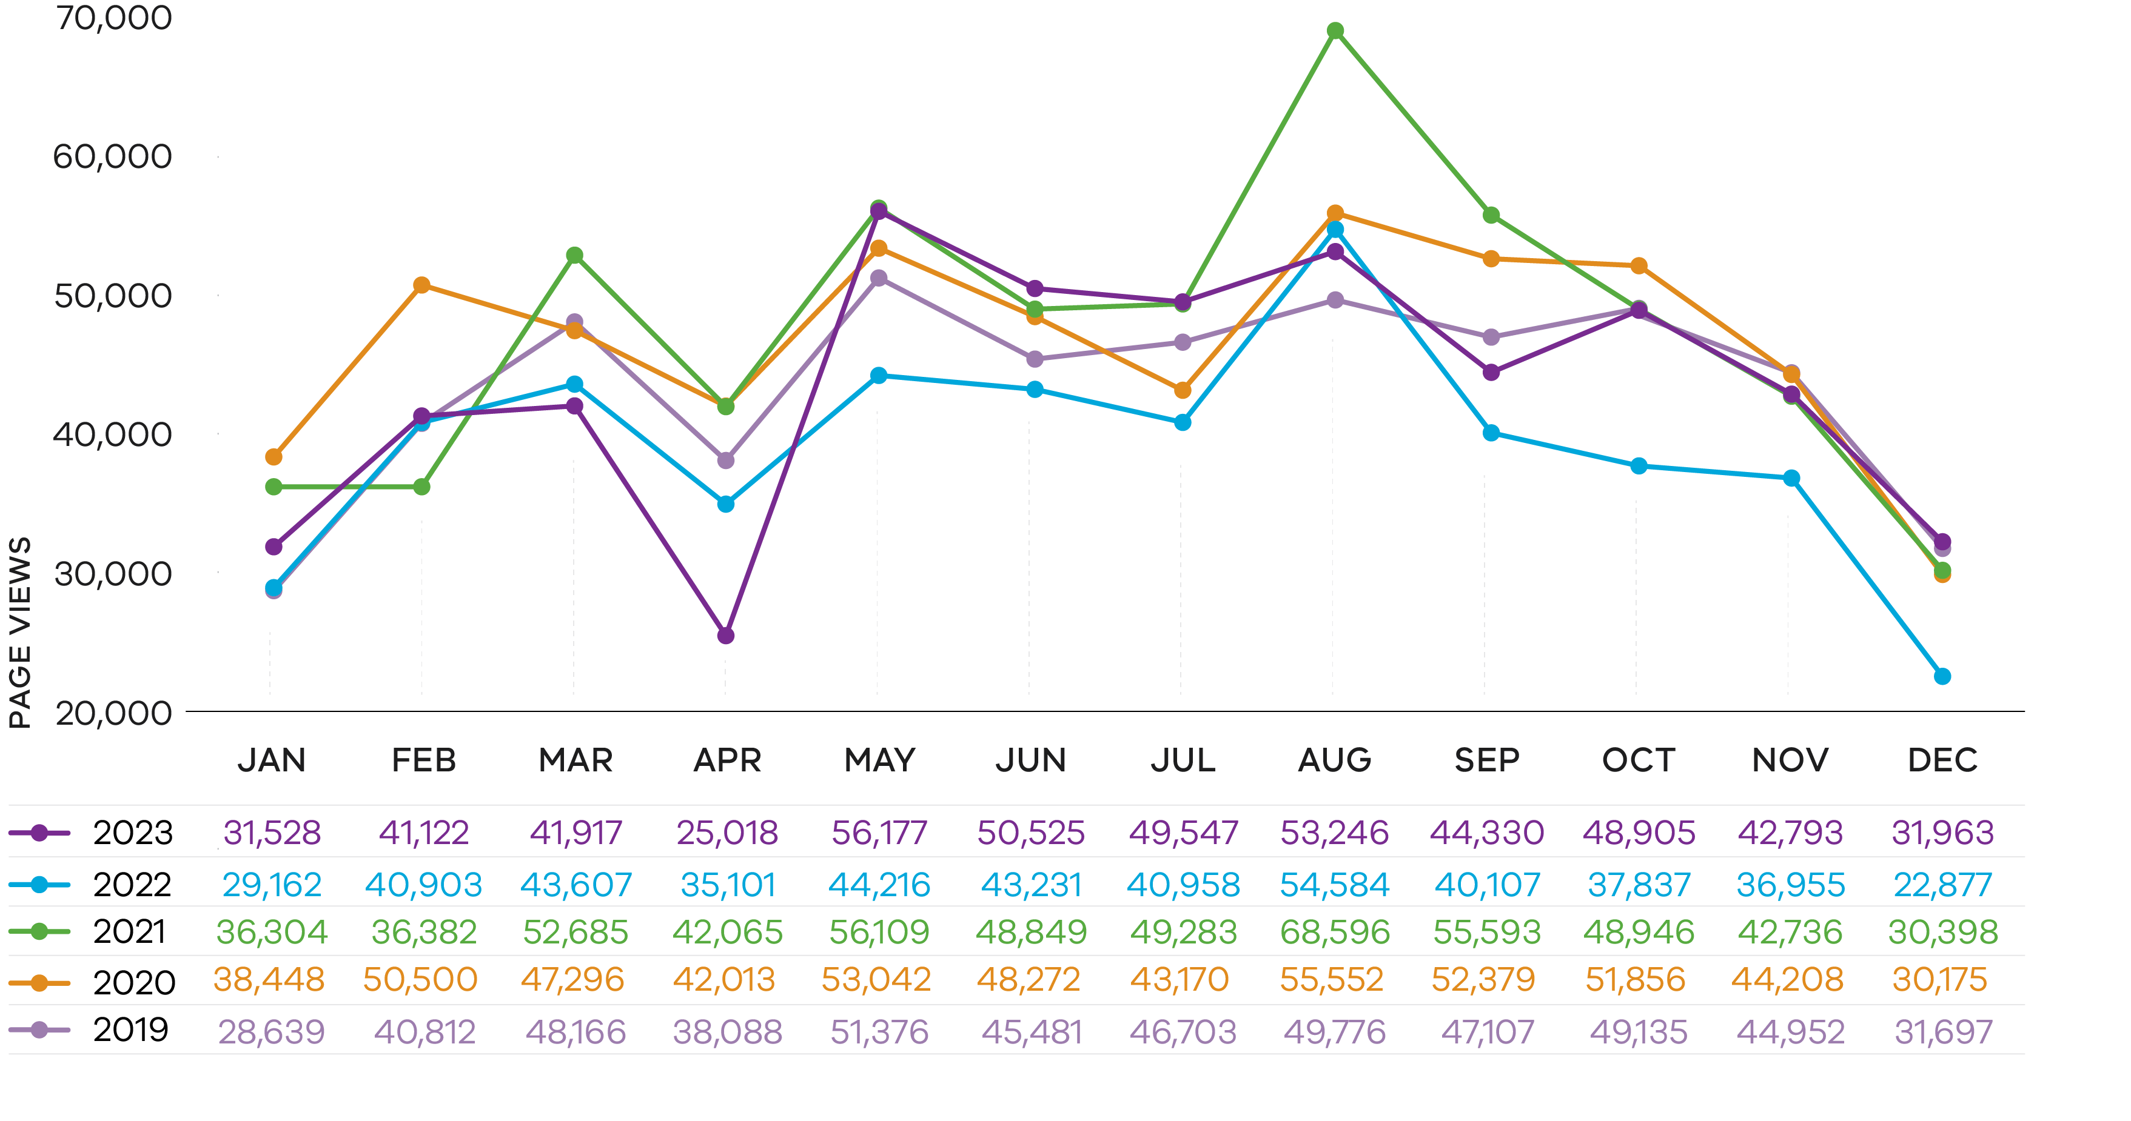

Sector reference groups
QARD continued to strengthen relationships with stakeholders at all levels in 2023. The Early Childhood Education and Care Regulatory Reference Group, consisting of key industry representatives, met in February, May and November 2023 via an online platform to discuss trends and issues within the sector. There was also a special information session focusing on implementing the CSS.
In addition to meeting with this group, QARD senior executives meet regularly with peak bodies and representatives of approved providers.

Red tape reduction
QARD continually works to improve processes. We provide ongoing support for improvements to the National Quality Agenda IT System (NQA ITS) public portal through a workplan coordinated and managed by ACECQA to streamline and standardise data capture for service providers.
From July 2023, prospective approved providers were able to submit applications for approval to administer the provider and service approvals together with their application for child care subsidy through a single portal. This ‘Joined Up Approvals’ (JUA) process allows the Australian Government to assess applications relating to child care subsidy while respective state Regulatory Authorities assess applications for provider and service approvals. The administrative burden is minimised for applicants because information for these applications is only submitted once through a shared portal (NQA ITS) rather than two different systems.
Using NQA ITS also enables applications for provider and service approval to be shared between each state and territory Regulatory Authority and the Australian Government. Access to shared information strengthens regulatory controls at the point of entry to both the provision of child care services and child care subsidies. The JUA process also improves efficiency for regulators making approval decisions under either scheme.


Stakeholder Satisfaction Survey

In 2023, QARD conducted its annual stakeholder satisfaction survey of regulated providers and services to gauge the quality of its compliance-related assistance and advice. Information received from the survey is used to improve QARD’s delivery in these areas.

The survey was distributed to all services and providers.
The 2023 response rate of 779 was higher than the previous year.
New questions and the response options of some questions in the survey changed in 2023. As a result, some responses cannot be compared directly to previous years.
Qualitative responses indicate that QARD continues to be accessible and responsive to families and the sector. Given the effort put into training and communications with the sector, it is pleasing to see increases in these measures.

Overall satisfaction with QARD’s regulatory support and guidance: | 71% | satisfied (+2%)
Effective and efficient systems and processes: | 85% | of respondents (strongly and somewhat) agreed that QARD uses effective IT solutions and  79% that the public portal is easy to use.
Providing compliance assistance and advice: | 89% | of respondents agreed that QARD staff are knowledgeable and 79% agreed that they were responsive when providing information.
Communicating with and engaging stakeholders: | 89% | of respondents agreed that QARD communicates simply, 92% that QARD uses relevant formats and 82% that QARD provides opportunities to engage with stakeholders.
Experience of regulatory practices: | 87%  84%  82% | of respondents agreed that regulatory requirements were clear.  of respondents agreed that compliance assistance and advice were clear.  of respondents agreed that processes were easy to understand and follow.

Note: Bases used to calculate percentages vary depending on number of responses provided.



Regulatory performance

Risk-based regulator
QARD’s primary objective as the regulator of early childhood services is to ensure they protect children’s safety, health and wellbeing and deliver quality education and care to support children’s learning and developmental outcomes.
We are committed to exemplifying best practice regulation across our regulatory functions and activities. To meet our objectives and deliver outcomes efficiently and effectively, we apply risk-based approaches to focus attention on areas or problems that present the greatest risk to the safety, health and wellbeing of children.
Our actions are responsive and proportionate to the problem being addressed.
Through its regulatory functions, QARD is responsible for:
- approving new provider applications including assessing applicants’ fitness and propriety to operate an early childhood education and care service
- approving new service premises suitability for providing education and care services, supporting and guiding service providers and staff to meet their regulatory obligations
- assessing and rating service quality against the NQS through the assessment and rating process
- monitoring compliance with, and enforcing requirements of, the National Law and Regulations, the CS Act and CS Regulations and the CSS
- investigating notifications of incidents and complaints.

Applications and notifications of change
QARD is responsible for assessing and determining licensing applications, notifications of change of circumstances and applicants’ fitness and propriety.

Applications
QARD received 2,047 licensing related applications in 2023. Of these 29% were applications for new provider or service approvals, and 29% for amendments to existing provider or service approvals.
In 2023 QARD approved 102 new provider applications, a reduction of 3% from 2022, and 234 new service applications, a 36% decrease from 2022. The decrease in new service approvals can be attributed to the winding down of the Victorian State Government’s OSHC Establishment Grant program from its peak in 2022.
Applications to amend approvals are used for changes to maximum number of approved places, removal of existing conditions, service name changes, and changes to approved provider details.
While there has been a large decrease in applications to amend service approval (594 in 2023 compared with 2022), this is due to a one-off bulk amendment undertaken by the Regulatory Authority in 2022. The amendments imposed new conditions on service approval to incorporate changes to Australia's national fire rating system. These amendments to condition on service approval related to bushfire and grassfire preparedness for services located in
designated high fire risk areas. Technically these are not applications from approved providers but rather amendments to service approvals by the Regulatory Authority to update the relevant bushfire related conditions.
At the end of 2023 there were 169 active waivers in place, 41 fewer than in 2022. Of these 104 related to staffing. In total there were 417 waiver applications submitted to QARD in 2023, 73 fewer than in 2022. Of these, 186 applications were withdrawn by the applicant (45%). This situation is consistent with the previous 3 years as applications are often withdrawn when the waiver is no longer required.

Figure 24: Number of applications submitted by application type, 2013–2023
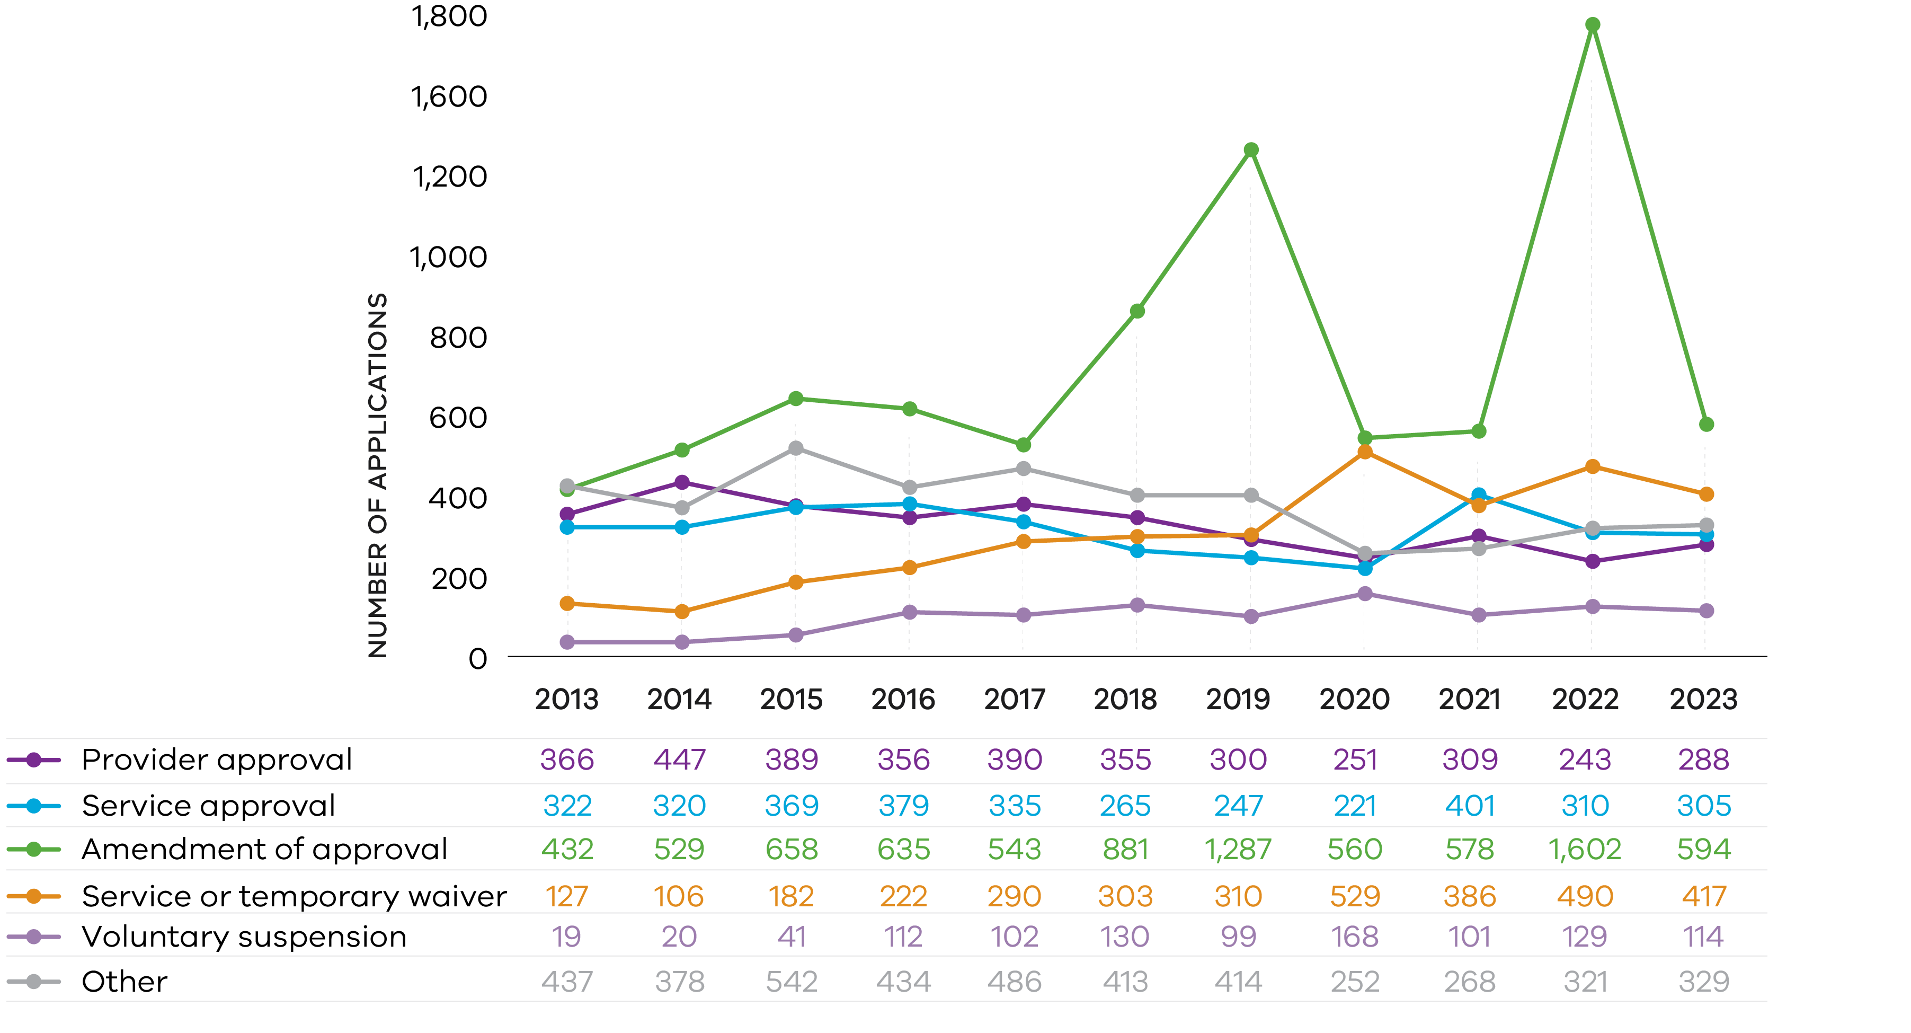

Notifications of change of circumstances
QARD receives and processes notifications of changes of circumstances and information relating to services regulated under both the NQF and the CS Act. These notifications include changes in the management or control of an approved provider or responsible persons at the service, surrenders of service or provider approval, and change of information about an early childhood service.
There were more than 12,100 notifications of change of circumstances received by QARD in 2023, up from 11,500 in 2022. Of these, notifications 67% were related to changes to services, with most related to the changes in nominated supervisors of services. A further 24% related to a change of contact details, most of them related to contact details for the service.
In July 2023, the expanded definition of a person with management or control (PMC) in the National Law took effect to include any person with significant influence of a service. This change resulted in an increase in the number of notifications of appointment or removal of PMC through the middle of 2023 as approved providers responded to the legislation changes.

Monitoring quality and compliance
QARD authorised officers monitor service quality against the NQS and compliance with legislative requirements by attending service premises to conduct quality assessments or compliance inspections. Authorised officers may also undertake targeted compliance campaigns and desktop audits.
In 2023, authorised officers conducted 4,816 visits to service premises across the State, compared with 4,506 visits in 2022. These visits included 1,489 quality assessment and rating visits, and 3,146 compliance inspections. Authorised officers also visit services regulated under the CS Act and unlicensed services (see Appendix Tables 29–31).

Assessment and rating
Assessment and rating is a core regulatory activity for QARD in delivering the NQF’s continuous improvement objective. It also seeks to improve knowledge, and access to information about the quality of services to help families make informed decisions about their child’s education and care.
The assessment and rating process involves authorised officers conducting an assessment of service quality against 40 elements of the NQS. As part of determining a quality rating, authorised officers conduct desktop audits and meet with senior leadership to review and discuss quality improvement plans, compliance histories, governance processes and internal controls. Authorised officers conduct service visits to observe children, families, educators, coordinators and staff members , discuss practice with educators and staff and sight documents required by legislation.
At the end of the assessment and rating process, approved providers receive a notice of rating providing their overall rating and rating against the 7 Quality Areas of the NQS. An approved provider also receives an assessment and rating report which provides information about the assessment findings including areas for service improvement. The report is available to share with parents and other members of the service’s community.
In 2023, QARD introduced changes to the way it undertakes assessment and rating visits, moving to a shorter notice period. For more information please read the section 'Refinements to the quality assessment and rating process' later in this report.
The 1,489 assessment and rating visits completed in 2023 is the highest number of quality assessment visits conducted annually by QARD.

Reviews of ratings
The National Law allows service providers to apply for a review of the service’s rating if the provider disagrees with the rating given.
The review of ratings by the regulatory authority is referred to as a ‘first tier review’. The National Law and Regulations do not specify particular grounds for first tier review, however only the information that relates to the facts from the point in time when the assessment and rating visit was conducted can be taken into account. In 2023 only 8 ratings given resulted in a first tier review, and in the last 7 years approved providers have applied for a first tier review for less than 2% of ratings.
If the approved provider is still not satisfied after the first tier review, they may apply to the National Authority (ACECQA) for a further review (a ‘second tier review’) by a ratings review panel. Second tier reviews allow approved providers to seek a further rating review where they disagree with the rating level awarded at the first tier review. There were no second tier reviews of a service in Victoria undertaken by the ratings review panel in 2023 and only one each year between 2018-2021 as shown in Table 4.
If approved providers have concerns about their rating, it can be raised through QARD’s complaints process or they can apply for a re-assessment and re-rating of a service’s ratings. If changes have been made at the service since the ratings assessment that might improve the service’s quality and therefore rating levels, the approved provider may apply for a reassessment and re-rating where changes made after the initial ratings assessment may be considered.

Table 4: Proportion of ratings with a first or second tier review, 2016–2023

 | 2016 | 2017 | 2018 | 2019 | 2020 | 2021 | 2022 | 2023
Second tier reviews | 0 | 0 | 1 | 1 | 1 | 1 | 0 | 0
First tier reviews | 12 | 15 | 14 | 12 | 5 | 4 | 5 | 8
Ratings given | 838 | 979 | 1,003 | 1,000 | 247 | 597 | 1,072 | 1,426
Proportion of ratings resulting in a first tier review | 1.4% | 1.5% | 1.4% | 1.2% | 2.0% | 0.7% | 0.5% | 0.6%

Note: Count of ratings given excludes partial reassessment and re-ratings. Ratings relate to those finalised in that year, where some visits were completed in the previous year. For this reason the number of assessment and rating visits will not match the ratings given.

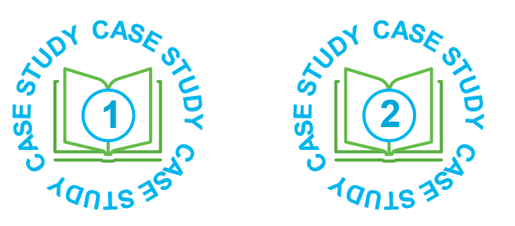
Case study: Compliance and quality improvement driven by data-informed regulatory practice

In 2023, the Regulatory Authority collaborated with Commonwealth agencies to undertake a detailed analysis of high-risk approved services in Victoria. This analysis identified a large FDC service with potential risks to the safety and wellbeing of children in their care.
When QARD authorised officers conducted a visit to the service’s principal office and 10 FDC residences they identified several issues, including FDC residences in disrepair, inaccurate attendance records, children being transported without appropriate car seats, risk assessments or parental authorisations.
The Regulatory Authority required action to be taken urgently to keep children safe in their service.

The Approved Provider responded with changes, providing evidence to the Regulatory Authority of the measures taken to ensure safe transportation by the service and lift the operational quality of the service.
Recognising the service’s willingness to address non- compliance and acknowledging the value of the FDC care for families, authorised officers guided the Approved Provider to implement measures to address safety and quality issues and improve practices.
When authorised officers conducted the 6-month post- monitoring visit, they found significant improvements made by the service to safeguard the health, safety and wellbeing of children.
The service achieved a rating of Meeting National Quality Standard in December 2023.

Compliance and investigations
QARD implements a range of strategies to motivate compliance with legislative requirements.
QARD takes risk-based approaches to regulating providers and service operations. Compliance inspections can be undertaken prior to service approval to ensure premises meet requirements, and on a regular ongoing basis to check that compliance requirements are maintained. General compliance checks are complemented by targeted compliance activities focused on particular themes or harms. Authorised officers may also attend a service to investigate an incident or complaint.
Authorised officers notify approved providers of non-compliances identified at their services. Depending on the nature and seriousness of the non-compliance, authorised officers may provide education and guidance to service operators and their staff to remedy the non-compliance. More serious matters may result in statutory sanctions being applied to duty holders to deter further non-compliance.
In 2023, authorised officers completed a total of 3,146 service compliance inspections. 2,993 were to services operating under the NQF, 124 were to services operating under the CS Act and around 25 were to unlicensed services.
Table 5: Number of compliance inspection visits completed per 100 services by care type, 2019–2023

Care type | 2019 | 2020 | 2021 | 2022 | 2023
Long day care | 88 | 70 | 72 | 75 | 75
Standalone kindergarten | 40 | 38 | 40 | 49 | 50
Outside school hours care | 54 | 36 | 41 | 60 | 54
Family day care | 76 | 38 | 36 | 108 | 93
CS Act service | 40 | 26 | 45 | 53 | 64

Note: A compliance visit is defined here as any of the following visit types in NQA ITS: application/assessment, change of ownership, complaint, incident, investigation and post-approval. Some compliance visits relate to services that were cancelled or surrendered by the end of each year.

Case study: Service improvement through tailored individual QARD support

In late 2022, QARD received a complaint about a LDC service in Melbourne. The complainant alleged that there were numerous health and safety risks for children at
the service. Due to the seriousness of the allegations, the Regulatory Authority conducted a comprehensive compliance visit to the service the next day.
When the authorised officers arrived at the service, they observed some significant issues: disengaged children running around without appropriate supervision, unkempt premises, educational programming that wasn’t catering to children’s interests and staffing that did not meet the qualification requirements in the National Regulations.
QARD immediately issued a non-compliance findings letter to the Approved Provider and the Regional Manager spoke directly to the Approved Provider about the immediate actions necessary. The Approved Provider made immediate changes to clean up the premises, disposing of broken resources and purchasing new resources.
QARD put the service on “additional monitoring” status, meaning more frequent visits to the service were scheduled to ensure that all the non-compliances were being rectified, and the risks to children addressed.

The Approved Provider was involved in each subsequent service monitoring visit allowing clear discussion with authorised officers about what needed to be addressed.
In addition, the QARD Regional Manager met with the Approved Provider and Nominated Supervisor to discuss the actions that QARD required to address the non-compliances. Authorised officers also held an educative session after hours with the service leadership team and all staff to emphasise all their regulatory obligations and the requirements of a quality educational program.
Throughout 2023, the Approved Provider made improvements to the educational program, resources, and strengthened educators’ practice and qualifications.
In the final scheduled visit, authorised officers were pleased to observe a much better service. No non-compliances were observed, children were engaged in learning and play, and the service had embedded continuous improvement conversations in their staff meetings led by a new Nominated Supervisor.
This extent of improvement was underscored when the service was assessed and rated for quality in early 2024, achieving a rating of Meeting NQS.

Investigations
Investigations can be triggered by an assessment and rating visit, inspection, intelligence from incident notifications, complaints or notifications from co-regulators. Investigations are initiated when authorised officers identify potential non-compliance with requirements or risk of harm to children’s safety and wellbeing.

Notification of serious incidents
The National Law and CS Act outline the circumstances under which services must notify QARD of a complaint or an incident. These include:
- the death of a child
- any incident involving serious injury or trauma to, or illness of, a child
- any incident where the attendance of emergency services was required
- any circumstance where a child being educated and cared for by an early childhood education and care service appears to be missing or cannot be accounted for.
In addition, QARD must be notified of incidents affecting the hours and days of operation of a service, of any circumstance that poses a risk to a child and matters related to FDC venues.

Table 6: Number of reported serious incidents per 100 services by care type, 2019–2023

Care type | 2019 | 2020 | 2021 | 2022 | 2023
Long day care | 158 | 148 | 196 | 197 | 217
Standalone kindergarten | 57 | 44 | 53 | 59 | 70
Outside school hours care | 46 | 31 | 38 | 39 | 52
Family day care | 56 | 48 | 47 | 39 | 49
CS Act service | 3 | 3 | 7 | 7 | 10

Note: Some serious incidents may relate to services that were not operating at the end of each year.

In 2023 QARD received 5,878 serious incident notifications, an increase of 18% on 2022 (5,001). Of these 5,864 were submitted directly by education and care services, both NQF and CS Act service. In 2023 Victorian NQF services made
123.5 notifications of serious incident per 100 services, compared to the 2022 average of 107.3 per 100 services.

Notification of other incidents
Other incident notifications, which excludes incidents defined by legislation as ‘serious incidents’, significantly decreased in 2023, with a sharp decrease (4,102 in 2023 from 28,728 in 2022, and 6,233 in 2021), mostly due to the absence of pandemic related notifications.
In 2023, around 1,733 (42%) other incident notifications related to service closures, and around 410 (10%) related to reduced number of children in attendance. Reasons cited for closures and reduced attendance include staffing
unavailability, staff professional development days, issues with building premises, low bookings, holiday closures and pupil free days.
Of the remaining other incident notifications, approximately 1,959 (48%) were related to circumstances that posed a risk to the health, safety or wellbeing of a child or children at the service. This category includes a wide range of situations including accidents, injuries, illness (‘gastro’, rashes, unwell children), facilities issues (gas leaks, water
leaks, emergency services attending, floods and storms), inadequate supervision and others. There were also a large number of notifications due to ‘gastro’ illness in particular.
All incident notifications were assessed by QARD for further action.

Complaints
In 2023, the total numbers of complaints received by QARD increased (2,463 in 2023 compared with 2,036 in 2022).
Of the 2,463 total complaints, 2,449 were related to services operating under the NQF, 6 related to services operating under the CS Act and 8 were about alleged unapproved services (see Appendix Table 38).
In 2023, QARD received 669 complaints directly from members of the public about early childhood services, including from parents of children attending services. The remaining 1,794 complaint notifications were notified through the NQA IT system from providers about complaints received from parents at the service, as required under the National Law.
This was an increase of 270 (18%) complaints compared to the previous year.
The largest number of complaints received in Victoria related to LDC services, which is consistent with historical trends (see Appendix Table 4). LDC also has the highest proportion of complaints in Victoria of all care types, with 104 direct and indirect complaints per 100 services in 2023. This higher rate reflects that LDC services typically have larger numbers of children attending, at younger ages, and for longer periods of time than other care types.

Compliance with Child Safe Standards (CSS)
On 1 January 2023 QARD became the ‘integrated sector regulator’ for the CSS in the early childhood sector in Victoria.
QARD provides education, information and advice on the CSS to promote consistency and continuous improvement by services, and also uses its powers under the National Law and the CSA to monitor and enforce compliance with the standards.
QARD collaborates with CCYP and other sector regulators where organisations operate in more than one sector to ensure a joined up approach, and to ensure organisations adhere to their obligations under the CSS. We also publish information online about non-compliance with the CSS in accordance with the National Law and Regulations which is updated quarterly.

Enforcement
QARD applies a range of regulatory tools to remedy or sanction duty holders for non-compliance with the relevant early childhood laws and regulations, or to address unacceptable risks of harm to children’s safety and wellbeing. Actions can range from lower level administrative actions which involve providing education and guidance to approved providers and service staff through to statutory sanctions such as prosecution or prohibition of an individual from being involved in the provision of education and care. The type of enforcement actions taken will depend on the nature and seriousness of the non-compliance or risk to children’s safety and wellbeing, and the attitude and responsive of duty holders to remediating non-compliance or risk.
In 2023, the Regulatory Authority issued 28 statutory sanctions against providers and services regulated under the NQF and CSA. The sanctions included 7 cancellations of provider approval, 2 cancellations of service approval,
2 suspensions of service approvals, 7 amendments of service and provider approval to impose a condition, 7 compliance notices, 2 compliance directions and 1 emergency action notice. Issues in FDC services remained significant with 13 of the 28 statutory sanctions in 2023 issued to FDC services.
Individuals can also be prohibited from being involved in the provision of early childhood services if they are they are considered to pose an unacceptable risk of harm to a child if that person were allowed to provide education and care for children. In 2023, QARD issued 9 show cause notices to individuals to prohibit them from being involved
in the provision of education and care. This resulted in the issuing of five prohibition notices and four enforceable undertakings. One direction to exclude an inappropriate person from being able to attend an education and care service was issued.

Child Safe Standards Enforcement
QARD uses its powers under the National Law and the CS Act to monitor and enforce compliance by early childhood services with the CSS.
Building on its work in 2022, QARD’s approach in 2023 was to continue to inform and educate early childhood services of the CSS and encourage their continuous improvement against the CSS. Where breaches of the CSS were identified, QARD took a risk-based approach, working with early childhood services to rectify non-compliances identified. For 2023, 93 breaches of the CSS were identified during these visits. Of non-compliances identified, the most common included non-compliance against Standard 2 and Standard 6.
Where an organisation delivering early childhood services operates in more than one sector, QARD works closely with the CCYP and other regulators to ensure a collaborative approach.



Reforms and initiatives

Refinements to the quality assessment and rating process
In 2023, refinements to some quality assessment and rating processes were progressively implemented by all jurisdictions including Victoria. These processes support the continuous quality improvement of services and include a shift to a shorter notice period of 1-5 days for most assessment and rating visits. They include:
- an enhanced focus on the service’s self- assessment and Quality Improvement Plan (QIP) as part of its continuous quality improvement, rather than as a point in time preparation for assessment and rating
- greater use of partial assessment and ratings as currently allowed under the National Law (only applicable to services rated under the 2018 NQS).
The introduction of adjusted notice periods for assessment and rating enables a more accurate and agile process that is more reflective of typical service practice, through targeted evidence gathering and focused discussions. This meets the intent of observing and assessing typical practice. Approved providers and their services have reported that they have experienced reduced anxiety or pressure in anticipation of a quality assessment visit.
A partial assessment and rating is where any aspect of a service that has already been fully assessed and rated is reassessed. Regulatory authorities have always had power under the National Law to conduct partial assessment and ratings of services. They provide the opportunity to target quality assessments to specific quality areas with a direct link to improving educational and developmental outcomes for children, without requiring a service to undergo a full assessment. They also require less evidence collection and can offer less disruption to service routines.
The QIP is a dynamic, evolving document that enables a service to plan future improvements, self-assessment, and self- reflection. As a part of these refinements, services were encouraged to review and update their QIP against the National Regulations and NQS in order to drive continuous improvement and provide quality outcomes for children.
QARD provided resources and information sessions to support the sector to adapt to these adjustments.

NQF Review 2019
The outcomes of the second 5-yearly review of the NQF were finalised in May 2022 with changes requiring legislation being passed by the Victorian Parliament in September 2022.
Those changes commenced progressively throughout 2023 together with changes to the National Regulations.
Key changes for services in the Review included:
- new safety requirements – introducing new policies, procedures and risk assessments to ensure the safety, health and wellbeing of children in education and care
- improved oversight and compliance tools for Regulatory Authorities – increasing transparency and accountability in the sector
- new workforce requirements – such as increasing mandatory minimum qualification requirements for family day care educators, and alleviating staffing requirements during short-term absences
- improved regulatory guidance – improving educator knowledge of best practice through government developed resources, including the Guide to the National Quality Framework.

Premises approval in principle scheme –
multi-storey buildings
A specific area of focus in the 2019 Review was the challenges associated with services located in multi-storey buildings, particularly in relation to the safety and wellbeing of children during emergency evacuations.
In addition to recommendations to improve safety measures related to services located in multi-storey buildings, the 2019 NQF Review identified an emerging issue in Victoria and the Australian Capital Territory. Newly built or renovated early childhood service premises in multi-storey buildings can be consistent with local building and planning law requirements, but not comply with the NQF requirements relating to the physical design and environment of education and care service premises. Costly post-construction rectification works may be required to make the service premises compliant with the NQF to enable a service approval to be granted.
The Review recommended establishing a premises approval in principle scheme for newly built or renovated service premises in multi-storey buildings in Victoria and the ACT to address commonly experienced design and safety issues.
Approved providers were consulted about the proposed scheme during the 2019 NQF Review. In April 2023, a short consultation paper outlining the proposed scheme was circulated to building and construction stakeholders in Victoria.
Currently in Victoria, less than 1% of approved early childhood services are located in multi-storey buildings. However, the number of proposals for early childhood services in multi-storey buildings is expected to increase. The scheme aims to improve the service approval application process by preventing the need for rectification works to be undertaken in new or renovated multi-storey buildings in order to make the service premises compliant and enable a service approval to be granted.
Changes to the National Law to establish the premises approval in principle scheme were passed as part of the Early Childhood Legislation Amendment (Premises Approval in Principle) Act 2023 (the 2023 Amendment Act). The scheme can be adopted by a participating jurisdiction as a mandatory or voluntary process. The scheme will be adopted as a voluntary process in Victoria.
The 2023 Amendment Act made corresponding changes to the CS Act to ensure that all proponents of new or altered early childhood service premises in multi-storey buildings in Victoria are able to access the benefits of the premises approval in principle scheme.
The premises approval in principle process commences in Victoria on 1 October 2024.

Maintaining alignment between the children’s services regulatory regime and the NQF
The children’s services regulatory regime is generally aligned with the NQF. Whenever changes are made to the National Law and National Regulations, consideration is given to making corresponding amendments to align the CS Act and CS Regulations with those changes.
In late 2023 QARD consulted the children’s services sector about proposed changes that would align the CS Regulations with changes for centre-based services that have been made to the National Regulations since October 2020. All approved children’s services and their approved providers were directly invited to participate in the consultation process. A summary of the proposed changes was presented at 3 well-attended online information sessions and there was a strong response to an online survey. 84% of survey respondents supported all proposed changes, while the majority of the other respondents supported most of the changes.
The Childrens’ Services Amendment Regulations 2024 commenced on 2 April 2024. Key areas of change included:
- the safety, health and wellbeing of children attending children’s services:
  - during periods of sleep and rest (including prohibiting bassinets on service premises)
  - on transportation
  - during daily movement between children’s services and schools or other early childhood services.
- embedding certain requirements of the Child Safe Standards in regulations
- children’s services in multi-storey buildings – service approval applications and emergency evacuations
- staffing relief during absence of educators and following resignation
- documenting the program for school age children
- notifications to the Regulatory Authority of changes to the nature of care offered by the children’s service.

Co-regulatory partners
QARD works with national and state regulatory authorities to support the successful implementation of the NQF. This includes regular interaction with all jurisdictions and ACECQA regarding the effectiveness of operational policy, training, systems, business processes, information management and sector support. We collaborate within a ‘Community of practice’ designed to improve regulatory practice, identify emerging issues and reduce risk.
We also collaborate with other state and national regulators to promote coherence through information sharing, enforcement and to build capability within the education and care sector.

Commission for Children and Young People
Throughout 2023 QARD continued to hold regular meetings with the CCYP to share information in relation to its role as the integrated sector regulator of the CSS for the early childhood sector. QARD continued to manage referrals from the CCYP to determine services’ compliance with the CSS and monitored aspects of services’ compliance with the CSS as part of the assessment and rating process for services.
QARD undertook a data matching exercise for all RCS notifications for 2022-23 to ensure the Regulatory Authority is aware of all reportable conduct notifications related to the early childhood education/care sector.
QARD collaborates with the CCYP and other sector regulators of the CSS where an organisation operates across more than one sector.

Victorian Registration and Qualifications Authority
QARD continues to work closely with the Victorian Registration and Qualifications Authority (VRQA) as a co-regulator. Information is shared and joint investigations carried out into OSHC providers, sometimes operated by school councils registered by the VRQA, and early childhood-related qualifications by Registered Training Organisations also regulated by the VRQA.

Department of Health
QARD works closely with the Department of Health to support and facilitate the implementation of a number of policy areas, and health safety alerts (eg. COVID, gastroenteritis, mosquitos), including the requirements of the No Jab, No Play legislation.

Department of Justice and Community Safety
QARD shares information with the Department of Justice and Community Safety where there are concerns a relevant person may not hold, or be eligible to hold, a Working with Children Clearance.

WorkSafe Victoria
QARD’s collaboration with WorkSafe Victoria ensures issues of shared interest impacting on the safety, health and wellbeing of children are addressed. We also collaborate when both agencies are investigating the same matter.

Victorian Institute of Teaching
QARD maintains a close relationship with the Victorian Institute of Teaching through an established Memorandum of Understanding and regular liaison over the registration of early childhood teachers.

Commonwealth Department of Education
Regular collaboration and information sharing between QARD and the Commonwealth Department of Education contributes to the identification of non-compliant services and providers. Sanctions taken by the Commonwealth in relation to child care funding are considered, and action taken to cancel provider approvals as appropriate.

Victoria Police
QARD works closely with Victoria Police on alleged criminal matters as required.

Glossary

Term | Acronym | Meaning
Approved provider |  | An entity which holds a provider approval under the NQF or the CS Act.
Approved service |  | An approved early childhood education and care service for which a service approval exists under the NQF. An approved children’s service for which a service approval exists under the CS Act.
Assessment and Rating | A&R | The process by which NQF services are assessed and rated by their regulatory authority against the NQS and given a rating for each of the 7 quality areas and an overall rating based on these results.
Care type classification |  | In this report centre-based services offering more than one type of service are classified as follows: services which provide LDC in addition to any other service type are classified as LDC services; services which only provide kindergarten programs to 3 and 4-year-old children as well as outside school hours care services are classified as standalone kindergarten services (KGN); services which provide outside school hours care services only are classified as outside school hours care services.
Centre-based service |  | An education and care service under the NQF other than a family day care service. This includes most LDC, preschool/standalone kindergarten and outside school hours care services that are delivered at a centre. Also refers to occasional care and limited hours services under the CS Act.
Complaint |  | Includes concerns raised about the safety, health or wellbeing of children, the behaviour and practices of staff an early childhood service, allegations that incidents of physical and sexual abuse of a child at an early childhood service, and allegations that either the National Law or CS Act have been contravened.
Children’s service |  | A service regulated under the Children’s Services Act 1996 for which a service approval exists.
Early childhood education and care services/early childhood services | ECEC | Blanket terms, used in reference to all early childhood education and care services under both the NQF and CS Act.
Incident notification |  | See Notification
Limited hours service |  | One of 2 types of service approval prescribed in the Children’s Services Regulations 2020. Children’s services with a Limited Hours service approval can provide education and care to a child for up to 3 hours per day to a maximum of 6 hours per week. They are often located in sports and leisure centres where the child’s parent is a patron.
National Law |  | The NQF operates under an applied law system, comprising the Education and Care Services National Law and the Education and Care Services National Regulations. The purpose of  the applied law system is to set a national standard for children’s education and care across Australia. In effect it means the same law is applied in each state and territory, but with some varied provisions as applicable to the needs of each state or territory. Victoria is the host jurisdiction of the Education and Care Services National Law which is set out in a Schedule to the Education and Care Services National Law Act 2010 (Vic). Application provisions in this Act apply the National Law in Victoria. Other jurisdictions adopted the National Law through an Application Act or passed corresponding legislation.
National Quality Agenda for Early Childhood Education and Care | NQA | The overarching name given to the quality reforms to early childhood education care, which incorporate the National Law and National Regulations, including the NQS, the Early Years Learning Framework, and the assessment and rating system.
National Quality Framework | NQF | The NQF covers services providing or intending to provide education and care on a regular basis to children under the age of 13 years. This includes family day care services, LDC services, outside school hours care services and preschools (standalone kindergartens). The NQF comprises the National Law, National Regulations and the NQS.
National Quality Standard | NQS | The NQS sets a high national benchmark for early childhood education and care and outside school hours care services in Australia. The NQS includes 7 quality areas that are important outcomes for children. Services are assessed and rated by their regulatory authority against the NQS and given a rating for each of the 7 quality areas and an overall rating based on these results.

Term | Acronym | Meaning
No Jab, No Play |  | Under the No Jab, No Play legislation, before enrolling a child, early childhood education and care services must first obtain evidence that the child is up to date with all vaccinations that are due for their age, or that they are able to receive. There is provision to allow enrolment of children whose immunisation documentation has not been provided if they are experiencing vulnerability and disadvantage.
Notification |  | Approved providers are required to notify the regulatory authority about incidents, complaints and changes to information.
National Quality Agenda IT System | NQA ITS | A web-based information system to assist state and territory regulatory authorities and ACECQA to manage the approval, monitoring and quality assessment of children’s education and care services. The system also enables NQF services, providers and educators to submit application and notification forms online to regulatory authorities and ACECQA.
Occasional Care |  | One of 2 types of service approval prescribed in the Children’s Services Regulations 2020. Children’s services with an Occasional Care service approval can provide education and care to a child on an ad hoc, irregular basis.
Outside School Hours Care | OSHC | Regulated under the NQF. Not defined in the National Law or National Regulations. A service that provides care for primary school aged children (typically 5 to 12 years) before and after school and can also operate during school holidays (vacation care) and on pupil free days Outside school hours care services are usually provided from primary school premises.  Services may also be located in child care centres or community facilities.
Places |  | Places only relates to centre-based services under the National Law and children’s services regulated under the Children’s Services Act 1996. The maximum number of children who can be educated and cared for by a service at any one time, stated on the service approval. Number of places reflects services’ approved capacity. Places data for FDC services is not collected.
Preschool |  | Not defined in the National Law or Regulations. A service that provides an early childhood education program, delivered by a qualified teacher, often but not necessarily on a sessional basis in a dedicated service. Alternative terms used for preschool in some jurisdictions include kindergarten, pre-preparatory and reception.
Provider management type |  | The type of legal or social entity responsible for managing the delivery of an early childhood education and care service or children’s service.
Provider |  | See Approved provider
Quality Improvement Plan | QIP | The approved provider of an NQF service must ensure a Quality Improvement Plan (QIP) is in place for each service. The aim of a QIP is to help providers self-assess their performance in delivering quality education and care, and to plan future improvements. The QIP also helps regulatory authorities with assessing the quality of the service.
Reportable Conduct Scheme | RCS | Scheme to improve oversight of how organisations respond to allegations of child abuse and child-related misconduct. Requires some organisations to respond to allegations made against their workers and volunteers, and to notify the Commission for Children and Young People of any allegations.
School holidays care service |  | Cares for or educates children for 4 weeks or more during school holidays under the National Law, or up to 4 weeks per calendar year under the Children’s Services Act 1996. Also referred to as vacation care.
Serious incident |  | Serious incidents that occur while a child is being educated and cared for by an education and care service include: the death of a child; a serious injury or trauma to a child; the serious illness of a child requiring hospital attendance; an emergency for which emergency services attended; circumstances where a child is missing or unaccounted for/is taken or removed/is mistakenly locked in or out of the service/service premises.
Service approval |  | A person must have service approval to operate an education and care service under the National Law or a children’s service under the Children’s Services Act 1996. Regulatory authorities are responsible for assessing and determining applications for service approval.
Waiver |  | An exemption from a requirement that an approved education and care service comply with a prescribed element(s) of the NQS or regulation of the National Regulations, or and approve children’s service comply with a prescribed regulation of the Children’s Services Regulations 2020. While a waiver is in force, the approved service is not required to comply with the element(s) or regulation(s) specified in the waiver.

Data tables

DATA IN THIS APPENDIX HAS BEEN GENERATED BY QARD (UNLESS SPECIFIED) AND RELATES ONLY TO EARLY CHILDHOOD SERVICES LOCATED IN VICTORIA

Appendix Table 1: Number of new ECEC services by care type, 2013–2023

Care type | 2013 | 2014 | 2015 | 2016 | 2017 | 2018 | 2019 | 2020 | 2021 | 2022 | 2023
Total Services | 251 | 214 | 289 | 223 | 260 | 219 | 206 | 188 | 228 | 345 | 228
NQF services | 251 | 214 | 224 | 198 | 233 | 204 | 192 | 178 | 224 | 334 | 223
Centre-based care | 123 | 140 | 163 | 160 | 213 | 191 | 185 | 170 | 212 | 323 | 211
- Long day care | 34 | 36 | 54 | 75 | 116 | 81 | 105 | 97 | 95 | 99 | 88
- Kindergarten | 31 | 23 | 30 | 22 | 19 | 22 | 23 | 20 | 20 | 37 | 41
- Outside school hours care | 58 | 81 | 79 | 63 | 78 | 88 | 57 | 53 | 97 | 187 | 82
Family day care | 128 | 74 | 61 | 38 | 20 | 13 | 7 | 8 | 12 | 11 | 12
CSA services | na | na | 65 | 25 | 27 | 15 | 14 | 10 | 4 | 11 | 5
Note: This table only counts services remaining approved at the end of each year and excludes services suspended, surrendered or cancelled in the same year. Total new services for 2013 and 2014 excludes new CSA services.

Appendix Table 2: Number of new places for centre-based services by care type, 2013–2023

Care type | 2013 | 2014 | 2015 | 2016 | 2017 | 2018 | 2019 | 2020 | 2021 | 2022 | 2023
Total Places | 7,376 | 8,293 | 11,433 | 12308 | 18,319 | 14760 | 16,177 | 14,273 | 14,356 | 20,046 | 14,395
NQF places | 7,376 | 8293 | 9,664 | 11767 | 17,623 | 14303 | 15,817 | 14,097 | 14,274 | 19,841 | 14,283
- Long day care | 3,172 | 3501 | 4,246 | 7348 | 12,092 | 8520 | 11,777 | 10,007 | 9,526 | 9,920 | 8,454
- Kindergarten | 1,474 | 1166 | 1,731 | 1117 | 828 | 1107 | 1,110 | 1,159 | 1,008 | 2,095 | 2,312
- Outside school hours care | 2,730 | 3626 | 3,687 | 3302 | 4,703 | 4676 | 2,930 | 2,931 | 3,740 | 7,826 | 3,517
CSA places | na | na | 1,769 | 541 | 696 | 457 | 360 | 176 | 82 | 205 | 112
Note: This table only counts places for services remaining approved at the end of each year and excludes services suspended, surrendered or cancelled in the same year. Total new places for 2013 and 2014 excludes new CSA places.

Appendix Table 3: Number of new ECEC services by provider management type, 2013–2023

Provider type | 2013 | 2014 | 2015 | 2016 | 2017 | 2018 | 2019 | 2020 | 2021 | 2022 | 2023
Total Services | 251 | 214 | 289 | 223 | 260 | 219 | 206 | 188 | 228 | 345 | 228
Catholic school | 1 | 0 | 2 | 2 | 2 | 1 | 0 | 0 | 1 | 0 | 0
Government school | 10 | 7 | 6 | 5 | 4 | 5 | 3 | 4 | 13 | 12 | 9
Independent school | 5 | 3 | 2 | 7 | 5 | 4 | 4 | 2 | 5 | 2 | 1
Local government | 7 | 10 | 31 | 11 | 9 | 12 | 8 | 9 | 10 | 16 | 8
Not-for-profit community managed | 34 | 27 | 56 | 34 | 37 | 36 | 20 | 24 | 19 | 38 | 48
Not-for-profit other | 4 | 5 | 17 | 5 | 16 | 13 | 11 | 11 | 10 | 34 | 9
Private for profit | 190 | 162 | 175 | 159 | 187 | 148 | 160 | 138 | 170 | 243 | 153

Appendix Table 4: Number of new places for centre-based services by provider management type, 2013–2023

Provider management type | 2013 | 2014 | 2015 | 2016 | 2017 | 2018 | 2019 | 2020 | 2021 | 2022 | 2023
Total Places | 7,376 | 8,293 | 11,433 | 12,308 | 18,319 | 14,760 | 16,177 | 14,273 | 14,356 | 20,046 | 14,395
Catholic school | 40 | 0 | 35 | 65 | 86 | 20 | 0 | 0 | 80 | 0 | 0
Government school | 389 | 290 | 186 | 191 | 117 | 214 | 45 | 175 | 277 | 254 | 370
Independent school | 343 | 170 | 69 | 294 | 309 | 192 | 320 | 31 | 403 | 164 | 25
Local government | 659 | 630 | 1,832 | 574 | 386 | 520 | 777 | 616 | 495 | 610 | 405
Not-for-profit community managed | 1,946 | 956 | 2,461 | 1,476 | 1,960 | 1,939 | 1,199 | 1,417 | 919 | 1,918 | 2,477
Not-for-profit other | 281 | 216 | 563 | 213 | 2,182 | 759 | 674 | 1,149 | 850 | 2,923 | 601
Private for profit | 3,718 | 6,031 | 6,287 | 9,495 | 13,279 | 11,116 | 13,162 | 10,885 | 11,332 | 14,177 | 10,517

Appendix Table 5: Number of approved ECEC services by care type, 2013–2023

Care type | 2013 | 2014 | 2015 | 2016 | 2017 | 2018 | 2019 | 2020 | 2021 | 2022 | 2023
Total Services | 4,265 | 4,381 | 4,457 | 4,514 | 4,612 | 4,567 | 4,546 | 4,578 | 4,706 | 4,881 | 4,953
NQF services | 3,808 | 3,928 | 4,027 | 4,108 | 4,233 | 4,209 | 4,229 | 4,299 | 4,435 | 4,662 | 4,759
Centre-based care | 3,541 | 3,589 | 3,645 | 3,737 | 3,886 | 3,961 | 4,043 | 4,140 | 4,278 | 4,512 | 4,613
- Long day care | 1,220 | 1,244 | 1,280 | 1,342 | 1,457 | 1,520 | 1,607 | 1,691 | 1,777 | 1,858 | 1,924
- Kindergarten | 1,211 | 1,197 | 1,197 | 1,203 | 1,205 | 1,194 | 1,186 | 1,183 | 1,185 | 1,200 | 1,208
- Outside school hours care | 1,110 | 1,148 | 1,168 | 1,192 | 1,224 | 1,247 | 1,250 | 1,266 | 1,316 | 1,454 | 1,481
Family day care | 267 | 339 | 382 | 371 | 347 | 248 | 186 | 159 | 157 | 150 | 146
CSA services | 457 | 453 | 430 | 406 | 379 | 358 | 317 | 279 | 271 | 219 | 194
Note: This table only counts services remaining approved at the end of each year and excludes services suspended, surrendered or cancelled in the same year.

Appendix Table 6: Number of approved places for centre-based ECEC services by care type, 2013–2023

Care type | 2013 | 2014 | 2015 | 2016 | 2017 | 2018 | 2019 | 2020 | 2021 | 2022 | 2023
Total Places | 212,057 | 234,951 | 228,856 | 241,748 | 257,659 | 268,682 | 280,416 | 290,591 | 302,668 | 316,420 | 326,519
NQF approved places | 200,809 | 223,873 | 218,287 | 231,645 | 248,143 | 259,542 | 272,414 | 283,552 | 295,897 | 311,101 | 321,763
- Long day care | 91,493 | 109,743 | 99,683 | 107,605 | 120,343 | 128,664 | 140,255 | 149,891 | 159,560 | 166,716 | 174,290
- Kindergarten | 44,736 | 46,101 | 48,077 | 49,811 | 50,099 | 50,567 | 51,073 | 51,798 | 52,316 | 54,878 | 56,419
- Outside school hours care | 64,580 | 68,029 | 70,527 | 74,229 | 77,701 | 80,311 | 81,086 | 81,863 | 84,021 | 89,507 | 91,054
CSA licensed places | 11,248 | 11,078 | 10,569 | 10,103 | 9,516 | 9,140 | 8,002 | 7,039 | 6,771 | 5,319 | 4,756
Note: This table only counts places for services remaining approved at the end of each year and excludes services suspended, surrendered or cancelled in the same year.

Appendix Table 7: Number of approved ECEC services by provider management type, 2013–2023

Provider management type | 2013 | 2014 | 2015 | 2016 | 2017 | 2018 | 2019 | 2020 | 2021 | 2022 | 2023
Total Services | 3,808 | 3,928 | 4,457 | 4,514 | 4,612 | 4,567 | 4,546 | 4,578 | 4,706 | 4,881 | 4,953
Catholic school | 44 | 41 | 41 | 39 | 33 | 29 | 26 | 20 | 19 | 14 | 12
Government school | 338 | 320 | 309 | 295 | 279 | 260 | 244 | 236 | 228 | 221 | 209
Independent school | 133 | 129 | 123 | 127 | 132 | 131 | 131 | 129 | 131 | 131 | 125
Local government | 458 | 433 | 496 | 484 | 467 | 456 | 440 | 438 | 432 | 418 | 403
Not-for-profit community managed | 1,130 | 1,114 | 1,294 | 1,281 | 1,285 | 1,261 | 1,221 | 1,203 | 1,191 | 1,190 | 1,199
Not-for-profit other | 312 | 309 | 375 | 365 | 376 | 379 | 374 | 355 | 379 | 410 | 418
Private for profit | 1,393 | 1,582 | 1,819 | 1,923 | 2,040 | 2,051 | 2,110 | 2,197 | 2,326 | 2,497 | 2,587
Note: This table only counts services remaining approved at the end of each year and excludes services suspended, surrendered or cancelled in the same year.

Appendix Table 8: Number of approved places for centre-based ECEC services by provider management type, 2013–2023

Provider management type | 2013 | 2014 | 2015 | 2016 | 2017 | 2018 | 2019 | 2020 | 2021 | 2022 | 2023
Total Places | 200,809 | 223,873 | 228,856 | 241,728 | 257,659 | 268,682 | 280,416 | 290,591 | 302,698 | 316,420 | 326,519
Catholic school | 2,398 | 2,144 | 2,106 | 1,996 | 1,758 | 1,567 | 1,484 | 1,173 | 1,143 | 923 | 803
Government school | 18,311 | 18,267 | 18,335 | 18,535 | 18,296 | 17,400 | 16,870 | 16,399 | 15,081 | 14,220 | 13,349
Independent school | 9,190 | 9,133 | 8,492 | 8,738 | 9,044 | 8,960 | 9,374 | 9,246 | 9,521 | 9,674 | 9,377
Local government | 19,125 | 18,575 | 21,183 | 21,589 | 21,333 | 20,986 | 21,185 | 21,474 | 21,622 | 21,553 | 21,345
Not-for-profit community managed | 47,646 | 62,491 | 53,738 | 54,193 | 55,330 | 55,587 | 54,885 | 55,038 | 55,319 | 56,466 | 57,995
Not-for-profit other | 22,923 | 22,997 | 25,005 | 25,220 | 27,076 | 27,692 | 28,020 | 28,296 | 29,754 | 30,949 | 31,898
Private for profit | 81,216 | 90,266 | 99,997 | 111,457 | 124,822 | 136,490 | 148,598 | 158,965 | 170,228 | 182,635 | 191,752
Note: This table only counts places for services remaining approved at the end of each year and excludes services suspended, surrendered or cancelled in the same year.

Appendix Table 9: Number of NQF services managed by Victorian providers, 2015–2023

Service jurisdiction | 2015 | 2016 | 2017 | 2018 | 2019 | 2020 | 2021 | 2022 | 2023
VIC | 3,557 | 3,602 | 3,687 | 3,629 | 3,620 | 3,669 | 3,777 | 3,975 | 4,020
Other jurisdictions | 464 | 546 | 581 | 552 | 535 | 556 | 642 | 720 | 752
ACT | 9 | 8 | 10 | 11 | 12 | 18 | 19 | 19 | 21
NSW | 157 | 189 | 201 | 191 | 195 | 204 | 269 | 331 | 304
NT | 7 | 16 | 20 | 18 | 18 | 17 | 12 | 10 | 11
QLD | 66 | 79 | 90 | 88 | 85 | 87 | 96 | 104 | 117
SA | 67 | 80 | 75 | 63 | 50 | 47 | 47 | 48 | 51
TAS | 1 | 1 | 10 | 8 | 5 | 5 | 7 | 9 | 9
WA | 157 | 173 | 175 | 173 | 170 | 178 | 192 | 199 | 239
Note: This table only counts services remaining approved at the end of each year and excludes services suspended, surrendered or cancelled in the same year.

Appendix Table 10: Number of applications submitted by application type, 2013–2023

Application type | 2013 | 2014 | 2015 | 2016 | 2017 | 2018 | 2019 | 2020 | 2021 | 2022 | 2023
Approval | 688 | 767 | 758 | 735 | 725 | 620 | 547 | 472 | 710 | 553 | 593
Provider Approval | 366 | 447 | 389 | 356 | 390 | 355 | 300 | 251 | 309 | 243 | 288
Service Approval | 322 | 320 | 369 | 379 | 335 | 265 | 247 | 221 | 401 | 310 | 305
Amendment of approval | 432 | 529 | 658 | 635 | 543 | 881 | 1,287 | 560 | 578 | 1,602 | 594
Amend Provider Approval | 48 | 109 | 144 | 166 | 179 | 237 | 140 | 121 | 145 | 122 | 207
Amend Service Approval | 384 | 420 | 514 | 469 | 364 | 644 | 1,147 | 439 | 433 | 1,480 | 387
Waiver (service or temporary) | 127 | 106 | 182 | 222 | 290 | 303 | 310 | 529 | 386 | 490 | 417
Suspension | 19 | 20 | 41 | 112 | 102 | 130 | 99 | 168 | 101 | 129 | 114
Suspension Provider Approval | 1 | 2 | 5 | 18 | 20 | 23 | 15 | 16 | 6 | 16 | 10
Suspension Service Approval | 18 | 18 | 36 | 94 | 82 | 107 | 84 | 152 | 95 | 113 | 104
Related to supervisor certificates | 5,161 | 2,969 | 553 | 400 | 230 | na | na | na | na | na | na
Amend Supervisor Certificate | 27 | 57 | 37 | 39 | 31 | na | na | na | na | na | na
Supervisor Certificate | 5,079 | 2,897 | 511 | 352 | 188 | na | na | na | na | na | na
Supervisor Certificate for Specified Class of Persons | 53 | 14 | 5 | 8 | 11 | na | na | na | na | na | na
Suspension Supervisor Certificate | 2 | 1 | 0 | 1 | 0 | na | na | na | na | na | na
Other | 437 | 378 | 542 | 434 | 486 | 413 | 414 | 252 | 268 | 321 | 329
Change of Information-Provider | 2 | na | na | na | na | na | na | na | na | na | 0
Decision – Request Review by Tribunal or Court | 0 | 1 | 2 | 3 | 8 | 1 | 1 | 1 | 0 | 0 | 1
Extension-Temporary Waiver | 0 | 0 | 0 | 1 | 3 | 10 | 26 | 20 | 27 | 32 | 41
Internal Review of Reviewable Decision | 58 | 55 | 65 | 32 | 29 | 14 | 14 | 8 | 4 | 2 | 22
Out of Scope Application | na | 1 | 84 | 144 | 156 | 97 | 135 | 10 | 11 | 2 | 1
Re-Assessment and Re-Rating | 3 | 19 | 26 | 64 | 19 | 31 | 33 | 27 | 20 | 24 | 25
Review of Ratings by RA | 16 | 19 | 14 | 25 | 21 | 27 | 14 | 5 | 5 | 9 | 12
Revocation-Service Waiver | 1 | 1 | 0 | 0 | 0 | 1 | 3 | 7 | 2 | 2 | 2
Transfer of Service Approval | 218 | 282 | 351 | 165 | 250 | 232 | 188 | 174 | 199 | 250 | 225
Total | 6,864 | 4,769 | 2,734 | 2,538 | 2,376 | 2,347 | 2,657 | 1,981 | 2,043 | 3,095 | 2,047

Note: This table includes applications submitted related to supervisor certificates that were excluded from the Applications section of this report. The requirement for supervisor certificates was removed from the National Law and Regulations on 1 October 2017. The 6,864 total in 2013 includes surrenders of provider and service approvals, which were no longer submitted as applications from 2014.

Appendix Table 11: Number of decisions by application type and decision type, 2013–2023

Approval type | 2013 | 2014 | 2015 | 2016 | 2017 | 2018 | 2019 | 2020 | 2021 | 2022 | 2023
Provider approval | 275 | 203 | 313 | 281 | 238 | 182 | 181 | 119 | 163 | 113 | 171
Approved (with additional conditions) | 2 | 1 | 1 | 5 | 29 | 50 | 29 | 37 | 53 | 33 | 26
Approved (with standard conditions) | 273 | 164 | 184 | 185 | 106 | 87 | 105 | 64 | 103 | 72 | 76
Refused | 0 | 38 | 128 | 91 | 103 | 45 | 47 | 18 | 7 | 8 | 69
Service Approval | 259 | 238 | 337 | 282 | 295 | 241 | 221 | 210 | 233 | 368 | 236
Approved (with additional conditions) | 130 | 89 | 98 | 111 | 119 | 91 | 91 | 73 | 99 | 194 | 127
Approved (with standard conditions) | 128 | 143 | 208 | 141 | 152 | 138 | 123 | 132 | 134 | 173 | 108
Refused | 1 | 6 | 31 | 30 | 24 | 12 | 7 | 5 | 0 | 1 | 1
Note: The decisions made do not necessarily relate to applications received in the calendar year.

Appendix Table 12: Number of decisions by month and application type, 2023

Application type | Jan | Feb | Mar | Apr | May | Jun | Jul | Aug | Sep | Oct | Nov | Dec | Total
Provider Approval | 10 | 10 | 10 | 16 | 11 | 38 | 21 | 12 | 16 | 10 | 9 | 8 | 171
Service Approval | 68 | 20 | 14 | 16 | 17 | 15 | 8 | 10 | 36 | 4 | 8 | 20 | 236
Amendment of approval | 37 | 29 | 27 | 10 | 26 | 24 | 10 | 46 | 67 | 99 | 64 | 19 | 458
Service or temporary waiver | 18 | 11 | 11 | 14 | 20 | 18 | 10 | 19 | 10 | 14 | 11 | 11 | 167
Voluntary suspension | 6 | 8 | 10 | 1 | 0 | 7 | 0 | 27 | 2 | 14 | 7 | 6 | 88
Other | 52 | 26 | 10 | 18 | 9 | 36 | 8 | 9 | 31 | 13 | 14 | 14 | 240
Total | 191 | 104 | 82 | 75 | 83 | 138 | 57 | 123 | 162 | 154 | 113 | 78 | 1,360
Note: The decisions made do not necessarily relate to applications received in the calendar year.

Appendix Table 13: Number of active waivers at the end of the year, by type, 2013–2023

Waiver type | 2013 | 2014 | 2015 | 2016 | 2017 | 2018 | 2019 | 2020 | 2021 | 2022 | 2023
Total | 94 | 144 | 114 | 208 | 134 | 222 | 193 | 254 | 178 | 210 | 169
Physical | 25 | 24 | 29 | 44 | 50 | 63 | 69 | 74 | 67 | 75 | 65
Service | 16 | 20 | 22 | 29 | 33 | 43 | 45 | 50 | 49 | 50 | 49
Temporary | 9 | 4 | 7 | 15 | 17 | 20 | 24 | 24 | 18 | 25 | 16
Staffing | 69 | 120 | 85 | 164 | 84 | 159 | 125 | 180 | 111 | 135 | 104
Service | 40 | 47 | 54 | 51 | 51 | 64 | 72 | 65 | 67 | 64 | 59
Temporary | 29 | 73 | 31 | 113 | 33 | 95 | 53 | 115 | 44 | 71 | 45
Note: Active waivers are either in place until 31 December of a particular year, expire in the future or remain in place for the duration of the service approval. Temporary waivers that were active and expired before 31 December are not included. Physical and staffing waiver subtotals may not sum up to the total number of active waivers as there may be waivers that fall into both categories. Physical waivers include FDC location waivers.

Appendix Table 14: Number of active waivers related to qualifications at the end of year, by waiver type, 2013–2023

Waiver type | 2013 | 2014 | 2015 | 2016 | 2017 | 2018 | 2019 | 2020 | 2021 | 2022 | 2023
Total | 69 | 120 | 85 | 75 | 56 | 151 | 125 | 179 | 111 | 135 | 103
Service | 40 | 47 | 54 | 51 | 51 | 64 | 72 | 65 | 67 | 64 | 59
Temporary | 29 | 73 | 31 | 24 | 5 | 87 | 53 | 114 | 44 | 71 | 44
Note: See footnote for Appendix Table 13.

Appendix Table 15: Number of active waivers related to educator-to-child ratios at the end of year, by waiver type, 2013–2023

Waiver type | 2013 | 2014 | 2015 | 2016 | 2017 | 2018 | 2019 | 2020 | 2021 | 2022 | 2023
Total | 0 | 0 | 0 | 89 | 28 | 8 | 0 | 1 | 0 | 0 | 1
Service | 0 | 0 | 0 | 0 | 0 | 0 | 0 | 0 | 0 | 0 | 0
Temporary | 0 | 0 | 0 | 89 | 28 | 8 | 0 | 1 | 0 | 0 | 1
Note: See footnote for Appendix Table 13.

Appendix Table 16: Overall quality ratings by rating level, 2014–2023

Rating | 2014 | 2015 | 2016 | 2017 | 2018 | 2019 | 2020 | 2021 | 2022 | 2023
Total services with an NQS rating | 2,351 | 3,407 | 3,792 | 3,908 | 3,930 | 3,989 | 3,984 | 4,013 | 4,052 | 4,160
Excellent | 4 | 8 | 8 | 10 | 9 | 10 | 6 | 5 | 6 | 9
Exceeding NQS | 772 | 1,137 | 1,271 | 1,326 | 1,314 | 1,282 | 1,252 | 1,113 | 1,106 | 1,155
Meeting NQS | 1,066 | 1,579 | 1,809 | 1,928 | 2,001 | 2,100 | 2,177 | 2,404 | 2,563 | 2,732
Working Towards NQS | 508 | 683 | 689 | 635 | 605 | 597 | 547 | 491 | 376 | 264
Significant Improvement Required | 1 | 0 | 15 | 9 | 1 | 0 | 2 | 0 | 1 | 0
Number of approved NQF services | 2,351 | 4,027 | 4,108 | 4,233 | 4,209 | 4,229 | 4,299 | 4,435 | 4,662 | 4,759
Percentage of services eligible for a rating | 100% | 94% | 95% | 94% | 95% | 95% | 96% | 95% | 93% | 95%
Percentage meeting or above NQS | 78% | 80% | 81% | 84% | 85% | 85% | 86% | 88% | 91% | 94%
Rating as % | 2014 | 2015 | 2016 | 2017 | 2018 | 2019 | 2020 | 2021 | 2022 | 2023
Total | 100% | 100% | 100% | 100% | 100% | 100% | 100% | 100% | 100% | 100%
Excellent | 0.2% | 0.2% | 0.2% | 0.3% | 0.2% | 0.3% | 0.2% | 0.1% | 0.1% | 0.2%
Exceeding NQS | 33% | 33% | 34% | 34% | 33% | 32% | 31% | 28% | 27% | 28%
Meeting NQS | 45% | 46% | 48% | 49% | 51% | 53% | 55% | 60% | 63% | 66%
Working Towards NQS | 22% | 20% | 18% | 16% | 15% | 15% | 14% | 12% | 9% | 6%
Significant Improvement Required | 0.0% | 0.0% | 0.4% | 0.2% | 0.0% | 0.0% | 0.1% | 0.0% | 0.0% | 0.0%

Appendix Table 17: Overall quality ratings by care type and rating level, 2023

Care type | Significant Improvement Required | Working Towards NQS | Meeting NQS | Exceeding NQS | Excellent | Total services with an NQS rating
All services | 0 | 264 | 2,732 | 1,155 | 9 | 4,160
Long Day Care | 0 | 128 | 1,172 | 398 | 7 | 1,705
Standalone Kindergarten | 0 | 24 | 457 | 655 | 2 | 1,138
Outside School Hours Care | 0 | 80 | 1,029 | 94 | 0 | 1,203
Family Day Care | 0 | 32 | 74 | 8 | 0 | 114
Rating as % by care type | Significant Improvement Required | Working Towards NQS | Meeting NQS | Exceeding NQS | Excellent | Total approved services | Percentage of services eligible for a rating | Percentage meeting NQS or above
All services | 0% | 6% | 66% | 28% | 0.2% | 4,759 | 95% | 94%
Long Day Care | 0% | 8% | 69% | 23% | 0.4% | 1,924 | 95% | 92%
Standalone Kindergarten | 0% | 2% | 40% | 58% | 0.2% | 1,208 | 97% | 98%
Outside School Hours Care | 0% | 7% | 86% | 8% | 0.0% | 1,481 | 94% | 93%
Family Day Care | 0% | 28% | 65% | 7% | 0.0% | 146 | 92% | 72%

Appendix Table 18: Overall quality ratings by provider management type and rating level, 2023

Provider management type | Significant Improvement Required | Working Towards NQS | Meeting NQS | Exceeding NQS | Excellent | Total services with an NQS rating
All services | 0 | 264 | 2,732 | 1,155 | 9 | 4,160
Catholic/independent school | 0 | 8 | 43 | 81 | 0 | 132
Government school | 0 | 24 | 117 | 35 | 1 | 177
Local government | 0 | 13 | 174 | 166 | 1 | 354
Not for profit | 0 | 46 | 694 | 634 | 5 | 1,379
Private for profit | 0 | 173 | 1,704 | 239 | 2 | 2,118
Rating as % by provider management type | Significant Improvement Required | Working Towards NQS | Meeting NQS | Exceeding NQS | Excellent | Total approved services | Percentage of services eligible for a rating | Percentage meeting NQS or above
All services | 0% | 6% | 66% | 28% | 0.2% | 4,759 | 95% | 94%
Catholic/independent school | 0% | 6% | 33% | 61% | 0.0% | 137 | 99% | 94%
Government school | 0% | 14% | 66% | 20% | 0.6% | 208 | 96% | 86%
Local government | 0% | 4% | 49% | 47% | 0.3% | 376 | 98% | 96%
Not for profit | 0% | 3% | 50% | 46% | 0.4% | 1,498 | 96% | 97%
Private for profit | 0% | 8% | 80% | 11% | 0.1% | 2,540 | 94% | 92%

Appendix Table 19: Overall LDC quality ratings by rating level, 2014–2023

Rating | 2014 | 2015 | 2016 | 2017 | 2018 | 2019 | 2020 | 2021 | 2022 | 2023
Total services with an NQS rating | 866 | 1,156 | 1,246 | 1,319 | 1,412 | 1,499 | 1,530 | 1,580 | 1,627 | 1,705
Excellent | 3 | 6 | 6 | 7 | 6 | 6 | 3 | 2 | 4 | 7
Exceeding NQS | 241 | 348 | 409 | 427 | 427 | 410 | 399 | 350 | 354 | 398
Meeting NQS | 439 | 586 | 650 | 711 | 767 | 861 | 913 | 1,025 | 1,093 | 1,172
Working Towards NQS | 182 | 216 | 181 | 174 | 212 | 222 | 214 | 203 | 176 | 128
Significant Improvement Required | 1 | 0 | 0 | 0 | 0 | 0 | 1 | 0 | 0 | 0
Number of approved services | 866 | 1,280 | 1,343 | 1,457 | 1,520 | 1,607 | 1,691 | 1,777 | 1,858 | 1,924
Percentage of services eligible for a rating | 100% | 96% | 94% | 92% | 95% | 93% | 94% | 95% | 95% | 95%
Percentage meeting or above NQS | 79% | 81% | 85% | 87% | 85% | 85% | 86% | 87% | 89% | 92%
Rating as % | 2014 | 2015 | 2016 | 2017 | 2018 | 2019 | 2020 | 2021 | 2022 | 2023
Total | 100% | 100% | 100% | 100% | 100% | 100% | 100% | 100% | 100% | 100%
Excellent | 0.3% | 0.5% | 0.5% | 0.5% | 0.4% | 0.4% | 0.2% | 0.1% | 0.2% | 0.4%
Exceeding NQS | 28% | 30% | 33% | 32% | 30% | 27% | 26% | 22% | 22% | 23%
Meeting NQS | 51% | 51% | 52% | 54% | 54% | 57% | 60% | 65% | 67% | 69%
Working Towards NQS | 21% | 19% | 15% | 13% | 15% | 15% | 14% | 13% | 11% | 8%
Significant Improvement Required | 0.1% | 0.0% | 0.0% | 0.0% | 0.0% | 0.0% | 0.1% | 0.0% | 0.0% | 0.0%

Appendix Table 20: Overall standalone kindergarten quality ratings by rating level, 2014–2023

Rating | 2014 | 2015 | 2016 | 2017 | 2018 | 2019 | 2020 | 2021 | 2022 | 2023
Total services with an NQS rating | 875 | 1,144 | 1,173 | 1,183 | 1,168 | 1,163 | 1,155 | 1,149 | 1,144 | 1,138
Excellent | 1 | 2 | 2 | 3 | 3 | 4 | 3 | 3 | 2 | 2
Exceeding NQS | 404 | 585 | 641 | 681 | 693 | 707 | 699 | 652 | 644 | 655
Meeting NQS | 365 | 444 | 446 | 429 | 396 | 386 | 394 | 440 | 459 | 457
Working Towards NQS | 105 | 113 | 84 | 70 | 76 | 66 | 59 | 54 | 39 | 24
Significant Improvement Required | 0 | 0 | 0 | 0 | 0 | 0 | 0 | 0 | 0 | 0
Number of approved services | 875 | 1,197 | 1,203 | 1,205 | 1,194 | 1,186 | 1,183 | 1,185 | 1,200 | 1,208
Percentage of services eligible for a rating | 100% | 97% | 98% | 98% | 98% | 98% | 98% | 98% | 97% | 97%
Percentage meeting or above NQS | 88% | 90% | 93% | 94% | 93% | 94% | 95% | 95% | 97% | 98%
Rating as % | 2014 | 2015 | 2016 | 2017 | 2018 | 2019 | 2020 | 2021 | 2022 | 2023
Total | 100% | 100% | 100% | 100% | 100% | 100% | 100% | 100% | 100% | 100%
Excellent | 0.1% | 0.2% | 0.2% | 0.3% | 0.3% | 0.3% | 0.3% | 0.3% | 0.2% | 0.2%
Exceeding NQS | 46% | 51% | 55% | 58% | 59% | 61% | 61% | 57% | 56% | 58%
Meeting NQS | 42% | 39% | 38% | 36% | 34% | 33% | 34% | 38% | 40% | 40%
Working Towards NQS | 12% | 10% | 7% | 6% | 7% | 6% | 5% | 5% | 3% | 2%
Significant Improvement Required | 0% | 0% | 0% | 0% | 0% | 0% | 0% | 0% | 0% | 0%
Note: Quality ratings in this table exclude ratings for kindergarten services provided in a long day care setting.

Appendix Table 21: Overall quality ratings for NQF services funded to provide a 3 and 4-year-old kindergarten program by rating level, 2014–2023

Rating | 2014 | 2015 | 2016 | 2017 | 2018 | 2019 | 2020 | 2021 | 2022 | 2023
Total services with an NQS rating | 1,523 | 2,027 | 2,125 | 2,306 | 2,333 | 2,310 | 2,503 | 2,567 | 2,618 | 2,710
Excellent | 4 | 8 | 8 | 10 | 9 | 9 | 6 | 5 | 6 | 9
Exceeding NQS | 608 | 882 | 980 | 1,064 | 1,069 | 1,027 | 1,060 | 979 | 979 | 1,030
Meeting NQS | 688 | 876 | 935 | 1,033 | 1,030 | 1,058 | 1,210 | 1,364 | 1,456 | 1,538
Working Towards NQS | 223 | 261 | 202 | 199 | 225 | 216 | 226 | 219 | 177 | 133
Significant Improvement Required | 0 | 0 | 0 | 0 | 0 | 0 | 1 | 0 | 0 | 0
Number of approved services | 1,523 | 2,121 | 2,168 | 2,352 | 2,374 | 2,349 | 2,579 | 2,693 | 2,804 | 2,917
Percentage of services eligible for a rating | 100% | 99% | 99% | 98% | 99% | 98% | 99% | 98% | 98% | 98%
Percentage meeting or above NQS | 85% | 87% | 90% | 91% | 90% | 91% | 91% | 91% | 93% | 95%
Rating as % | 2014 | 2015 | 2016 | 2017 | 2018 | 2019 | 2020 | 2021 | 2022 | 2023
Total | 100% | 100% | 100% | 100% | 100% | 100% | 100% | 100% | 100% | 100%
Excellent | 0.3% | 0.4% | 0.4% | 0.4% | 0.4% | 0.4% | 0.2% | 0.2% | 0.2% | 0.3%
Exceeding NQS | 40% | 44% | 46% | 46% | 46% | 44% | 42% | 38% | 37% | 38%
Meeting NQS | 45% | 43% | 44% | 45% | 44% | 46% | 48% | 53% | 56% | 57%
Working Towards NQS | 15% | 13% | 10% | 9% | 10% | 9% | 9% | 9% | 7% | 5%
Significant Improvement Required | 0% | 0% | 0% | 0% | 0% | 0% | 0% | 0% | 0% | 0%
Note: Quality ratings in this table include ratings for funded 3 and 4-year-old kindergarten programs provided in a long day care setting as well as in a standalone kindergarten service.

Appendix Table 22: Overall OSHC quality ratings by rating level, 2014–2023

Rating | 2014 | 2015 | 2016 | 2017 | 2018 | 2019 | 2020 | 2021 | 2022 | 2023
Total | 511 | 931 | 1,095 | 1,126 | 1,152 | 1,173 | 1,166 | 1,160 | 1,159 | 1,203
Excellent | 0 | 0 | 0 | 0 | 0 | 0 | 0 | 0 | 0 | 0
Exceeding NQS | 100 | 167 | 187 | 186 | 171 | 150 | 140 | 101 | 96 | 94
Meeting NQS | 231 | 496 | 637 | 717 | 777 | 797 | 822 | 885 | 951 | 1,029
Working Towards NQS | 180 | 268 | 271 | 222 | 204 | 226 | 204 | 174 | 112 | 80
Significant Improvement Required | 0 | 0 | 0 | 1 | 0 | 0 | 0 | 0 | 0 | 0
Number of approved services | 511 | 1,168 | 1,191 | 1,224 | 1,247 | 1,250 | 1,266 | 1,316 | 1,454 | 1,481
Percentage of services eligible for a rating | 99% | 93% | 95% | 94% | 93% | 95% | 96% | 93% | 87% | 94%
Percentage meeting or above NQS | 65% | 71% | 75% | 80% | 82% | 81% | 83% | 85% | 90% | 93%
Rating as % | 2014 | 2015 | 2016 | 2017 | 2018 | 2019 | 2020 | 2021 | 2022 | 2023
Total | 100% | 100% | 100% | 100% | 100% | 100% | 100% | 100% | 100% | 100%
Excellent | 0.0% | 0.0% | 0.0% | 0.0% | 0.0% | 0.0% | 0.0% | 0.0% | 0.0% | 0.0%
Exceeding NQS | 20% | 18% | 17% | 17% | 15% | 13% | 12% | 9% | 8% | 8%
Meeting NQS | 45% | 53% | 58% | 64% | 67% | 68% | 70% | 76% | 82% | 86%
Working Towards NQS | 35% | 29% | 25% | 20% | 18% | 19% | 17% | 15% | 10% | 7%
Significant Improvement Required | 0.0% | 0.0% | 0.0% | 0.1% | 0.0% | 0.0% | 0.0% | 0.0% | 0.0% | 0.0%

Appendix Table 23: Overall FDC quality ratings by rating level, 2014–2023

Rating | 2014 | 2015 | 2016 | 2017 | 2018 | 2019 | 2020 | 2021 | 2022 | 2023
Total services with an NQS rating | 99 | 176 | 278 | 280 | 198 | 154 | 133 | 124 | 122 | 114
Excellent | 0 | 0 | 0 | 0 | 0 | 0 | 0 | 0 | 0 | 0
Exceeding NQS | 27 | 37 | 34 | 32 | 23 | 15 | 14 | 10 | 12 | 8
Meeting NQS | 31 | 53 | 76 | 71 | 61 | 56 | 48 | 54 | 60 | 74
Working Towards NQS | 41 | 86 | 153 | 169 | 113 | 83 | 70 | 60 | 49 | 32
Significant Improvement Required | 0 | 0 | 15 | 8 | 1 | 0 | 1 | 0 | 1 | 0
Number of approved services | 99 | 382 | 371 | 347 | 248 | 186 | 159 | 157 | 150 | 146
Percentage of services eligible for a rating | 100% | 84% | 90% | 94% | 95% | 96% | 95% | 92% | 93% | 92%
Percentage meeting or above NQS | 59% | 51% | 40% | 37% | 42% | 46% | 47% | 52% | 59% | 72%
Rating as % | 2014 | 2015 | 2016 | 2017 | 2018 | 2019 | 2020 | 2021 | 2022 | 2023
Total | 100% | 100% | 100% | 100% | 100% | 100% | 100% | 100% | 100% | 100%
Excellent | 0.0% | 0.0% | 0.0% | 0.0% | 0.0% | 0.0% | 0.0% | 0.0% | 0.0% | 0.0%
Exceeding NQS | 27% | 21% | 12% | 11% | 12% | 10% | 11% | 8% | 10% | 7%
Meeting NQS | 31% | 30% | 27% | 25% | 31% | 36% | 36% | 44% | 49% | 65%
Working Towards NQS | 41% | 49% | 55% | 60% | 57% | 54% | 53% | 48% | 40% | 28%
Significant Improvement Required | 0.0% | 0.0% | 5.4% | 2.9% | 0.5% | 0.0% | 0.8% | 0.0% | 0.8% | 0.0%

Appendix Table 24: Overall LDC quality ratings by provider management type and rating level, 2023

Provider management type | Significant Improvement Required | Working Towards NQS | Meeting NQS | Exceeding NQS | Excellent | Total services with an NQS rating
All LDC | 0 | 128 | 1,172 | 398 | 7 | 1,705
Catholic/independent school | 0 | 1 | 7 | 21 | 0 | 29
Government school | 0 | 2 | 3 | 3 | 0 | 8
Local government | 0 | 4 | 45 | 38 | 1 | 88
Not for profit | 0 | 15 | 284 | 165 | 4 | 468
Private for profit | 0 | 106 | 833 | 171 | 2 | 1,112
Rating as % by provider management type | Significant Improvement Required | Working Towards NQS | Meeting NQS | Exceeding NQS | Excellent | Total approved services | Percentage of services eligible for a rating | Percentage meeting NQS or above
All LDC | 0% | 8% | 69% | 23% | 0.4% | 1,924 | 95% | 92%
Catholic/independent school | 0% | 3% | 24% | 72% | 0.0% | 32 | 97% | 97%
Government school | 0% | 25% | 38% | 38% | 0.0% | 8 | 100% | 75%
Local government | 0% | 5% | 51% | 43% | 1.1% | 93 | 97% | 95%
Not for profit | 0% | 3% | 61% | 35% | 0.9% | 493 | 98% | 97%
Private for profit | 0% | 10% | 75% | 15% | 0.2% | 1,298 | 94% | 90%

Appendix Table 25: Overall standalone kindergarten quality ratings by provider management type and rating level, 2023

Provider management type | Significant Improvement Required | Working Towards NQS | Meeting NQS | Exceeding NQS | Excellent | Total services with an NQS rating
All KGN | 0 | 24 | 457 | 655 | 2 | 1,138
Catholic/independent school | 0 | 1 | 23 | 56 | 0 | 80
Government school | 0 | 2 | 15 | 15 | 1 | 33
Local government | 0 | 3 | 107 | 122 | 0 | 232
Not for profit | 0 | 17 | 306 | 461 | 1 | 785
Private for profit | 0 | 1 | 6 | 1 | 0 | 8
Rating as % by provider management type | Significant Improvement Required | Working Towards NQS | Meeting NQS | Exceeding NQS | Excellent | Total approved services | Percentage of services eligible for a rating | Percentage meeting NQS or above
All KGN | 0% | 2% | 40% | 58% | 0.2% | 1,208 | 97% | 98%
Catholic/independent school | 0% | 1% | 29% | 70% | 0.0% | 81 | 100% | 99%
Government school | 0% | 6% | 45% | 45% | 3.0% | 33 | 100% | 94%
Local government | 0% | 1% | 46% | 53% | 0.0% | 244 | 99% | 99%
Not for profit | 0% | 2% | 39% | 59% | 0.1% | 842 | 95% | 98%
Private for profit | 0% | 13% | 75% | 13% | 0.0% | 8 | 100% | 88%
Note: Quality ratings in this table exclude ratings for kindergarten programs provided in a long day care setting.

Appendix Table 26: Overall ratings for NQF services funded to provide a 3 and 4-year-old kindergarten program by provider management type and rating level, 2023

Provider management type | Significant Improvement Required | Working Towards NQS | Meeting NQS | Exceeding NQS | Excellent | Total funded services with an NQS rating
All funded services | 0 | 133 | 1,538 | 1,030 | 9 | 2,710
Catholic/independent school | 0 | 2 | 27 | 77 | 0 | 106
Government school | 0 | 3 | 18 | 17 | 1 | 39
Local government | 0 | 7 | 146 | 158 | 1 | 312
Not for profit | 0 | 30 | 562 | 612 | 5 | 1,209
Private for profit | 0 | 91 | 785 | 166 | 2 | 1,044
Rating as % by provider management type | Significant Improvement Required | Working Towards NQS | Meeting NQS | Exceeding NQS | Excellent | Total funded approved NQF services | Percentage of services eligible for a rating | Percentage meeting NQS or above
All funded services | 0% | 5% | 57% | 38% | 0.3% | 2,917 | 98% | 95%
Catholic/independent school | 0% | 2% | 25% | 73% | 0.0% | 108 | 100% | 98%
Government school | 0% | 8% | 46% | 44% | 2.6% | 39 | 100% | 92%
Local government | 0% | 2% | 47% | 51% | 0.3% | 323 | 100% | 98%
Not for profit | 0% | 2% | 46% | 51% | 0.4% | 1,271 | 98% | 98%
Private for profit | 0% | 9% | 75% | 16% | 0.2% | 1,176 | 97% | 91%
Note: Quality ratings in this table include ratings for funded 3 and 4-year-old kindergarten programs provided in a long day care setting as well as those in a standalone kindergarten service.

Appendix Table 27: Overall OSHC quality ratings by provider management type and rating level, 2023

Provider management type | Significant Improvement Required | Working Towards NQS | Meeting NQS | Exceeding NQS | Excellent | Total services with an NQS rating
All OSHC | 0 | 80 | 1,029 | 94 | 0 | 1,203
Catholic/independent school | 0 | 6 | 13 | 4 | 0 | 23
Government school | 0 | 20 | 99 | 17 | 0 | 136
Local government | 0 | 1 | 10 | 2 | 0 | 13
Not for profit | 0 | 13 | 95 | 6 | 0 | 114
Private for profit | 0 | 40 | 812 | 65 | 0 | 917
Rating as % by provider management type | Significant Improvement Required | Working Towards NQS | Meeting NQS | Exceeding NQS | Excellent | Total approved services | Percentage of services eligible for a rating | Percentage meeting NQS or above
All OSHC | 0% | 7% | 86% | 8% | 0% | 1,481 | 94% | 93%
Catholic/independent school | 0% | 26% | 57% | 17% | 0% | 24 | 100% | 74%
Government school | 0% | 15% | 73% | 13% | 0% | 167 | 95% | 85%
Local government | 0% | 8% | 77% | 15% | 0% | 18 | 89% | 92%
Not for profit | 0% | 11% | 83% | 5% | 0% | 151 | 95% | 89%
Private for profit | 0% | 4% | 89% | 7% | 0% | 1,121 | 94% | 96%

Appendix Table 28: Overall FDC quality ratings by provider management type and rating level, 2023

Provider management type | Significant Improvement Required | Working Towards NQS | Meeting NQS | Exceeding NQS | Excellent | Total services with an NQS rating
All FDC | 0 | 32 | 74 | 8 | 0 | 114
Local government | 0 | 5 | 12 | 4 | 0 | 21
Not for profit | 0 | 1 | 9 | 2 | 0 | 12
Private for profit | 0 | 26 | 53 | 2 | 0 | 81
Rating as % by provider management type | Significant Improvement Required | Working Towards NQS | Meeting NQS | Exceeding NQS | Excellent | Total approved services | Percentage of services eligible for a rating | Percentage meeting NQS or above
All FDC | 0% | 28% | 65% | 7% | 0% | 146 | 92% | 72%
Local government | 0% | 24% | 57% | 19% | 0% | 21 | 100% | 76%
Not for profit | 0% | 8% | 75% | 17% | 0% | 12 | 100% | 92%
Private for profit | 0% | 32% | 65% | 2% | 0% | 113 | 89% | 68%

Appendix Table 29: Number of visits by visit type, 2014–2023

Visit type | 2014 | 2015 | 2016 | 2017 | 2018 | 2019 | 2020 | 2021 | 2022 | 2023
Total visits | 3,122 | 3,144 | 3,058 | 3,413 | 4,044 | 4,003 | 2,644 | 3,326 | 4,506 | 4,816
Assessment and Rating | 1,213 | 1,156 | 886 | 1,007 | 984 | 991 | 227 | 609 | 1,126 | 1,489
Compliance | 1,798 | 1,863 | 2,047 | 2,274 | 2,848 | 2,847 | 2,244 | 2,485 | 3,168 | 3,146
Other | 111 | 125 | 125 | 132 | 212 | 165 | 173 | 232 | 212 | 181
Note: A compliance visit is defined as any of the following visit types in NQA ITS: application/assessment, change of ownership, complaint, incident, investigation and post-approval, while other visits are education or pre-approval visits. Some visits relate to services that were not operating at the end of the year.

Appendix Table 30: Number of assessment and rating visits per 100 services by care type, 2014–2023

Care type | 2014 | 2015 | 2016 | 2017 | 2018 | 2019 | 2020 | 2021 | 2022 | 2023
NQF services | 31 | 29 | 22 | 24 | 23 | 23 | 5 | 14 | 24 | 31
Long Day Care | 33 | 25 | 21 | 27 | 28 | 24 | 6 | 12 | 23 | 35
Standalone Kindergarten | 31 | 25 | 15 | 23 | 24 | 18 | 3 | 20 | 25 | 34
Outside School Hours Care | 32 | 40 | 24 | 21 | 19 | 31 | 6 | 10 | 25 | 24
Family Day Care | 20 | 19 | 39 | 22 | 17 | 9 | 4 | 13 | 26 | 33

Appendix Table 31: Number of compliance visits completed per 100 services by care type, 2014–2023

Care type | 2014 | 2015 | 2016 | 2017 | 2018 | 2019 | 2020 | 2021 | 2022 | 2023
All services | 41 | 42 | 45 | 49 | 62 | 63 | 49 | 53 | 65 | 64
Long Day Care | 69 | 67 | 78 | 76 | 86 | 88 | 70 | 72 | 75 | 75
Standalone Kindergarten | 25 | 22 | 27 | 32 | 42 | 40 | 38 | 40 | 49 | 50
Outside School Hours Care | 31 | 28 | 27 | 39 | 55 | 54 | 36 | 41 | 60 | 54
Family Day Care | 61 | 49 | 51 | 44 | 69 | 76 | 38 | 36 | 108 | 93
CSA services | 15 | 51 | 39 | 36 | 47 | 40 | 26 | 45 | 53 | 64
Note: Unapproved services’ compliance visits have been included in the all services total.

Appendix Table 32: Number of reported serious incidents by care type, 2013–2023

Care type | 2013 | 2014 | 2015 | 2016 | 2017 | 2018 | 2019 | 2020 | 2021 | 2022 | 2023
All services | 3,529 | 3,247 | 3,507 | 3,568 | 3,882 | 3,595 | 3,897 | 3,494 | 4,704 | 5,001 | 5,878
Long Day Care | 2,223 | 1,928 | 2,039 | 2,296 | 2,535 | 2,278 | 2,536 | 2,506 | 3,489 | 3,655 | 4,170
Standalone Kindergarten | 725 | 685 | 718 | 704 | 750 | 734 | 673 | 515 | 625 | 708 | 846
Outside School Hours Care | 406 | 496 | 577 | 448 | 487 | 473 | 572 | 390 | 496 | 564 | 771
Family Day Care | 175 | 138 | 154 | 96 | 96 | 98 | 105 | 76 | 74 | 59 | 72
CSA services | na | na | 19 | 24 | 14 | 12 | 11 | 7 | 20 | 15 | 19
Note: Under s174 of the National Law Approved providers are required to notify the regulatory authority of certain information including incidents and complaints in relation to their ECEC service. ‘Serious incidents’ are notifiable incidents under s174(2)(a). The meaning of a ‘serious incident’ is described under R12 of the National Regulations. ‘Other incidents’ refer to incidents required to be notified to the regulatory authority under r175(2) of the National Regulations except r(175(2)(a) which is about a change in the hours of operation. Some incidents include notifications of COVID-19 cases at the service, and some relate to services that were not operating at the end of the year. Long day care services continue to report a much higher rate of serious incidents compared to other service types. This is to be expected given they have more children attending for longer periods of time, with these children also often being younger.

Appendix Table 33: Number of reported serious incidents per 100 services by care type, 2013–2023

Care type | 2013 | 2014 | 2015 | 2016 | 2017 | 2018 | 2019 | 2020 | 2021 | 2022 | 2023
All services | 83 | 74 | 79 | 79 | 84 | 79 | 86 | 76 | 100 | 102 | 119
Long Day Care | 182 | 155 | 159 | 171 | 174 | 150 | 158 | 148 | 196 | 197 | 217
Standalone Kindergarten | 60 | 57 | 60 | 59 | 62 | 61 | 57 | 44 | 53 | 59 | 70
Outside School Hours Care | 37 | 43 | 49 | 38 | 40 | 38 | 46 | 31 | 38 | 39 | 52
Family Day Care | 66 | 41 | 40 | 26 | 28 | 40 | 56 | 48 | 47 | 39 | 49
CSA services | na | na | 4 | 6 | 4 | 3 | 3 | 3 | 7 | 7 | 10
Note: See footnote for Appendix Table 32.

Appendix Table 34: Number of reported non-serious incidents by care type, 2013–2023

Care type | 2013 | 2014 | 2015 | 2016 | 2017 | 2018 | 2019 | 2020 | 2021 | 2022 | 2023
All services | 137 | 450 | 663 | 930 | 887 | 1,010 | 1,549 | 4,590 | 6,233 | 28,728 | 4,102
Long Day Care | 99 | 332 | 460 | 580 | 584 | 615 | 835 | 1,001 | 2,627 | 17,514 | 1,538
Standalone Kindergarten | 24 | 71 | 137 | 192 | 178 | 194 | 293 | 1,882 | 1,444 | 7,159 | 1,470
Outside School Hours Care | 7 | 28 | 41 | 110 | 93 | 163 | 390 | 1,355 | 1,597 | 2,819 | 988
Family Day Care | 7 | 19 | 25 | 47 | 32 | 35 | 30 | 107 | 359 | 1,062 | 38
CSA services | na | na | 0 | 1 | 0 | 3 | 1 | 245 | 206 | 174 | 68
Note: See footnote for Appendix Table 32.

Appendix Table 35: Number of reported non-serious incidents per 100 approved services by care type, 2013–2023

Care type | 2013 | 2014 | 2015 | 2016 | 2017 | 2018 | 2019 | 2020 | 2021 | 2022 | 2023
All services | 3 | 10 | 15 | 21 | 19 | 22 | 34 | 100 | 132 | 589 | 83
Long Day Care | 8 | 27 | 36 | 43 | 40 | 40 | 52 | 59 | 148 | 943 | 80
Standalone Kindergarten | 2 | 6 | 11 | 16 | 15 | 16 | 25 | 159 | 122 | 597 | 122
Outside School Hours Care | 1 | 2 | 4 | 9 | 8 | 13 | 31 | 107 | 121 | 194 | 67
Family Day Care | 3 | 6 | 7 | 13 | 9 | 14 | 16 | 67 | 229 | 708 | 26
CSA services | na | na | 0 | 0 | 0 | 1 | 0 | 88 | 76 | 79 | 35
Note: See footnote for Appendix Table 32.

Appendix Table 36: Number of complaints by complaint type as at 31 December, 2013–2023

Complaint type | 2013 | 2014 | 2015 | 2016 | 2017 | 2018 | 2019 | 2020 | 2021 | 2022 | 2023
All complaints | 1,394 | 1,552 | 1,627 | 1,828 | 1,765 | 1,694 | 2,000 | 1,542 | 1,985 | 2,036 | 2,463
Direct complaints | 1,167 | 822 | 653 | 649 | 585 | 650 | 677 | 380 | 515 | 512 | 669
Complaints through notifications | 227 | 730 | 974 | 1,179 | 1,180 | 1,044 | 1,323 | 1,162 | 1,470 | 1,524 | 1,794
Note: Complaint notifications are a requirement under s174 of the National Law for an approved provider to notify the regulatory authority of any complaint alleging a serious incident at the service or a breach of the National Law. Direct complaints are complaints received directly from a parent or other member of the public
usually expressing dissatisfaction about a service. Some complaints relate to services that were not operating at the end of the year or were not licensed/approved to operate.

Appendix Table 37: Number of complaints per 100 services by complaint type, 2013–2023

Complaint type | 2013 | 2014 | 2015 | 2016 | 2017 | 2018 | 2019 | 2020 | 2021 | 2022 | 2023
All complaints | 33 | 35 | 37 | 40 | 38 | 37 | 44 | 34 | 42 | 42 | 50
Direct complaints | 27 | 19 | 15 | 14 | 13 | 14 | 15 | 8 | 11 | 10 | 14
Complaints through notifications | 5 | 17 | 22 | 26 | 26 | 23 | 29 | 25 | 31 | 31 | 36
Note: See footnote for Appendix Table 36.

Appendix Table 38: Number of complaints by care type, 2013–2023

Care type | 2013 | 2014 | 2015 | 2016 | 2017 | 2018 | 2019 | 2020 | 2021 | 2022 | 2023
All services | 1,394 | 1,552 | 1,627 | 1,828 | 1,765 | 1,694 | 2,000 | 1,542 | 1,985 | 2,036 | 2,463
Long Day Care | 991 | 1,068 | 1,057 | 1,256 | 1,252 | 1,173 | 1,454 | 1,255 | 1,670 | 1,710 | 1,993
Standalone Kindergarten | 246 | 313 | 326 | 318 | 250 | 258 | 256 | 128 | 166 | 171 | 222
Outside School Hours Care | 78 | 74 | 128 | 119 | 166 | 147 | 196 | 111 | 105 | 105 | 208
Family Day Care | 78 | 95 | 86 | 102 | 68 | 86 | 63 | 35 | 33 | 25 | 26
CSA services | na | na | 15 | 17 | 14 | 15 | 13 | 7 | 5 | 11 | 6
Note: See footnote for Appendix Table 36.

Appendix Table 39: Number of complaints per 100 services by care type, 2013–2023

Care type | 2013 | 2014 | 2015 | 2016 | 2017 | 2018 | 2019 | 2020 | 2021 | 2022 | 2023
All services | 33 | 35 | 37 | 40 | 38 | 37 | 44 | 34 | 42 | 42 | 50
Long Day Care | 81 | 86 | 83 | 94 | 86 | 77 | 90 | 74 | 94 | 92 | 104
Standalone Kindergarten | 20 | 26 | 27 | 26 | 21 | 22 | 22 | 11 | 14 | 14 | 18
Outside School Hours Care | 7 | 6 | 11 | 10 | 14 | 12 | 16 | 9 | 8 | 7 | 14
Family Day Care | 29 | 28 | 23 | 27 | 20 | 35 | 34 | 22 | 21 | 17 | 18
CSA services | na | na | 3 | 4 | 4 | 4 | 4 | 3 | 2 | 5 | 3
Note: See footnote for Appendix Table 36.




