QUALITY ASSESSMENT AND REGULATION DIVISION
Annual Report 2017
Published by the Department of Education and Training July 2018
© State of Victoria (Department of Education) 2018
This work is licensed under a Creative Commons Attribution 4.0 licence. You are free to reuse the work under that licence, on the condition that you credit the State of Victoria (Department of Education and Training), indicate if changes were made and comply with the other licence terms available at creativecommons.org/licenses/by/4.0/deed.en
The licence does not apply to:any trademarks or branding, including the Victorian Government logo and the Department of Education and Training logo, images or photographs or other content supplied by third parties.
Copyright queries may be directed to
copyright@edumail.vic.gov.au
Authorised by the Department of Education and Training
2 Treasury Place, East Melbourne, Victoria, 3002

Contents
1.0 Foreward 4
2.0 What we regulate 5
3.0 Engaging with stakeholders 16
4.0 Performance of the sector 21
5.0 Glossary 43
6.0 Appendix 50

1.0 Foreward
I am pleased to present the Quality Assessment and Regulation Division, Department of Education and Training Annual Report for 2017.
2017 marks the culmination of an extraordinary period for the Quality Assessment and Regulation Division (QARD) with the finalisation of the 2014 Review of the National Quality Framework (NQF), under the auspices of the Council of Australian Governments. This review provided everyone interested in quality outcomes for children the opportunity to reflect on the NQF’s capacity to deliver improved educational and developmental outcomes for children in safe and caring environments.
A highlight for 2017 was the contribution from Victoria, as the host jurisdiction of the National Law, in delivering the regulatory reforms to the NQF. The collaborative efforts and dedication of staff across all jurisdictions has been a wonderful example of national cooperation, which I believe demonstrates our overall commitment to the delivery of high quality education and care services.
Four years of consultation and deliberation resulted in the passing of the amended Education and Care Services National Law Act 2010 in October 2017, which incorporates legislative changes aimed at improving quality education and care outcomes for children while balancing the pressing need to reduce red tape.
Another area of achievement has been our contribution, in collaboration with other agencies, towards delivering Government reforms affecting young children in Victoria. Our monitoring programs have supported initiatives to improve immunisation rates in young children by checking compliance with No Jab, No Play enrolment requirements at early childhood education and care services.
We have also engaged closely with education and care sector providers to support their implementation of the child protection reforms such as the Child Safe Standards and the Reportable Conduct Scheme. Other highlights from the year include the success from our risk-based strategies and joint work with the Victorian Institute of Teaching and the Commission for Children and Young People. We have had success managing emerging risks from the family day care (FDC) sector using a comprehensive range of compliance strategies.
Maintaining the theme of improvement and reform, the recent changes to the NQF provided a timely opportunity for us to evaluate our approaches to make sure we exemplify being a best practice regulator. Already, the changes to the National Quality Standard (NQS) have led to improvements in the assessment and rating of services, reducing burdens on both the sector and our staff while effectively driving continuous improvement in the quality of education and care services in Victoria.
Looking forward to 2018 and beyond, two areas of particular focus will be continuing to develop our risk-based compliance and enforcement frameworks and being more responsive to the sector by improving our communication and engagement. Through this, we can better support and guide services to meet and manage their regulatory requirements.
I am proud of the work and achievement of my team and our progress within the sector. I would like to extend a big thank you to Victoria’s dedicated educators and service providers for their effort and ongoing commitment to the NQF and for promoting quality in the learning and development of the many children in their education and care.
Madeleine Smith, Executive Director, Quality Assessment and Regulation Division

2.0 What we regulate
Victoria’s early childhood education sector plays a significant role in contributing to a harmonious, healthy and prosperous society.
The foundations for long-term development are laid in early childhood, where children develop crucial cognitive and emotional skills such as reasoning, problem solving, and how to get along with others. The pivotal time for the development of vision, emotional control and language is before the age of three, and the development of social skills is before the age of six. These and other important skills such as creativity, resilience and communication are enhanced through participation in high quality early childhood education.
As the regulatory authority for Victoria, the Secretary of the Department of Education and Training Victoria (the Department) has delegated this responsibility to the Quality Assessment and Regulation Division (QARD). We are responsible for the approval and regulation of more than 4,600 early childhood services in Victoria. We regulate providers of early childhood services in Victoria with the objective of driving continuous improvement in quality in the provision of education and care services to ensure the safety, health and wellbeing of children attending these services and improve their educational and developmental outcomes.
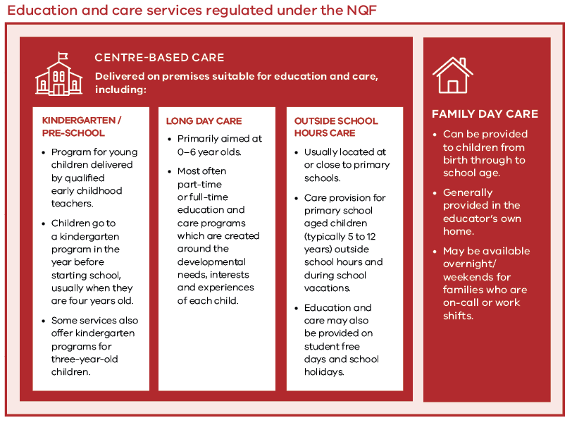
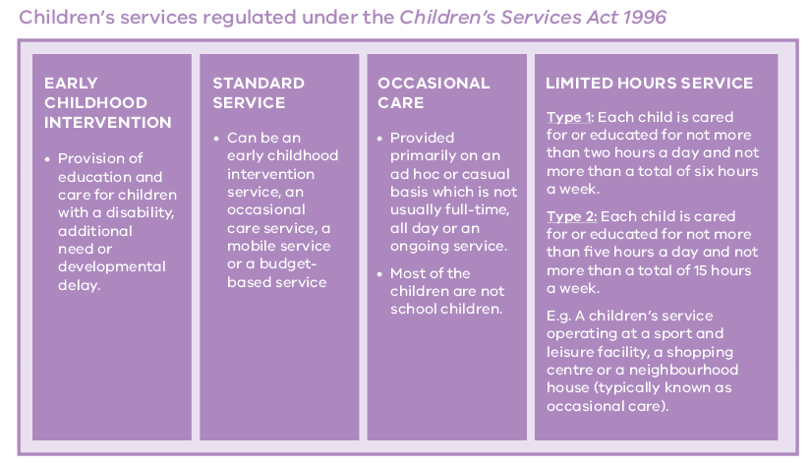
FIGURE 1 SERVICES REGULATED IN VICTORIA

2.1 Regulatory Framework
Along with the Australian Government and seven other States and Territories, Victoria is a party to the National Partnership Agreement on the National Quality Agenda for Early Childhood Education and Care that established the National Quality Framework (NQF) for regulating education and care services across Australia. Children’s services that fall outside the scope of the NQF are also regulated in Victoria.

Legislative Framework
The Department’s regulatory functions are established by the Education and Care Services National Law Act 2010 (National Law) and the Children’s Services Act 1996 (Children’s Services Act).
The National Quality Framework
The National Quality Framework (NQF), introduced in 2012, promotes high quality education and care services through the National Law and Education and Care Services National Regulations (National Regulations), the National Quality Standard (NQS), approved learning frameworks and a system of quality assessment and rating.
The legislative framework of the NQF comprises:
- • National Law
- • National Regulations
- • National Quality Standard (NQS)
Administratively, responsibility for implementing and administering the NQF is shared between State Regulatory Authorities and the National Authority, the Australian Children’s Education and Care Quality Authority (ACECQA).
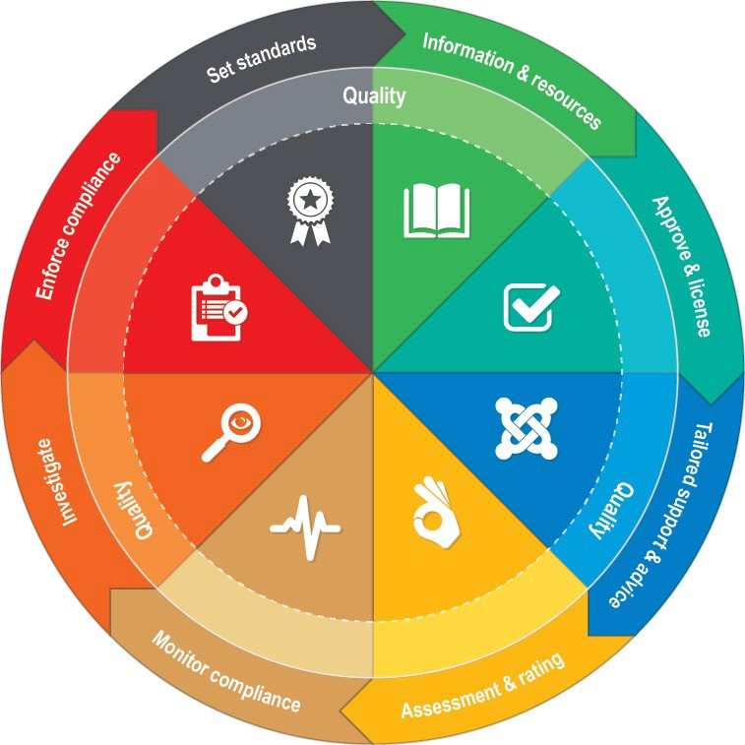
FIGURE 2 REGULATORY FRAMEWORK
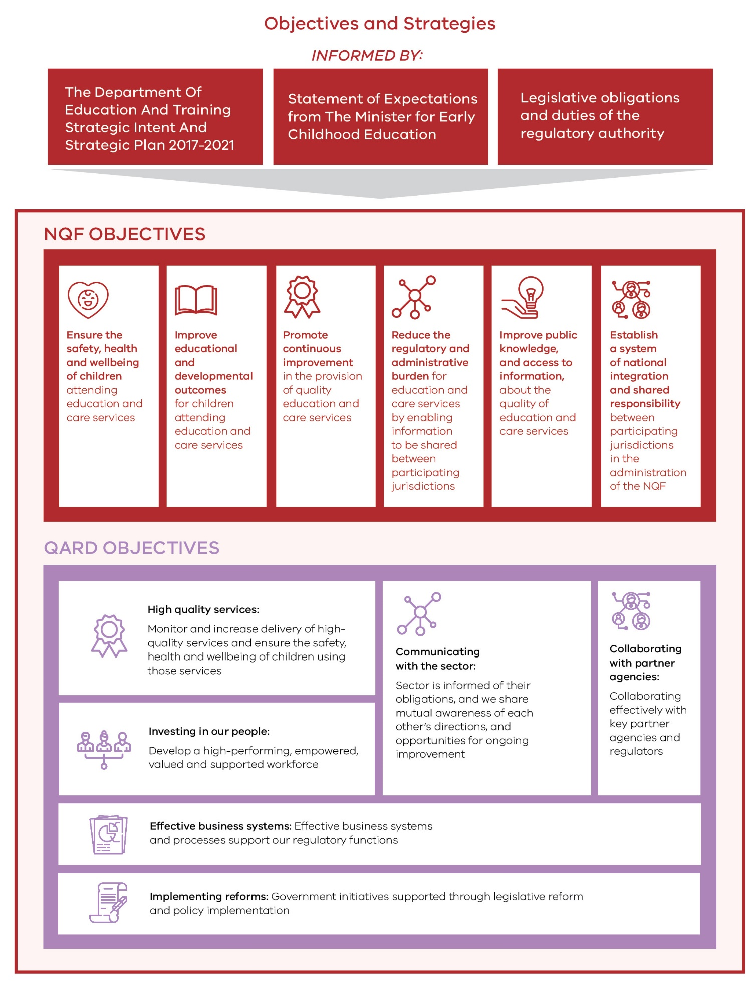
FIGURE 3 SHARED OBJECTIVES OF THE NQF AND QARD

2.2 Strategic objectives
The QARD objectives and strategic plans are informed by broader Department objectives and:
- • the Department’s strategic intent and strategic plan 2017-2021
- • obligations and duties of the regulatory authority under the National Law
- • the Statement of Expectations from the Minister for Early Childhood Education (the Minister)

About the Education State
The Victorian Government has invested $5 billion to make Victoria the Education State, improving outcomes for every student, in every classroom, in every school, and for all communities. The Education State is building a system that provides every student with the knowledge, capabilities and attributes that will see them thrive throughout their lives, to have the skills that industry needs, and those that employers expect.

Early Childhood Reform Plan
Making Victoria the Education State starts with the early years. Through a $202.1 million investment, the Victorian Government is committed to give every child the best start in life. The Early Childhood Reform Plan outlines the Victorian Government’s vision for the early years. This plan will deliver systemic change, aimed at giving every Victorian child the best start in life. These initiatives aim to create a higher quality, more equitable and inclusive early childhood system, helping Victorian families get their kids ready for kindergarten, ready for school and ready for their lives ahead.

Minister’s Statement of Expectations
The implementation, administration and enforcement of QARD’s regulatory framework is guided by the Minister’s expectation that the safety, health and wellbeing of children attending services is promoted and their educational and developmental outcomes improved. Our approaches continually evolve to strengthen our regulatory performance to support our early childhood education and care sector. This report outlines areas where we are meeting the Minister’s expectations to:
- implement clear and consistent regulatory activities
- adopt risk-based strategies
- deepen stakeholder consultation and engagement
- improve accountability and transparency in decision-making processes
- provide compliance assistance and advice
- promote greater cooperation, information sharing, regulatory coherence and efficiency with other regulators and key partners.

2.3 Key legislative changes and reforms

Changes to the NQF
Changes to the NQF were effective from 1 October 2017. The changes balanced technical and operational improvements with the need to reduce red tape and unnecessary administrative burden for approved providers and educators.
Key changes include:
- A revised NQS taking effect on 1 February 2018
- Removing supervisor certificate requirements to allow service providers autonomy in deciding who can be the responsible person in each service
- Improved oversight of, and support within, FDC to achieve better compliance and quality across the whole sector
- Improved compliance and enforcement tools for regulatory authorities
- Clarifying requirements for child protection and safe sleeping practices
The QARD team has undertaken extensive work to support the sector to prepare for the changes to the NQF. In 2017, we:
- provided general information and targeted support to the sector in Victoria, especially around the new requirements for FDC services and the revised NQS
- directly informed every approved provider of details of the key changes
- provided articles on key topics in our regular newsletter
- held interactive forums for services and stakeholders
- updated and created web-based resources
- responded to numerous telephone and email queries

Child Safe Standards
We continue to support services through changes introduced in response to the Inquiry into the Handling of Child Abuse by Religious and Other Organisations including Child Safe Standards, the Reportable Conduct Scheme and Organisational Duty of Care, including:
- Information sessions delivered to the sector and QARD staff to increase understanding of these initiatives
- Ensure services comply with requirements to have policies and procedures for providing a child safe environment
- QARD authorised officers continuing to raise awareness of the standards and allow services to ask questions and seek further guidance
- Correspondence to all approved providers to advise of their respective obligations under the Reportable Conduct Scheme and its implementation

No Jab, No Play
Since the introduction of the No Jab, No Play (NJNP) legislation in 2016, immunisation rates have increased in Victoria. Enrolments of children under school age in education and care services are subject to NJNP laws for the following services:
- long day care
- kindergarten
- some occasional care
- family day care
During visits to services, authorised officers monitor services compliance with the NQF and the Children’s Services Act by checking children’s enrolment records to ensure the required documentation is in place to meet NJNP requirements.

2.4 Our operations
Part of the Early Childhood and School Education Group (ECSEG) of the Department of Education and Training Victoria, QARD administers the NQF and the Children’s Services Act in Victoria under delegation from the Secretary.
QARD is comprised of three branches:
The Operations Branch: manages and supports area-based teams of authorised officers who;
- assess and rate NQF services,
- undertake service inspections to monitor compliance, and
- conduct regional forums to support and guide providers of early childhood services.
The Service Quality and Legislation Branch (SQLB): develops the guidelines, frameworks, policies and procedures, which ensure regulatory processes are effective, risk-focused and maintain the safety, health and wellbeing, and quality of early childhood services.
Its Monitoring and Compliance Unit (MCU) manages and supports high priority and serious investigations, and its Consistent Practice and Support Unit (CPSU) monitors and supports the assessment and rating process.
The Systems Administration and Performance Branch: the Service Administration and Support Unit (SASU) provides a first point of contact for new and existing providers of early childhood services through the administration of applications, notifications of change of circumstances, and the assessment of an applicant’s fitness and propriety.
The Business Systems and Review Unit (BSRU) supports QARD’s information management, reporting, data analytics, stakeholder engagement and communications functions.
We have a strong commitment to the training and development of our team, with a dedicated training program for new staff and ongoing professional and technical development opportunities.
In October 2017, the People Development and Culture Committee (PDCC) formed to provide support and influence opportunities to develop a positive QARD culture. Quarterly QARD Staff Forums were held to discuss technical and professional development topics to ensure the effective regulation of the sector.

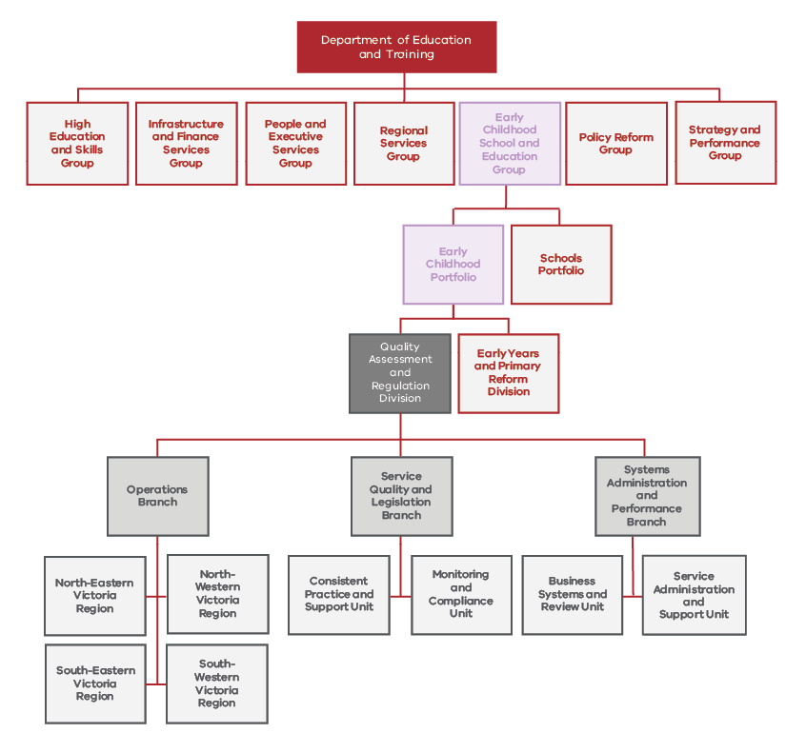
FIGURE 4 QARD ORGANISATIONAL CHART

2.5 Delivering efficient and effective regulation
Our team works alongside national and state regulatory authorities to support the successful implementation of the NQF. This includes regular interaction with all jurisdictions and ACECQA regarding the effectiveness of operational policy, training, systems, business processes, information management and sector support. We collaborate within a ‘community of practice’ designed to improve regulatory practice, identify emerging issues and reduce risk.

Co-regulatory Partners
We collaborate with other regulators to promote coherence through information sharing and to build capability within the early education sector through our compliance monitoring inspection regime.
Commission for Children and Young People
Regular meetings with the Commission for Children and Young People (CCYP) support the implementation and monitoring of the Child Safe Standards and the implementation of the Reportable Conduct Scheme to:
- ensure that concerns about a service’s compliance with the Child Safe Standards and Reportable Conduct Scheme are investigated by QARD
- establish information sharing protocols for investigations between QARD and the CCYP
- plan for the implementation of the reportable conduct scheme for the majority of education and care services on 1 January 2019.
Victorian Registration and Qualifications Authority
The Secretary of the Department signed a Memorandum of Understanding (MoU) with the Director of the Victorian Registration and Qualifications Authority (VRQA). The VRQA and the Secretary have a number of shared interests, including school councils that are the providers of early childhood education and care services (such as OSHC), and the provision of early childhood-related qualifications by Registered Training Organisations (RTOs) regulated by the VRQA. The aim of the MoU is to create a framework for conducting joint investigations and foster collaboration to align policy and minimise regulatory burden for the jointly regulated sector.
Department of Health and Human Services
Alongside the Department of Health and Human Services, we work with Nutrition Australia and the Healthy Eating Advisory Service to develop resources and strategies to raise awareness that supports:
- early childhood services to provide food and beverages that are nutritious and to promote healthy eating
- authorised officers’ capacity to assess service compliance with the food and beverage provisions and the promotion of healthy eating.
WorkSafe Victoria
Collaboration with WorkSafe Victoria (WSV) ensures an increase in awareness of key safety issues in education and care services. In 2017 our work alongside WSV included:
- presentation by our team to WSV staff on the NQF and role of authorised officers
- presentation by WSV to team managers, with knowledge then distributed and passed on to our regional teams
- communicating information to services through our newsletters on safety issues of mutual interest.
Victorian Institute of Teaching
We maintain close relationships with the Victorian Institute of Teaching through an established MoU and regular liaison regarding registration of early childhood teachers.
Australian Government Department of Education and Training
To ensure the successful implementation of the NQF across all jurisdictions, we work closely with the Australian Government Department of Education and Training by sharing relevant information. This aims to improve quality and streamline management of compliance risks for education and care services that receive Child Care Benefit (CCB) funding, particularly regarding alleged fraud.

Business Improvements
We evaluate our practices and processes as a regulator to improve our efficiency and effectiveness, and to identify opportunities to reduce red tape.
Initiatives from across QARD in collaboration with various Departmental and external stakeholders include:
- New risk-based processes for assessing, prioritising and handling the large volumes of complaint and incident notifications (1,764 complaints and 4,775 incidents recorded in 2017) we receive each year by strengthening the risk assessment and triage of notifications.
- Collaboration with DET Security and Emergency Management Division to develop the Early Childhood Services Closure Guidelines supporting services to manage closures during emergencies.
- Development and publication of our Regulatory Framework and Investigations Guidelines manuals to give services clarity about our role and approaches.

3.0 Engaging with stakeholders

3.1 Information sessions
Our authorised officers and regional teams engage with local services and educators to ensure a better understanding of the NQF and enhance their capacity to meet regulatory obligations.
Information sessions focus on current issues and areas of change and help to encourage dialogue and information sharing amongst our team, services, and partners.

3.2 Stakeholder forums
Our team continued to strengthen relationships with stakeholders in 2017, with more than 30 stakeholder forums and ongoing meetings with major providers and peak groups, such as bi- annual meetings with the Australian Childcare Alliance Victoria (ACAV) in addition to presenting at their AGM. We also engaged with the FDC sector to communicate changes to the NQF.

3.3 Phone and email enquiries
The Department’s service tracking and recording tool (STaR) records queries or requests received through our phone and email service. STaR provides regular data and insights into the types of issues and enquiries raised by the early childhood sector and the Victorian community, and to inform the continuous improvement of our service delivery.
Almost 6,000 enquiries in 2017 were received from the public, applicants, existing providers and services, educators, parents and other government agencies.
Two in five enquiries relate to approvals, licensing and other applications, while one in five relate to early childhood legislation.
5,208 enquiries through STaR in 2017

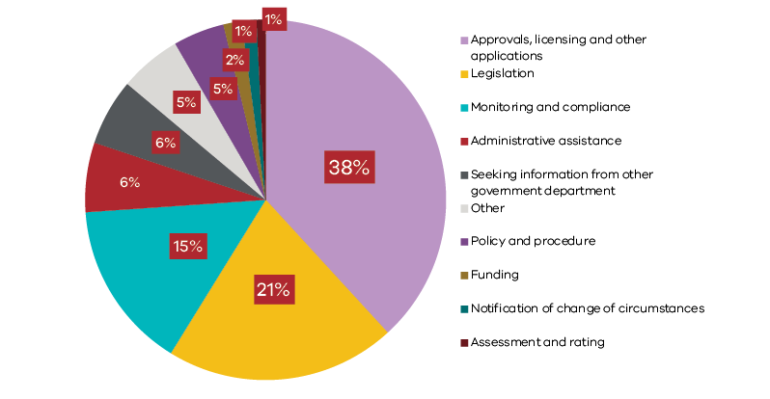
FIGURE 5 STAR ENQUIRIES 2017

3.4 Communicating online

Website Visits
Across 2017, we saw a general increase in the number of website visits, most specifically across the second half of the year when comparing with 2016 visits.
Changes in the NQF coincide with the spike visible in website traffic in October 2017, a significant peak compared to the previous year at the same time.
2 minutes 29 seconds was the average time spent on website (8% increase on 2016)

Website User Sentiment
The Department’s online communications team facilitates activity to improve user experience across the Department’s website, which resulted in a sentiment survey conducted between June and September 2017.
Analysis has indicated that the majority of users found website content relevant and had a positive experience. We can use negative feedback to influence content improvement as we work toward website content that is accessible and adheres to Government best practice standards.
93% users found the website useful (1,159 out of 1,233 polled)
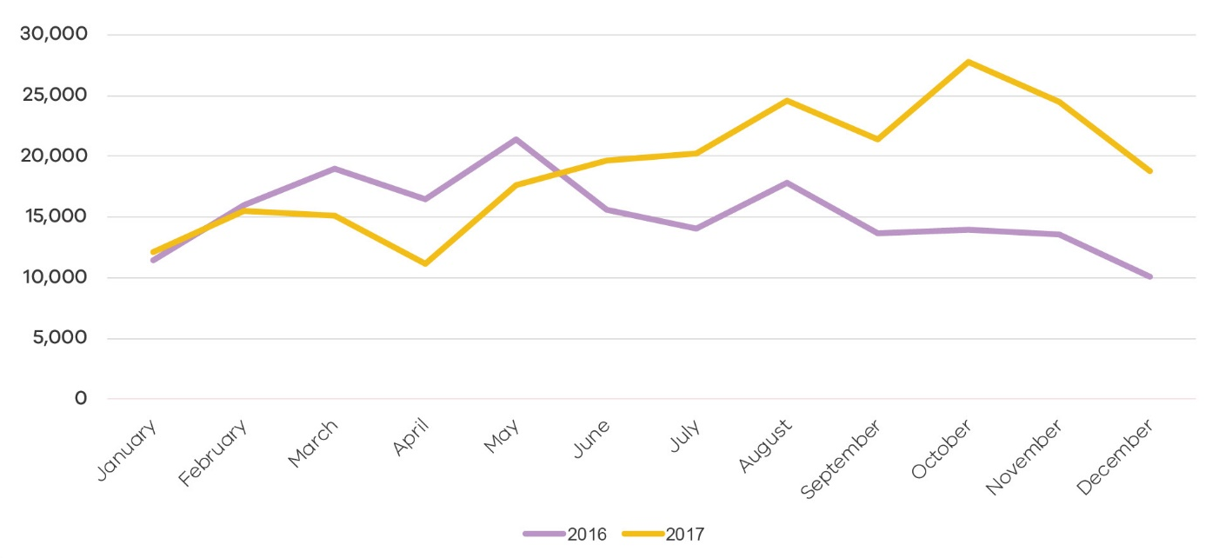

FIGURE 6 NUMBER OF PAGE VIEWS IN 2016 AND 2017

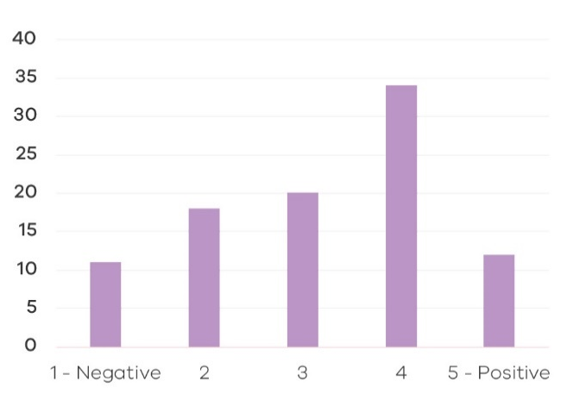

FIGURE 7 WEBSITE SENTIMENT FEEDBACK

3.5 Newsletters
The QARD newsletter is one of the Department’s most-read publications. This year, we engaged more proactively with the sector. As a part of this strategy, we distributed our newsletter eight times. This is double the frequency of 2016 and enabled us to meet the needs of services and distribute important information effectively and efficiently. A newsletter format was introduced to improve accessibility and make content suitable for mobile devices. Each newsletter is distributed to all approved services and providers, Victorian children’s services and key stakeholders. It includes information about policy changes, requirements, alerts to new issues and general “good to know” information.

3.6 Emergency management plan
How does Emergency Management Planning Work?
Emergency Management Planning is integral to ensuring the health, safety and wellbeing of children in early childhood services. In the past year, we’ve seen services affected by bushfires, a car crash, a chemical fire near the service and a plane crash near a service.
Every service must have policies and procedures in relation to emergency and evacuations. A well-developed EMP includes preparedness, prevention, response and recovery strategies, agreed staff emergency management roles and responsibilities, and a site-specific risk assessment.
The plans should list contacts for emergencies, procedures for different kinds of threats (e.g. bomb threat or suspicious person reported nearby), and maps showing evacuation routes and assembly points. Services must periodically review and rehearse their emergency evacuation procedures. During compliance and monitoring visits authorised officers will check that services are complying with this requirement.
Services in high-risk bushfire-prone areas are listed on the Department’s Bushfire At-Risk Register (BARR). These services must review their plan annually and submit the plan to the Department each November.

Emergency Management Planning in Action
A few years ago a nominated supervisor of an early childhood centre attended sessions on emergency management planning run by the Department. The service had a comprehensive EMP that addressed the risks that were likely to affect the service: it was not near any industrial areas, was located in a middle-inner suburb, and was near a busy road.
At the EMP session run by the Department, they ran through a variety of scenarios, learning good and poor responses to each scenario. In reviewing the EMP with the team, the service staff identified the issues relevant to their service, ‘We decided that bushfires and plane crashes weren’t very likely, but the service was located on a roundabout, so cars crashing into the centre raised the risk profile. A new member of the team raised a concern that some parents at the centre seemed more stressed and occasionally aggressive than at their previous service.’
The team made sure to include information in their EMP on how to deal with suspicious people, car crashes, aggressive parents, parents who might be attempting to violate custody arrangements, and severe weather. These risks better represented the operating context of the service, rather than perceived risks.
About a year later a parent tried to take their child home, however staff were aware that the child’s custody arrangements were very specific and had instructions to not release the child to that parent. It was a tense situation.
The nominated supervisor sympathised with the upset parent, but stood her ground. ‘My primary goal was to make sure the child was safe. Throughout the situation, I kept that in my mind.’
‘After talking in a calm manner with the parent and reminding them that violating the custody order would not result in a good outcome for the parent or the child, they left without the child. We reported the situation to the other parent and to the Department.’ The other parent was especially grateful that we took a polite but firm position and diffused the situation.
‘I’m glad I had received the training and the opportunity to practice thinking about our risks. It gave me confidence to address the situation.’’
The Department’s Security and Emergency Management Division offers regular training for early childhood centres to help staff prepare and respond to a variety of threats and risks.

4.0 Performance of the sector
Our primary objective as the regulator of services is to ensure they protect children’s safety, health and wellbeing and deliver quality education and care to support children’s learning and developmental outcomes.
We are committed to exemplifying best practice regulation across our regulatory functions and activities. To meet our regulatory objectives and deliver outcomes efficiently and effectively, we use risk-based approaches to focus attention on areas or problems that present the greatest risk to the safety, health and wellbeing of children.
Our actions are responsive and proportionate to the problem being addressed.
In accordance with our regulatory model, QARD is responsible for:
- assessing an applicant’s suitability to operate an early childhood education and care service
- educating providers and staff within services, including the broader early childhood sector, on regulatory obligations
- monitoring compliance with requirements of the NQF and Children’s Services Act and taking enforcement action when required
- receiving and investigating notifications of incidents and complaints
- assessing service program and practice through the assessment and rating process
- collaborating with ACECQA and other government agencies to promote compliance with legislative requirements and continuous quality improvement in services

4.1 Sector performance
There continues to be steady growth in the early childhood sector. In particular, there was significant increase in the number of Long Day Care (LDC) services, which has contributed to a 9.4% increase in overall early childhood places available.
At the end of 2017 there were 4,612 early childhood education and care services in Victoria providing 257,659 approved places.
For NQF services, private for profit is the largest single entity type, operating 1,948 (46 per cent) of NQF services, with 1,228 (63 per cent) of these run by multi-service providers many of whom have services in other jurisdictions.
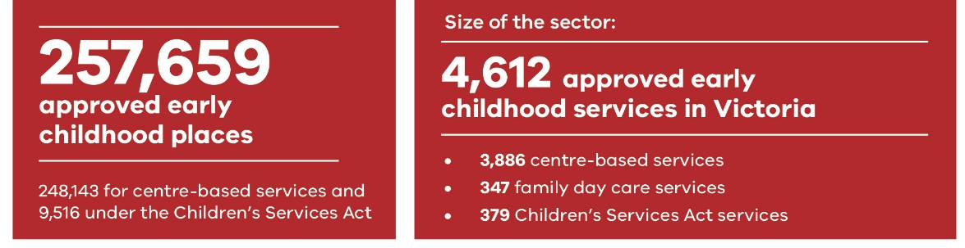
FIGURE 8 SIZE OF THE EARLY CHILDHOOD EDUCATION AND CARE SECTOR IN VICTORIA

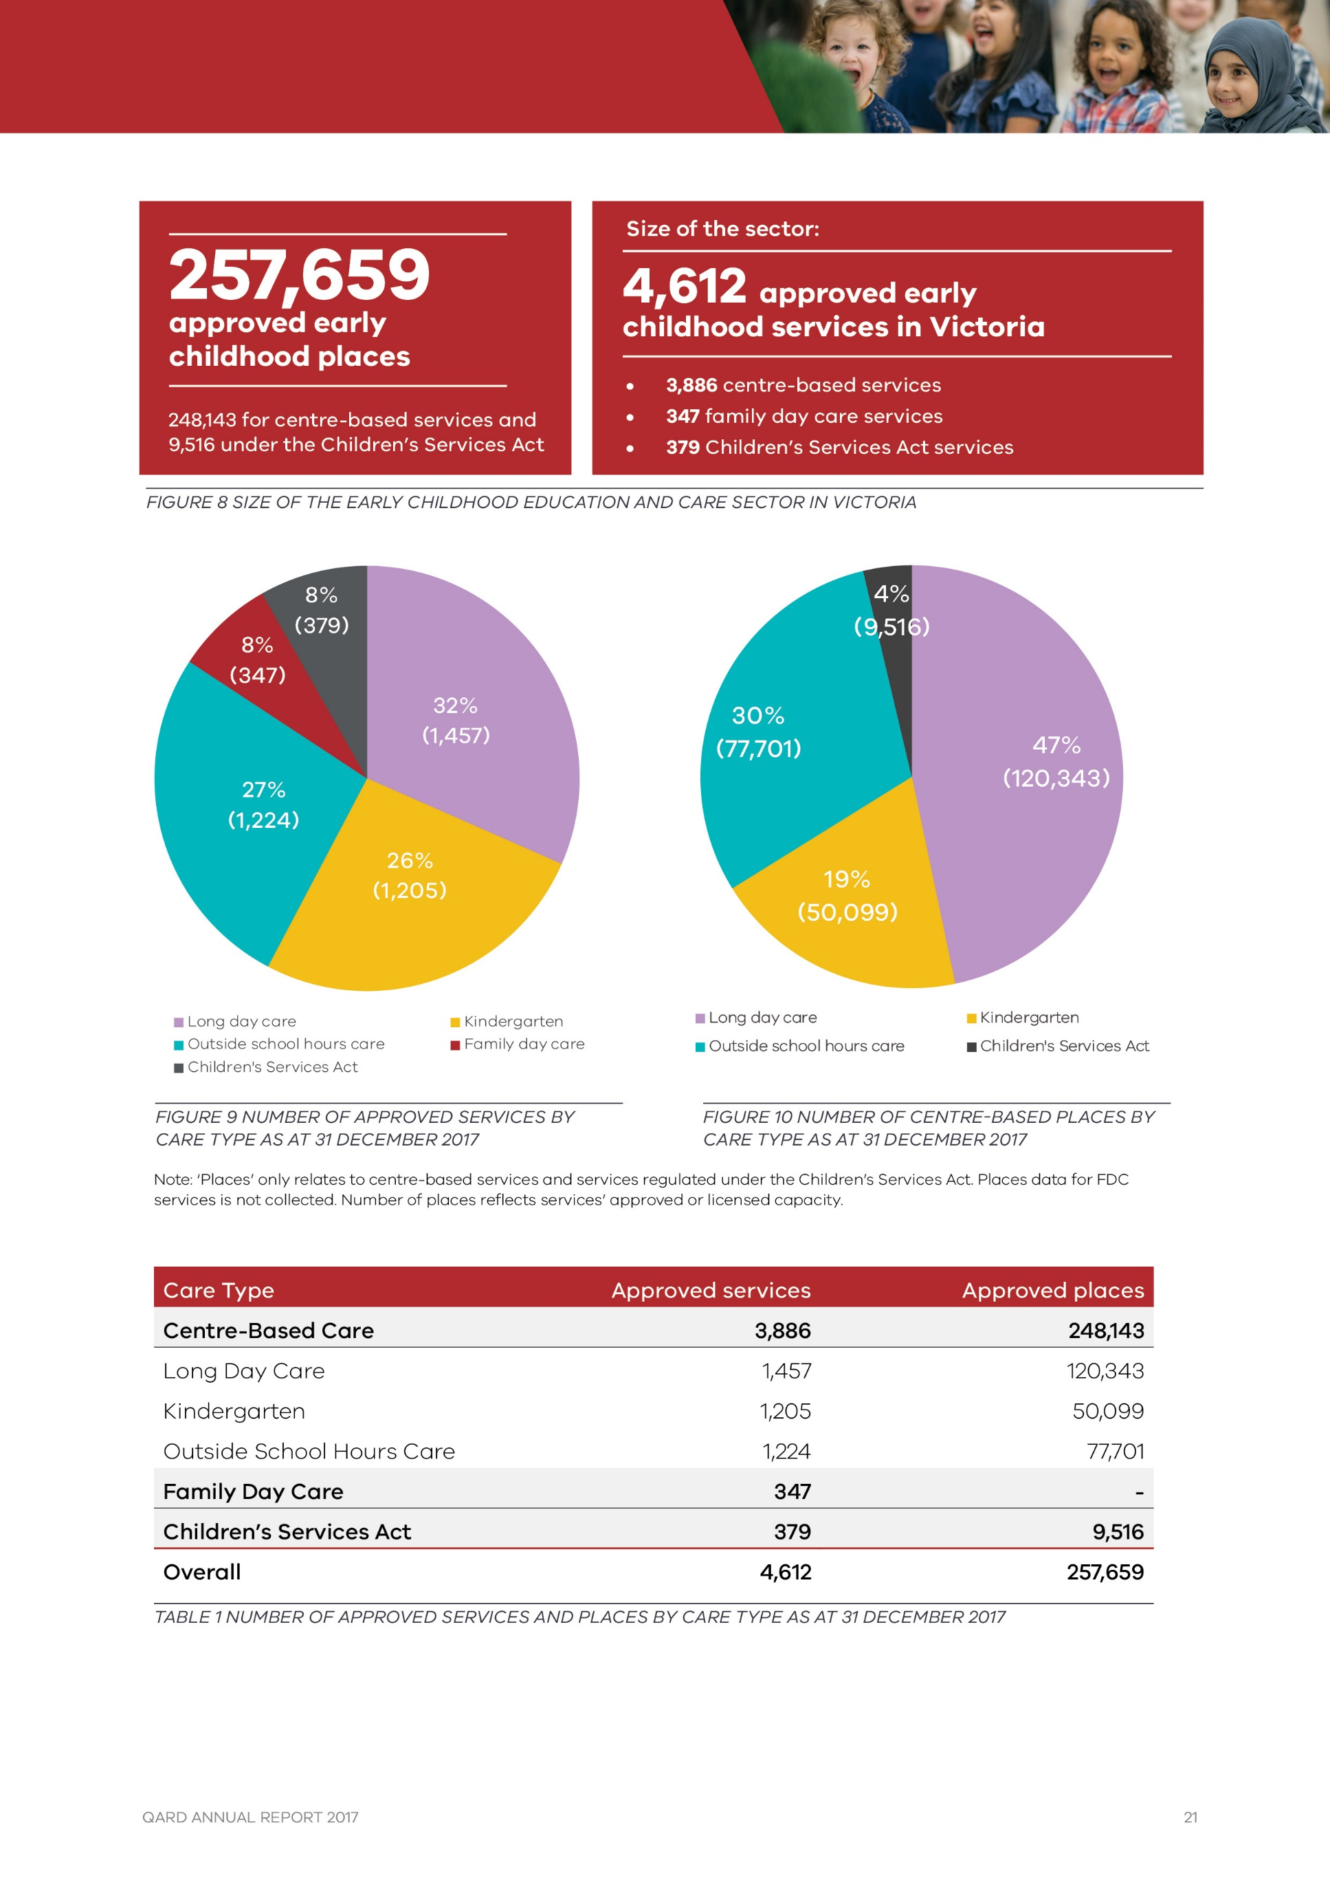
FIGURE 9 NUMBER OF APPROVED SERVICES BY CARE TYPE AS AT 31 DECEMBER 2017
FIGURE 10 NUMBER OF CENTRE-BASED PLACES BY CARE TYPE AS AT 31 DECEMBER 2017
Care Type | Approved services | Approved places
Centre-Based Care | 3,886 | 248,143
Long Day Care | 1,457 | 120,343
Kindergarten | 1,205 | 50,099
Outside School Hours Care | 1,224 | 77,701
Family Day Care | 347 | -
Children’s Services Act | 379 | 9,516
Family Day Care | 347 | -
Overall | 4,612 | 257,659
TABLE 1 NUMBER OF APPROVED SERVICES AND PLACES BY CARE TYPE AS AT 31 DECEMBER 2017
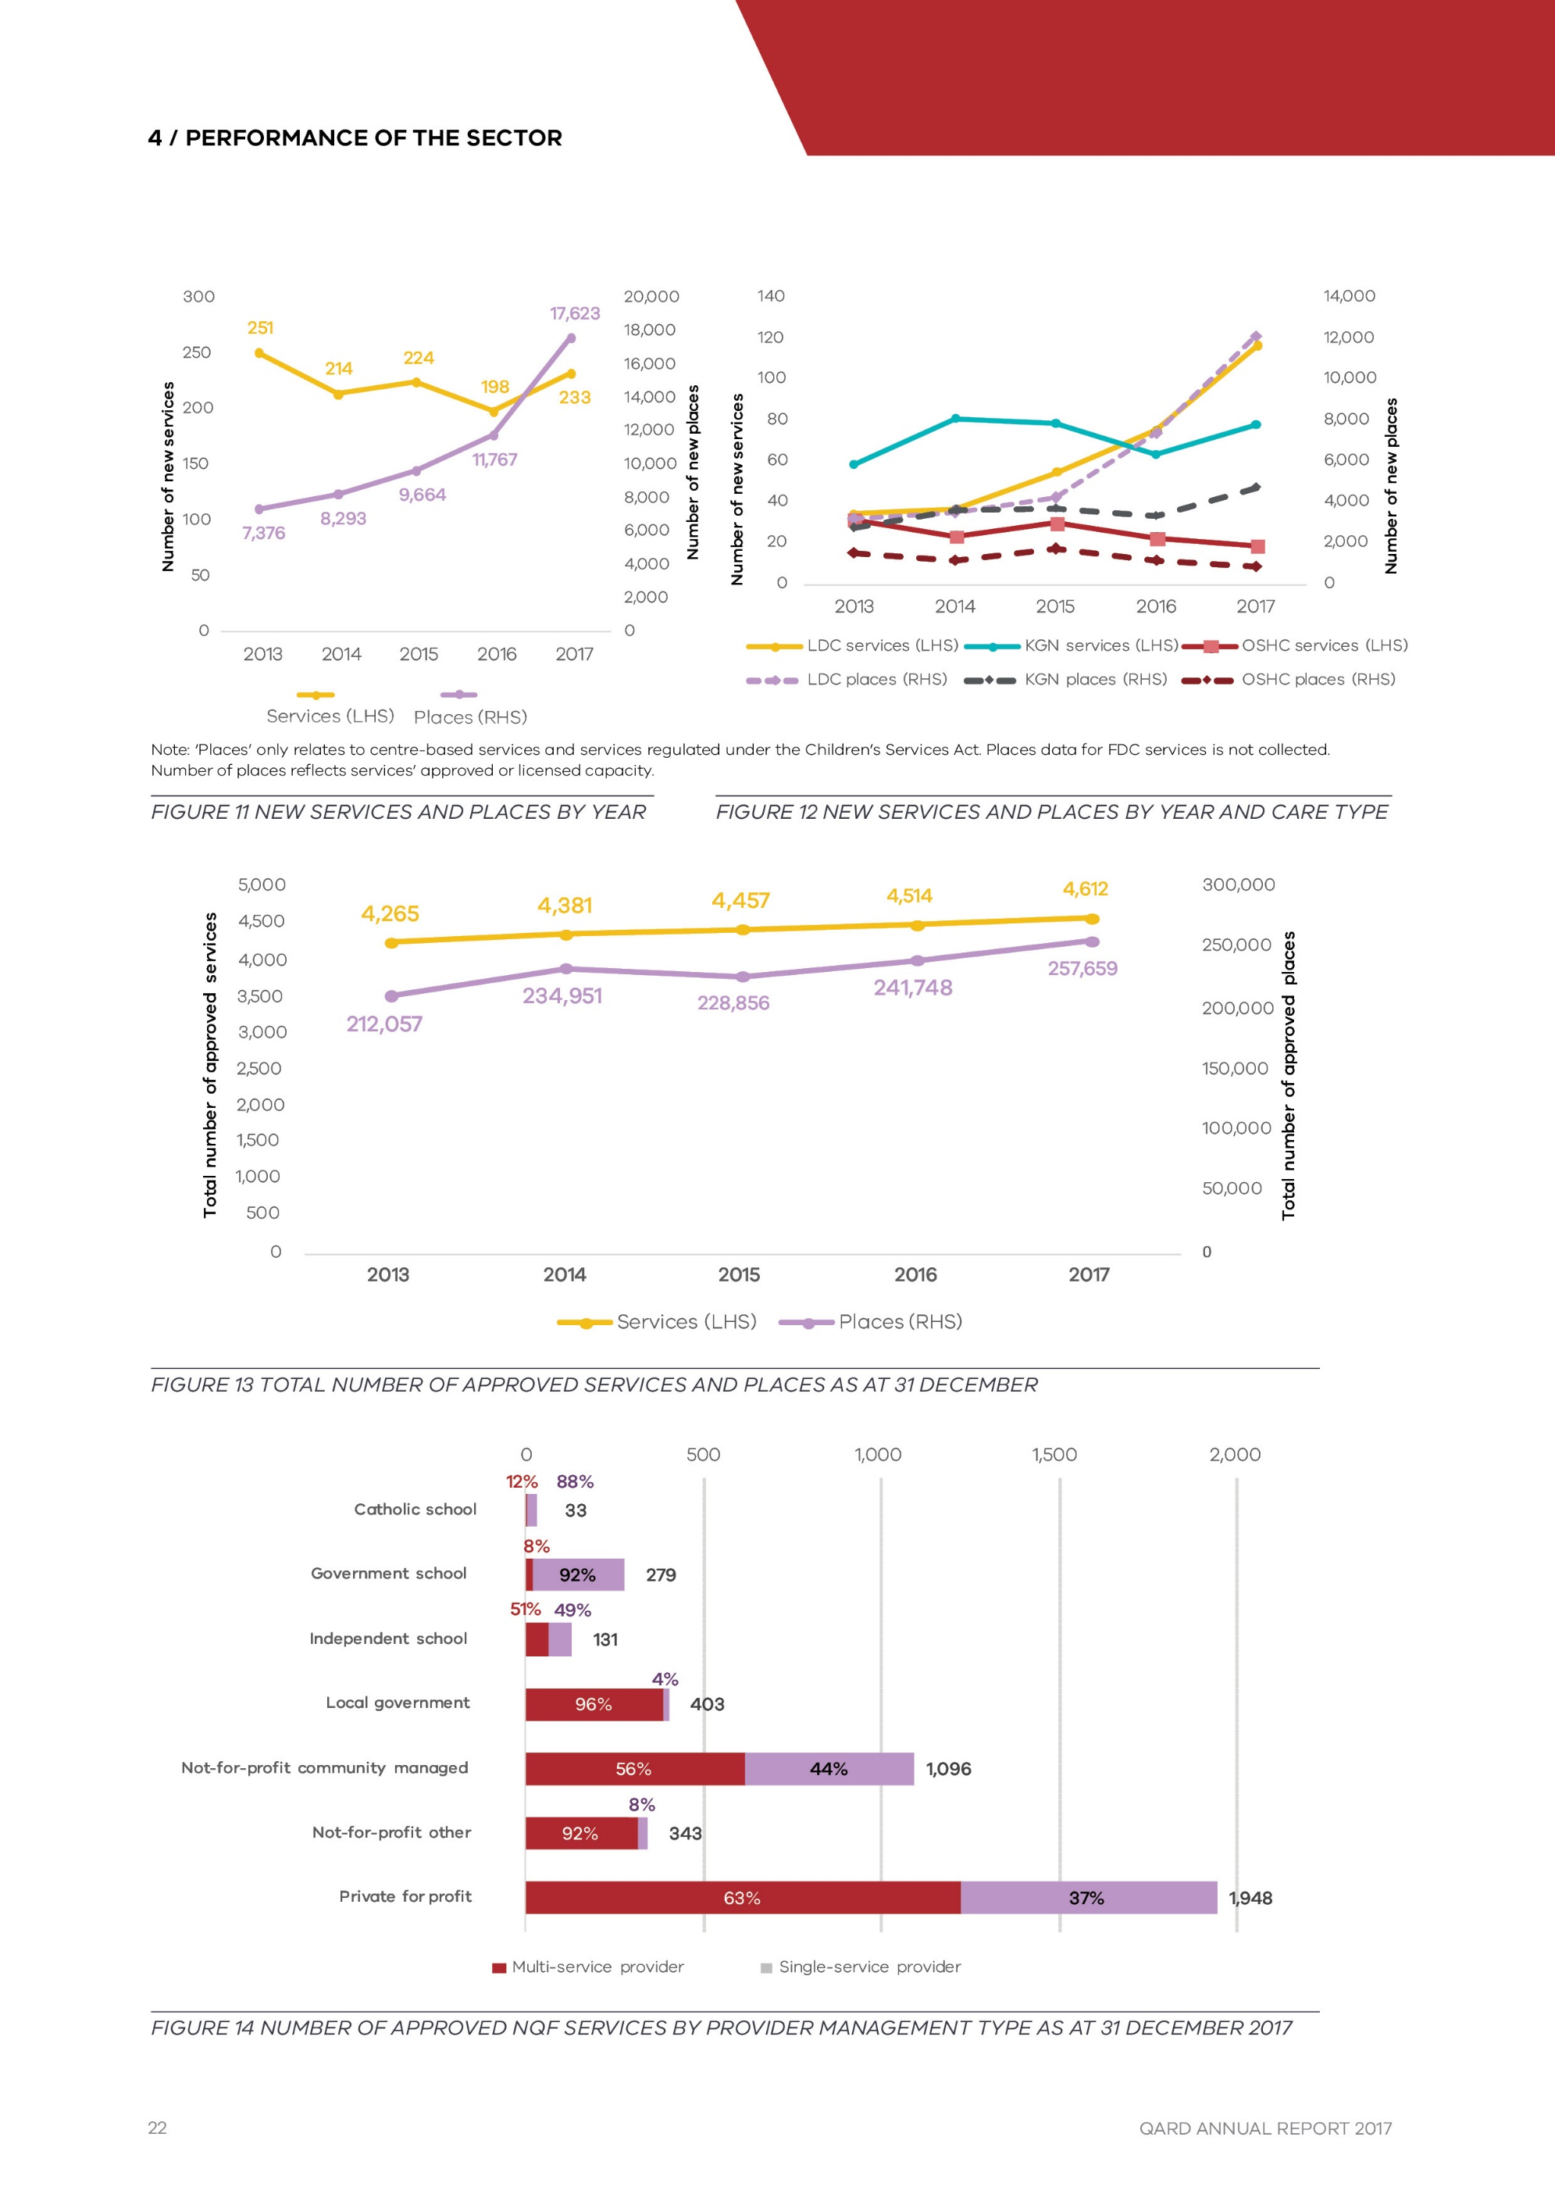
FIGURE 11 NEW SERVICES AND PLACES BY YEAR
FIGURE 12 NEW SERVICES AND PLACES BY YEAR AND CARE TYPE
FIGURE 13 TOTAL NUMBER OF APPROVED SERVICES AND PLACES AS AT 31 DECEMBER
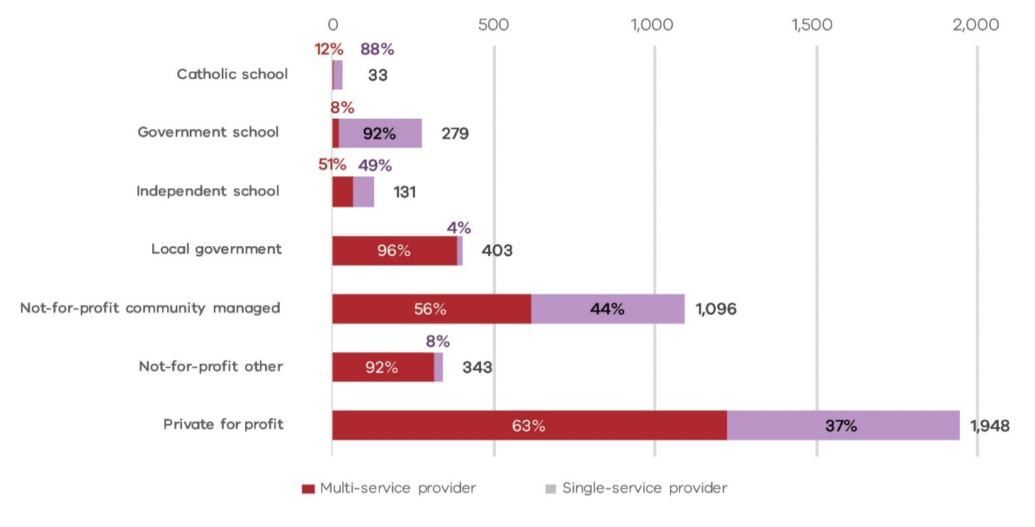

FIGURE 14 NUMBER OF APPROVED NQF SERVICES BY PROVIDER MANAGEMENT TYPE AS AT 31 DECEMBER 2017

4.2 Cente-based care

Long Day Care
The Long Day Care (LDC) sector makes up the largest component (34 per cent) of services under the NQF, offering approximately forty- eight per cent (48%) of approved childcare places in the sector. Most LDC services (80 per cent) also offer kindergarten programs.
The steady growth in the LDC sector saw 116 services commence operation in 2017. This was a significant increase on previous years and is accompanied by an increase in the average number of approved places in new services.
This trend towards maximising capacity is reflected in the increasing number of multi- storey service developments. Multi-storey services require careful design to ensure children have access to quality outdoor spaces on each level that allow them to explore the natural environment.
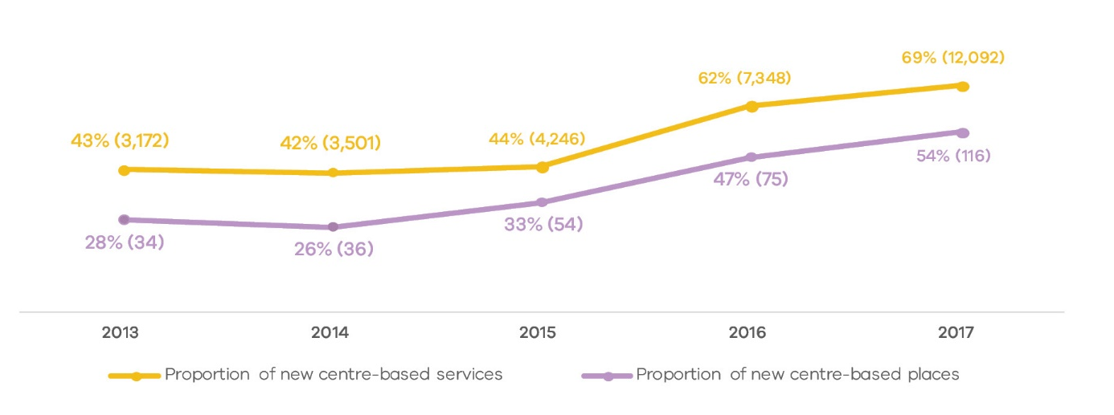
FIGURE 15 GROWTH IN LONG DAY CARE: PROPORTION OF LONG DAY CARE GROWTH IN CENTRE-BASED SERVICE GROWTH (NUMBER OF LONG DAY CARE SERVICES AND PLACES IN BRACKETS)
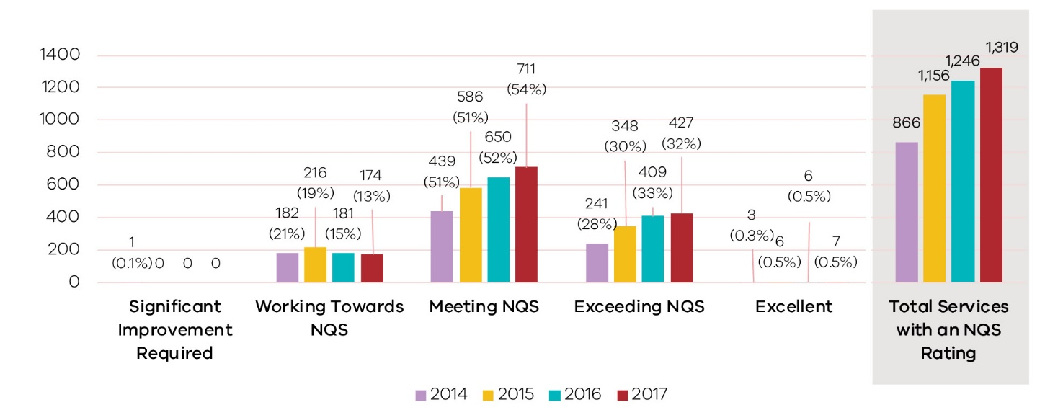
FIGURE 16 NUMBER AND PROPORTION OF LONG DAY CARE SERVICES WITH QUALITY RATINGS AT THE END OF THE YEAR, BY RATING LEVEL, 2014–2017
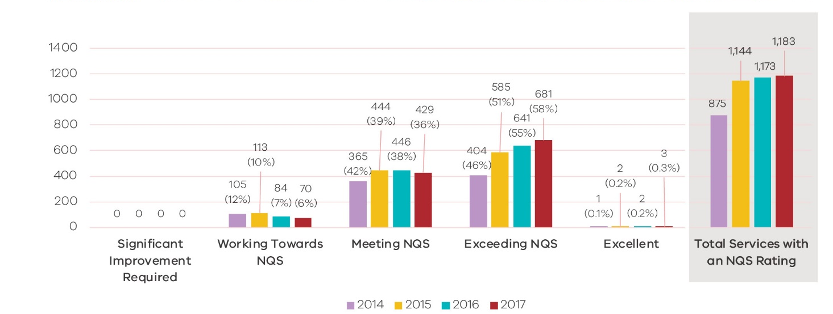
FIGURE 17 NUMBER AND PROPORTION OF KINDERGARTEN SERVICES WITH OVERALL QUALITY RATINGS AT THE END OF THE CALENDAR YEAR, BY RATING LEVEL, 2014–2017

Kindergarten/Preschool
The kindergarten sector in Victoria has been stable over time, with around 1,200 services operating across the state. The sector is almost exclusively operated by not-for-profit and local government managed providers (89 per cent of all services). Of these, three in five providers (62 per cent) operate more than one kindergarten service.
Kindergarten services have the highest quality ratings compared with other service types, in both Victoria and nationally. Victoria regulates the highest number of kindergartens, with 1,205 approved services at the end of 2017, compared with New South Wales (798 services) and Queensland (514 services).
The vast majority (94 per cent) of services in Victoria had a rating of Meeting or Above NQS at the end of 2017. Almost all rated kindergarten services are Meeting NQS or Exceeding NQS in the quality area related to Physical Environment.
The Department is undertaking ongoing analysis of NQS ratings of Victorian services funded to provide a kindergarten program, to understand the impact of Early Years Management (EYM) on service quality. Of the 16 services that have been re-assessed since 2013 after moving to EYM from standalone provision, nine of these increased their rating (57 per cent), compared to 38 per cent of funded services not part of an EYM. This is an initial indication of the strength of the platform for supporting quality improvement. This analysis will be revisited to confirm the trend as more of the services that have moved to EYM are re-rated over the coming years.
In addition, analysis of data for all services in EYM that have been re-rated indicates that they are more likely to improve in quality than non-EYM services (45 percent had an improved quality rating compared to 38 percent of other services).

Outside Schools Hours Care (OSHC)
Almost two-thirds (64 per cent) of services in the OSHC sector are operated by private, for-profit providers. Three in four services (76 per cent) are run by multi-service providers. In recent years, there has been a trend toward schools engaging third party providers to deliver their OSHC program.
Victoria has the highest proportion of OSHC services Meeting or Exceeding NQS. Four in five (80 per cent of) OSHC services in Victoria had a quality rating of Meeting NQS or above at the end of 2017, compared with sixty-nine per cent (69%) nationally.
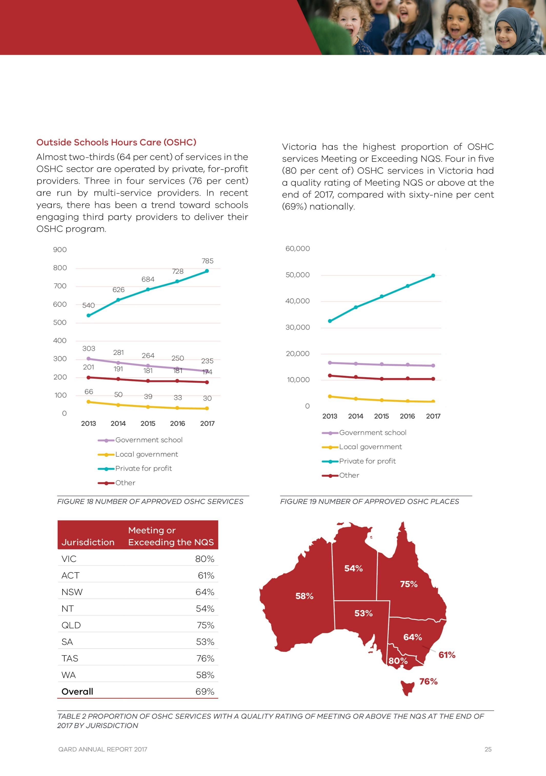
FIGURE 18 NUMBER OF APPROVED OSHC SERVICES
FIGURE 19 NUMBER OF APPROVED OSHC PLACES
Jurisdiction | Meeting or Exceeding the NQS
VIC | 80%
ACT | 61%
NSW | 64%
NT | 54%
QLD | 75%
SA | 53%
TAS | 76%
WA | 58%
Overall | 69%
TABLE 2 PROPORTION OF OSHC SERVICES WITH A QUALITY RATING OF MEETING OR ABOVE NQS AT THE END OF 2017 BY JURISDICTION
In particular, Victorian OSHC services are performing better in the following quality areas:
- Quality Area 6: Collaborative partnerships with families and communities - Ninety-six per cent (96%) of rated services Meeting or Exceeding NQS compared with eighty- seven per cent (87%) nationally
- Quality Area 3: Physical environment - Ninety-three per cent (93%) of rated services Meeting or Exceeding NQS compared with eighty-one per cent (81%) nationally
- Quality Area 1: Educational program and practice - Eighty-nine per cent (89%) of rated services Meeting or Exceeding NQS compared with seventy-six per cent (76%) nationally.
Eighty-nine per cent (89%) of rated services Meeting or Exceeding NQS compared with seventy-six per cent (76%) nationally.
The number of rated OSHC services increased by over eighty per cent (80%) between 2014 and 2015. The proportion of services rated as Working Towards NQS has decreased over time and those rated as Meeting NQS has increased.
Larger approved providers of OSHC have indicated that the predominantly part-time sector workforce can create challenges in staff retention. This can affect quality in the sense that educators require time to understand each child’s individual needs and may be less likely to form enduring relationships with the community and families. From time to time, QARD receives complaints from parents in relation to the fee arrangements in place at OSHC services. As fee arrangements are not regulated under the National Law, QARD has worked closely with Consumer Affairs Victoria (CAV) to assist them in understanding the OSHC market, and to ensure that parental concerns relating to fees and pricing received by QARD can be referred to CAV where appropriate.
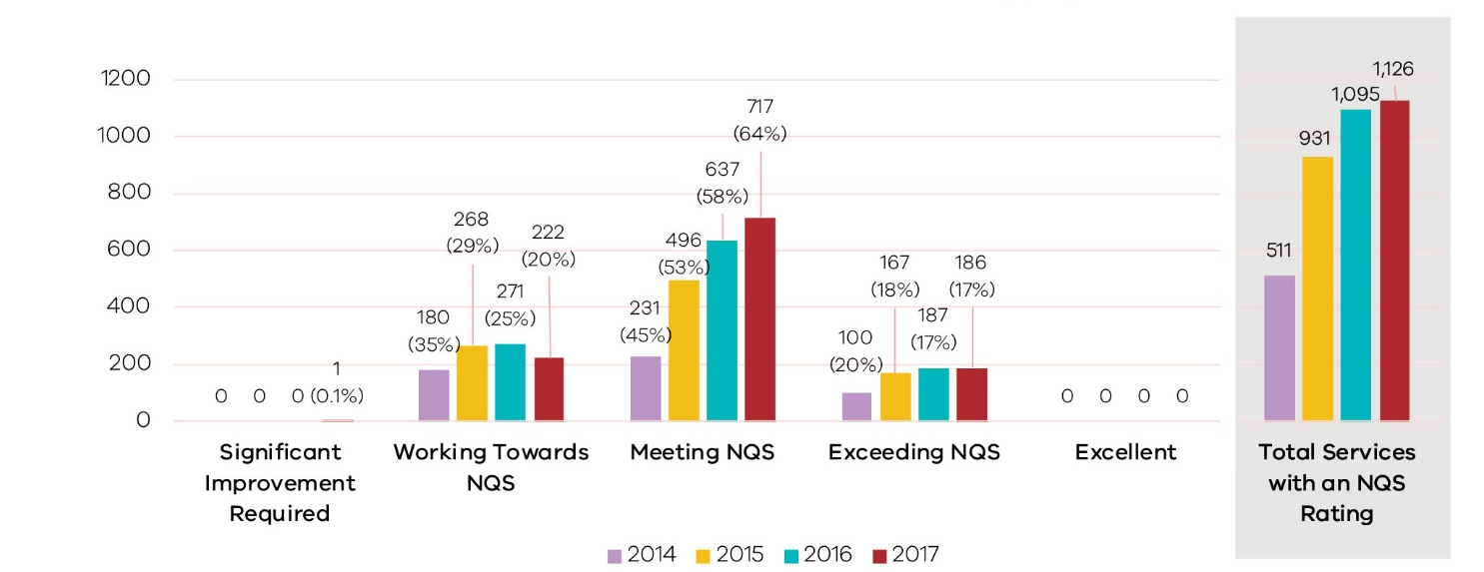
FIGURE 20 NUMBER AND PROPORTION OF OUTSIDE SCHOOL HOURS CARE SERVICES WITH OVERALL QUALITY RATINGS AT THE END OF THE CALENDAR YEAR, BY RATING LEVEL, 2014–2017
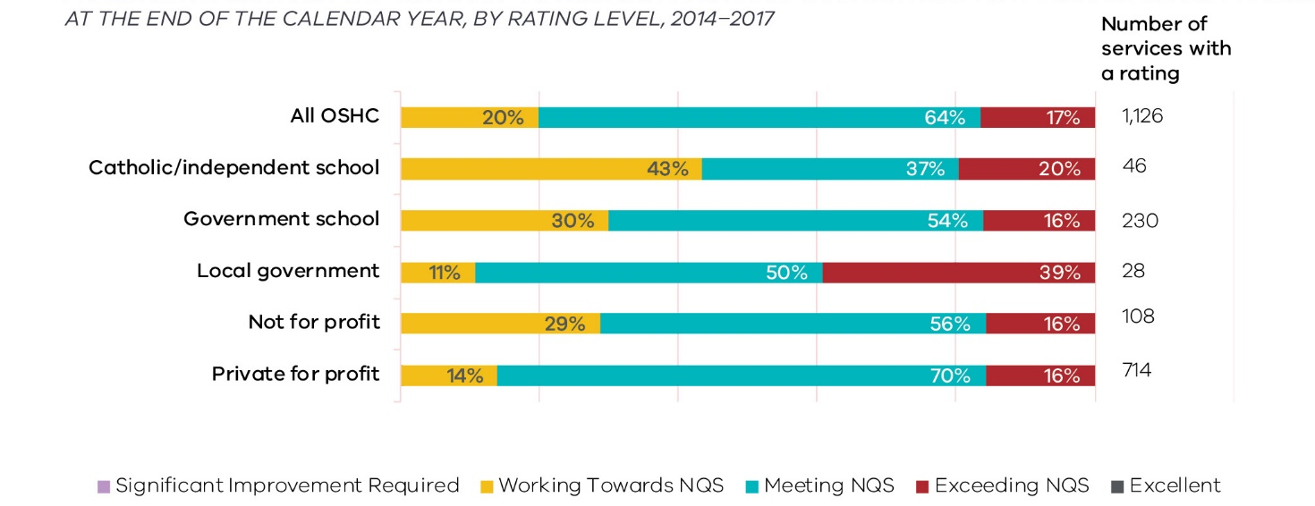
FIGURE 21 OUTSIDE SCHOOL HOURS CARE OVERALL QUALITY RATINGS BY PROVIDER MANAGEMENT TYPE AND RATING LEVEL (AND NUMBER OF RATINGS) AS AT 31 DECEMBER 2017
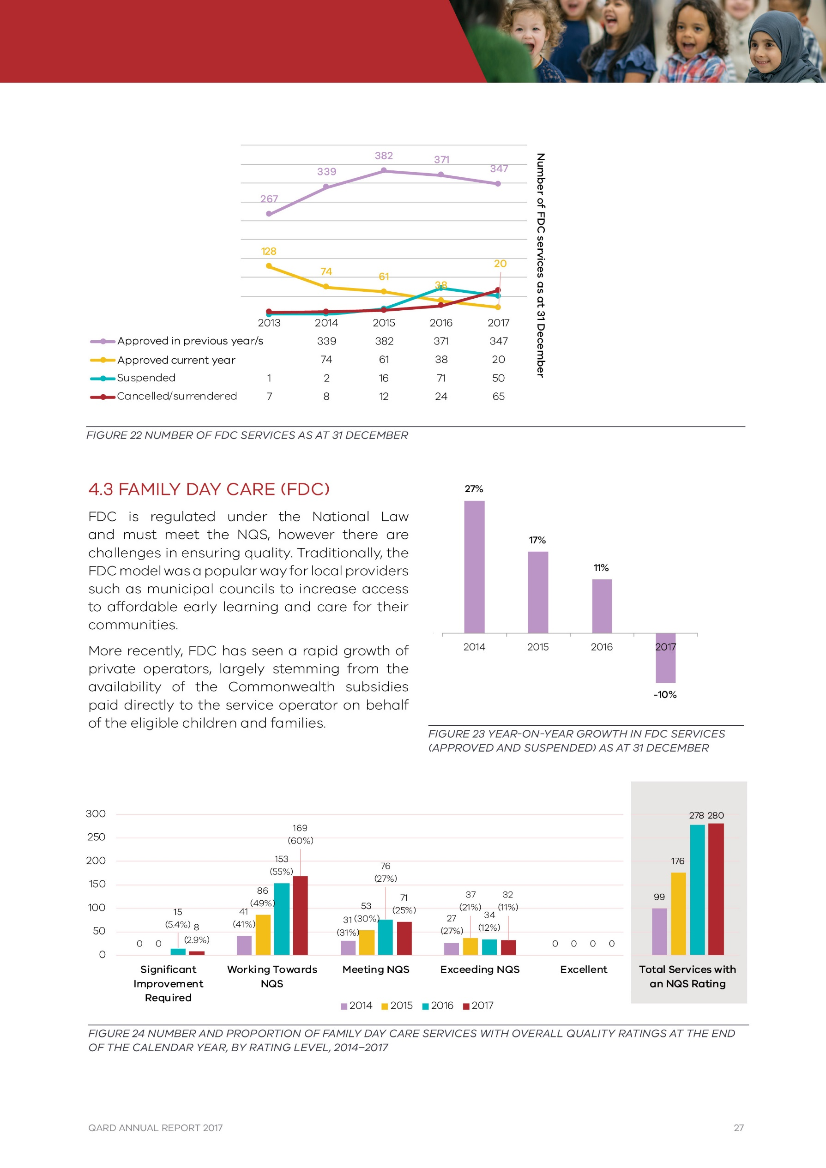
FIGURE 22 NUMBER OF FDC SERVICES AS AT 31 DECEMBER

4.3 Family Day Care (FDC)
FDC is regulated under the National Law and must meet the NQS, however there are challenges in ensuring quality. Traditionally, the FDC model was a popular way for local providers such as municipal councils to increase access to affordable early learning and care for their communities.
More recently, FDC has seen a rapid growth of private operators, largely stemming from the availability of the Commonwealth subsidies paid directly to the service operator on behalf of the eligible children and families.
FIGURE 23 YEAR-ON-YEAR GROWTH IN FDC SERVICES (APPROVED AND SUSPENDED) AS AT 31 DECEMBER
FIGURE 24 NUMBER AND PROPORTION OF FAMILY DAY CARE SERVICES WITH OVERALL QUALITY RATINGS AT THE END OF THE CALENDAR YEAR, BY RATING LEVEL, 2014–2017

Addressing the challenges with FDC compliance in Victoria
QARD has been acting strongly on compliance issues in FDC for some time, and rigorously assesses applicants before they are approved to operate. Our monitoring and enforcement action has significantly increased.
Recent legislative changes that strengthen the regulation of FDC services in Victoria (and nationally) include:
- requiring approved providers of FDC services to only operate from a jurisdiction in which they hold a service approval and to have a principal office in each jurisdiction in which they operate
- imposing a limit on the number of FDC educators that can be engaged by each service
- ensuring approved providers engage a minimum number of FDC co-ordinators based on the number of educators at the service
- requiring stronger oversight of FDC educators by approved providers
- enhancing authorised officers’ powers of entry to FDC residences to investigate an offence.
Where services fall into serious non-compliance, QARD will take enforcement action, including imposing conditions on service approvals, suspending or cancelling provider and service approvals, or taking prosecution action.
There are broader quality issues with FDC services. As at 31 December 2017, around sixty- three per cent (63%) of services did not meet the NQS. However, the percentage of rated FDC services with a Significant Improvement Required (SIR) rating decreased from five per cent (5%) in 2016 to three per cent (3%) in 2017, demonstrating work that QARD has undertaken to improve the integrity and quality of the FDC sector.
Due to action from QARD, the number of approved FDC services has been reduced from 382 in 2015 to 347 services at the end of 2017.
These stronger requirements have resulted in a reduction in the number of the overall number of approved FDC providers, along with a lower number of applications for service approvals received in 2017.

Enforcement actions
In Victoria there continues to be significant compliance issues within FDC services. Approximately half of enforcement actions in 2017 related to FDC services, despite them making up only eight per cent (8%) of NQF services operating in Victoria. In 2017, the Department took 37 enforcement actions in relation to FDC services, including four emergency action notices, twelve prohibition notices and seven cancellations of provider approval.

4.4 Children’s Services Act
We have a responsibility for regulating nearly 400 services operating under the Children’s Services Act. These services include occasional care, early childhood intervention and limited hour’s services.
The steady reduction in the number of services regulated under the Children’s Services Act partly reflects some services that have transitioned to a service approval under the National Law in order to operate for longer hours.
Approved | 2013 | 2014 | 2015 | 2016 | 2017
Services | 457 | 453 | 430 | 406 | 379
Places | 11,248 | 11,078 | 10,569 | 10,103 | 9,516
TABLE 3 NUMBER OF APPROVED CHILDREN’S SERVICES ACT SERVICES AND PLACES AS AT 31 DECEMBER 2013-2017

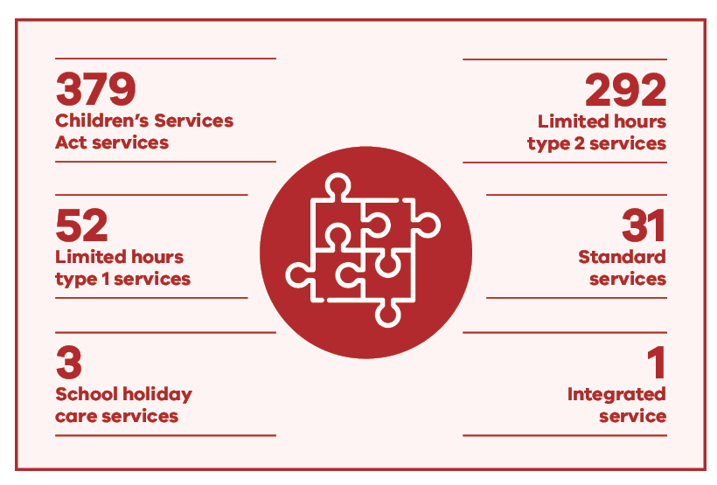

4.5 Applications, licensing and notifications
QARD is responsible for processing applications, notifications of change of circumstances and assessing an applicant’s fitness and propriety.

Applications
There were 2,371 applications submitted to QARD in 2017. The majority of them relate to provider and service approvals (31 per cent) and amendments to provider and service approvals (23 per cent).

Notifications of Change of Circumstances
QARD receives notifications of certain circumstances and information, which include change in the management or control of an approved provider or responsible persons at the service, surrenders of service or provider approval, and change of information about an early childhood service. There were 6,895 notifications of change of circumstances received by QARD in 2017.
Forty-nine per cent (49%) of these notifications in 2017 were related to changes to services, with the majority of them related to the changes in nominated supervisors to services. Thirty-six per cent (36%) of these notifications in 2017 were related to change of contact details, most of them related to services contact details.

Notification of Serious Incidents
The National Law and Children’s Services Act outline the circumstances under which services must notify QARD of a complaint or an incident. These include:
- the death of a child
- any incident involving serious injury or trauma to, or illness of, a child
- any incident where the attendance of emergency services was required
- any circumstance where a child being educated and cared for by an early childhood education and care service appears to be missing or cannot be accounted for.
In addition, QARD is required to be notified of incidents affecting the hours and days of operation of a service, any circumstance that poses a risk to a child and matters related to FDC venues. In 2017, QARD received 3,881 notifications of serious incidents from early childhood education and care services.
Care type | 2017
Long day care | 173
Kindergarten | 63
Outside school hours care | 40
Family day care | 28
Note: Some serious incidents may relate to services that were not operating at the end of each year.
TABLE 4 NUMBER OF SERIOUS INCIDENTS PER 100 NQF SERVICES BY CARE TYPE, 2017

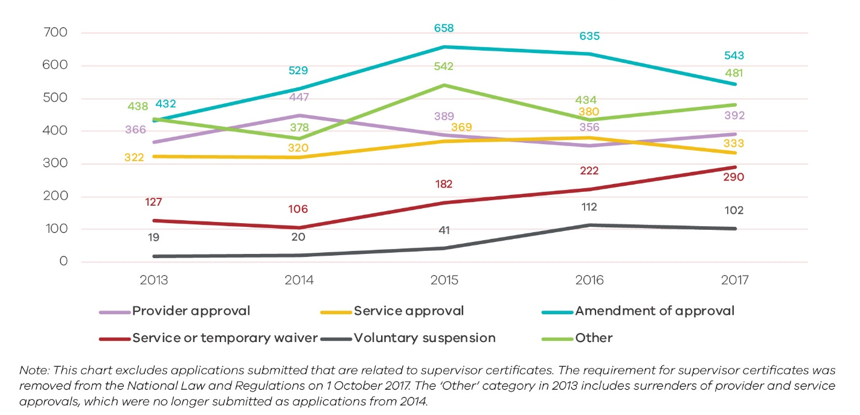
FIGURE 25 NUMBER OF APPLICATIONS SUBMITTED BY APPLICATION TYPE, 2013–2017

4.6 Assessment and ratings
As at the end of 2017, QARD had rated ninety- two per cent (92%) of approved services in Victoria, compared to the national average of ninety-four per cent (94%). Services are eligible for assessment and rating after 12 months of operation. Of these eligible services, QARD rated 97.7 per cent by 31 December 2017 compared with 98.1 per cent nationally.
Eighty-four per cent (84%) of Victorian services with a quality rating received an overall rating of Meeting NQS or above. This is higher than the national average of seventy-seven per cent (77%).
The National Partnership Agreement on the National Quality Agenda for Early Childhood Education and Care 2015-2016 to 2017-18 stipulates that fifteen per cent (597) of services in Victoria as at 30 June 2015 be assessed and rated during 2017. As at 31 December 2017, 929 services received an assessment and rating report.
986 assessment and rating visits conducted between 1 January and 31 December 2017
5 in 6 services are rated Meeting NQS or Exceeding NQS in Victoria
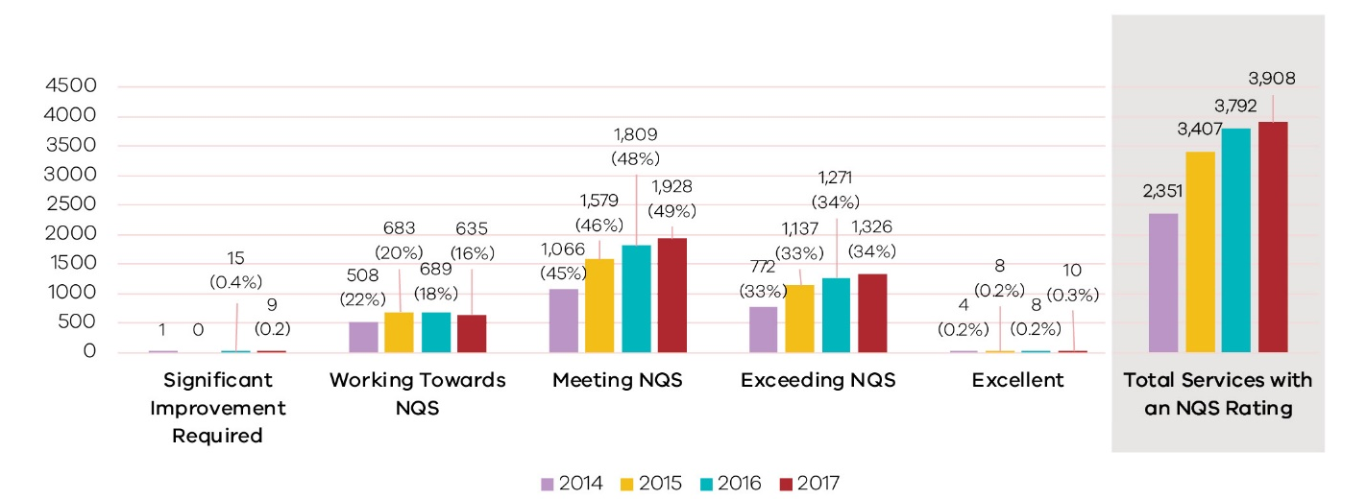
FIGURE 26 OVERALL QUALITY RATINGS BY RATING LEVEL, 2014-2017
Victorian education and care services continue to show a steady improvement in quality as the proportions of overall ratings of Meeting NQS or above continues to grow. Quality Areas with the greatest opportunity for improvement are Quality Area 7 Governance and Leadership, Quality Area 1 Educational Program and Practice and Quality Area 2 Children’s Health and Safety where 12, 11 and 10 per cent of ratings (respectively) result in a Working Towards NQS.
The introduction through the NQF of approved learning frameworks has raised the benchmark for educational programs and practice resulting in Quality Area 1 Education Program and Practice being most challenging for education and care services to meet overall nationally (18 per cent of services receive a Working Towards
NQS). The relatively stronger performance Victorian services in Quality Area 1 (11 percent Working Towards NQS) can be attributed to the stronger performance of kindergartens and their historical focus on educational programs and practice and the presence of early childhood teachers.
Kindergartens are the strongest performing care type, in terms of overall quality ratings with ninety-four per cent (94%) of rated services achieving a quality rating Meeting NQS or above. FDC services receive the lowest overall quality ratings overall with only forty-six per cent (46%) of rated services achieving a quality rating Meeting NQS or above.
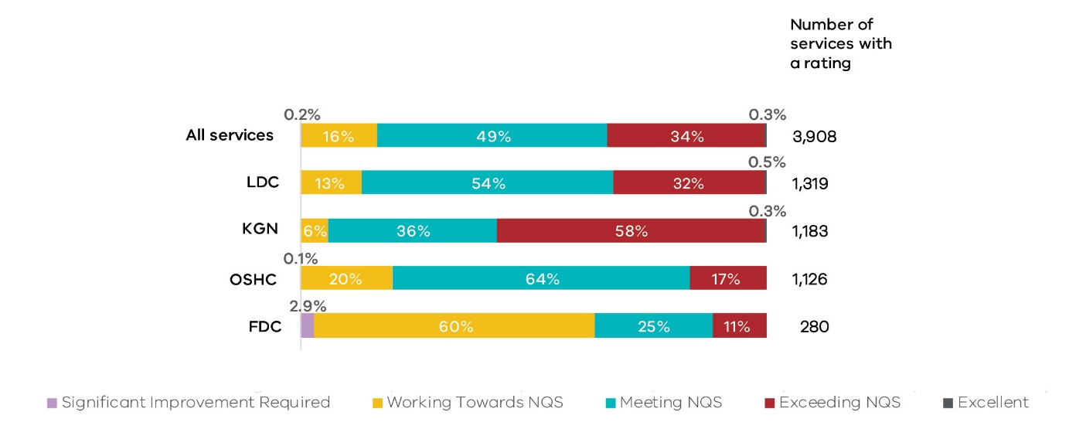
FIGURE 27 OVERALL QUALITY RATINGS BY CARE TYPE AND RATING LEVEL (AND NUMBER OF RATINGS) AS AT 31 DECEMBER 2017
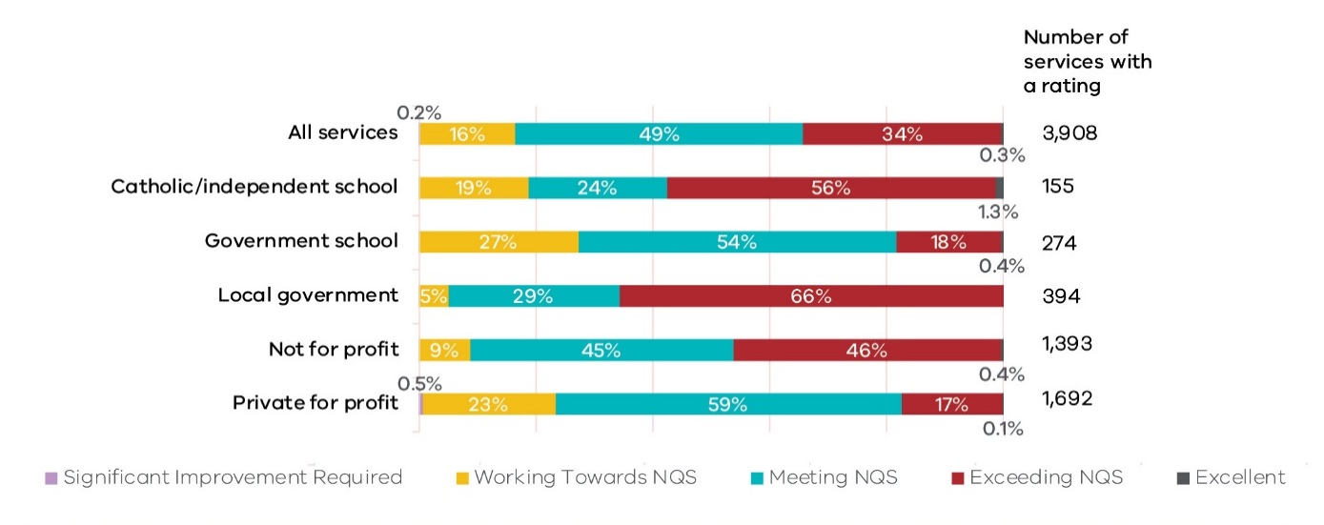
FIGURE 28 OVERALL QUALITY RATINGS BY PROVIDER MANAGEMENT TYPE AND RATING LEVEL (AND NUMBER OF RATINGS) AS AT 31 DECEMBER 2017
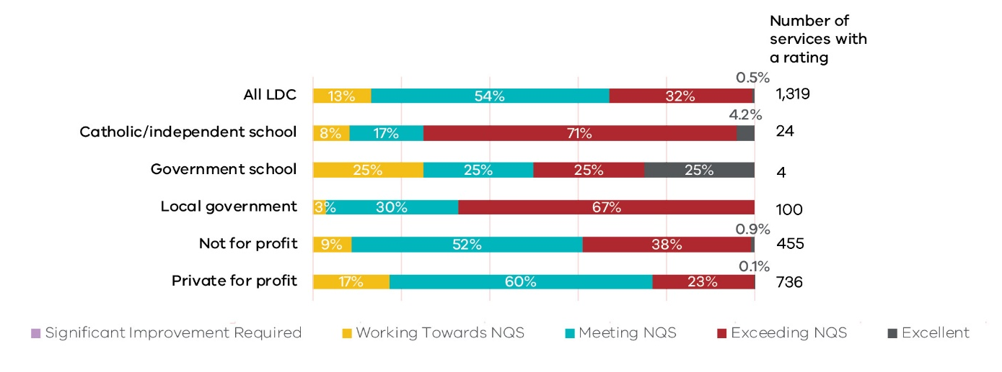
FIGURE 29 LONG DAY CARE OVERALL QUALITY RATINGS BY PROVIDER MANAGEMENT TYPE AND RATING LEVEL (AND NUMBER OF RATINGS) AS AT 31 DECEMBER 2017
79% of the education and care sector has a management type of private for profit (43%) or not for profit (36%)
The 30 local government operated FDC services assessed and rated in 2017 significantly out- performed those operated by the private for profit management type on their quality rating outcomes.
LDC services are mostly distributed between private for profit and not for profit management types. Schools as a management type, although relatively small, typically have higher overall ratings
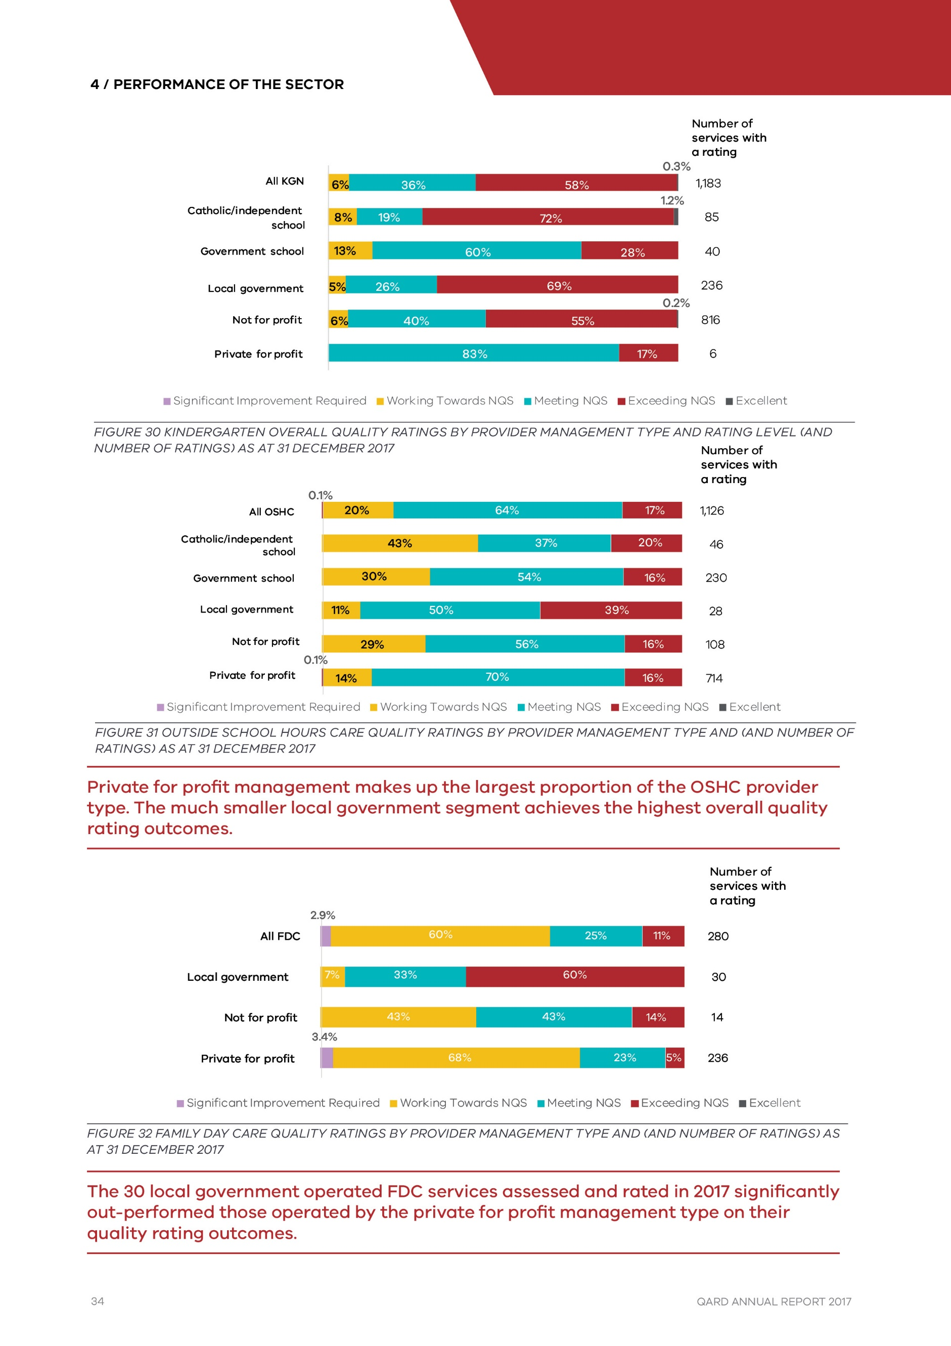
FIGURE 30 KINDERGARTEN OVERALL QUALITY RATINGS BY PROVIDER MANAGEMENT TYPE AND RATING LEVEL (AND NUMBER OF RATINGS) AS AT 31 DECEMBER 2017
FIGURE 31 OUTSIDE SCHOOL HOURS CARE QUALITY RATINGS BY PROVIDER MANAGEMENT TYPE AND (AND NUMBER OF RATINGS) AS AT 31 DECEMBER 2017
Private for profit management makes up the largest proportion of the OSHC provider type. The much smaller local government segment achieves the highest overall quality rating outcomes.
FIGURE 32 FAMILY DAY CARE QUALITY RATINGS BY PROVIDER MANAGEMENT TYPE AND (AND NUMBER OF RATINGS) AS AT 31 DECEMBER 2017
The 30 local government operated FDC services assessed and rated in 2017 significantly out-performed those operated by the private for profit management type on their quality rating outcomes.

Next Assessment and Rating
Next assessment and rating visits (reassessments) represent any assessment and rating visit after a service’s initial assessment and rating. These visits reveal whether quality issues have been addressed.
By the end of 2017, QARD had conducted 1,333 rating reassessments, with forty-five per cent (45%) achieving a higher rating. Forty-eight per cent (48%) of reassessments were for services with a prior rating of Working Towards NQS. Of these, seventy-one per cent (71%) resulted in a higher quality rating.
7 in 10 services with an initial rating of Working Towards NQS received a higher rating after reassessment

Significant Improvement Required
At the end of 2017, Victoria had nine services with a Significant Improvement Required (SIR) rating, eight were FDC services and the other was an OSHC service. These services were assessed and found they did not meet at least one quality area or relevant regulation in a way that constituted an unacceptable risk to the safety, health or wellbeing of children attending the service. These services face greater departmental oversight, enforcement action and possible cancellation of approval if they do not improve.

Excellent Rating
At the end of 2017, 10 Victorian services had achieved the highest level rating of Excellent (seven LDC and three kindergarten).
An Excellent rating is assessed and determined by ACECQA following application from a service. The service must be rated Exceeding NQS in all quality areas in order to apply for the Excellent rating.
10 Services with an Excellent Rating
- Balnarring Preschool
- Baxter Kindergarten & Children's Centre
- Clarendon Children's Centre Co-op
- CPS Children's Centre
- Doveton College Early Learning Centre
- Jindi Woraback Children's Centre
- Lady Gowrie Child Centre (Melb) Inc
- Little Beacons Learning Centre
- Millville
- Wesley College Melbourne Glen Waverley Early Childhood Learning Centre

4.7 Assessment and rating process
The Assessment and Rating (A&R) process was a key change introduced with the NQF and is one of the main tools for driving continuous improvements to the quality of education and care services across Australia.
An Authorised Officer from our Northern Metropolitan region team discussed the A&R process and why it is such an important part of our work.
About six weeks prior to the A&R visit we send a letter to let the service know that we are coming and to ask them to submit their Quality and Improvement Plan (QIP). The QIP is a planning tool to help services identify and record what they are doing well, and areas they wish to improve.
“Everyone wants to do well and put their best foot forward and initially some services were quite nervous about going through the assessment and rating process, but they are more confident now.”
We contact the service before the assessment visit to talk them through the process, what to expect, and answer any questions they may have.
“The NQS has definitely improved quality for services across the board”
During the assessment, we spend time gathering evidence, speaking to the educators and observing practices using the NQF’s Observe, Discuss, Sight approach. The key is to try to discover how the service is operating, what it does really well and identify areas for improvement.
We produce and deliver a report to the service following the visit. Final ratings are published on the ACEQCA website where families can search for information about their current or potential services, and access information about their rating.
- OBSERVE what educators, children, families, co-ordinators and staff members are doing
- DISCUSS why and how particular practices occur at the service with educators and staff
- SIGHT documentation provided as evidence to support particular practices at the service required by the National Law and National Regulations

4.8 Compliance monitoring
In 2017, authorised officers completed 2,096 compliance visits to services operating under the NQF and 135 compliance visits to services operating under the Children’s Services Act.
Number of compliance visits completed per 100 services by care type
- Long day care: 74 in 2017
- Kindergarten: 31 in 2017
- Outside school hours care: 39 in 2017
- Family day care: 42 in 2017
- Children's Services Act service: 36 in 2017
Note: A compliance visit is defined here as any of the following visit types in NQA ITS: application/assessment, change of ownership, complaint, incident, investigation and post-approval. Some compliance visits relate to services that were cancelled or surrendered by the end of 2017.

4.9 Enforcement actions
The Department uses a range of regulatory tools to address non-compliance. These tools range from providing information and guidance through to prosecution before a court or cancelling a provider’s approval to operate. To achieve compliance within the regulated community, the Department focuses on selecting regulatory responses that match the seriousness of the issues and the behaviour of those involved.
The Department applies sanctions that it determines as appropriate for the level of seriousness and culpability of non-compliances.
In 2017, the Department applied 77 statutory enforcement sanctions relating to serious non- compliance. This compares to 48 similar actions in 2016. The Department publishes all applicable enforcement actions on its website.

Investigation of a serious incident
A member of the public contacted us about an incident where they discovered a child wandering alone on a street the previous day. They were then approached by an educator who said the child was from a nearby childcare centre service. QARD had received no notification of this serious incident, which led the officer to phone the service for further information. We received vague responses that contradicted the account provided by the caller. A high priority investigation into the incident was initiated involving our investigations unit.
The investigation found that the same child had left the service previously and was found nearby, however no serious incident notification was submitted at this time.
The subsequent evidence collected highlighted discrepancies between versions of events provided by staff, service management and other witnesses.
The service’s failure to adequately supervise the child was compounded by their failure to comply with the requirements of the regulations to lodge a notification of a serious incident. In addition, no preventative action was taken by the service following the first incident to ensure the child would remain securely within the service.
Given the serious nature of the failures and particularly the service’s negative attitude toward compliance obligations, the Department proceeded to prosecute the service.
The court found the offences proven and issued penalties of fines and a 12-month good behaviour bond against the approved provider and staff member for:
- inadequate supervision of children
- failure to ensure every reasonable precaution was taken to protect children at the service from harm and any hazard likely to cause injury
- failure to notify the Regulatory Authority of serious incidents
- providing the Regulatory Authority or an authorised officer false and misleading information.

4.10 Complaints
The Department assesses all complaints made by parents or the public and considers the risk to the health and wellbeing of children, the circumstances of each incident, the compliance history of the service and the action the provider or service has taken since the incident when determining whether further action is required. In all circumstances where there is a risk to the child, the service is subject to a compliance visit.
Not all complaints are substantiated, but where they are and as appropriate the Department takes further action. No further action may be required where an investigation finds the risk to the child was low and the service was found to be taking appropriate actions to prevent further occurrences of incidents. These remedies include improving and reviewing policies and procedures with staff or disciplinary action against staff concerned.
Other investigation outcomes include interviews and meetings with the service provider, compliance actions such as additional monitoring of the service, conditions on the service approval, enforceable undertakings, notices of caution and where required, prosecution of the service provider.
In 2017, QARD received 1,764 complaints; 1,736 about services operating under the NQF, 14 about services operating under the Children’s Services Act and 14 regarding alleged illegal services operating.
Providers have an obligation to notify the Department of complaints they have received from parents or guardians of children at the service. In addition, the Department also receives complaints directly from parents, members of the public or staff at services by phone or email.
In 2017 thirty-three per cent (33%) of complaints were received directly, which has decreased from forty per cent (40%) in 2015. Contributing factors to this reduction include the improving quality of the services and their response to complaints they receive.

5.0 Glossary
TERM | MEANING
Amendment of approval | An approved provider may apply to the regulatory authority for an amendment to their provider/service approval.
Approved number of places | In relation to a centre-based service, the maximum number of children who can be educated and cared for by a service at any one time, stated on the service approval.
Approved provider | A person who holds a provider approval under the NQF.
Approved service | An approved early childhood education and care service for which a service approval exists under the NQF.
Assessment and Rating | The process by which services are assessed and rated by their regulatory authority against the National Quality Standard, and given a rating for each of the seven quality areas and an overall rating based on these results.
Budget-based service | An early childhood service in receipt of Australian Government (AG) Budget Based Funding (BBF). The AG BBF program provides a contribution to the operational costs of approximately 300 child care and early learning and school aged care services nationally (around 10% of these services are in Victoria). Services supported by the BBF program are mostly located in regional, remote and Aboriginal and Torres Strait Islander communities, where the market would not otherwise be viable. Many of these BBF services are the sole providers of child care in their communities.
Centre-based service | An education and care service other than a family day care service. This includes most long day care, preschool/kindergarten and outside school hours care services that are delivered at a centre.
Child Care Benefit | A payment to help with the cost of day care, outside school hours care, vacation care, pre-school and kindergarten.
Child Safe Standards | Minimum standards for ensuring child-safe organisations from recommendations of the Victorian Parliament's report of its inquiry into the Handling of Child Abuse by Religious and Other Non-Government Organisations (the Betrayal of Trust Inquiry).
Children's services | Early childhood education and care services regulated under the Victorian Children's Services Act 1996.
Children’s Services Act 1996 (Children’s Services Act). | Victorian law under which children's services are regulated where those services do not meet the definition of an education and care service under the Education and Care Services National Law Act 2010
Commission for Children and Young People | An independent statutory body that promotes improvement in policies and practices affecting the safety and wellbeing of Victorian children and young people.
Complaint notification | See Notification
Consumer Affairs Victoria | Victoria's consumer affairs regulator, a unit of the Department of Justice and Regulation. Its role includes advising and educating consumers and businesses on their rights, responsibilities and changes to the law, conciliating disputes between consumers and businesses, and enforcing and ensuring compliance with consumer laws.
Department of Education and Training Victoria (the Department)
Early Childhood and School Education Group | The area in the Department of Education and Training Victoria that is responsible for the design and development of operational policy and programs to support improved outcomes for children, students and families from birth through school. ECSEG plays a key role in designing and developing policy to provide a person-centred, outcomes-focused and integrated service system.
Education and Care Services National Law Act 2010 (National Law) | See: National Law
Emergency Management Plan | All early childhood services in Victoria must have emergency and evacuation policies and procedures. In addition, those listed in the Bushfire At-Risk Register must also submit their updated Emergency Management Plan by 21 November of each year.
Enforcement action | Action taken by the Department for the purpose of ensuring that those providing education and care services are ensuring the safety, health and wellbeing of children attending early childhood education and care services and compliance with the Education and Care Services National Law Act 2010 and the Victorian Children’s Services Act 1996. Enforcement actions include the application of administrative and statutory sanctions.
Early Years Management | Early Years Management (EYM) organisations are funded by DET to provide centralised management of community-based kindergartens and other complementary early childhood services. EYM organisations must be a local government or community-based, not-for-profit organisation and must manage a minimum of three community-based services that offer a funded kindergarten program. (Formerly known as Kindergarten Cluster Management (KCM)).
Family day care service | Regulated under the NQF, an education and care service that is delivered through the use of two or more educators to provide education and care to children and operates from two or more residences. A family day care service that is an approved family day care service may provide education and care to children from a family day care residence or an approved family day care venue.
Incident notification | See Notification
Integrated service | Regulated under the Children's Services Act 1996, a service that consists of two or more service types (other than a short-term service) provided at one premises by one licensee.
Kindergarten | Regulated under the NQF, (also called preschool) a program for young children delivered by qualified early childhood teachers. Children go to a kindergarten program in the year before starting school, usually when they are four years old. Some services also offer kindergarten programs for three-year-olds.
Licensed service | A service regulated under the Children’s Services Act 1996 for which a licence exists.
Limited hours service | Regulated under the Children’s Services Act 1996, a service that provides education and care to a child at a sports and leisure centre or shopping centre where the parent is a patron
Limited hours type 1 service | A service that cares for or educates children for not more than 2 hours per day and not more than a total of 6 hours per week (e.g. children’s service operating at a sport or leisure facility or shopping centre)
Limited hours type 2 service | A service that cares for or educates children for not more than 5 hours per day and not more than a total of 15 hours per week (e.g. children’s service operating at a Neighbourhood house)
Long Day Care | Regulated under the NQF. Not defined in the National Law or Regulations. A centre-based form of service which provides all-day or part-time care for children aged birth to six who attend on a regular basis (National Partnership Agreement on the National Quality Agenda for Early Childhood Education and Care, p. 6).
National Law | The National Quality Framework (NQF) operates under an applied law system, comprising the Education and Care Services National Law and the Education and Care Services National Regulations. The purpose of the applied law system is to set a national standard for children’s education and care across Australia. In effect it means the same law is applied in each state and territory, but with some varied provisions as applicable to the needs of each state or territory. In this case Victoria passed the Education and Care Service National Law Act 2010 and other jurisdictions adopted that law through an Application Act or passed corresponding legislation.
National Quality Agenda | The overarching name given to the quality reforms to early childhood education care, which incorporate the National Quality Standard, including the Early Years Learning Framework, the assessment and rating system and the National Regulations.
National Quality Framework | The National Quality Framework was the result of an agreement between all Australian governments to work together to provide better educational and developmental outcomes for children. It covers services providing or intending to provide education and care on a regular basis to children under the age of 13 years. This includes family day care services, long day care services, outside school hours care services and preschools (kindergartens). The NQF comprises the National Law, National Regulations and National Quality Standard and Approved Learning Frameworks.
National Quality Standard | The National Quality Standard (NQS) sets a high national benchmark for early childhood education and care and outside school hours care services in Australia. The NQS includes 7 quality areas that are important outcomes for children. Services are assessed and rated by their regulatory authority against the NQS, and given a rating for each of the 7 quality areas and an overall rating based on these results.
National Regulations | See: National Law
No Jab No Play | Under the No Jab No Play legislation, before enrolling a child, early childhood education and care services have to first obtain evidence that the child is up to date with all vaccinations that are due for their age, or that they are able to receive.
Notification | Approved providers are required to notify the regulatory authority about incidents, complaints and changes to information.
National Quality Agenda IT System | A web-based information system to assist state and territory regulatory authorities and ACECQA to manage the approval, monitoring and quality assessment of children’s education and care services. The system also enables services, providers and educators to submit application and notification forms online to regulatory authorities and ACECQA.
Occasional Care | Regulated under the Children’s Services Act 1996. Casual, occasional care services that offer care of less than two hours per day and less than six hours per week, which includes crèches at gyms and shopping centres
Outside School Hours Care | Regulated under the NQF. Not defined in the National Law or Regulations. A service that provides care for primary school aged children (typically 5 to 12 years) before and after school and can also operate during school holidays (vacation care) and on pupil free days (National Partnership Agreement on the National Quality Agenda for Early Childhood Education and Care, p. 7). Outside school hours care services are usually provided from primary school premises. Services may also be located in child care centres or community facilities. Outside school hours care services are often provided by parent associations or non-for-profit organisations.
Preschool | Not defined in the National Law or Regulations. A service that provides an early childhood education program, delivered by a qualified teacher, often but not necessarily on a sessional basis in a dedicated service. Alternative terms used for preschool in some jurisdictions include kindergarten, pre-preparatory and reception (National Partnership Agreement on the National Quality Agenda for Early Childhood Education and Care, p.7).
Provider management type | Providers include local councils, health departments, the vocational training arms of government, and other government-controlled agencies that are not government schools. Provider service sub-type profile also varies significantly across and within jurisdictions.
Provider | See Approved provider
Quality Improvement Plan | A document created by an approved provider to help services self-assess their performance in delivering quality education and care and to plan future improvements. Regulatory authorities consider the service’s QIP as part of the quality assessment and rating process. The QIP includes three components:  1. An assessment of the quality of service practices against the NQS and the National Regulations  2. Identified areas for improvement  3. A statement of the philosophy of the service.
Reportable Conduct Scheme | Scheme to improve oversight of how organisations respond to allegations of child abuse and child-related misconduct, commenced on 1 July 2017.
School holidays care service | Licensed under the Children’s Services Act 1996. Cares for or educates children for no more than 4 weeks per calendar year during school holidays
Serious incident | Serious incidents that occur while a child is being educated and cared for by an education and care service include: the death of a child; a serious injury or trauma to a child; the serious illness of a child requiring hospital attendance; an emergency for which emergency services attended; circumstances where a child is missing or unaccounted for/is taken or removed/is mistakenly locked in or out of the service/service premises
Service approval | A person must have service approval to operate an education and care service under the National Law and Regulations. Regulatory authorities are responsible for assessing and determining applications for service approval.
Significant Improvement Required | During the assessment and rating process when an authorised officer (in consultation with their manager) is satisfied that the service does not meet a standard, quality area, or relevant regulation for that quality area in a way that poses 'a significant risk to the safety, health and wellbeing of any child or children being educated and care for by a service'.
Waiver | An exemption from a requirement that an approved education and care service comply with a prescribed element(s) of the National Quality Standard or regulation of the National Regulations. While a waiver is in force, the approved service is not required to comply with the element(s) or regulation(s) specified in the waiver.

6.0 Appendix

Number of applications submitted by application type, 2013–2017
Application type | 2013 | 2014 | 2015 | 2016 | 2017
Approval | 688 | 767 | 758 | 736 | 725
Provider Approval | 366 | 447 | 389 | 356 | 392
Service Approval | 322 | 320 | 369 | 380 | 333
Amendment of approval | 432 | 529 | 658 | 635 | 543
Amend Provider Approval | 48 | 109 | 144 | 166 | 179
Amend Service Approval | 384 | 420 | 514 | 469 | 364
Waiver | 127 | 106 | 182 | 222 | 290
Service or Temporary Waiver | 127 | 106 | 182 | 222 | 290
Suspension | 19 | 20 | 41 | 112 | 102
Suspension Provider Approval | 1 | 2 | 5 | 18 | 20
Suspension Service Approval | 18 | 18 | 36 | 94 | 82
Related to supervisor certificates | 5,161 | 2,970 | 553 | 400 | 230
Amend Supervisor Certificate | 27 | 57 | 37 | 39 | 31
Supervisor Certificate | 5,079 | 2,898 | 511 | 352 | 188
Supervisor Certificate for Specified Class of Persons | 53 | 14 | 5 | 8 | 11
Suspension Supervisor Certificate | 2 | 1 |  | 1
Other | 438 | 378 | 542 | 434 | 481
Change of Information-Provider | 2 | - | - | - | -
Decision – Request Review by Tribunal or Court | - | 1 | 2 | 3 | 5
Extension-Temporary Waiver | - | - | - | 1 | 3
Internal Review of Reviewable Decision | 58 | 55 | 65 | 32 | 29
Out of Scope Application | - | 1 | 84 | 144 | 154
Re-Assessment and Re-Rating | 3 | 19 | 26 | 64 | 19
Review of Ratings by RA | 16 | 19 | 14 | 25 | 21
Revocation-Service Waiver | 1 | 1 | - | - | -
Transfer of Service Approval | 219 | 282 | 351 | 165 | 250
Total | 6,865 | 4,770 | 2,734 | 2,539 | 2,371
Note: (i) This table includes applications submitted related to supervisor certificates. The regulatory requirements relating to supervisor certificates were amended in 2014. In 2017 the requirement for supervisor certificates was removed from the National Law and Regulations.
(ii) The 6,865 total includes surrenders of provider and service approvals, which were no longer submitted as applications from 2014.
Number of new NQF services approved as at 31 December by care type
Care type | 2013 | 2014 | 2015 | 2016 | 2017
Long Day Care | 34 | 36 | 54 | 75 | 116
Kindergarten | 31 | 23 | 30 | 22 | 19
Outside School Hours Care | 58 | 81 | 79 | 63 | 78
Family Day Care | 128 | 74 | 61 | 38 | 20
Overall | 251 | 214 | 224 | 198 | 233
Number of new places for centre-based services approved as at 31 December by care type
Care Type | 2013 | 2014 | 2015 | 2016 | 2017
Long Day Care | 3,172 | 3,501 | 4,246 | 7,348 | 12,092
Kindergarten | 1,474 | 1,166 | 1,731 | 1,117 | 828
Outside School Hours Care | 2,730 | 3,626 | 3,687 | 3,302 | 4,703
Overall | 7,376 | 8,293 | 9,664 | 11,767 | 17,623
Number of new NQF services approved as at 31 December by provider management type
Provider type | 2013 | 2014 | 2015 | 2016 | 2017
Catholic school | 1 | 0 | 2 | 2 | 2
Government school | 10 | 7 | 6 | 5 | 4
Independent school | 5 | 3 | 2 | 7 | 5
Local government | 7 | 10 | 15 | 8 | 6
Not-for-profit community managed | 34 | 27 | 36 | 26 | 23
Not-for-profit other | 4 | 5 | 7 | 3 | 15
Private for profit | 190 | 162 | 156 | 147 | 178
Overall | 251 | 214 | 224 | 198 | 233
Number of new places for centre-based services approved as at 31 December by provider management type
Provider type | 2013 | 2014 | 2015 | 2016 | 2017
Catholic school | 40 | 0 | 35 | 65 | 86
Government school | 389 | 290 | 186 | 191 | 117
Independent school | 343 | 170 | 69 | 294 | 309
Local government | 659 | 630 | 1,249 | 505 | 318
Not-for-profit community managed | 1,946 | 956 | 1,966 | 1,289 | 1,656
Not-for-profit other | 281 | 216 | 346 | 169 | 2,168
Private for profit | 3,718 | 6,031 | 5,813 | 9,254 | 12,969
Overall | 7,376 | 8,293 | 9,664 | 11,767 | 17,623
Number of decisions by month and application type, 2017
Approval type | Jan | Feb | Mar | Apr | May | Jun | Jul | Aug | Sep | Oct | Nov | Dec | Total
Provider approval | 21 | 13 | 27 | 17 | 28 | 14 | 16 | 11 | 18 | 20 | 22 | 31 | 238
Service approval | 53 | 26 | 13 | 18 | 14 | 37 | 28 | 12 | 29 | 20 | 12 | 31 | 293
Amendment of approval | 42 | 23 | 26 | 20 | 40 | 38 | 34 | 21 | 26 | 42 | 32 | 28 | 372
Service or temporary waiver | 8 | 33 | 11 | 5 | 18 | 5 | 4 | 5 | 6 | 13 | 7 | 23 | 138
Voluntary suspension | 8 | 2 | 8 | 3 | 9 | 12 | 10 | 8 | 6 | 12 | 8 | 2 | 88
Related to supervisor certificates | 33 | 32 | 21 | 12 | 21 | 33 | 21 | 6 | 15 | 0 | 0 | 0 | 194
Other | 50 | 32 | 13 | 13 | 17 | 26 | 95 | 22 | 26 | 37 | 22 | 25 | 378
Total | 215 | 161 | 119 | 88 | 147 | 165 | 208 | 85 | 126 | 144 | 103 | 140 | 1,701

