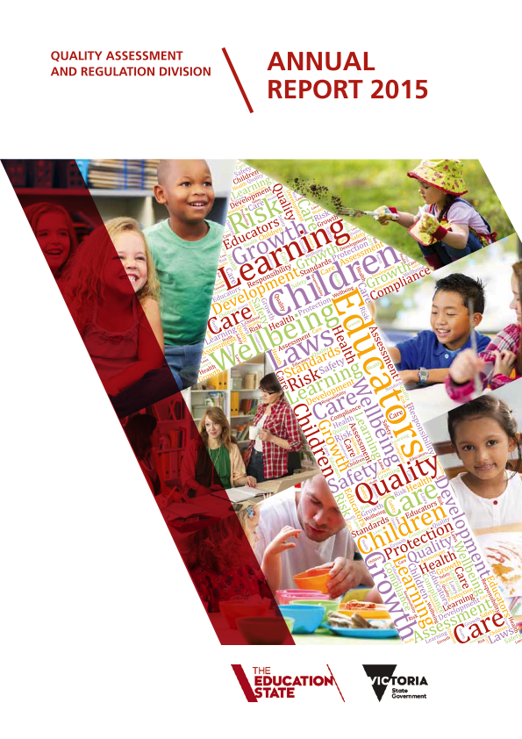

Published by
the Department of Education and Training
Melbourne
July 2016
© State of Victoria (Department of Education and Training) 2016
The copyright in this document is owned by the State of Victoria (Department of Education and Training), or in the case of some materials, by third parties (third party materials). No part may be reproduced by any process except in accordance with the provisions of the Copyright Act 1968, the National Education Access Licence for Schools (NEALS) (see below) or with permission.
An educational institution situated in Australia, which is not conducted for profit, or a body responsible for administering such an institution may copy and communicate the materials, other than third party materials, for the educational purposes of the institution.
Authorised by the Department of Education and Training
2 Treasury Place, East Melbourne, Victoria, 3002.
ISBN 978-0-7594-0811-1
Note: Due to rounding, individual values throughout this document may not add to 100 per cent. This report reflects the 2015 calendar year. Source data is collected by the Quality Assessment and Regulation Division within the Department of Education and Training.


Contents
Introduction 2
About us 3
Our people 6
Services we regulate 10
Our functions 11
Policy 11
Informing and educating the sector 12
Approvals and licensing 13
Monitoring and compliance 15
Assessment and rating 18
emergency management 21
reviews of qard decisions 21
Glossary 22
appendix 23

Introduction
I am delighted to present the third annual report of the Quality Assessment and Regulation Division (QARD) of the Department of Education and Training (the Department). QARD is responsible for the licensing and regulation of children’s services under the Children’s Services Act 1996 (Vic) (Children’s Services Act), and for the approval and regulation of education and care services that operate under the Education and Care Services National Law Act 2010 (the National Law).
QARD regulates providers of education and care services and licensees of children’s services to
ensure providers protect children’s safety, health
and wellbeing.
We also drive quality improvement in education and care and children’s services so children receive the best possible education and care to support their health, learning and development.
There are now over 4430 services in Victoria regulated by QARD.
Our 2015 highlights included:
• a continued focus on assessment and rating that saw 85 per cent of services assessed by year’s end
• improvement in 67 per cent of assessed services by one or two rating levels for the 210 services re-rated
• assessment and rating of 1152 services
• responding to 5818 notifications of complaints and incidents
• granting 279 new approvals and licences
• substantial progress on the Council of Australian Governments (COAG) Review of the National Partnership Agreement on the National Quality Agenda for Early Childhood Education and Care (NQA Review)
• amendments to the Public Health and Wellbeing Act 2008, which require children to be immunised or have an appropriate exemption prior to enrolment
• registration of early childhood teachers by the Victorian Institute of Teaching (VIT)

• preparing for changes to the staffing arrangements from 1 January 2016 including the improved ratio for children older than 36 months of age
• engagement in the consultation processes for making Victoria the Education State.
QARD continued to proactively engage stakeholders in a number of ways during 2015. This included targeted education and training programs, and eight newsletters that provided topical information to assist services to meet their regulatory obligations. A critical area this year has been the safety and supervision of children, particularly on excursions.
QARD has continued to closely monitor service compliance with the law, with a few services requiring extra monitoring due to a history of non-compliance. We continue to use enforcement actions to promote compliance. These actions are published on our website and included in this report.
The National Quality Framework (NQF) is now four years old. Over this time, I’ve seen an increased focus on quality improvement and outcomes for children and recognition of the value of early childhood experiences. I would like to thank all service providers, educators and peak bodies that support the sector for their commitment to enhancing the learning and development of the many children who benefit from Victoria’s education and care services and children’s services.
Karen Weston
Acting Executive Director
Quality Assessment and Regulation Division


About us

Our role
QARD regulates more than 4000 Victorian education and care services that operate under the NQF. This covers family day care (FDC) services, centre-based services such as kindergarten (KGN), long day care (LDC) and outside school hours care (OSHC).
QARD also regulates the 430-plus services operating under the Children’s Services Act. These include occasional care, early childhood intervention and limited hours services.
Our role is to regulate providers of education and care services and licensees of children’s services
to ensure they protect children’s safety, health
and wellbeing.
We also drive continuous improvement in early childhood services, so children receive quality education and care to support their health,
learning and development.
Specifically, this involves:
• reviewing the law and policies

• educating providers, services and the community on regulatory obligations
• approvals and licensing
• conducting quality assessment and rating
of services
• working with the Australian Children’s
Education and Care Quality Authority
(ACECQA) to support and promote
continuous quality improvement in services
• monitoring compliance and enforcing the
requirements of the NQF and the Children’s
Services Act
• receiving and investigating notifications of
serious incidents and complaints
• collecting information to assist with
reporting and to inform our risk-based
regulatory approach
• reviewing and reporting on our work
• sharing information with other
relevant agencies.
How we approach our work
The aim of government regulation is economic
or social improvement. Our role is to regulate education and care services and children’s services
to ensure providers protect children’s safety, health and wellbeing.
A responsive and risk-based approach
A responsive approach means we support the efforts of providers who want to comply with the requirements of the law with education and information so they can understand what is required. We also take appropriate enforcement action where providers are not complying with the law. Our regulatory effort is tailored to how the provider is responding to the law.
We combine the responsive approach with assessing risk on the basis of its impact on the safety, health and wellbeing of children, and the seriousness of any non-compliance with Victorian laws. Our strategies to address risk include:
• regular compliance, and assessment and
ratings visits
• extra monitoring of services with
compliance issues
• investigating serious incidents, notifications
and complaints
• taking enforcement action for serious and/
or ongoing non-compliance.
Assessment of risk determines the timing and scope of action in response to:
• notifications
• investigations
• compliance visits and compliance history
• assessment and ratings visits.
How we embed values into our work
Regulating providers and services requires strong collaboration, rigorous and transparent processes, along with a highly-skilled and capable workforce. The core principles of how we work include that we are accountable, work with integrity and are responsive to the needs of Victorian children and families. We are also committed to demonstrating behaviour consistent with all Victorian Public Sector Values. Recently we have been transitioning from our Department values to the Victorian Public Service values. In 2015 we embedded Department values into our work in the following ways:
Collaboration and knowledge sharing
We make sure education and care providers and services, and key stakeholders have information and tools to understand how to meet their legislative obligations. We share knowledge and expertise with other areas of the Department and other Victorian government departments and are constantly reviewing our Information Sharing Protocols. QARD collaborates with the ACECQA, Commonwealth Department of Education and Training (DoE), and state and territory regulators.
Outcomes
We are focused on two interrelated outcomes; regulating providers to ensure children’s safety, health and wellbeing, and supporting quality improvement in services so children’s health, learning and development are enhanced.
Respect and diversity
We strive to attract and develop a skilled, capable workforce, and focus on learning that responds
to their professional goals. We also provide information and advice to providers and services
to help them meet legislative obligations and deliver quality services.
Empowerment
We empower individuals to reach their potential and maximise their contribution to our work. We talk more about this in the ‘Our people’ section.
Minister’s expectations and our progress
The Minister’s Statement of Expectations is released at the start of each calendar year but the annual report reflects the financial year. Given this, we have compiled the expectations from 2014–15 and 2015–16 below. Please note, all of the expectations are completed or on-track to be completed by the final date of 30 June 2016.
1. Streamline assessment and rating of
education and care services.
2. Apply best endeavours to assess and rate all
Victorian education and care services
regulated under the National Law. Report
to the Minister regularly on Victoria’s
progress towards this target.

3. Contribute to and implement the outcomes
of the 2014 COAG NQA Review for early
childhood education and care with a view
to maintaining and improving education
and care outcomes for Victorian children,
and reducing the regulatory burden on
service providers.
4. Get greater consistency in regulatory
practice and outcomes by aligning the
administration of the Children’s Services Act
with the National Law.
5. Align records management of Victorian
children’s services with the national
system by December 2015.

6. Continue a risk-based approach to ensuring
that services are adequately monitored,
and notifications and complaints are
investigated quickly. This includes reviewing
risk-assessment frameworks to secure the
safety, health and wellbeing of children,
and to develop appropriate risk-based and
timely responses to the strong growth in the
FDC sector.
7. Work with the Commonwealth Department
of Social Services and other relevant agencies
to address compliance issues associated with
the strong growth in the FDC sector.

8. Further engage providers, families and other
stakeholders about improving regulatory
activities. Publish a stakeholder engagement
strategy that commits to consulting with
stakeholders on industry trends and seeking
feedback on key operational matters. The
strategy should provide for greater use of
online mechanisms.
9. Further improve the transparency and
accountability of regulatory and decision-
making processes. This includes providing
clear and timely information about
regulatory processes and decisions, and
avenues for appeal.
10. Ensure public accountability and provide
information about regulatory work by
publishing an annual report on the activities
of QARD for early childhood education and
care services in Victoria.
11. Reduce non-compliance by giving information
to providers and services about their
legislated obligations.
12. Continue to advise services with a ‘Working
Towards National Quality Standard’ (NQS)
rating to help them meet that standard.
13. Greater cooperation, information sharing,
regulatory coherence and efficiency with
other regulators and key partners. Continue
working cooperatively with ACECQA and
other state and territory regulatory
authorities to administer the National Law.
14. Establish memoranda of understanding or
other arrangements to streamline processes
and share information with:
• the Victorian Registration and Qualifications Authority (VRQA), regarding the regulation of kindergartens on school grounds and school-aged care where school councils are the approved provider
• the VIT, with respect to its responsibility to
register early childhood teachers from
September 2015
• the Early Childhood and School Education
Group (ECSEG), about kindergarten
funding and management.

Our people
Structure
QARD is a statewide regulator and is a division within the Department’s ECSEG. It has three branches and nine area-based teams. QARD is responsible for ensuring providers and services meet their regulatory and reporting obligations, and improve in quality.
Our staff report to an executive team comprising:
• the Executive Director
• Director, Operations Branch
• Manager, Operations Branch
• Manager, Service Quality and
Legislation Branch
• Manager, Systems Administration and
Performance Branch (Figure 1).
Service Quality and Legislation Branch
The Service Quality and Legislation Branch comprises the Monitoring and Compliance Unit, the Consistent Practice and Support Unit, and the Victorian Lead

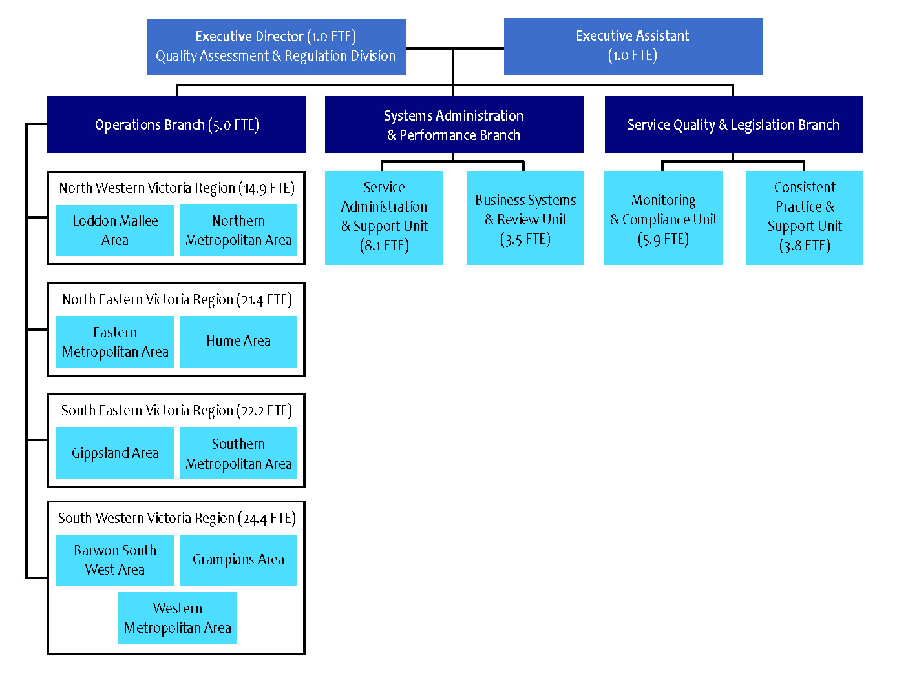
Figure 1 : QARD organisational chart

Assessor for assessment and rating. The Branch is responsible for developing guidelines, frameworks, policies and procedures to ensure that assessment and rating, compliance monitoring, investigations and sanctions are effective, targeted according to risk, and contribute to the safety, health and wellbeing, and quality of early childhood services.
The Branch is also responsible for developing and delivering targeted training on assessment and rating, compliance and investigations.
Operations Branch
The Operations Branch comprises both central office and regional staff. The Branch is responsible for the management and support of the area-based teams to ensure timeliness and consistency of regulatory practice, assessment and rating of all NQF services within nationally-agreed timeframes and targets, and oversight of the regulatory functions.

Systems Administration and
Performance Branch
The Systems Administration and Performance Branch comprises the Business Systems and Review Unit and the Service Administration and Support Unit. The Branch plays an important regulatory role being the first point of contact for new and existing providers of education and care services. The team manages the assessment and analysis of applications, notifications of change of circumstances and undertakes the assessment of an applicant’s fitness and propriety. Information is provided through a designated telephone and email inquiry line, and through conducting information and assessment sessions. The Branch also manages Victoria’s responsibilities and requirements in relation to financial management and data analysis, in
particular, identification of trends and monitoring
of performance.
Our culture and staff engagement

The People Matter Survey is an employee opinion survey run by the Victorian Public Sector Commission. It monitors how public sector values and employment principles are being applied across the Department and our employees’ perceptions of how these are demonstrated by leaders, managers

and colleagues. It also looks at employee satisfaction and engagement. The 2015 report revealed that
our people:
• see QARD managers and staff as responsive,
impartial, accountable and having integrity
• know how QARD and their work contributes
to the Department’s objectives
• believe QARD is committed to high-quality
customer service
• support each other and feel supported
• help each other understand and adapt to new
ways of working.
Things we want to strengthen
We remain committed to training and developing our staff to strengthen our overall capability. Initiatives we have planned include:
• further developing our induction process
• continuing to inspire staff to do their best and
fostering a high sense of team spirit
• meeting with staff and using surveys and
information from staff to review staff
engagement strategies
• building accountability, respect and
leadership skills
• providing development opportunities.

Committed to developing our people
QARD’s high-performing team is engaged, inspired
to work at their best, and supported to develop the best skills for their role and career. QARD teams are encouraged to take ownership of their own wellbeing including sharing their ideas with colleagues and other teams.

We continued to improve their practice and performance in 2015 by providing training, career development opportunities and resources. A focus
of our training in 2015 was Certificate IV in Government (Investigations). Defensive driver training has been introduced in response to a need identified by our rural teams, and staff with financial or procurement tasks have undertaken refresher finance/procurement training.

Feedback via our training evaluation tool continues to help us measure our program’s effectiveness, and ascertain future training and resource needs.
New authorised officers
Before they can assess and rate education and care services, all authorised officers must complete a six-day training program and pass a reliability assessment. This training is delivered jointly by us
and ACECQA. QARD delivers part one of the training over two days, which is supported by well-respected early childhood consultants. To ensure national consistency, ACECQA’s Training Working Group delivers part two over three days with the final day delivered by QARD. The training covers:
• the NQS and its legislative framework
• the approved learning frameworks

• supporting services to improve and self-assess
• monitoring and compliance
• determining a rating
• evidence-gathering and reliability
• assessment and rating in the Victorian context
• cultural awareness and sensitivity.
In 2015, QARD provided two days of additional training for new authorised officers. One day covered conducting compliance visits and reporting and the other day covered assessment and rating visits.
In 2015, Victoria welcomed eight new authorised officers to the QARD team.
Further training for experienced
authorised officers
In 2015, QARD provided 42 days of training for authorised officers in skills such as compliance visits and investigations, assessment and rating, and report writing. The training aims to promote a statewide consistent approach and also covers changes to legislation, policy and practices.
We continued to focus on investigation training in 2015 with 34 authorised officers successfully completing the four-day Certificate IV in
Government (Investigations). Another 20 staff completed prerequisite training that will allow them to complete the Certificate IV in 2016.
A total of 36 QARD staff attended two investigations training sessions for managers (one day) and senior authorised officers (one day).
Seventy-four authorised officers attended
an additional four days of topic-specific
training covering:
• educational program and assessment practice
in early childhood services
• a focus on OSHC
• Children’s Services Act services refresher
• editing assessment and rating reports.
Authorised officers must also complete an annual ‘drift test’ through ACECQA’s eLearning portal to ensure their continued reliability in assessment
and rating.

Quarterly authorised officer forums
These forums give our officers the chance to engage with their colleagues across the regions, and hear expert theories and perspectives about early childhood education and care and regulatory practices. They also provide updates about the Department and feature keynote speakers on a range of topics.
Our 2015 forums covered:
• assessment of learning and new resources for
early childhood
• guidelines for nutrition and development of
a tool for assessing nutrition in education and
care services
• the Education State and early childhood reform
• FDC compliance visits
• reflecting cultural competencies in early
childhood services with a specific focus on
Indigenous culture
• early childhood teacher registration
• new policy requirements for 2016 including:
– No Jab No Play
– child safe standards
– changes to staffing arrangements
including 1:11 educator to child ratio
– early childhood teacher registration with
the VIT.
Case study
– Joanne Manser
I’ve been a Senior Children’s Services Authorised Officer for 10 years. I monitor compliance, undertake assessment and rating, conduct investigations, make recommendations, and provide information and guidance. Over this time I have seen the evolution of legislative requirements, government policy and practice, and this is continually developing my knowledge and rewarding me with a skill-set that’s more extensive than I ever anticipated.
The most enjoyable part of my job is talking
with providers, educators and key stakeholders.
I always have to be prepared to answer questions and this keeps me fully across all current requirements and practices. I really like sharing this knowledge to support best practice and improve outcomes for children.
Over the years I have helped a lot of providers and services improve their service, and the experience they offer each child and their family. I’ve also discovered many truly inspirational curricula and approaches to education and care along the way. But, for me, the most rewarding thing, in terms of my own skill development, is the assessment and rating process. Each one gives me the chance to engage with the sector at the ground level and re-connect with why I joined the education and care industry in the first place — to observe first-hand how quality professional practice can enhance the learning and development of our children. And, of course, there’s nothing more rewarding than being told at the end
of each visit that ‘it wasn’t as bad or as scary as I
thought it would be’.


Services we regulate
As at 31 December 2015, the number of centre-based services operating in the sector had a capacity of 228,856 places. Each place may be used by a number of children. The number of children enrolled in funded kindergarten in 2015 was 74,149.
The Report on Government Services 2016 reported that there were 294,376 children in Victoria aged 0-12 attending Government Child Care Benefit approved childcare services for the March quarter 2015.

Service Summary — Children’s Services Act

Figure 2 : Services regulated under the Children’s Services Act, by type (31 December 2015)
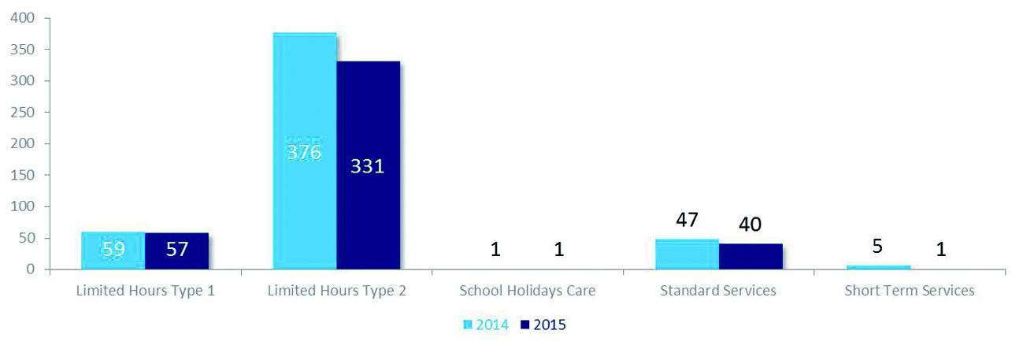
Service Summary — NQF


Figure 3 : Services regulated under the NQF, by type (31 December 2015)
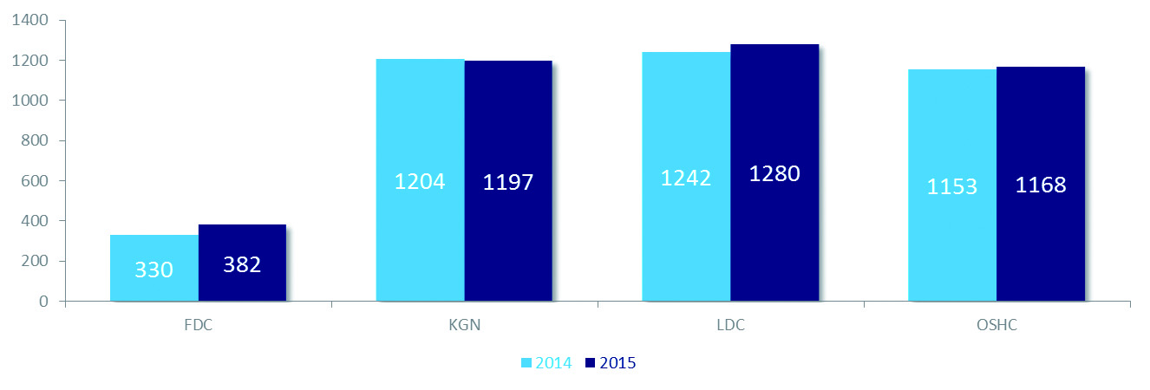

Our functions

policy
Here’s an overview of 2015’s regulatory policy development and how we’ve prepared the sector for new policy requirements from 1 January 2016.
NQF Review
The Consultation Regulation Impact Statement on the 2014 Review of the NQF was released in November 2014. It focused on emerging issues since the NQF’s implementation, including unnecessary regulatory and administrative burden, inconsistency and clarity and incomplete regulatory coverage. The Education Council of all Ministers has agreed the review’s recommendations can only be considered after future funding negotiations and conditions under the Commonwealth State Government National Partnership agreement have been finalised. For now, the NQF will stay as it is.
Registration of early childhood teachers under the VIT
For the first time in Victoria, early childhood teachers were required to register with VIT. According them the status of a registered teacher recognises the significant contribution early childhood teachers make to children’s education.
All early childhood teachers registered with VIT become mandated reporters under the Children, Youth and Families Act 2005.
Criminal Law Reform – Failure to Protect
To improve responses to sexual abuse within organisations and the community, including early childhood services, three new criminal offences were introduced in 2016. The new offences relate to sexual abuse of a child under 16 years.
QARD has provided advice to the sector regarding the new failure to protect offences under the Crimes Act 1958, which make it an offence for any adult working at a service (including volunteers) to not report sexual offences against children under 16 to police and for anyone in authority at a service who knows there’s a risk of sexual abuse and has the power or responsibility to reduce or remove it to
fail to do so.
Nutrition policy
Young children who eat healthy food and drink enough water are on the right path to healthy living, good dental hygiene, and overall wellbeing and energy for playing and learning. Education and care services are required to promote healthy eating as well as educate children and families about nutritious food and drinks.
In 2015, we partnered with the Department of Health and Human Services (DHHS) and the Healthy Eating Advisory Service at Nutrition Australia to focus on nutrition for children in education and care services. We raised awareness with services of the importance of nutrition and developed a new resource to assist authorised officers to assess if services meet requirements relating to nutrition. We worked with stakeholders to develop this resource.
Staffing arrangements – 1:11 ratio
From 1 January 2016 the educator-to-child ratios for all centre-based services for Victorian children 36 months and older, up to and including preschool age, were aligned with most Australian jurisdictions, which require a ratio of one educator for every 11 children. In addition, the first in every two educators must have an early childhood diploma or above. There must also be a qualified teacher in every centre-based service with more than 25 children.

Better educator-to-child ratios, along with changes in qualification requirements, aim to improve educator interactions, levels of individual care and attention, and learning outcomes.
Information about these changes has been
promoted on our website and we have worked closely with other areas of the Department to support these changes.
Child safe standards
New child safe standards for early childhood services came into effect on 1 January 2016. These standards have been developed in response to the Victorian Government’s ‘Betrayal of Trust Inquiry’ and aim
to raise awareness about child abuse and assist services and organisations to create and maintain child-safe environments.
We supported consultations with key stakeholders on the standards and have worked collaboratively with DHHS to provide advice to the sector about these important changes to protect children.
To support the sector prepare for the child safe standards, new resources were developed by DHHS, the Commission for Children and Young People and the Department.
No Jab No Play
From 1 January 2016, under new No Jab No Play laws, Victorian children enrolled after 1 January 2016 must meet the No Jab No Play requirements to attend early childhood education and care services. However the new laws won’t apply to:
• OSHC
• casual, occasional care services that offer care
of less than two hours per day and less than
six hours per week, which includes crèches at
gyms and shopping centres
• playgroups
• children enrolled in primary or
secondary school.
To support the sector prepare for the new No Jab No Play laws that came into effect from 1 January 2016, an immunisation tool kit was developed by the DHHS in collaboration with QARD.
Informing and educating the sector
QARD works with education and care providers, services and key stakeholders to provide information and tools so they can meet their legislative obligations and to understand the NQF and Children’s Services Act.
Our activities include:
• working on key ACECQA working groups,
advising on operational policy and
development, supporting publication of
a quarterly snapshot and the delivery of 10
national workshops focusing on Quality Area
1 of the NQS
• providing representation on, and contribution
to, the NQA Review
• working with the Australian Government on
FDC issues
• working with VRQA to verify qualifications
• working with VIT on 2015’s early childhood
teacher registration changes.
In 2015, QARD used a number of ways to support, educate and inform the sector to ensure they know their responsibilities under Victorian law. This included:
• a website
• a 1300 number (which took 12,579 calls during
2015) and an email enquiry service
• producing eight newsletters in 2015, which
reached over 5000 approved providers,
licensees and services
• downloadable fact sheets
• information and assessment sessions for
applicants wanting to run a family day
care service
• regional staff working directly with services
• regional education forums
• key stakeholder forums focused on new
policy changes.
QARD’s website had 225,977 visits during 2015
with a significant increase in visits to fact sheets, resources and newsletters, which shows the sector is strongly engaged in understanding their obligations (Figure 4).
New fact sheets developed in 2015 included:
• acceptance and refusal of
authorisations policy
• amendment of service approval –
verandah space
• waiver of outdoor space requirements for
centre-based services
• applying for provider and service approval
for FDC.
Figure 4 : Most popular page visits for the website in 2014 and 2015
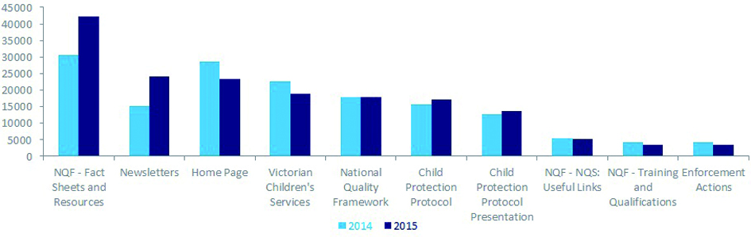


Approvals and licensing
QARD has an important informative and educative role for new and existing providers of education and care services. The Service Administration and Support team manages the assessment and analysis of applications and notifications of change of circumstances, and undertakes the assessment of
an applicant’s fitness and propriety.
Approvals are granted for a provider to operate an education and care service. Several providers were not actually operating a service, and 14 had not paid annual fees as at 31 December 2015.
A total of 2261 applications were processed in 2015. Applications to QARD decreased overall compared to 2014 due to the removal of Supervisor Certificate Applications (Figure 5).
The number of notifications received has increased, the top two notification types being ‘changes to services’ and ‘change of contact details’ (Figure 6).
Over 2015 QARD made a number of process and system changes to help approved providers and new applicants meet their statutory requirements when lodging applications and notifications.
New fact sheets were also developed to help inform applicants of the application process. QARD regularly reviews its processes and the information it provides to the sector to streamline the application process for the applicant and also to meet regulatory time lines for processing.
With the DoE, QARD holds information sessions for people interested in starting an FDC service. These provide detailed insights into the application
process, and clearly outline federal and Victorian Government expectations.

Figure 5 : Comparison of the number of applications submitted in 2014 and 2015

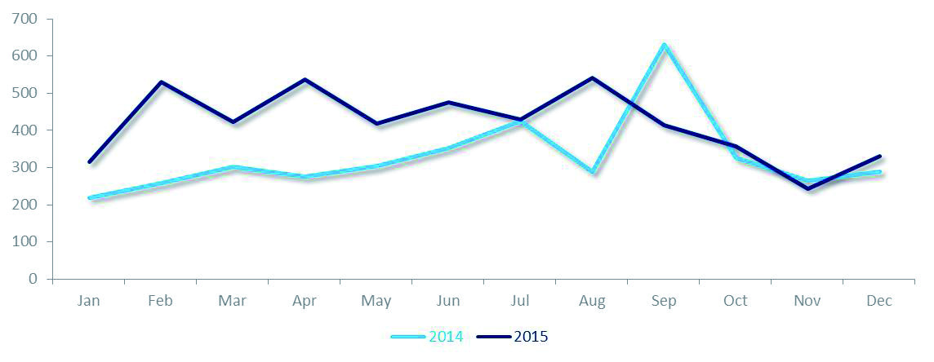
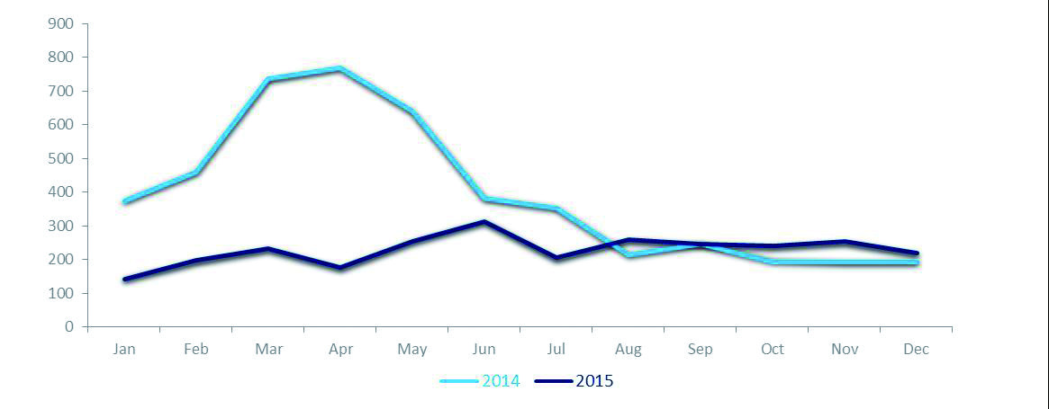
Figure 6 : Application-related notifications submitted in 2014 and 2015



Case study
– FDC forum
The Service Administration and Support Unit holds information and assessment sessions for people interested in starting an FDC service. The initial session outlines the role and responsibilities of an approved provider under the NQF and also demystifies the application process. Once an application is completed, the applicant attends an assessment session that is designed to evaluate their fitness to manage or control a service. All this supports QARD’s work of meeting the objectives and guiding principles of the NQF.
In 2015, 250 people attended QARD’s 12 information and assessment sessions.
These sessions allow us to inform people about the National Law, the Education and Care Services National Regulations 2011 (National Regulations),
the NQS, and the procedures and processes for their implementation. They also provide the opportunity to discuss Victoria-specific requirements, for example, managing bushfire risks in FDC.
Applicants can ask questions face-to-face and
be guided to resources that help them with their applications and in meeting legal and regulatory requirements. Sessions are delivered in collaboration with the DoE, and also inform applicants about
the process and procedures for obtaining
childcare benefits.
Attendance at a session begins stakeholder engagement with QARD, which continues through the application process and later, in a less direct way, through other applications and activities like notifications and amendments, post-approval.
Monitoring and compliance
We take a responsive, risk-based approach to our regulatory role. Compliance visits and assessment and rating visits ensure approved providers and licensees:
• comply with the National Law and National
Regulations or the Children’s Services Act
and Children’s Services Regulations 2009
(Regulations)
• support the safety, health and wellbeing of
children and their educational and
developmental needs.
In 2015, authorised officers completed 1606 compliance visits to services operating under the NQF, and 213 compliance visits to services operating under the Children’s Services Act.
Notifications of complaints and incidents
The NQF and Children’s Services Act include requirements for service providers to notify QARD of serious incidents including:
• the death of a child
• any incident involving serious injury or trauma
to, or illness of, a child
• any incident where the attendance of
emergency services was required
• any circumstance where a child being
educated and cared for by an education and
care service appears to be missing or cannot
be accounted for.
In addition, under Regulation 175 (2), QARD is required to be notified of changes affecting the hours and days of operation of a service, any circumstance that poses a risk to a children and matters related to FDC venues.
Service providers must also notify QARD of complaints where there may have been a contravention of the relevant law or where the safety, health or wellbeing of a child may have
been compromised.
In 2015, QARD received 5818 notifications of complaints and incidents.
Serious incidents
In 2015, there were 3490 notifications of serious incidents for services operating under the NQF. A further 19 were received for services operating under the Children’s Services Act (Figure 7).
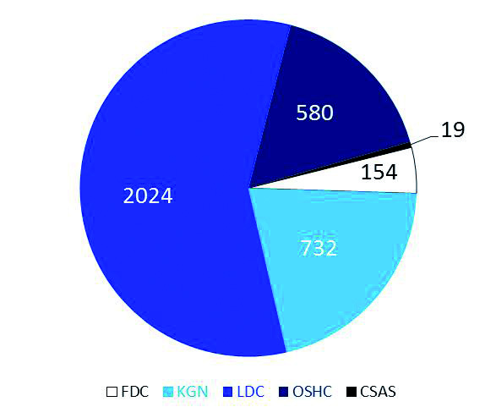
Figure 7 : Notifications of serious incidents by
service type
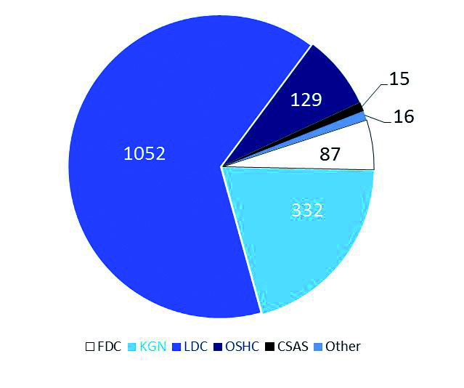

Complaints
Complaints can be made to QARD by any
person including parents, members of the public
or educators.
In 2015, there were a total of 1616 notifications of complaints for services operating under the NQF and a further 15 complaints for services operating under the Children’s Services Act (Figure 8).
Sanctions
Where there is evidence that a service and/or an approved provider is operating in serious and/or persistent non-compliance, QARD may take action including administrative or statutory sanctions or the prosecution of an approved provider.
QARD publishes relevant statutory sanctions
on the Department’s website. A total of 19 sanctions were published in 2015 (Figure 9).
Figure 8 : Notifications of complaints by
service type
FDC compliance
In 2015, 9 of the enforcement actions applied to FDC services or providers. QARD sought to address this over representation by collaborating with relevant Commonwealth Government departments to identify compliances issues. It also took part in a FDC working group, comprising representatives from each state and territory government, the Commonwealth Government and ACECQA.
Proposed amendments to the National Regulations, scheduled for 2016, are intended to allow regulatory authorities to more effectively regulate FDC services.

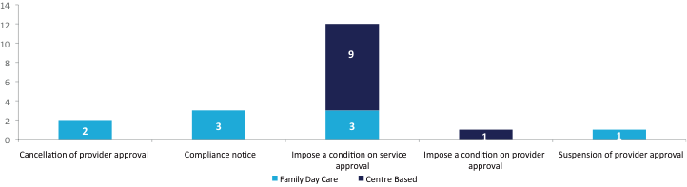
Figure 9 : Statutory sanctions NQF 2015
Case study
– operation caulis
In December 2015, the Department worked with the Australian Federal Police to investigate fraudulent practices by FDC operators and educators. These related to Commonwealth subsidies for 50 hours of care a week in approved childcare services. Our ‘powers of entry’ to principal offices and help with Operation Caulis saw six people arrested and luxury cars, bank accounts and two Melbourne properties seized over the alleged rorting of more than
$15 million.
QARD will continue to partner with Commonwealth departments and other regulatory authorities to promote the safety, health and wellbeing of children in early childhood services, and to ensure providers are ‘fit and proper’.
Prosecutions
Service providers or licensees can be brought before a court to answer charges of a breach of legislation.
To bring a prosecution, charges must be laid within a year of the date of the commission of the offence under the Children’s Services Act, and within two years of the date of the commission of the offence under the NQF.
In 2015, four prosecutions were commenced before the courts. Of these matters, one was finalised in 2015 with the individual pleading guilty to operating without a licence.
Prohibition Notices
Prohibition notices may be issued to a person involved in the provision of an approved education and care service where it is considered by QARD that there may be an unacceptable risk of harm to a child or children.
In 2015, there were three prohibition notices issued to individuals by QARD.
Unlike many other sanctions that QARD can impose, details about prohibition notices are not published on the website.
Waivers
Approved providers may apply to QARD for waivers from elements of the NQS and the National Regulations relating to their physical environment and staffing arrangements.
A small number of physical environment waivers are granted each year. Often they relate to indoor and outdoor space requirements, and are granted to allow services to undertake renovations or to allow OSHC services to operate without outdoor space at the premises, where appropriate.
Most waivers continue to be from staff qualification requirements (Figure 10).
In 2015, the majority of qualification waivers were from the new early childhood teacher requirements for centre-based services for children from birth to preschool age.
A waiver strategy was developed, allowing a service more time to comply with early childhood teacher requirements provided it took steps to comply with the requirements by the end of 2015.

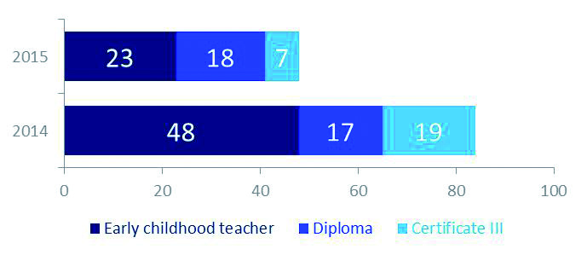
Figure 10 : Qualification waivers granted in 2014 and 2015

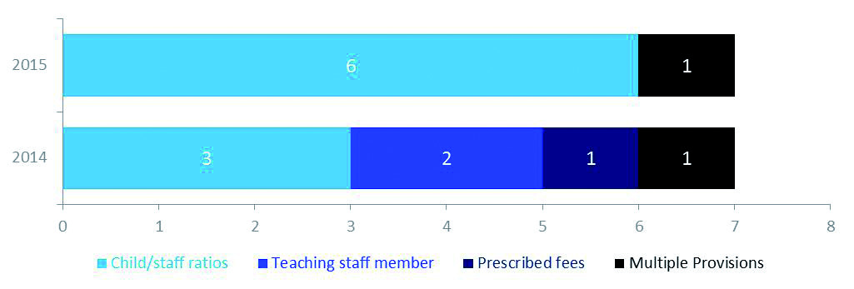
Figure 11 : Exemptions granted under the Children’s Services Act and Regulations in 2014 and 2015

Exemptions
A licensee may apply to QARD for an exemption from all or any of the provisions of the Children’s Services Act and its regulations. Few exemptions were granted, consistent with the small number of services that continue to operate under this legislation (Figure 11).
QARD developed an exemption strategy in 2014
to reduce the regulatory burden on services operating under the Children’s Services Act. Under the Regulations, someone working towards a qualification may not be counted as a qualified staff member.
However, to align the requirements of these regulations to the National Regulations, services can now apply for an exemption to allow staff working towards a qualification to be counted
as qualified.
Reporting
The QARD team captures Victoria’s data on a national system and then does reporting and data analysis. This helps us to take a responsive, risk-based approach to our regulatory role and to evaluate the outcomes of our work and sector-wide trends over time.
All enforcement actions in 2015 are included in the Appendix and published on the website.
Assessment and Rating
Our staff work as a team to assess and rate Victoria’s many services. Authorised officers assess and rate services using the seven quality areas, 18 standards and 58 elements that make up the NQS. Services get a rating for each of the seven quality areas and an overall rating. Results are showing

December 2015 assessment and rating summary – NQF
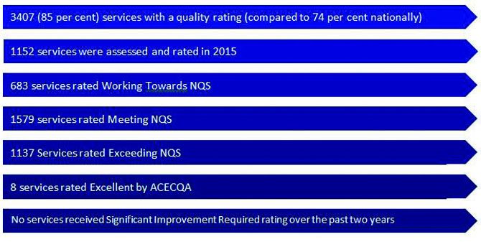
initially that, for the 210 services re-rated, the assessment and rating process is improving quality, with 67 per cent of assessed services improving by one or two rating levels.
Kindergartens continue to be the strongest performers with 90 per cent meeting or exceeding the NQS, compared with 81 per cent of LDC services, 71 per cent of OSHC services and 51 per cent of FDC services (Figure 12).
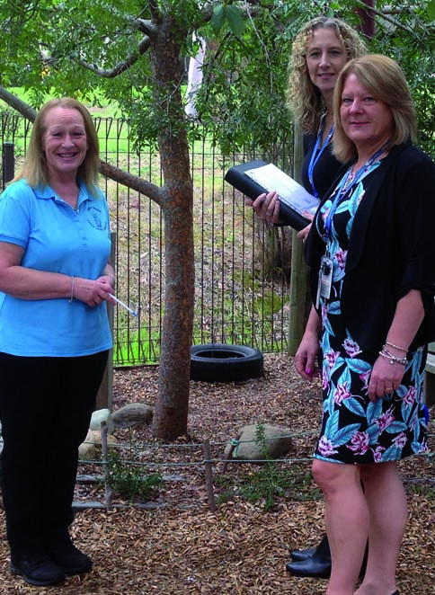
Figure 13 shows the provider management types for services and the related assessment and rating outcomes. State/territory and local governmentmanaged services are the highest performing in Victoria reflecting the strong role local government play in early childhood services in this state.
Authorised Officers at service visit
In 2015, a new initiative was introduced to seek feedback about the assessment and rating process from approved providers. Seventy-two survey responses (42%) were received regarding their experience of the process, with very positive responses. In particular, services commented on the professionalism of authorised officers and the support they received throughout the assessment and rating process. Further analysis of the responses from 2015 and the first quarter in 2016 is planned to identify any improvements that could be incorporated into the current assessment and rating process.

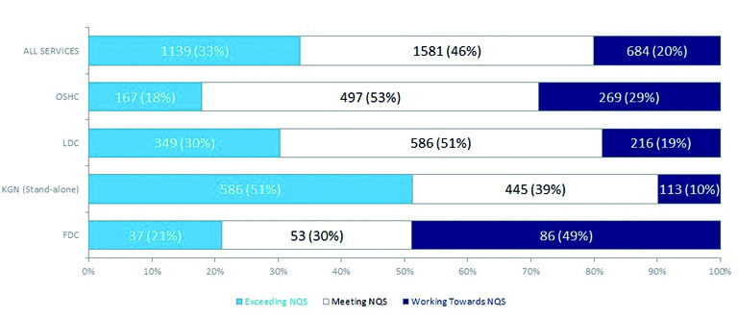
Figure 12 : Final rating by care type (31 December 2015)

Figure 13 : Final rating by management type (31 December 2015)
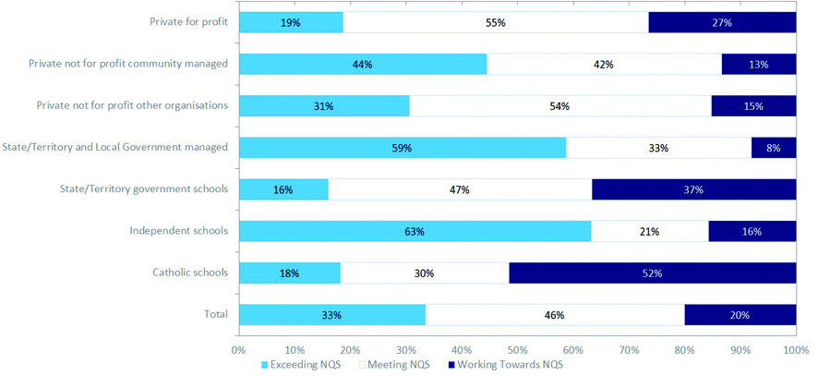

This initiative builds on the current process where the service has the opportunity to consider the draft assessment and rating report and provide feedback about the rating outcome the service will receive.
Excellent work!
If a service gets an Exceeding NQS rating it can apply to ACECQA for the ‘Excellent’ rating. The coveted Excellent rating has been awarded to the following centres in 2015.
• The Lady Gowrie Child Centre (Melb) Inc.,
located in the Docklands and
despite its high-rise location, provides
outdoor space and an engaging indoor/
outdoor program. It’s also building
meaningful, ongoing links with the local
community through an extensive ‘community
connections excursion program’.
• Little Beacons Learning Centre in Pakenham
was recognised for its exceptional
commitment to children and families through
embedded, respectful practice that
celebrates cultural diversity.
• Baxter Preschool and Children’s Centre
works with vulnerable families and children
with additional needs. Its high-quality service
exemplifies an outstanding education and
care program that is tailored to respond to
disadvantaged children and families.

• Clarendon Children’s Centre Cooperative
was recognised for its exceptional education
and care through its practice and sustained
commitment to the professional
development and support of educators.
Case study
– improving care
A wonderful story about a service focused on improving the quality of care and education
for children ...
In February 2014 QARD received a complaint about an early childhood service and launched an investigation. During our investigation into the complaint our officers talked with the service about areas of its program and practice, and its physical environment. We visited regularly and met with the approved provider. Soon after, a new kindergarten educator was appointed and QARD regional staff worked with the approved provider through compliance visits and also provided an education session for all employees about understanding the National Law and the National Regulations.
This is a fantastic turnaround story because, after two years of continuous improvement and following an Assessment and Rating visit in November 2015, the service was rated ‘Exceeding NQS’ across all seven quality areas.
Another strong example of how QARD staff work alongside services to create great outcomes for children! This service is managed by Eureka Community Kindergarten Association, a kindergarten cluster manager that supports services by managing human resources, policy development, quality improvement processes and compliance with the National Law.

Emergency management
Every service in Victoria must have a regularly-reviewed and updated emergency management plan, and notify us in the case of an emergency or safety incident like a fire or bomb threat. During September and October 2015 we held information sessions
on emergency management planning for service providers across regional and metropolitan
Victorian centres.
In 2015, QARD continued to work with the Department’s Regional Services Group to support the sector’s preparations for bushfires, floods, intruders, bomb or shooting threats and more. We updated the Bushfire At-Risk Register with at-risk early childhood services and schools and encouraged all services to have plans in place to manage emergencies and accurate contact details for families.
Reviews of QARD decisions
We aim to be fully transparent in our decision-making and ensure people know their avenues for appeal.

After receiving their draft assessment and rating report providers have 10 days to provide formal feedback to QARD over any factual inaccuracies that could significantly impact the service’s rating.
A review of the assessment and rating outcomes can be requested in writing with QARD. Five first-tier reviews were received in 2015 and no second-tier reviews were received.
Some other decisions are also reviewable, for example, refusing provider approvals, revoking a service waiver or a compliance notice. The person who is the subject of a reviewable decision may apply to QARD for an internal review of the decision or to the Victorian Civil and Administrative Tribunal for an external review of the decision. In 2015, two applications were considered by the Victorian Civil and Administrative Tribunal for an external review of the decision.
In 2015, we were approached by the Ombudsman regarding two QARD investigations and closed
both satisfactorily.

Glossary
ACECQA Australian Children’s Education and Care Quality Authority
Children’s Services Act Children’s Services Act 1996 (Vic)
COAG Council of Australian Governments
CSAS Children’s Services Act Services
the Department Department of Education and Training (Vic)
DHHS Department of Health and Human Services (Vic)
DoE Department of Education and Training (Commonwealth)
ECSEG Early Childhood and School Education Group
FDC Family day care
KGN Kindergarten
LDC Long day care
National Law Education and Care Services National Law Act 2010 (Commonwealth)
National Regulations Education and Care Services National Regulations 2011
NQA Review Review of the National Partnership Agreement on the National Quality
Agenda for Early Childhood Education and Care
NQF National Quality Framework
NQS National Quality Standard
OSHC Outside school hours care
QARD Quality Assessment and Regulation Division (Vic)
Regulations Children’s Services Regulations 2009
VIT Victorian Institute of Teaching
VRQA Victorian Registration and Qualifications Authority

Appendix
Enforcement actions
Enforcement actions under the National Law and the National Regulations in 2015. For further details, click on any of the bold titles below to download the 2015 enforcements document.
• African Australian Family Day Care Pty Ltd
– Cancellation of provider approval (23/12/15).
• YMCA Ballarat — Ballarat Specialist
School OSHC
(Young Men’s Christian Association of
Ballarat Inc.)
25 Gillies Street North, Lake Gardens
– Imposition of conditions on service
approval (22/12/2015).
• YMCA Koroit Creek Early Learning Centre
(Victorian YMCA Community Programming
Pty Ltd)
130 Tenterfield Drive, Burnside Heights
– Imposition of conditions on service
approval (04/12/15).
• Gippsland Lakes Community Health
Children’s Centre
(Gippsland Lakes Community Health)
45 Coates Road, Lakes Entrance
– Imposition of conditions on service
approval (26/11/15).
• Fairy Hills Kindergarten
(Try Australia Children’s Services)
7 Thyer Road, Ivanhoe
– Imposition of conditions on service
approval (24/11/15).
• Little Jazzys Child Care and Kindergarten
(SR & NR Pty Ltd)
632 Mountain Highway, Bayswater
– Imposition of conditions on service
approval (24/11/15).
• Kensington Community Children’s Centre
(Kensington Community Children’s Co-op Ltd)
81B Altona Street, Kensington
– Imposition of conditions on service
approval (30/10/15).
• Eagles Family Day Care
(6Js Pty Ltd)
9 Ian Street, Noble Park
– Cancellation of provider approval (12/10/15).
• Hello Children Family Day Care
(Hello Children Family Day Care Pty Ltd)
37A Devonshire Road, Sunshine

– Suspension of provider approval for six
months from 23/09/15–23/03/16 (22/09/15).
• Mitcham OSHClub
(OSHClub Pty Ltd)
294 Mitcham Road, Mitcham
– Imposition of conditions on service
approval (07/08/15).
• All for Kids Family Day Care
(All for Kids Family Day Care Pty Ltd)
76 Doveton Avenue, Eumemmerring
– Imposition of conditions on service
approval (18/06/15).
• Gateway Family Day Care
(SA Dayib & MM Mohammed)
– Compliance notice (09/06/15).
• Yarriambiack Shire Council
– Imposition of conditions on provider
approval (18/05/15).
• Goodstart Early Learning Newtown
(Goodstart Early Learning Ltd.)
15 Aberdeen Street, Newtown
– Imposition of conditions on service
approval (18/05/15).
• Learn and Play House
(Learn and Play House Pty Ltd.)
Suite 1, 96 Garden Road, Clayton
– Compliance notice (23/04/15).
• Down Under Family Day Care
(Acvei Riak)
Shop 2, 144-148 Nicholson Street, Footscray
– Imposition of conditions on service
approval (27/02/15).
• Kidding Around Childcare and Kindergarten
(Kenji Pty Ltd)
36-38 Grimwade Crescent, Frankston
– Imposition of conditions on service
approval (04/02/15).
• In Loving Hands
(In Loving Hands Family Day Care Service
Pty Ltd)
185 High Street, Thomastown
– Imposition of conditions on service
approval (20/01/15).
• Rise High Early Learning Family Day Care
(Hafsatu Abubakar)
169 Ryrie Street, Geelong
– Compliance notice (16/01/15).


