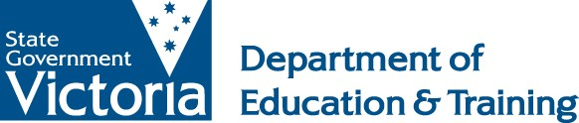
Quality Assessment and Regulation Division
2014 Annual Report

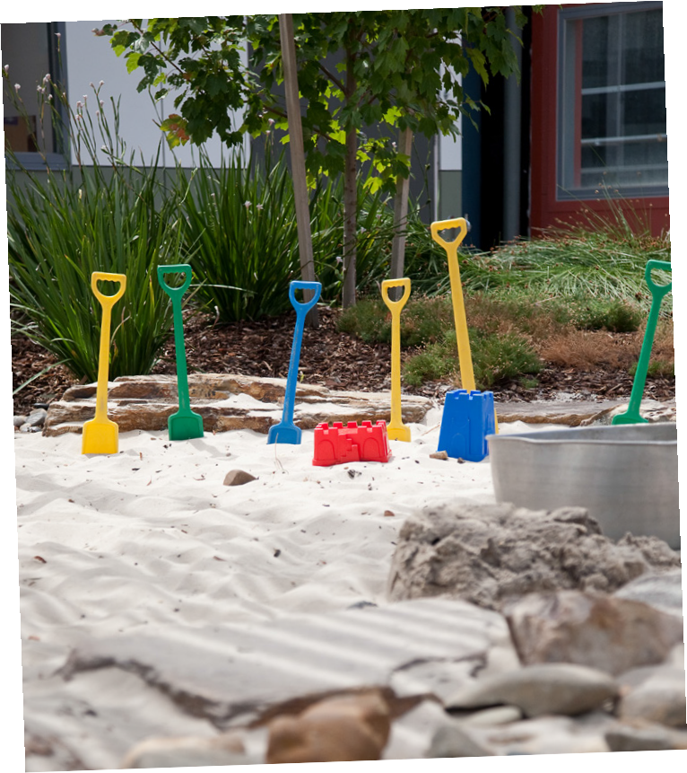









Published by the
Department of Education and Training
Melbourne
April 2015

©State of Victoria (Department of Education and Training) 2015

The copyright in this document is owned by the State of Victoria (Department of Education and Training), or in the case of some materials, by third parties (third party materials). No part may be reproduced by any process except in accordance with the provisions of the Copyright Act 1968, the National Education Access Licence for Schools (NEALS) (see below) or with permission.

An educational institution situated in Australia which is not conducted for profit, or a body responsible for administering such an institution may copy and communicate the materials, other than third party materials, for the educational purposes of the institution.

Authorised by the Department of Education
and Training
2 Treasury Place, East Melbourne, Victoria, 3002.
ISBN 978-0-7594-0791-6

Contents

Introduction 3
Quality Assessment and Regulation Division 4
Structure 5
Regulated services 6
Services operating under the NQF 6
Services operating under the Children’s Services Act 7
Approved providers 7
Key functions 8
Approvals and licensing 8
Monitoring and compliance 10
Notifications and investigations 12
Compliance action 14
Assessment and rating 16
Training and development 23
Stakeholder engagement 24
Provision of information 24
Conclusion 25

Introduction

Madeleine Smith, Executive Director, Quality Assessment and Regulation Division

I am pleased to present the second annual report of the Quality Assessment and Regulation Division (QARD).

QARD is Victoria’s regulatory authority, responsible for ensuring the safety, health and wellbeing of children in kindergarten, long day care, family day care and outside school hours care.

QARD also drives the improvement of services so children receive the best possible care and education to support their social, emotional and intellectual development.

There are almost 4000 education and care services in Victoria, which operate under the National Quality Framework (NQF), introduced in 2012 to provide better outcomes for children.

QARD regulates these services as well as over 450 other services, mainly offering occasional care, which continue to operate under the Children’s Services Act 1996 (Children’s Services Act).

In 2014, QARD enhanced its efforts to support providers to meet their legislative obligations, and improve the quality of their services. QARD not only responds to the needs of its stakeholders, but takes a proactive approach, including through targeted education and training programs.

QARD has maintained its strong focus on monitoring providers and services to ensure they comply with regulations. Its activities include assessment and rating visits, and the investigation of serious incidents and complaints. Growth in the number of family day care (FDC) services has determined extra monitoring of these services, and the assessment process for FDC applicants has been strengthened.

QARD has emphasised the effective use of sanctions to combat non-compliance across all types of services. In rare cases of serious or persistent non-compliance, QARD has considered prosecution.

Meanwhile, QARD has continued to work with governments and agencies across Australia to improve NQF processes. A new, streamlined assessment and rating process, including a more efficient report-writing tool, contributed to a 30 per cent increase in completed assessment and rating visits in the second half of 2014. Amendments to the Education and Care Services National Regulations 2011 (National Regulations) allowed approved providers to assess supervisors for accreditation, significantly reducing QARD’s workload in this area.

QARD is on-track to meet its national obligation to assess and rate all services operating under the NQF in Victoria by the end of 2015. It has also made significant gains in enhancing the quality of those services.

By 31 December 2014, 60 per cent of services in Victoria had received at least one assessment and rating visit. Of those services, 78 per cent met or exceeded the National Quality Standard (NQS), compared with 65 per cent of services across Australia.

Quality Assessment and Regulation Division
In each Australian state and territory, a regulatory authority ensures the safety, health and wellbeing of children using education and care services. The Quality Assessment and Regulation Division (QARD) is Victoria’s regulatory authority, established by delegation from the Secretary of the Department of Education and Training (DET).

QARD:
- licenses and approves providers and services and approves certified supervisors
- monitors service compliance
- investigates serious incidents and complaints
- assesses and rates education and care services against the NQS and National Regulations
- educates and guides providers to meet legislative obligations
- enforces legislation through appropriate administrative and statutory sanctions and prosecutions
- works with the Australian Children’s Education and Care Quality Authority (ACECQA) and other jurisdictions to educate services, families and the community about the NQF
- contributes to a consistent national approach to regulating education and care services
- works with other divisions of DET and external stakeholders to foster continuous improvement in education and care services
- collects, reviews and shares data, including for the regulation of services and to meet NQF reporting requirements.

QARD has continued to meet NQF milestones by:
- establishing, maintaining and supporting a viable, capable and reliable authorised officer workforce
- ensuring a risk-based approach to regulation, including establishing an effective monitoring regime and risk-based strategies for investigating notifications of complaints and serious incidents
- undertaking timely and effective assessment and rating of services against the NQS and National Regulations
- monitoring approved education and care services and licensed children’s services under the Education and Care Services National Law 2010 (National Law) and the Children’s Services Act
- developing and maintaining effective business systems and reporting processes to support QARD’s legal obligations
- maintaining and developing timely and effective provider, service and supervisor approval processes
- communicating with providers, services and key stakeholders about the purpose and implementation of the NQF, the requirements of the National Law, the Children’s Services Act and respective regulations
- ensuring that relevant information about the regulation of education and care services in Victoria is publicly available.

Structure
QARD is a statewide service. Its central office is responsible for ensuring regulatory and reporting obligations are met. It includes units specialising in service quality and legislation, monitoring and compliance, consistent practice and support, operations, business systems and review, and service administration and support.

The central team manages and supports nine area-based teams: Barwon South West, Grampians, Western Metropolitan, Loddon Mallee, Northern Metropolitan, Gippsland, Southern Metropolitan, Eastern Metropolitan and Hume. Authorised officers in area-based teams assess and rate services, investigate serious incidents and complaints and conduct service compliance visits.

Area-based teams have a total of 81 approved full-time equivalent positions; the central office has 30.

Organisational chart

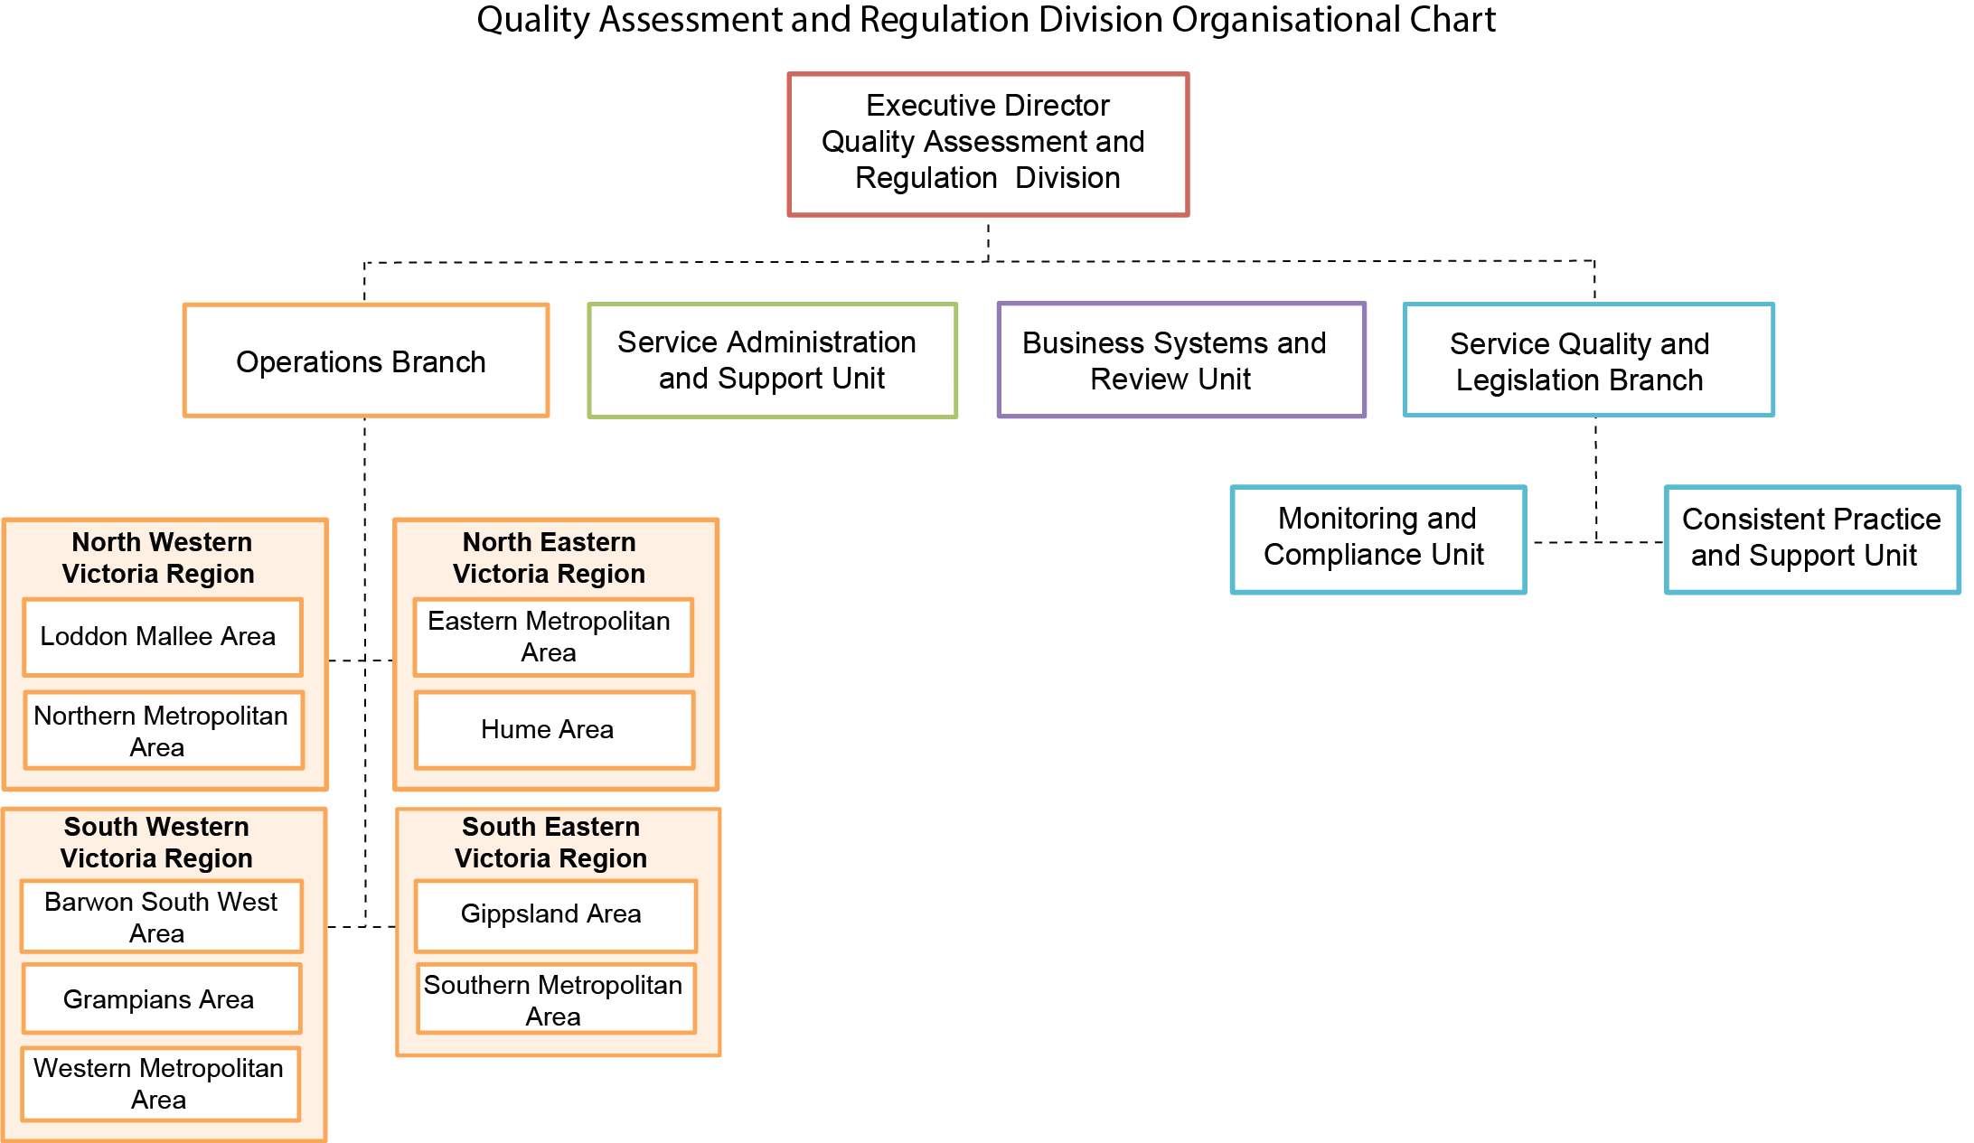

Regulated services

Services operating under the National Quality Framework
There are 3930 education and care services operating in Victoria under the NQF. They comprise kindergartens (preschools) and long day care (LDC), outside school hours care (OSHC) and family day care (FDC) services.
Figure 1: Services regulated under the NQF, by type (31 December 2014)
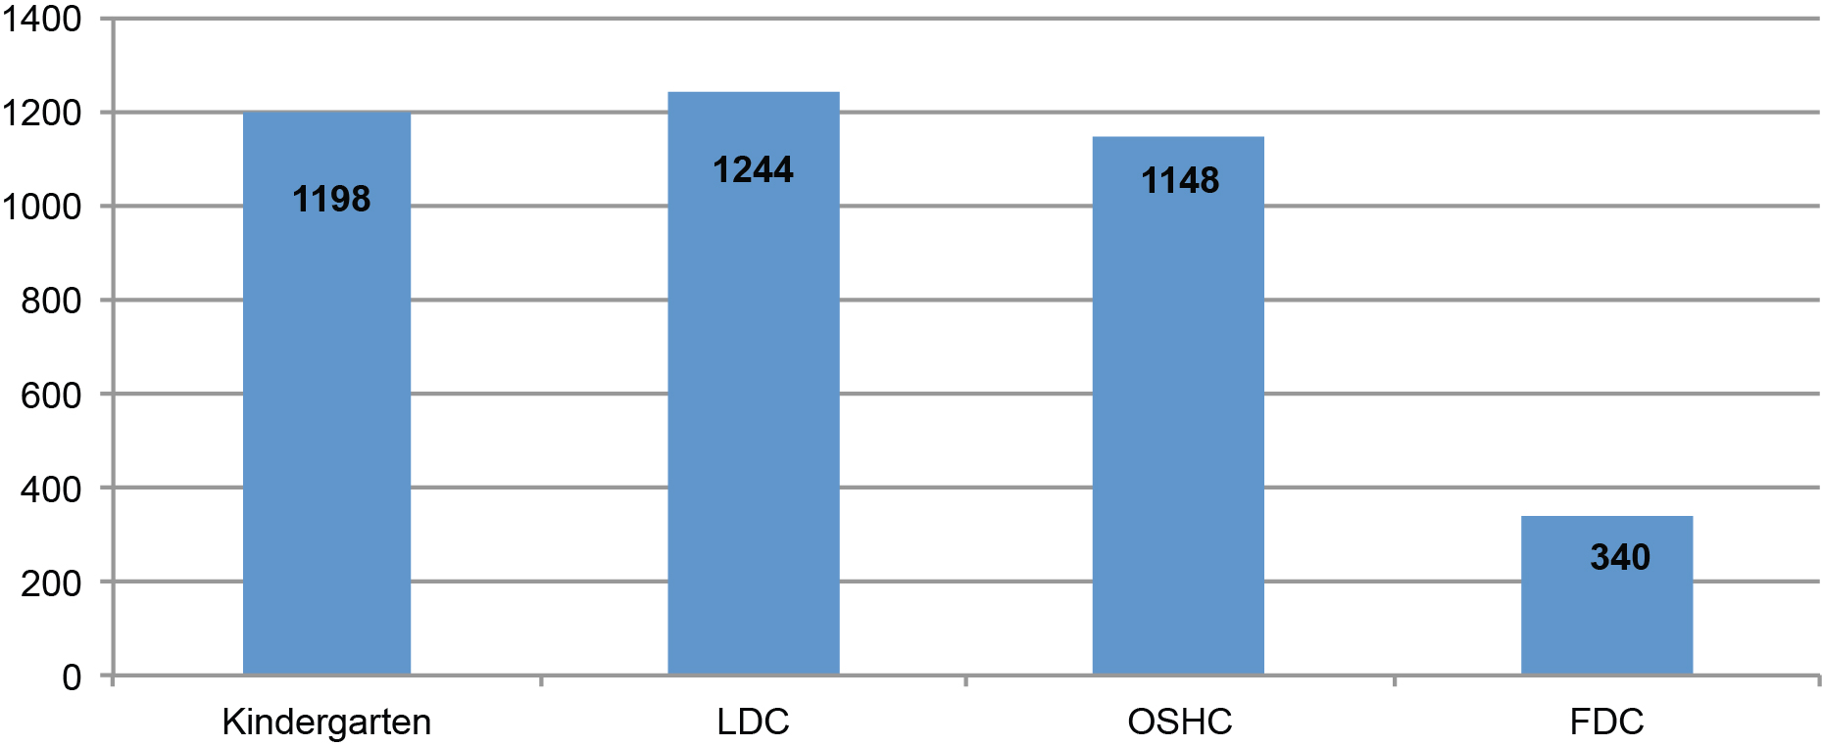

Growth in education and care services by region
Services operating under the NQF have increased from 3719 services in 2013 to 3930 services in 2014: a net increase of 211 services. The Western Metropolitan Area added the most services (67).
Figure 2: Comparative growth in education and care services, by region (2013-2014)
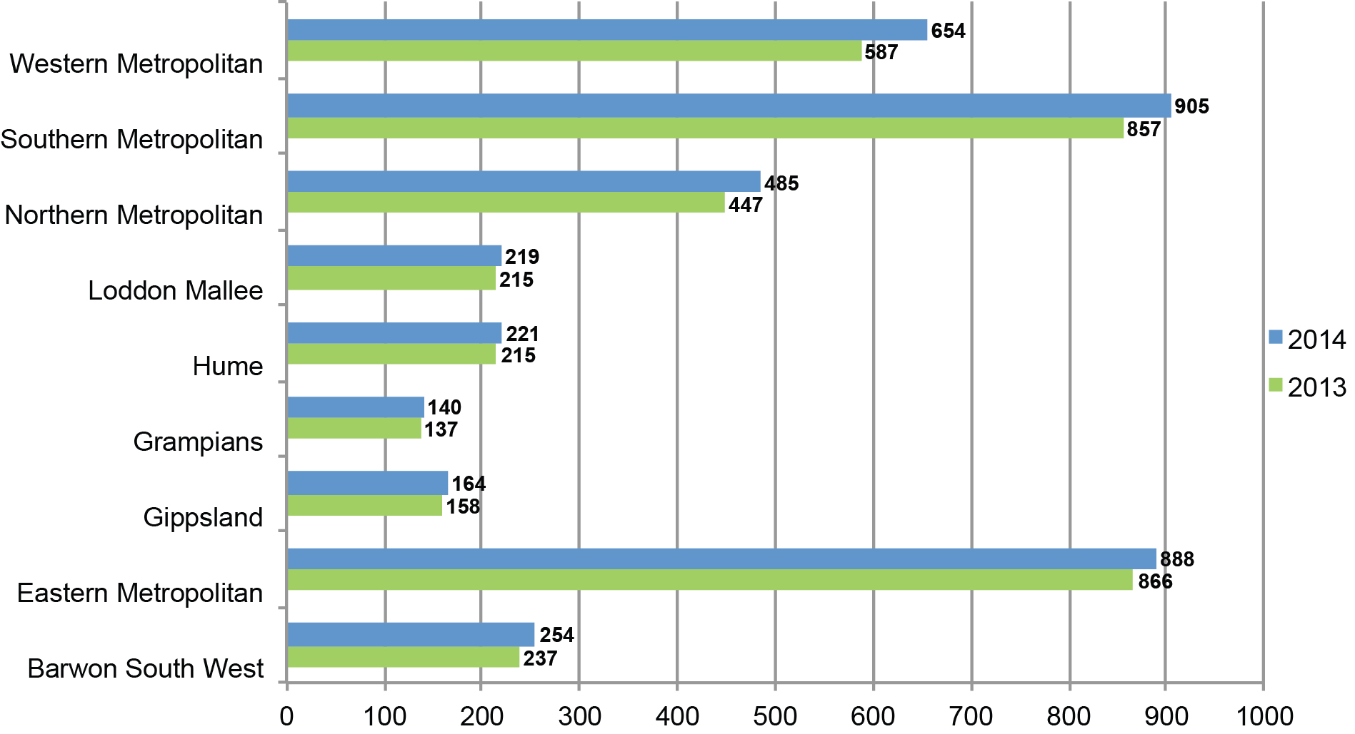

Services operating under the Children’s Services Act
There are 488 services operating under the Children’s Services Act. Most provide occasional care. Services include all limited-hours and short-term licensed services, budget-based services not funded for the Child Care Benefit, occasional care, sports and leisure services, early childhood intervention and mobile services, and one school holiday care service.
Figure 3: Services regulated under the Children’s Services Act, by type (31 December 2014)
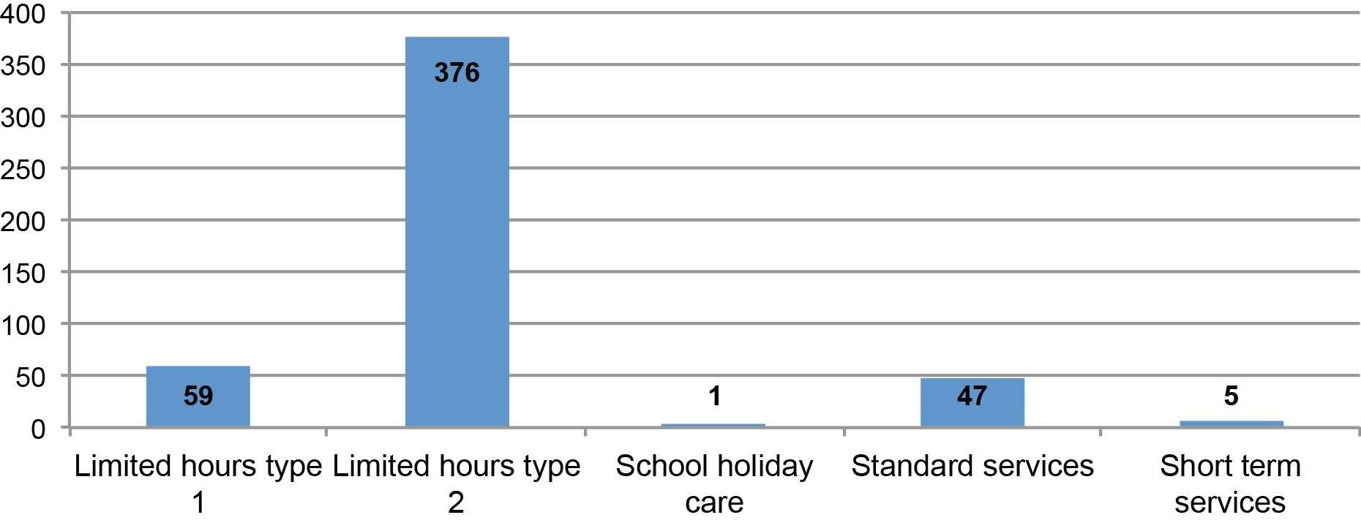

Approved providers
There were 2127 approved providers operating under the NQF in 2014. Most approved providers
(75 per cent) manage only one education and care service.

Less than 1 per cent of approved providers manage 25 or more centre-based education and care services. This 1 per cent manages a total of 1282 services, or 36 per cent of all centre-based services. Among them are Camp Australia, OSHClub and Extend, providing a total of 44 per cent of all OSHC services.

Table 1: Approved providers with 25 or more centre-based education and care services
Approved provider | Services | Type of service
Camp Australia | 343 | OSHC
Goodstart Early Learning | 172 | LDC
The Partnership of Quality Recreational Service Pty Ltd ATF Bruce Family Trust and Telepress Pty Ltd ATF Telepress Discretionary Trust (OSHClub) | 108 | OSHC
G8 Education Limited | 84 | LDC
Uniting Church in Australia Property Trust (Victoria) | 67 | Mixed
Early Childhood Management Services Inc. | 66 | Mixed
Child & Family Care Network | 61 | Mixed
Extend (Australia) Pty Ltd | 54 | OSHC
Young Men's Christian Association of Ballarat Inc. | 48 | Mixed
Casey City Council | 41 | Mixed
Knox City Council | 36 | Mixed
Brimbank Preschool Association Inc. | 33 | Mixed
Geelong Kindergarten Association Ltd | 32 | KGN
Victorian YMCA Community Programming Pty Ltd | 31 | Mixed
Try Australia Children's Services | 29 | Mixed
Hume City Council | 27 | Mixed
Guardian Community Early Learning Centres Pty Ltd | 25 | LDC
Latrobe City Council | 25 | Mixed

Table 2: Approved providers by management type
Approved providers—management type
Private for-profit | 953
Private not-for-profit, community managed | 598
Government schools | 318
Independent schools | 92
Local government managed | 72
Other private not-for-profit organisations | 50
Catholic schools | 42
Other | 2
Total | 2127

Key functions

Approvals and licensing
Changes to the National Law in June 2014 allowed approved providers to assess and certify education and care supervisors. This significantly reduced the burden on QARD to assess supervisor certificates. In the first six months of 2014, QARD received and processed 2247 applications for certified supervisors. In the last six months of 2014, 650 applications were received and processed — a reduction of 1597 applications.

Applications to QARD decreased overall, from 6510 in 2013 to 4484 in 2014, due mainly to the June 2014 National Law changes. However, applications increased for provider approval and amendment of provider approval, amendment of service approval, re-assessment and re-rating, review of ratings and amendment of the supervisor certificate.

There were also more applications for approval of FDC providers and services. In response, advice for FDC applicants and FDC assessment processes were centralised. A total of 180 applicants, represented by 251 people, attended FDC information and assessment sessions. These are now held every four to six weeks and are fully subscribed until July 2015.

Table 3: Applications submitted (2013–14)
Applications submitted | 2013 | 2014
Amendment of provider approval | 48 | 109
Amendment of service approval | 384 | 416
Internal review of reviewable decision | 57 | 55
Provider approval | 367 | 455
Re-assessment and re-rating | 3 | 18
Review of ratings by regulatory authority | 16 | 19
Revocation of service waiver | 1 | 1
Service approval | 326 | 318
Service or temporary waiver | 127 | 106
Supervisor certificate | 5080 | 2897
Voluntary suspension of a supervisor certificate by certified supervisor | 2 | 1
Voluntary suspension of provider approval | 1 | 2
Voluntary suspension of service approval | 18 | 17
Amend a supervisor certificate | 27 | 56
Supervisor certificate for specified class of persons | 53 | 14
Total | 6510 | 4484
A greater proportion of provider approval applications were refused in 2014. Provider approval is refused when an applicant proposing to operate an education and care service is assessed as not fit and proper, and cannot demonstrate an understanding of the NQF and/or the ability to manage an education and care service. Of 455 applications for provider approval, 13 were refused.

Of 55 applications for internal review of a decision made by QARD, 35 were decided in favour of the applicant. A total of 318 applications for service approval were received; three were refused.

Applicants who have an internal review upheld may lodge an application for external review to the Victorian Civil and Administration Tribunal (VCAT). There was one application made to VCAT in 2014, to be heard in 2015.

The number of notifications received by QARD has increased to 4196 in 2014, the top two notification types being ‘changes to services’ and ‘change of contact details’.

Table 4: Notifications received (2013-2014)
Notifications | 2013 | 2014
Change of contact details | 390 | 1074
Changes to services | 1937 | 2193
Fitness and propriety | 5 | 14
Person with management or control and receivers | 363 | 478
Surrenders | 110 | 140
Transfers | 201 | 15
Change of Information about Approved Provider | 2 | 0
Surrender of Provider Approval | 33 | 0
Surrender of Service Approval | 106 | 0
Transfer of Service Approval | 219 | 282
Total | 3366 | 4196

Monitoring and compliance
QARD is responsible for monitoring:
- education and care services approved under the National Law and the National Regulations
- children’s services licensed to operate under the Children’s Services Act and Regulations.

To meet these responsibilities, QARD:
- regularly monitors and assesses services by conducting compliance visits and quality assessment and rating visits
- undertakes extra monitoring of services with poor compliance
- investigates complaints and notifications of serious incidents
- acts to address serious and/or persistent non-compliance
- uses a risk-based methodology, assessing risk according to the impact on children’s safety, health and wellbeing, together with the seriousness of the contravention with the National Law and National Regulations or Children’s Services Act and Regulations.

Waivers and exemptions
A service’s ability to comply with legislation may be affected by factors including its location, size and the type of care delivered. Waivers and exemptions allow services extra time to meet their legislative requirements and help them continue to operate while maintaining an acceptable level of compliance. Temporary waivers are also available when services cannot meet requirements for a short term.

Waivers
Approved providers may apply to QARD for waivers from elements of the NQS and the National Regulations relating to their physical environment and staffing arrangements. The National Law provides for two types of waivers: a service waiver that has no specified expiry date, and a temporary waiver that has a specified period of no more than 12 months.

A small number of physical environment waivers are granted each year. Often they relate to the amount of indoor and outdoor space required, and are granted to allow services to undertake renovations or to allow OSHC services to operate without outdoor space at the premises.

In 2014, two of these waivers were granted to allow children to move services during the Morwell mine fires.
Figure 4: Physical environment waivers granted (2013–14)
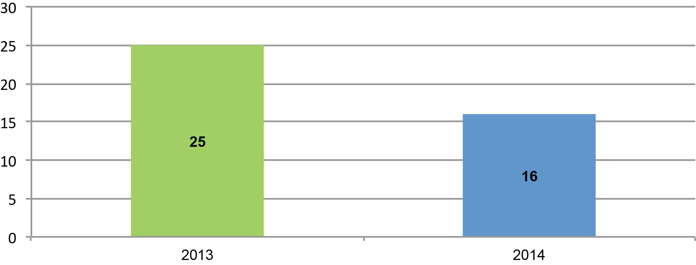

Most waivers continue to be from staff qualification requirements. In 2014, the majority of qualification waivers were from the new early childhood teacher (ECT) requirements for centre-based services for children from birth to preschool age. A waiver strategy was developed, allowing a service more time to comply with ECT requirements, provided it took steps to comply with the requirements by the end of 2014.
Figure 5: Qualification waivers (2013–14)
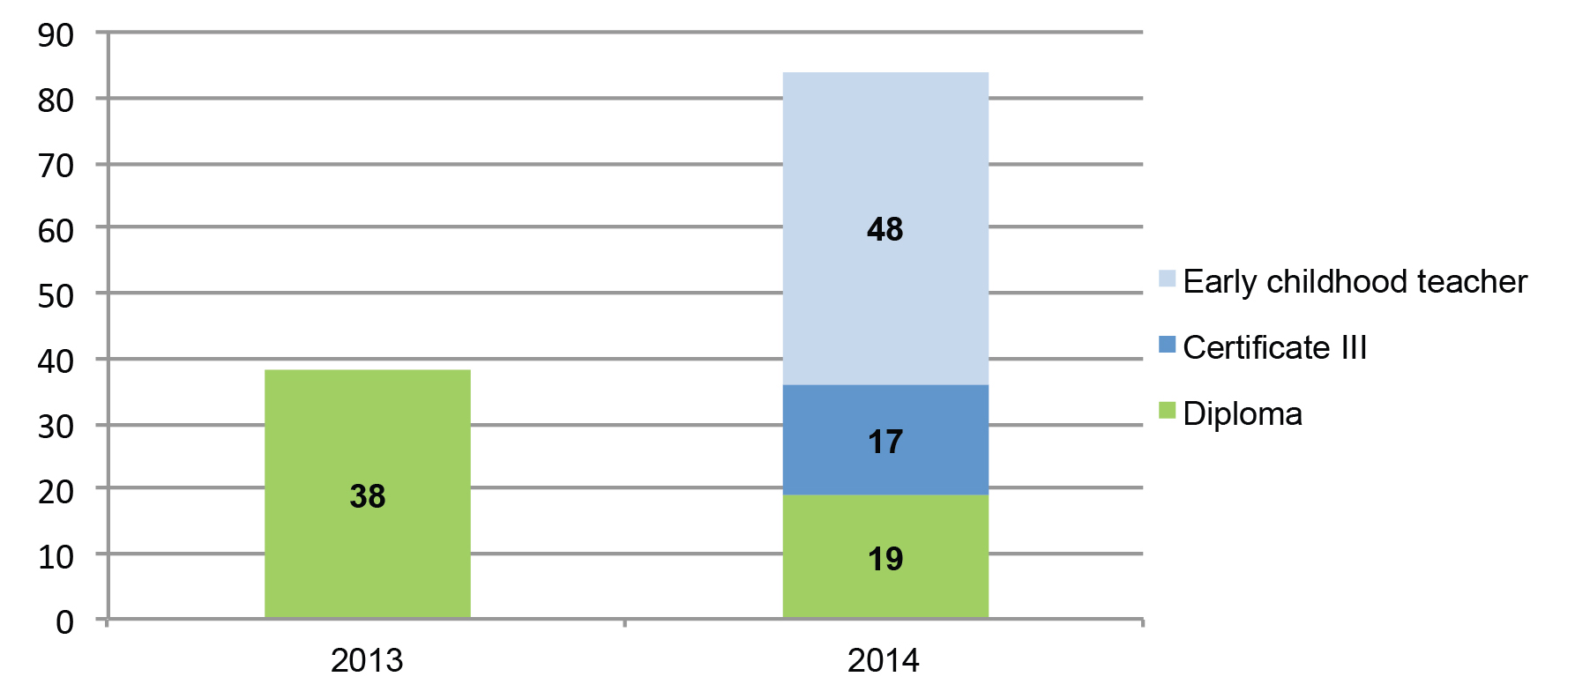

Exemptions: Children’s Services Act and Regulations
A licensee may apply to QARD for an exemption from all or any of the provisions of the Act and its regulations. Few exemptions were granted, consistent with the small number of services that continue to operate under this legislation.
Figure 6: Exemptions granted to Children’s Services Act and Regulations (2013–14)
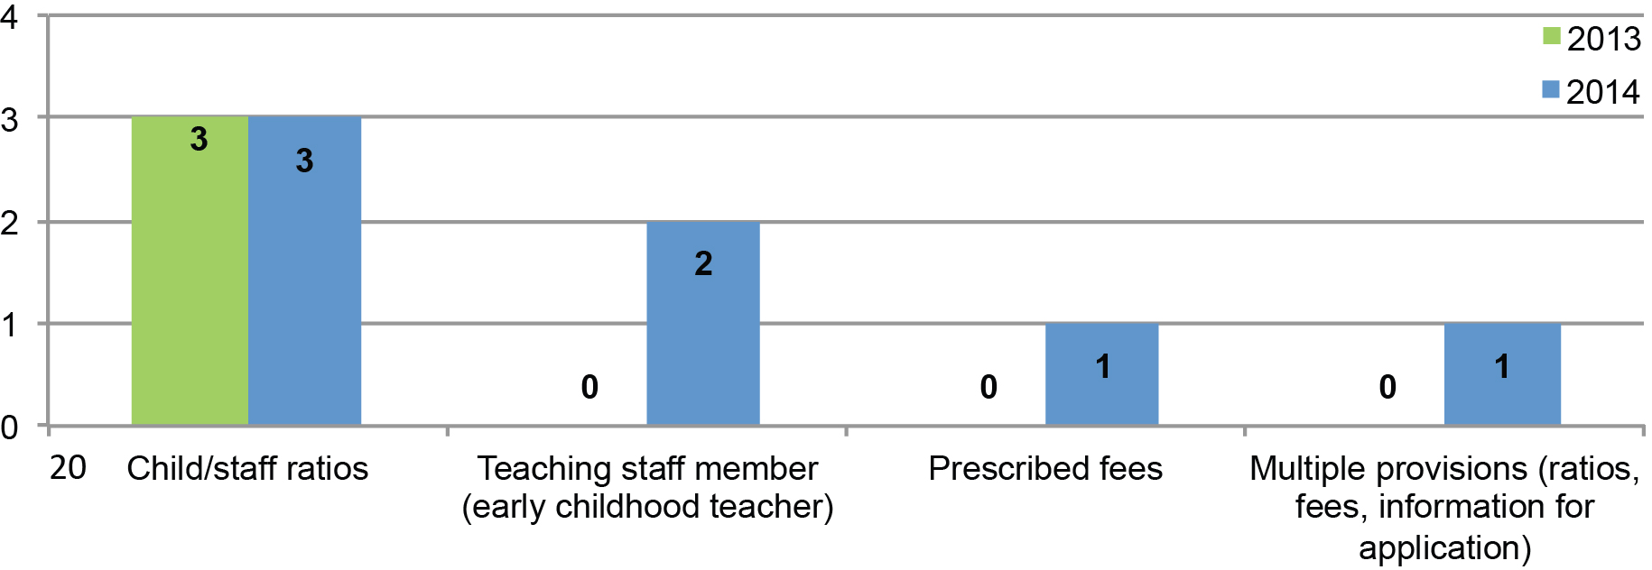

QARD developed an exemption strategy in 2014 to reduce the regulatory burden on services operating under the Children’s Services Act. Under the Children’s Services Regulations 2009 (Regulations), someone working towards a qualification may not be counted as a qualified staff member. However, to align the requirements of these regulations to the National Regulations, services can now apply for an exemption to allow staff working towards a qualification to be counted as qualified.

Compliance visits
Compliance visits and assessment and rating visits ensure approved providers and licensees:
- comply with the National Law and National Regulations or Children’s Services Act and Regulations
- support the safety, health and wellbeing of children, and their and educational and developmental needs.

In 2014, authorised officers completed 1651 compliance visits to services operating under the NQF.
A further 79 compliance visits were made to services operating under the Children’s Services Act.
Figure 7: Compliance visits to NQF services, by type (2014)
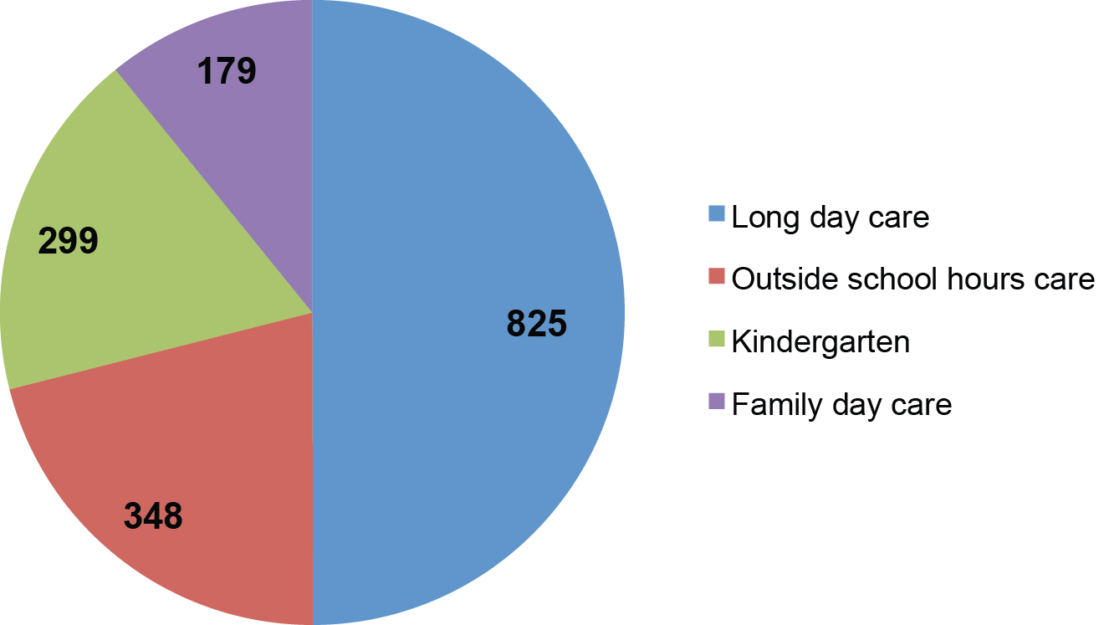

Following compliance visits, services are assigned a status according to their performance. This determines which services require more frequent visits to rectify problems.

Notifications and investigations
The NQF and Children’s Services Act include requirements for service providers to notify QARD of serious incidents including:
- the death of a child
- any incident involving serious injury or trauma to, or illness of, a child
- any incident where the attendance of emergency services was required
- any circumstance where a child being educated and cared for by an education and care service appears to be missing or cannot be accounted for.
Service providers must also notify QARD of complaints where there may have been a contravention of the relevant law or where the safety, health or wellbeing of a child may have been compromised.

Notifications of serious incidents
In 2014, there were 3249 notifications of serious incidents for services operating under the NQF.
Figure 8: Notifications of serious incidents in NQF services, by type (2014)

Complaints
Complaints can be made to QARD by any person including parents, members of the public or educators.

In 2014, there were a total of 1551 notifications of complaints for services operating under the NQF, and 33 for services operating under the Children’s Services Act.
Figure 9: Notifications of complaints against NQF services, by type (2014)
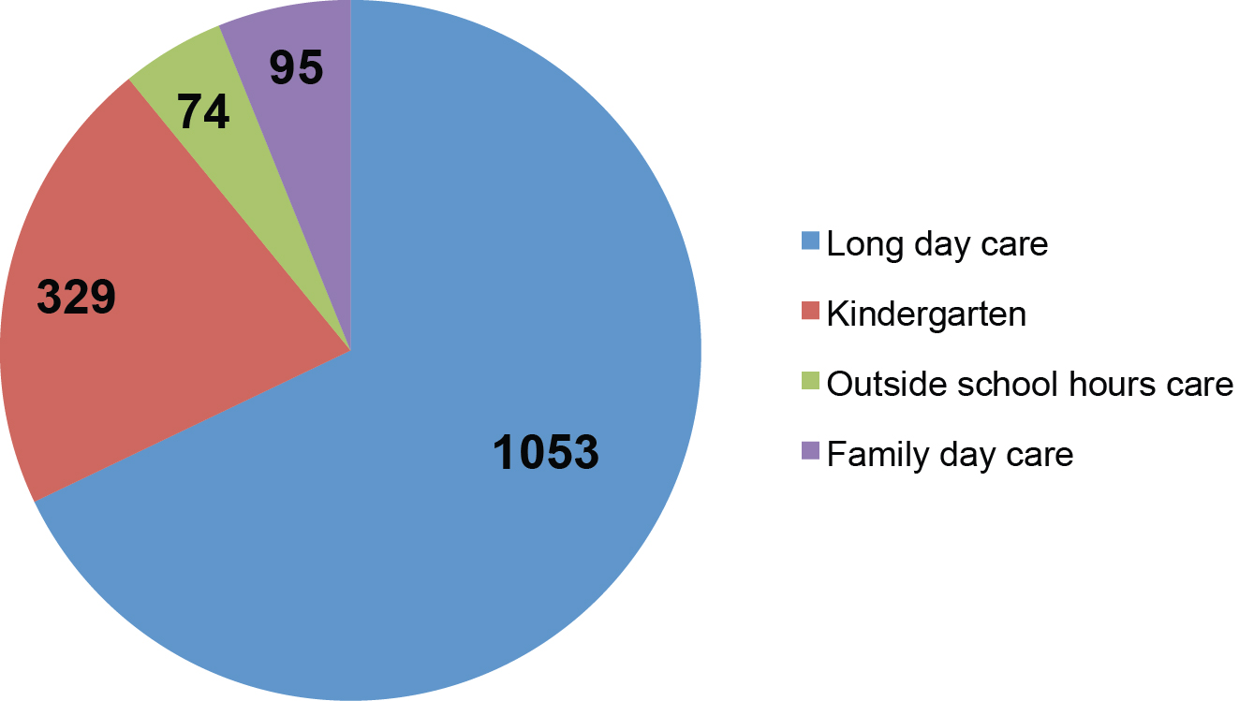

QARD complaints procedure framework

In 2014, QARD formalised its policy for managing complaints about the conduct of its staff in exercising their duties under the National Law and the Children’s Services Act. In the latter part of 2014, a Complaints Procedure Framework was developed, outlining QARD’s process and actions to address complaints. This provides an efficient, transparent and respectful way for resolving complaints.

Investigations
Notifications of serious incidents and complaints are investigated to:
- ensure compliance with the relevant legislation
- identify and mitigate risks to children’s safety, health and wellbeing.
In 2014, authorised officers undertook 1078 investigations.
Figure 10: Investigations into NQF services, by type (2014)
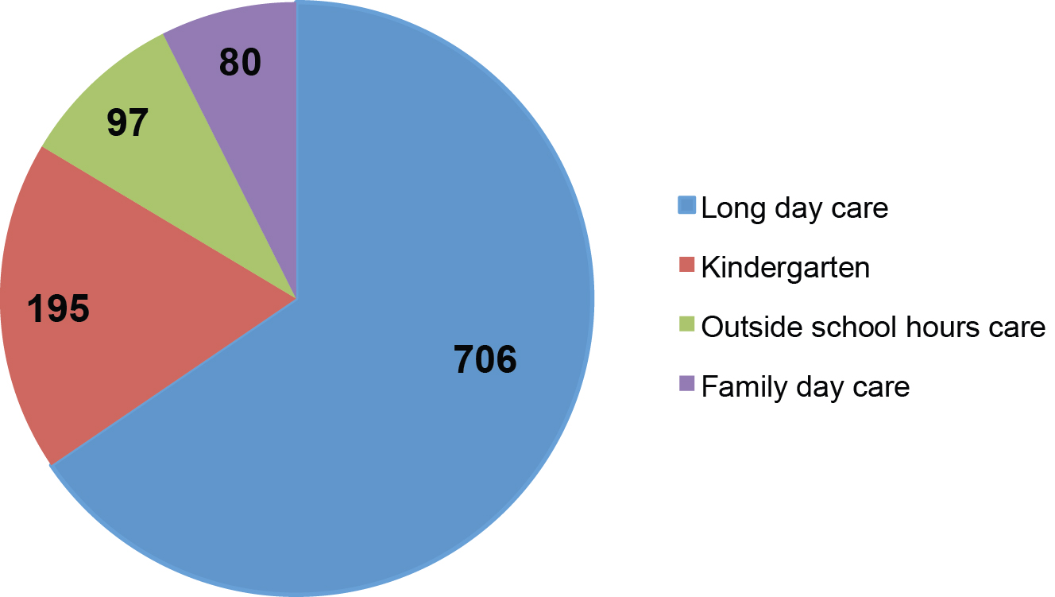

Compliance action
Where there is evidence that a service and/or an approved provider is operating in serious and/or persistent non-compliance, QARD may take action including administrative or statutory sanctions or the prosecution of an approved provider.

A serious compliance issues advisory panel meets to:
- provide support in managing serious and/or persistent non-compliance
- determine the most appropriate response, in accordance with statutory, common law and policy requirements
- define and improve practice by building consistency and the capacity of regulatory staff to respond to and manage complex compliance issues
- ensure the use of principles of best-practice regulation.
The panel may choose to apply administrative or statutory sanctions or recommend prosecution. QARD managers can also bring other complex issues to the panel for discussion.

Administrative sanctions
Administrative sanctions are not expressly prescribed in the legislation and include:
- increased monitoring of a service
- requiring the provider/licensee attend a formal interview
- issuing a notice of caution to the provider/licensee and, in some circumstances, a staff member.

Statutory sanctions
Statutory sanctions are prescribed in the National Law and Children’s Services Act and are reserved for the most serious cases of non-compliance. Statutory sanctions can only be imposed by senior officers of DET under delegation from the Secretary.

Statutory sanctions under the NQF include:
- suspension of a supervisor certificate, provider approval or service approval
- cancellation of a supervisor certificate, provider approval or service approval
- a compliance direction or notice
- a direction to exclude inappropriate persons from service premises
- an emergency action notice
- an enforceable undertaking
- imposing a condition on provider approval or service approval
- a notice to suspend education and care by FDC educator
- a prohibition notice.

The statutory sanctions under the Children’s Services Act include:
- a suspension of licence
- a cancellation of licence
- a notice to enforce
- a notice to take emergency action
- the removal of children in an emergency
- imposing a condition or restriction on a licence.
Statutory sanctions continued to be imposed in 2014, to better manage non-compliant services.
In rare cases of continual non-compliance, QARD escalated sanctions or considered prosecution.

Figure 11: Statutory sanctions against NQF services, by type (2014)
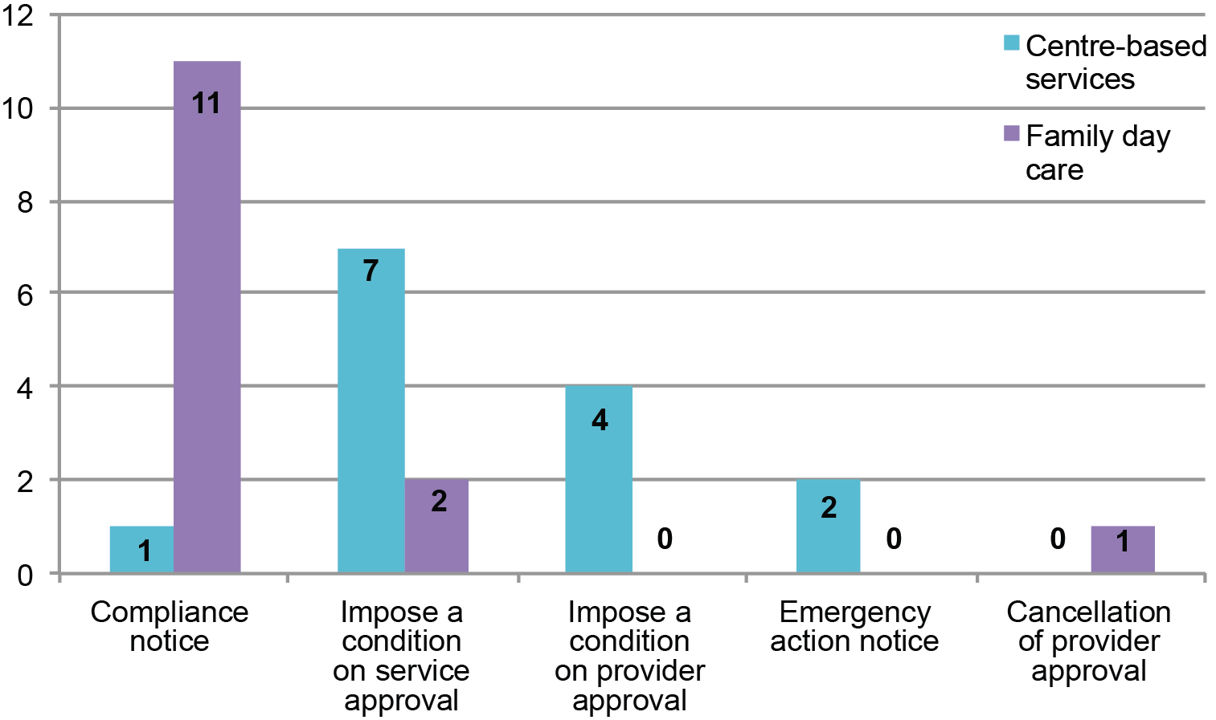

Most statutory sanctions were compliance notices, advising a provider to take certain steps within a specified time (not less than 14 days), or conditions.

QARD is increasingly applying conditions on service or provider approval to combat non-compliance where services or providers show a lack of understanding of the relevant legislation and/or the knowledge or skills to ensure children’s health, safety and wellbeing, and their educational and developmental needs.
Among conditions imposed in 2014, QARD:
- required service management and educators attend its NQF information sessions
- required service management and educators complete approved professional development courses in creating effective programs to meet children’s individual learning needs, including guiding and encouraging acceptable behaviour
- limited the number of educators who can be engaged by or registered with an FDC service
- prescribed the number of FDC co-ordinators to monitor and assist FDC educators.

QARD publishes relevant statutory sanctions on the DET website. A total of 33 have been published since 2012: 18 in 2014, 12 in 2013 and three in 2012.

Family day care compliance
Fourteen sanctions applied to FDC services or providers. QARD sought to address this over representation by collaborating with relevant Commonwealth Government departments to identify compliances issues. It also took part in an FDC working group, comprising representatives from each state and territory government, the Commonwealth Government and ACECQA.

The working group developed a new national Protocol for the Regulation of FDC Services, which promotes a coordinated national approach, including the sharing of expertise and information. Proposed amendments to the National Regulations, scheduled for 2016, are intended to allow regulatory authorities to more effectively regulate FDC services.

Case study—cancellation of provider approval
The statutory sanctions issued against a particular education and care service in 2014 provide an example of the actions QARD takes to combat serious and persistent non-compliance with the National Law, and significant risks to children that cannot be mitigated.
In this case, a Notification of a Serious Incident was substantiated by an investigation. The service was found non-compliant with the National Law and National Regulations. QARD provided continual feedback, advice and guidance to help the service rectify its problems, but it remained in serious non-compliance. Provider approval was cancelled in 2014 after the following statutory actions were taken:
- a compliance notice gave the provider 14 days to rectify serious and ongoing compliance issues
- a show cause notice for suspension of service approval for failure to comply with the compliance notice gave the provider 30 days to provide a written response explaining why the service approval should not be suspended
- a notice of suspension was issue. This was stayed by VCAT, subject to a number of orders. The provider failed to comply with some of the orders.
- A show cause notice for intention to cancel an approved provider gave the provider 30 days to provide a written response explaining why its approval should not be cancelled
- The provider’s approval was cancelled.

Prosecutions
Service providers or licensees can be brought before a court to answer charges of a breach of legislation.

To bring a prosecution, charges must be laid within a year of the date of the commission of the offence under the Children’s Services Act, and within two years of the date of the commission of the offence under the NQF.

In 2014, QARD considered prosecuting a small number of services, including those:
- operating without approval under the National Law or a licence under the Victorian Law
- operating under the National Law with serious and/or persistent non-compliance.

Assessment and rating
QARD continues to focus on meeting the national requirement to assess and rate every education and care service by the end of 2015.

At 31 December 2014, there were 2352 approved services with a final quality rating, representing 60 per cent of the education and care services in Victoria. Nationally, 52 per cent of services have received a final quality rating.

QARD streamlined its processes for assessment and ratings in 2014 and is now accelerating towards the target.

Changes included the introduction of a more efficient and concise rating report template and rating process. These were developed by ACECQA, in conjunction with the Early Childhood Policy Group (ECPG). The new report template is a “smart form” with automatic functions, which allows for evidence to be written at a “standard” rather than at an “element” level, significantly reducing the length of the report.

The new processes allowed for a reduction in the time needed for the assessment and rating. More flexible timelines increased the capacity of authorised officers to conduct assessment and rating visits.

QARD also conducted intensive, targeted training of authorised officers to increase Victoria’s capacity to conduct assessment and rating visits. It also introduced cross-regional assessment and rating visits.

Outcomes of assessment and rating in Victoria
In Victoria, 2352 approved services have received the following quality rating:
- Significant improvement required: one service
- Working towards NQS: 508 services
- Meeting NQS: 1067 services
- Exceeding NQS: 772 services
- Excellent: four services.

Table 5: Comparison of quality ratings (2013–14)
 | 2013 | 2014
Significant improvement required | 1 | 1
Working towards NQS | 310 | 508
Meeting NQS | 635 | 1067
Exceeding NQS | 378 | 772
Excellent | 0 | 4
Figure 12: Final ratings, by type (2014)
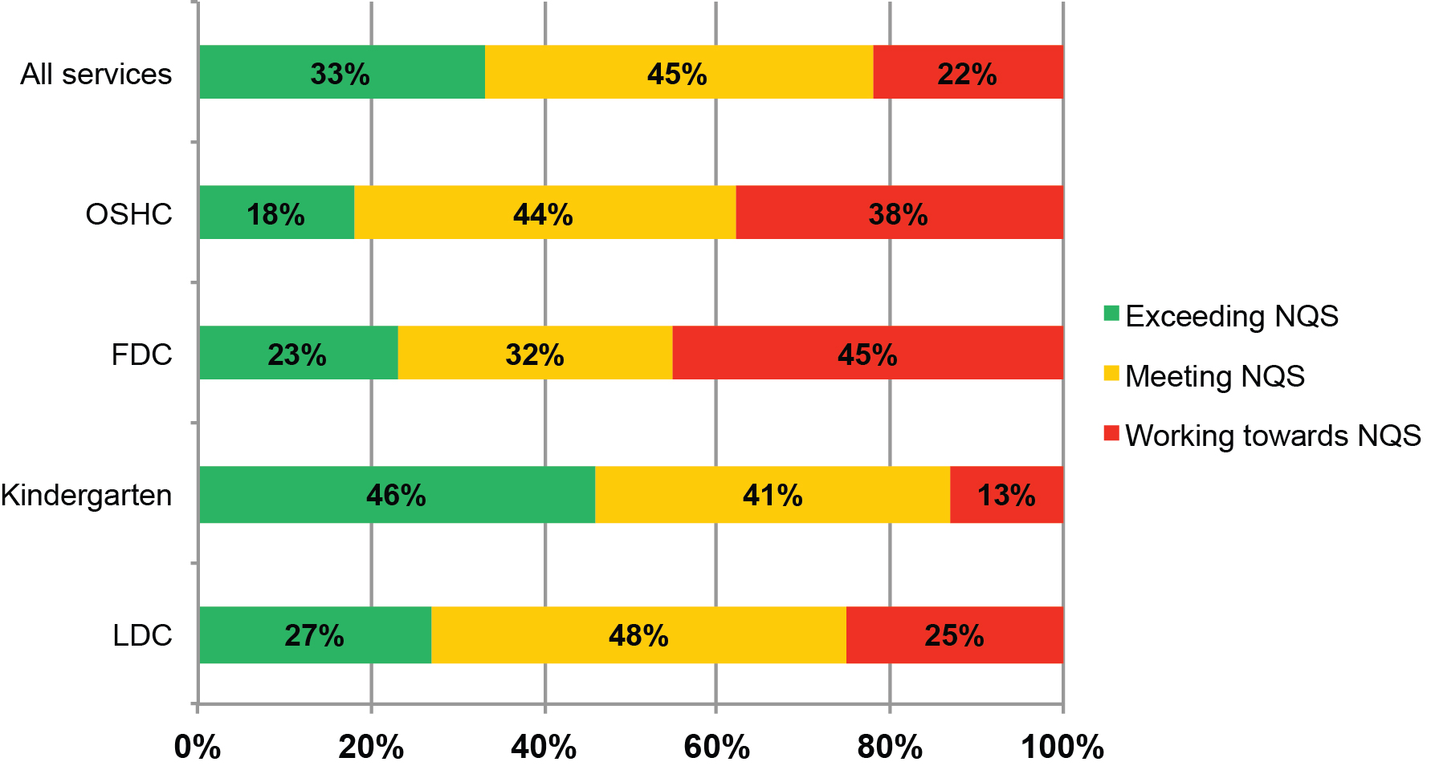
Final ratings for Victorian services exceed the national results: 78 per cent of services met or exceeded the NQS, compared to 65 per cent nationally.

Kindergartens continued to be the strongest performers, with 87 per cent meeting or exceeding NQS, compared with 75 per cent of long day care services, 62 per cent of outside school hours care services and 55 per cent of family day care services.

Under the NQS, services are assessed against seven “quality areas”:
- Educational program and practice
- Children’s health and safety
- Physical environment
- Staffing arrangements
- Relationships with children
- Partnerships with families and communities
- Leadership and service management

Figures 13–16 show how different service types rate according to these quality areas. (Services with overall ratings of “excellent” and “significant improvement required” are not represented due to their small numbers, but are detailed later in the section).

Figure 13: Kindergartens: overall ratings and ratings by quality area (2012–14)
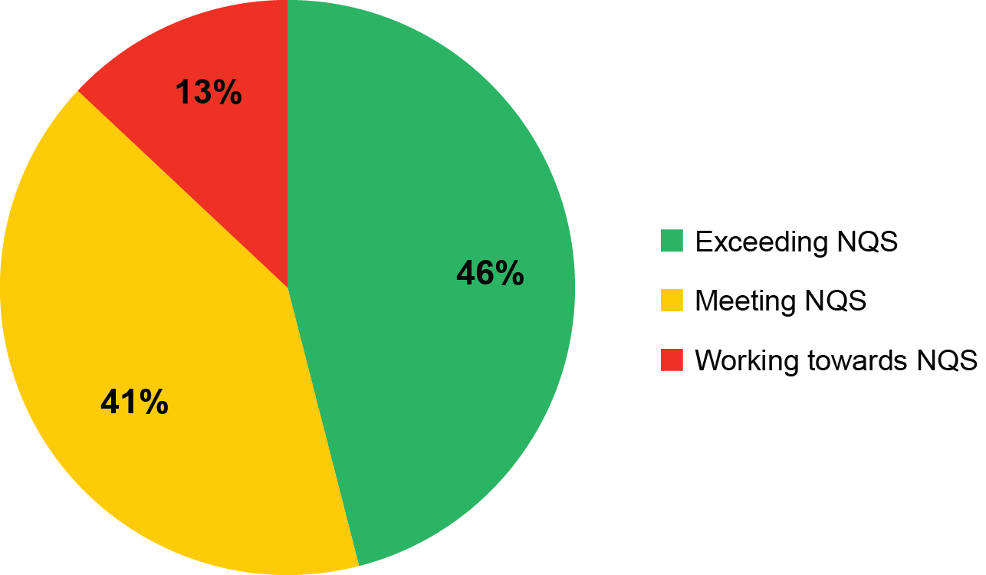 | 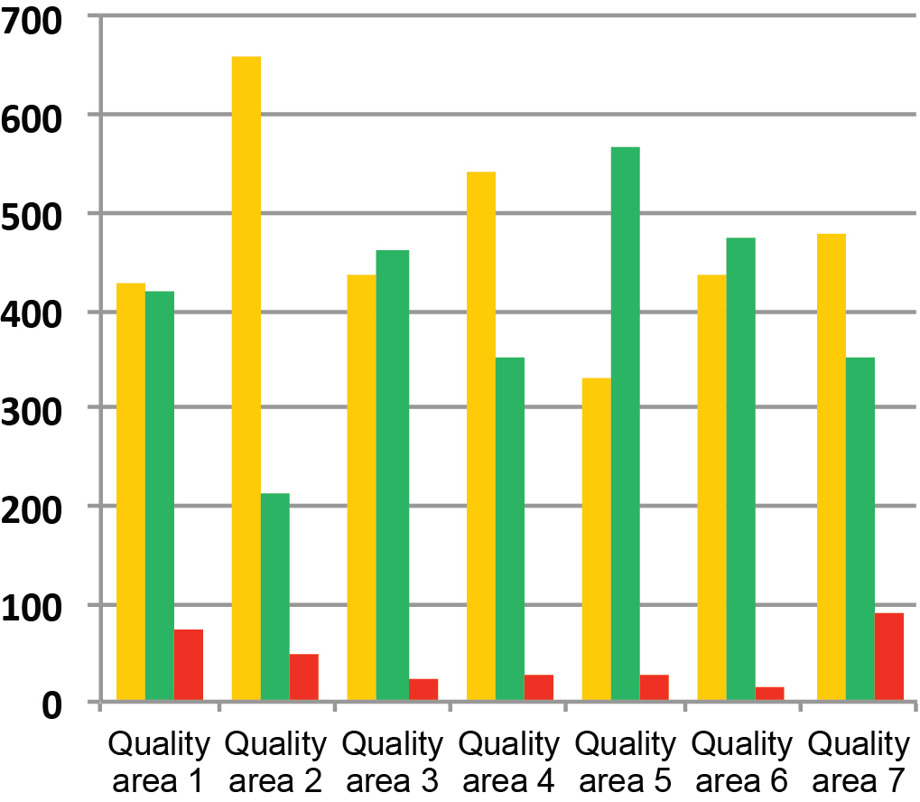
Figure 14: LDC services: overall ratings and ratings by quality area (2012–14)
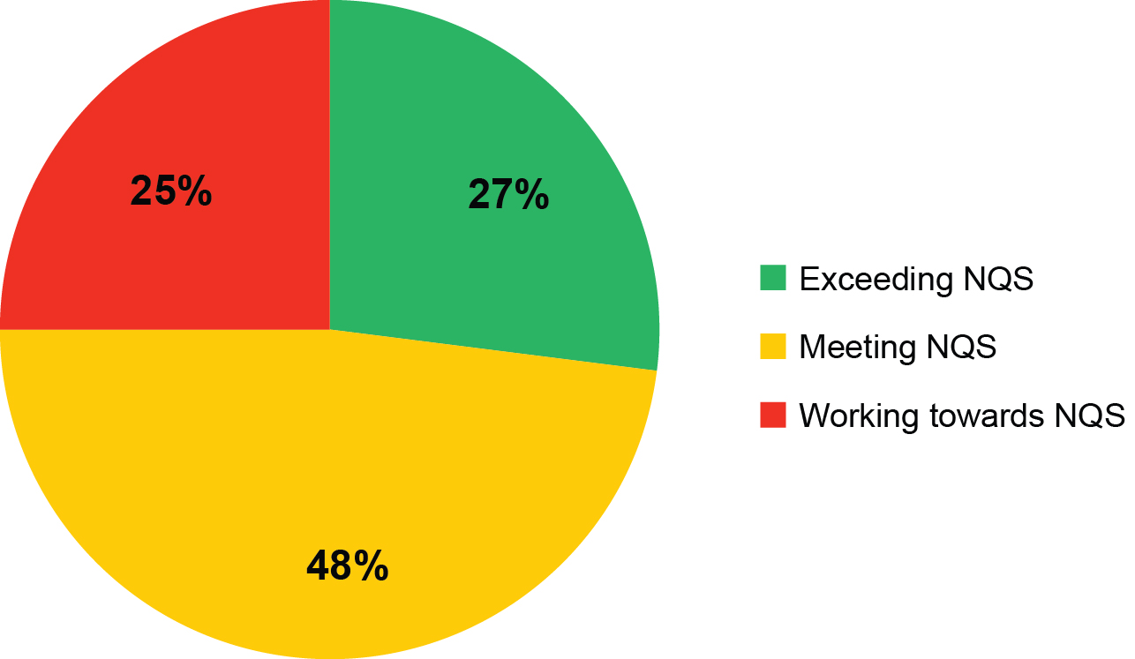 | 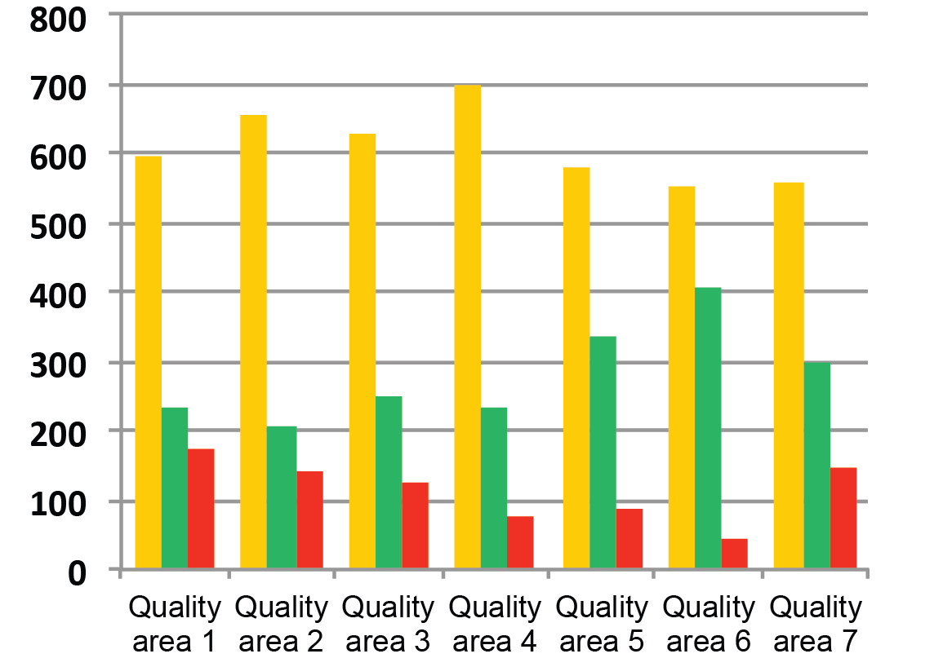

Figure 15: OSHC services: overall ratings and ratings by quality area (2012–14)
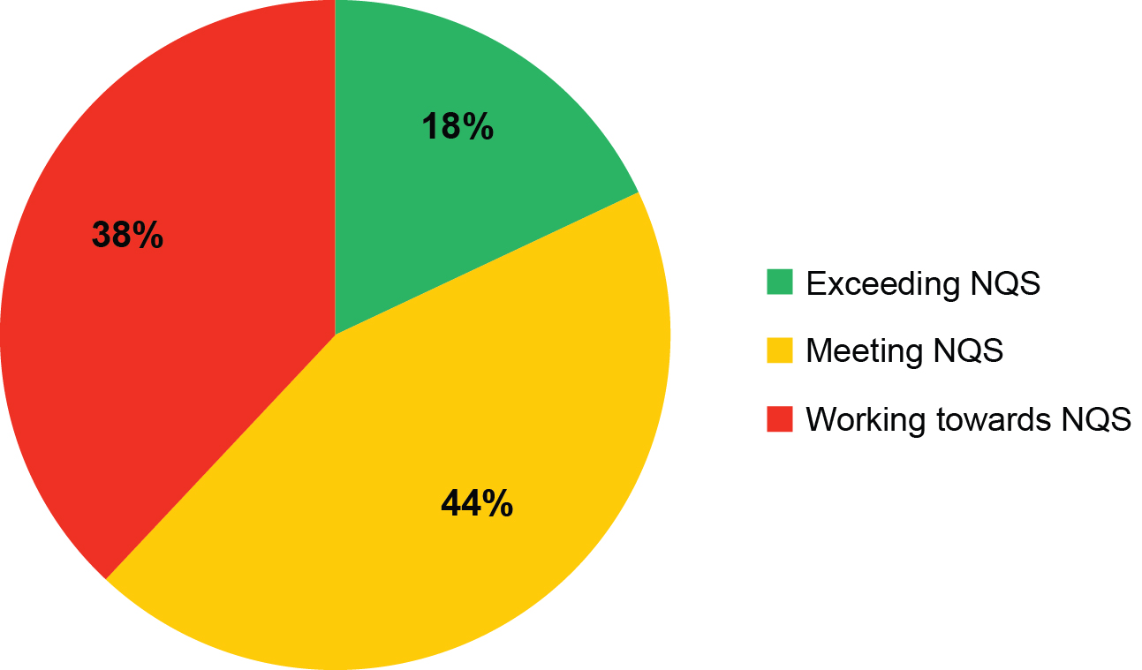 | 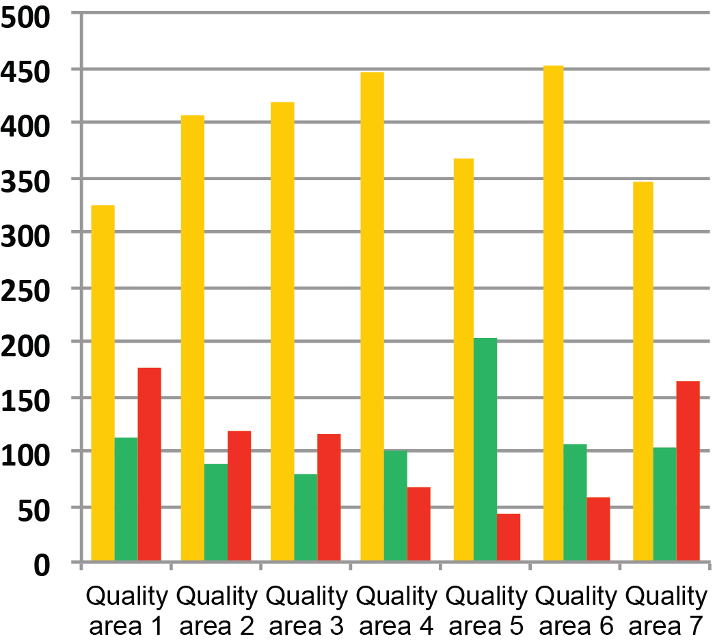

Figure 16: FDC: overall ratings and ratings by quality area (2012–14)
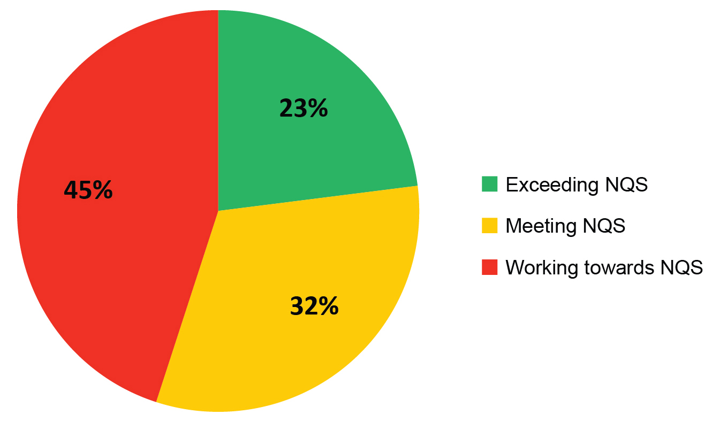 | 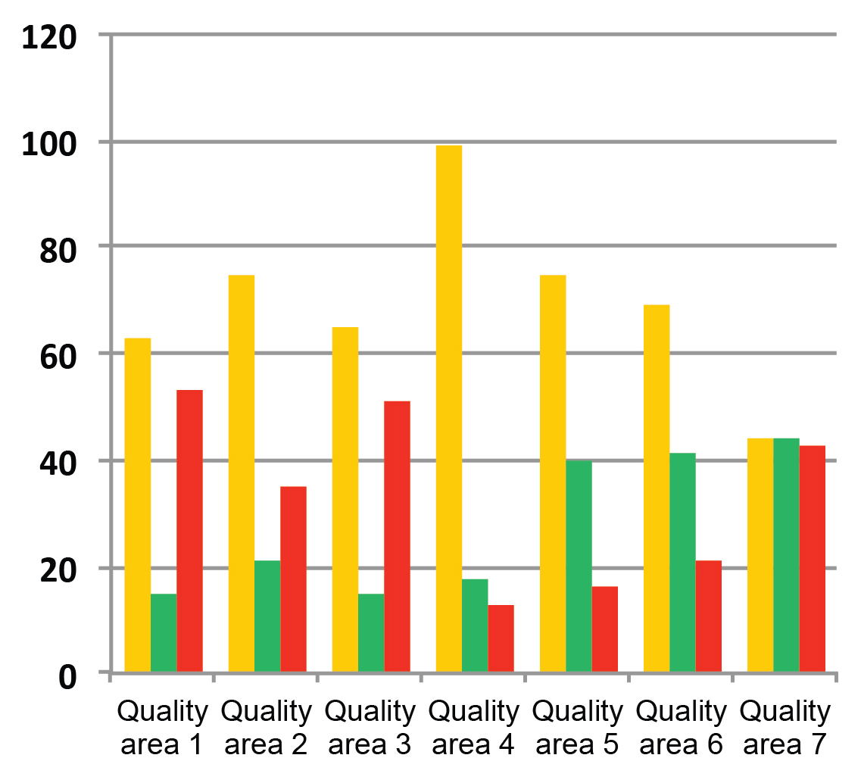

Services working towards NQS
Figure 17 shows how almost half of the services in Victoria with an overall rating of “working towards NQS” had issues with one or two quality areas only. The national figure is 37 per cent.

Nationally, more services had six or seven areas rated as “working towards NQS” than in Victoria.
Figure 17: Services with a final rating of “working towards NQS”, by the number of quality areas rated at this level
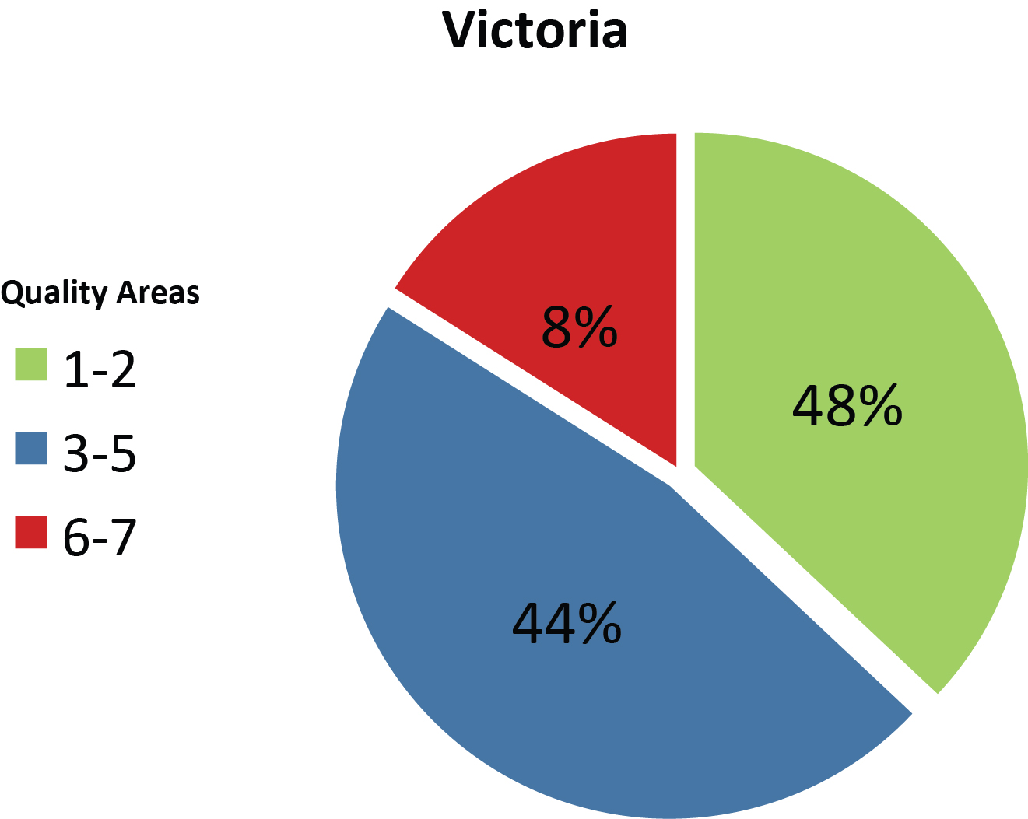 | 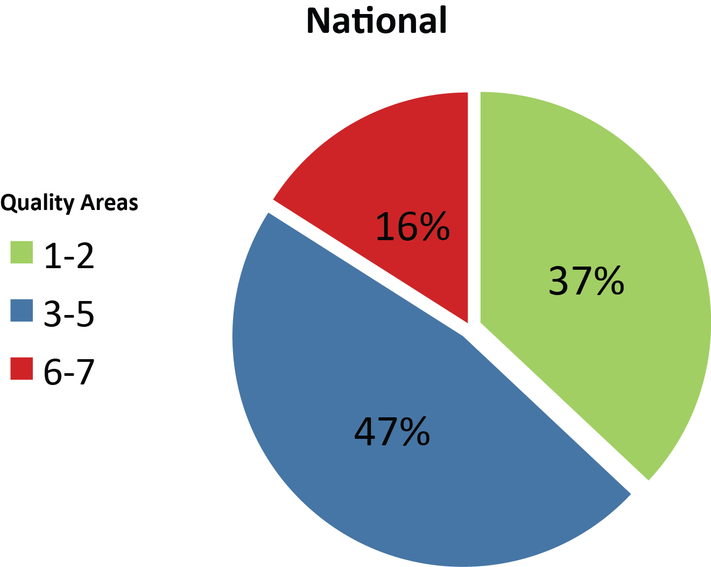
Source: ACECQA Snapshot Q4 2014

Excellent rating
To achieve this rating, services rated “excellent” must:
- exemplify and promote exceptional education and care that improves outcomes for children and families
- demonstrate leadership that contributes to the development of a community, a local area or the wider education and care sector.
- demonstrate commitment to sustained excellent practice through continuous improvement and comprehensive forward-planning.

Four services were awarded an excellent rating in Victoria in 2014: CPS Children’s Centre, Wesley College Early Childhood Learning Centre, Jindi Woraback Children’s Centre and Doveton College Early Learning Centre. Each exemplifies and promotes exceptional education and care that improves outcomes for children and families.

Children's Protection Society Incorporated is the approved provider for the CPS Children’s Centre. The centre’s achievements include an orientation plan to assist each family and child’s transition into the service, an attachment model of care, and a calm, warm and nurturing atmosphere that supports children’s education and care.The service is also collaborating with the University of Melbourne and the Murdoch Children’s Research Institute to determine the impact of high-quality education and care on vulnerable children’s long-term social and educational outcomes.

Uniting Church in Australia Property Trust (Victoria) is the approved provider for Wesley College Early Childhood Learning Centre (Glen Waverley campus). Its innovative programs include a partnership with the Yiramalay community in the Kimberley, including regular cultural exchange visits to the early learning centre by Yiramalay children. It also provides excellent support and inclusion programs for families, especially those from non-English-speaking backgrounds.

Jindi Woraback Children’s Centre Incorporated is the approved provider of the Jindi Woraback Children’s Centre. Among its achievements are an early intervention program and an anti-bullying program, created with five other early childhood services. These programs support vulnerable families in particular. The centre has also established a partnership with the Moondani Balluk Academic Unit at Victoria University. The unit helps the centre embed a respectful, authentic indigenous program to use in everyday practice.

Doveton College is the approved provider of Doveton College Early Learning Centre. The service provides innovative programs and partnerships that demonstrate exceptional engagement with local people, many of whom are newly arrived refugees and migrants. The service recognises the importance of supporting children’s families to achieve excellent outcomes for children and works in partnership with a number of other organisations.

Significant improvement required
Services deemed to place children’s safety, health and wellbeing at risk are rated as “significant improvement required”.
In Victoria, only two services have ever received this rating. The first, a long day care service, was assessed and rated in September 2012 with a rating of “significant improvement required” and was subsequently reassessed and re-rated again in October 2013 with a rating of “working towards NQS”. QARD took compliance actions of increasing severity until April 2014, when the service was transferred to another approved provider.

In July 2013, another long day care service received this lowest rating. Again, compliance actions were taken, including conditions, an Emergency Action Notice and interviews. The service transferred to another approved provider in 2014, with assessment and rating scheduled for 2015.

Assessment and rating review process
Services have three opportunities to have their rating reviewed. First, they may provide feedback or evidence to QARD in response to the draft assessment and rating report, correcting inaccuracies or addressing specific concerns, which may improve their rating.

Following the final assessment and rating report, the provider may apply to QARD for a “tier one” review of their rating by QARD. If unsuccessful, the provider may apply to ACECQA for a “tier two” review. This is conducted by a ratings review panel of three members, drawn from different states and territories and with relevant expertise in areas including early childhood learning and development, law, education and care quality assessment, and best-practice regulation.

In 2014, ACECQA worked with regulatory authorities to develop resources to assist services wishing to respond to or challenge their draft assessment and rating report. These included an application form and information resources.

Of the services assessed and rated in 2014, 148 or 14 per cent provided feedback on their drafts; 18 or 1.7 per cent applied for a tier one review and one applied for a tier two review.

Figure 18: Proportion of reviews, by type (2012–14)
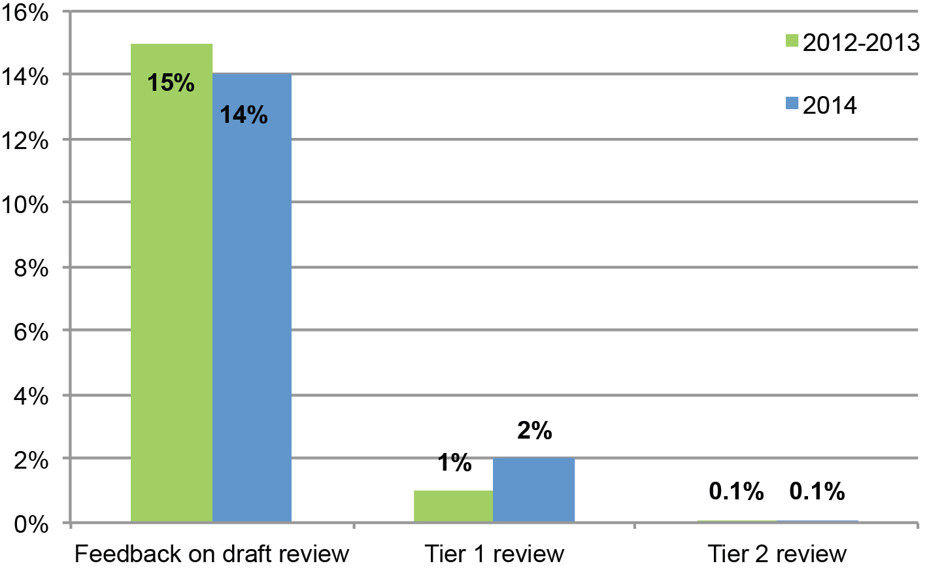
Figure 19, below, shows that half of the services that provided feedback for their draft assessment and rating report did not have their rating changed. Of the remaining 50 per cent that had their rating changed, 33 per cent of services had their ratings changed in only 1 quality area (QA).

Figure 19: Results of feedback to draft assessment and rating report
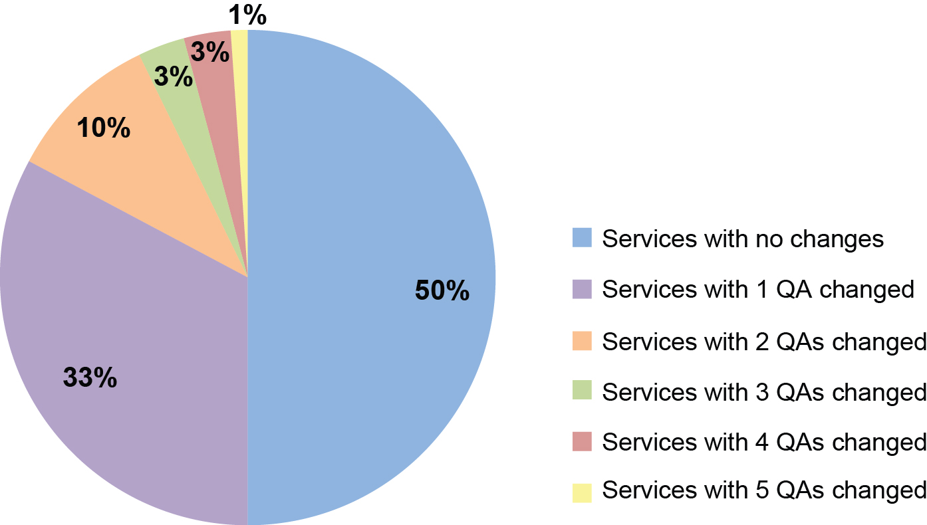

Training and development
QARD continued to improve staff practice and performance in 2014 by providing targeted training, opportunities and resources. This included the introduction of two-hour orientation presentations for new staff.

A new online evaluation process was also introduced. The process allows training participants to provide feedback to help QARD measure the effectiveness of its programs and identify training needs.

New authorised officers
All Australian authorised officers must complete the National Training Program and pass a reliability assessment before they can assess and rate education and care services.

The program comprises seven days of training and is managed by ACECQA’s Training Working Group (TWG) to ensure national consistency. In Victoria, QARD delivers part one of the training, with support from well-respected early childhood consultants. Part two is delivered by QARD and ACECQA.

The training covers areas including the NQS and its legislative framework; the approved learning framework; supporting services to improve and self-assess; monitoring and compliance; determining a rating; evidence-gathering and reliability; and the Victorian context. It also teaches cultural awareness and sensitivity.

In 2014, 17 Victorian candidates successfully completed the National Training Program and became authorised officers.

Experienced authorised officers
QARD organises frequent training sessions for experienced authorised officers to help them hone their skills in areas such as assessment and rating, and investigations. Training aims to promote a consistent approach and can also cover changes to legislation, policy and practices.

QARD’s investigation training program was a particular focus in 2014, with more than 70 authorised officers completing the course. Authorised officers who have completed this training will have the opportunity to complete a Certificate IV in Government (Investigations).

Authorised officers must also complete an annual “drift test” to ensure they maintain reliability in assessment and rating. Drift testing is managed through ACECQA’s eLearning portal. In 2014, 64 authorised officers completed their drift test.

QARD also developed a training package, resources and new business rules to assist with the introduction of the new streamlined assessment and rating process. Senior authorised officers tested the training before it was rolled out. All authorised officers, managers and administrative staff were then trained to implement the new requirements.

Authorised officer forums
These quarterly forums continue to be an important means of engaging with and developing the skills of authorised officers in Victoria. Authorised officers and QARD staff hear expert theories and perspectives about early childhood education and care and regulatory practices.

QARD Executive Director Madeleine Smith opens each forum, providing an update from DET and introducing keynote speakers. In 2014, these included Dr Jillian Rodd, discussing leadership and the pathway to quality improvement in early childhood services; Professor Iram Siraj, discussing key determinants of quality in education and care services; and Heather Barnes, who discussed the educational program, assessing practice and program documentation.

Stakeholder engagement
QARD works with education and care providers and services and key stakeholders to ensure they have the necessary information and tools to meet their legislative obligations and to understand and foster the intentions of the NQF.

QARD maintains strong relationships with internal and external stakeholders, shares its knowledge and expertise with other areas of DET and works collaboratively and proactively with ACECQA, the Commonwealth Department of Education and Training, and state and territory regulatory authorities in policy development and information sharing.

Stakeholder engagement in 2014 focussed on the new requirements in the NQF and the Children’s Services Act that came into effect on 1 January 2014, the regulatory amendments to the National Regulations of June 2014, the Productivity Commission’s public inquiry into early childhood and childcare and the 2014 COAG review of the National Partnership Agreement on the National Quality Agenda. Department representatives continued to deliver presentations at forums, conferences, workshops and meetings.

Provision of information
QARD provides information to support education and care services to comply with legislation. This includes responding to telephone and email enquiries from services, educators and the public and developing resources such as fact sheets, responses to “frequently asked questions” and guidelines.

In 2014, QARD responded to 271 emails on complex regulatory matters. Most enquiries (105) were about staffing arrangements and qualifications. The majority of these related to the early childhood teacher and Certificate III qualification requirements introduced in 2014.

More than 20,800 telephone calls to the 1300 enquiry line were received. The top three enquiries per month were in relation to supervisor certificates, qualifications and FDC approvals. QARD answered 24,090 emails; 22,530 in relation to an application or notification and 1560 general or regulatory enquiries.

In 2014, QARD developed or revised fact sheets on topics including:
- Early childhood teachers—centre based services
- Staffing arrangements
- Transporting children
- Bush kinders
- Children with medical conditions attending education and care services
- Criminal history requirements (centre-based and FDC services)
- Medical conditions
- Managing bushfire risk in centre-based and FDC services

QARD also developed a guide for FDC educators and a guide to delivering a program in an FDC service, and developed educator-to-child ratio calculators to help services meet their NQF ratios.

Conclusion
By 31 December 2014, 2352 approved education and care services—60 per cent of all approved services in Victoria—had been assessed against the NQS and received a final rating.

QARD is on-track to assess all Victorian services by the end of 2015. It will continue to develop strategies to meet this target, particularly relating to the deployment of authorised officers across Victoria and contingency arrangements to maintain scheduled assessment and rating visits.

Findings from the first stage of the 2014 NQF review outlined inconsistencies in the application of the assessment and rating process. To address this, QARD aims to deliver targeted training to the regional workforce and introduce an approved provider summary to capture service feedback on the process.

QARD will continue to engage providers and stakeholders so they can participate in decision-making and have their issues heard. For QARD, stakeholder engagement provides important opportunities to road-test policies, provide information and resources and influence services to comply with legislation.

QARD is now looking forward to the finalisation of the 2014 review of the National Quality Agenda by the Coalition of Australian Governments. The first stage of the review was public consultation on components of the NQF. Feedback informed the development of a Consultation Regulation Impact Statement (RIS). This will be used to make recommendations for agreement by all governments that will be included in a Decision RIS, to be presented to ministers.

The Decision RIS will be published in the first quarter of 2015 to provide the sector with information about any proposed changes to the NQF and the timeframes for change. QARD will engage with education and care services and key stakeholders to provide information and identify any potential issues with the proposed changes, scheduled for 2016.

In 2015, QARD will also consult with other branches of DET and the education and care sector in relation to recommendations made in the Betrayal of Trust Report—the report on the Victorian inquiry into the handling of child abuse by religious and other non-government organisations. QARD will consult with the sector about organisations that should be in the scope of the proposed child-safe standard and reportable conduct schemes. QARD will also communicate with the sector and provide information and resources to ensure responsibilities are understood.

From September 2015, early childhood teachers will be required to be registered with the Victorian Institute of Teaching and will be subject to mandatory reporting requirements. QARD will engage with these educators to ensure they understand their responsibilities.

QARD will continue to play a lead role in the implementation of the NQF in collaboration with ACECQA, the Commonwealth Government and all states and territories. It will continue to collaborate and share knowledge with stakeholders, education and care providers and services to ensure they have the information and tools necessary to meet legislative obligations and to understand and foster the intentions of the NQF.

Above all, QARD will continue to monitor and drive the improvement of services so children receive the best possible care and education to support their social, emotional and intellectual development.

In Victoria, education and care services operated in a government school are generally operated by the school council.

